Peter Samuel
BNFO 300
Professor Jeff Elhai
April 30, 2017

Research Proposal: Citrulline coupled with Arsenic Trioxide as a potential inducer of the PERK/eIF2-alpha apoptotic pathway in GBM cells

Introduction:
Cancer research grants are the fifth highest category of grants that are funded by the NIH annually. In addition, cancer is the second leading cause of death in the United States (Carter et al. 2012). The evolution of scientists understanding of cancer has been a long and arduous process, but has borne much fruit. A strong focus on cell death pathways, such as apoptosis, autophagy, and necrosis, has been pursued by many in the scientific community. Understanding the regulation of these pathways provides a deeper understanding of cellular life, with an emphasis on how to induce cell death. If applied properly, many of these pathways can lead to a deeper understanding of how to specifically target cancer and systematically induce the death of cancer cells in a human host.
One of the primary difficulties in treating cancer today, has been the off-target effects of cancer therapies like radiation and chemotherapy. Both treatments are often nondiscriminatory in their effects on cellular survival. By working to eradicate cancer, these cancer therapies are also causing damage to healthy cells and tissues in the host’s body. Targeted drug delivery systems (TDD) have been studied at length in recent decades in order to combat this issue. In addition to studying TDD systems, much research has been devoted to understanding how biomolecules can also be used in a “targeted” fashion. (Utreja et al. 2010)
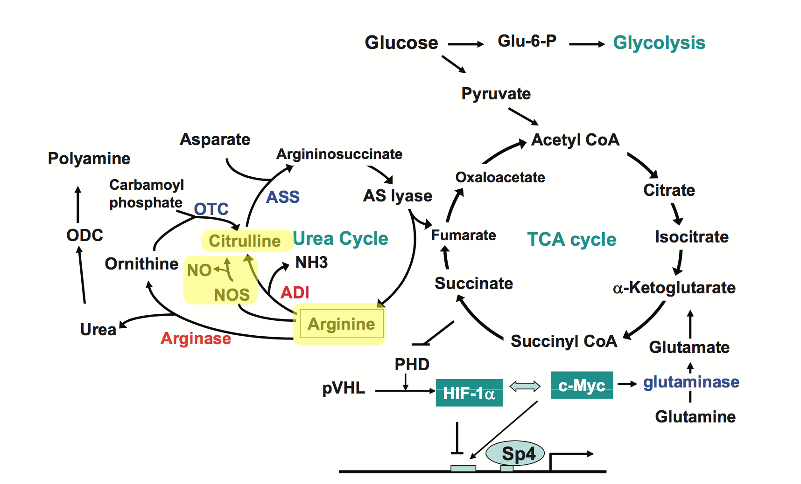
Cellular stress can arise from various events such as; damage to protein, damage to cellular organelles, and interference with other components of the cell that carry out the cells regular tasks (Kourtis et al. 2011). The accumulation of these cellular stressors can surpass a threshold, which differs from cell to cell, and could result in the cell entering into three potential systematic events; autophagy, necroptosis, and apoptosis. Cellular autophagy is the process of degradation of various cellular components such as proteins, nucleic acids, damaged proteins, and various pathogens (Glick et al. 2010). This process is carefully regulated through pathways, many of which have yet to be studied. These pathways are regulated through the expression or repression of genes that code for instrumental proteins in the cell.
L-citrulline is an amino acid naturally generated by the human body. Both arginine and citrulline are a part of the urea cycle, which takes place in the kidneys. In addition to breaking arginine down into citrulline, citrulline is then converted back into arginine through a series of biochemical reactions. The conversion of arginine into citrulline results in the production of NO through an inducible nitric oxide synthase pathway (iNOS). This reaction occurs separate of the urea cycle. Due to the feedback pathway in which L-arginine and L-citrulline are a part of, the addition of L-citrulline will result in an increase in NO synthesis more so than adding arginine directly. This phenomenon has been supported by the data produced through experiments, such as the one conducted by Schwedhelm et al in 2007, where patients receiving oral supplements of L-citrulline increased NO synthesis more so than those receiving oral supplements of L-arginine.
Figure 1 – Depicts the urea cycle and the relationship between arginine, citrulline and NO synthesis (Kuo et al. 2010)
Arsenic Trioxide (ATO) was re-discovered as a cancer therapy in 1999 as a novel treatment for Acute Promyelocytic Leukemia (APL) (Conrad et al). Since then, several studies have shown the efficacy of using ATO as a viable cancer therapeutic (Akao et al. 1999), in addition to exploring the other properties of ATO that make it unique. Of these properties, ATO in relation to NO has been studied at length. Kang et al. (2003) performed experiments to measure whether stress-responsive signaling pathways or NO had a greater effect on the ability of ATO to induce apoptosis in HepG2 cells. Kang and their colleagues observed that the down regulation of these stress-responsive signaling pathways did not change the amount of apoptosis observed among HepG2 cells treated with ATO. When iNOS was inhibited, they observed a significant decrease in apoptosis of HepG2 cells treated with ATO. In addition, ATO, when coupled with Metformin (a Type-II Diabetes medication), has been shown to specifically target glioblastoma cells in the brain. ATO/Metformin combo were observed to have low to no effect on normal human glia cells (Carmignani et al. 2014). Further, evidence generated from Kulshrestha and their colleagues’ study of arsenic compounds suggested that the presence of arsenic compounds increases the generation of superoxides and reactive oxygen species in general (2014).
Reactive oxygen species (ROS) are known for their detrimental effects on cellular DNA (Lee et al. 2015). This DNA damage can lead to the production of damaged proteins, organelles, and other biomolecules. According to the data collected during a study performed by Breher et al. (1996), damage caused by the formation of ROS is actually what often induces cells to become cancerous. Similarly, as ROS increase in a cell, they may also induce cellular apoptosis through excessive damage to lipids, proteins, and DNA. (Lee et al. 2015) Nitric Oxide (NO) coupled with superoxide molecules has been shown to produce ROS (Hickok et al. 2010). ROS have been the focus of much study due to their destructive properties when generated in large amounts in a cell.
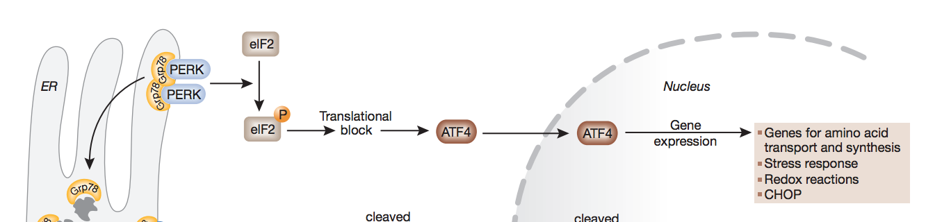
eIF2 is a eukaryotic translation initiation factor, a heterotrimer, that is required for proper translation of proteins throughout eukaryotic cells. The alpha subunit of eIF2, eIF2-alpha, is the sub-unit that is phosphorylated at serine 51 in response to various cellular stress signals. These stress signals include; ER stress, diminished presence of amino acids, dsRNA, and heavy metals. The phosphorylation of serine 51 inhibits the eIF2-alpha sub-unit from binding with eIF2-beta sub-unit. Without the two sub-units bound together, eIF2 initiation factor is unable to stimulate the production of proteins in the host cell (Kimball, 1999). Of particular interest is the evidence from a study conducted by Verfaillie and colleagues (2012) that describes the necessity of PERK, a kinase found in the endoplasmic reticulum, in phosphorylating the eIF2-alpha sub unit. PERK is naturally bound up by the ER chaperone GRP78. When stress is introduced in the ER, GRP78 releases PERK as a response to the introduced stress. PERK was observed to be generated when oxidative stress was introduced in the ER, specifically through ROS. This pathway has been referred to as the PERK/eIF2-alpha apoptotic pathway.
Figure 2 – Role of PERK/eIF2-alpha in causing cell damage and apoptosis (Szegezdi et al. 2006).
The purpose of this study is to see if citrulline coupled with ATO will induce apoptosis mediated through PERK. The methods used to study this potential phenomenon are described below.

The Experiment:

Overview
GBM cells will be treated in two groups; one group will be treated as the negative control (siRNA knocking down the gene responsible for generating PERK), the other group will be the treatment group (no alteration of natural PERK generation). Within each of these two groups, there will be sub treatments using saline (control), citrulline, ATO, and an ATO/citrulline combo. Several analyses will be run in order to ensure the efficacy of treatment using citrulline/ATO as a direct inducer of the PERK/eIF2-alpha apoptotic pathway. These analyses include western blots looking for expression of PERK protein, eIF2-alpha phosphorylated protein, and eIF2-alpha unphosphorylated protein expressions. In addition, cell death assays will be run in order to quantify the efficacy of this treatment.

Growth and Treatment
In order to measure the PERK/eIF2-alpha apoptotic pathway in GBM cells, GBM cells must be grown and proliferated in three groups, each group will be treated as a control, positive control, or negative control. Three large flasks containing GBM cells will be grown in appropriate medium and at appropriate incubation temperatures until they contain 2-3 million cells per flask. They will then be plated in 96 well plates at 20,000 cells per well, along with growth medium. They will be allowed to continue proliferating for another 24-hour period. Once the plated GBM cells are given time to proliferate, the negative control group will be exposed to their appropriate siRNA using procedures outlined by Zhang et al. (2016). The use of siRNA to knock down protein production has been well studied. siRNA is a double stranded RNA molecule that binds to a RNA-induced silencing complex (RISC). siRNA is delivered to the cell through a liposome, and this technique is most common using Lipofectamine. (Zhang et al. 2016) The RISC identifies a double stranded RNA molecule as siRNA through the two 3’ thymine overhangs that siRNA is designed with. Once the siRNA binds to RISC, the (+) sense siRNA strand is cleaved, leaving the antisense siRNA strand. RISC then finds the mRNA that would translate for the protein PERK, and bind the siRNA antisense strand to it. Then, RISC would release cleaving inducing signals that would result in the degradation of mRNA bound to it. (Hammond et al. 2013) Specific PERK siRNA have been designed by a previously conducted study. (Lü et al. 2014) The reason that a negative control group will be employed is because inhibiting the development of PERK should render the citrulline/ATO combo treatment useless, since the PERK/eIF2-alpha pathway not be able to proceed without the presence of PERK. The normal control group that will not be treated with any siRNA will be used to see if this drug therapy produces results different from that the negative control group produces.
Figure 3 – siRNA Mechanism (http://vignette1.wikia.nocookie.net/mmg-233-2013-genetics-genomics/images/4/42/SiRNA.jpgwill)
After siRNA treatment, a 12-hour period is given to allow the siRNA to knockdown their appropriate targets (Zhang et al. 2016). After this, the 96 well plates will be divided and treated within the 3 sub groups (saline, citrulline, ATO, and citrulline/ATO), this will result in 19 wells per sub group. The need for 5 sub group stems from similar reasoning for having the treatment group and negative control group. After the treatment of each sub group, western blot analysis will be run with antibodies for PERK, phosphorylated eIF2-alpha, unphosphorylated eIF2-alpha, as outline in the study conducted by Zhang et al. (2016).
Western Blot
Western blotting is a technique that measures the presence of a certain protein. Western blotting kits, such as the one used in this experiment, contain lysing buffer. The lysing buffer is mixed in with the cells in order to break them open to examine protein presence. After the lysing buffer is added, inhibitors are added that inhibit enzymes like protease and phosphatase in order to preserve the integrity of proteins. Then, the mixture is centrifuged and the supernatant is kept, while the pellet is discarded. The supernatant contains the proteins of interest. The proteins are then placed in a buffer known as SDS. SDS binds to proteins and causes them to be negatively charged, and then the buffer (containing the proteins) is loaded into a gel. The gel, transfer membrane, blotting paper, and pads are then placed in a container with buffer that runs a current through the gel and transfers the proteins from the gel to the transfer membrane. Once complete, the transfer membrane is removed and stained using antibodies designed to identify the protein PERK. The antibodies are designed specifically for an epitope, which is unique to the sequence of the protein. After the initial antibodies stain the transfer membrane, a secondary antibody is used to stain the transfer membrane, and binds to the primary antibody. The secondary antibody contains an enzyme, such as horseradish peroxidase or alkaline phosphatase, that when exposed to a substrate will fluoresce. The final step is to observe the bands that may be present using digital imaging calibrated to observe the fluorescence. (Mahmood et al. 2012)
Figure 4 - Depiction of Western Blot (https://www.emdmillipore.coERSHOP/static/WFS/Merck-Site/-/Merck/en_US/Freestyle/BI-Bioscience/Protein-Detection/western-blotting/western-blotting/8.jpg)

Discussion:
Several results could arise from this study. The hypothesis of the proposed experiment is that in the presence of citrulline/ATO, GBM cells would undergo apoptosis at a high rate through the induction of the PERK/eIF2-alpha apoptotic pathway. This would produce western blots that can be analyzed to show high expression of PERK and phosphorylated eIF2-alpha sub-unit and low expression of unphosphorylated eIF2-alpha sub-unit. This result would support the hypothesis. In addition, cell death assays would be run and control GBM cells treated with ATO/citrulline would result in the highest level of cell death. Though ATO has been shown to be a cancer specific therapy (Akao et al. 1999), it must be tested in normal human glia cells as well.
Some discouraging results that may be observed include results that would suggest that the PERK/eIF2-alpha apoptotic pathway is not being induced in the GBM cells at all or even no cell death is taking place. The first possible result could be observed through analysis of the western blots that show phosphorylated eIF2-alpha and PERK to not be expressed or only expressed at low levels. Further, unphosphorylated eIF2-alpha would be shown to be strongly expressed in the GBM cells. The second possible result of having no cell death would suggest that the addition of ATO/citrulline drug combination has no effect on GBM cells. Though I am not entirely sure why this would occur, ATO/citrulline have never been combined before and may not result in the formation of ROS. This could be possible if ATO does not encounter NO in GBM cells.
Another possible result is that apoptosis is occurring, but not through the PERK/eIF2-alpha apoptotic pathway. The presentation of results of western blots would be the same as if this apoptotic pathway is not being induced. The cell death assays would be interpreted as showing significant cell death. This could mean that another apoptotic pathway is induced, or another pathway involving autophagy or necroptosis is being employed. In order to measure for these other apoptotic pathways, other experiments would have to be completed with the focus being on these potential apoptotic pathways. Though that would require an extensive amount of studies and research, further research might yield likely apoptotic pathways to pursue first. Other likely apoptotic pathways that have been induced in GBM cells include; caspase-3 dependent apoptosis (Lu et al. 2010), cAMP agonist mediated apoptosis (Daniel et al. 2016), and PEITC induced apoptosis (Chuo et al. 2015) are some of many.

References:

Akao, Y., Nakagawa, Y., & Akiyama, K. (1999). Arsenic trioxide induces apoptosis in neuroblastoma cell lines through the activation of caspase 3 in vitro. FEBS Letters, 455(1-2), 59-62. Retrieved April 29, 2017.

Carmignani, M., Volpe, A. R., Aldea, M., Soritau, O., Irimie, A., Florian, I. S., Valle, G. (2014). Glioblastoma Stem Cells: A New Target for Metformin and Arsenic Trioxide. Journal of Biological Regulators & Homeostatic Agents, 28(1), 1-15. Retrieved April 29, 2017.

Carter, A. J., & Nguyen, C. N. (2012). A comparison of cancer burden and research spending reveals discrepancies in the distribution of research funding. BMC Public Health, 12(1), 1-12. Retrieved April 26, 2017.

Conrad, M. E. (1999). Treatment of Acute Promyelocytic Leukemia with Arsenic Trioxide. New England Journal of Medicine, 340(13), 1043-1045. Retrieved April 29, 2017.

Daniel, P. M., Filiz, G., & Mantamadiotis, T. (2016). Sensitivity of GBM cells to cAMP agonist-mediated apoptosis correlates with CD44 expression and agonist resistance with MAPK signaling. Cell Death and Disease, 7(12). Retrieved April 29, 2017.

Glick, D., Barth, S., & Macleod, K. F. (2010). Autophagy: cellular and molecular mechanisms. The Journal of Pathology, 221(1), 3-12. Retrieved April 27, 2017.

Hammond, S. M., Caudy, A. A., & Hannon, G. J. (2001). Post-transcriptional gene silencing by double-stranded RNA. Nature Reviews Genetics, 2(2), 110–9. Retrieved April 27, 2017.

Hickok, J., & Thomas, D. (2010). Nitric Oxide and Cancer Therapy: The Emperor has NO Clothes. Current Pharmaceutical Design, 16(4), 381-391. Retrieved April 28, 2017.

Kang, S., Song, J., Kang, H., Kang, J., Kim, S., Kang, H., Park, D. (2003). Arsenic trioxide-induced apoptosis is independent of stress-responsive signaling pathways but sensitive to inhibition of inducible nitric oxide synthase in HepG2 cells. Experimental and Molecular Medicine, 35(2), 83-90. Retrieved April 29, 2017.

Kimball, S. R. (1999). Eukaryotic initiation factor eIF2. The International Journal of Biochemistry & Cell Biology,31(1), 25-29. Retrieved April 29, 2017.

Kourtis, N., & Tavernarakis, N. (2011). Cellular stress response pathways and ageing: intricate molecular relationships. The EMBO Journal, 30(13), 2520-2531. Retrieved April 27, 2017.

Kulshrestha, A., Jarouliya, U., Prasad, G., Flora, S., & Bisen, P. S. (2014). Arsenic-induced abnormalities in glucose metabolism: Biochemical basis and potential therapeutic and nutritional interventions. World Journal of Translational Medicine, 3(2), 96-111. Retrieved April 29, 2017.

Kuo, M. T., Savaraj, N., & Feun, L. G. (2010). Targeted cellular metabolism for cancer chemotherapy with recombinant arginine-degrading enzymes. Oncotarget, 1(4), 246-251. Retrieved April 28, 2017.

Lee, K., Jeong, J. E., Kim, I. H., Kim, K., & Ju, B. (2015). Cyclo(phenylalanine-proline) induces DNA damage in mammalian cells via reactive oxygen species. Journal of Cellular and Molecular Medicine, 19(12), 2851-2864. Retrieved April 27, 2017.

Lu, H., Wang, H., Chuang, Y., Tang, Y., Yang, J., Ma, Y., Chung, J. (2009). Danthron Induced Apoptosis Through Mitochondria- and Caspase-3-Dependent Pathways in Human Brain Glioblastoma Multiforms GBM 8401 Cells. Neurochemical Research, 35(3), 390-398. Retrieved April 29, 2017.

Lü, P., Li, X., Ruan, L., Xu, H., & Liu, Q. (2014). Effect of siRNA PERK on fluoride-induced osteoblastic differentiation in OS732 cells. Biological Trace Element Research, 159(1–3), 434–439. Retrieved April 29, 2017.

Mahmood, T., & Yang, P. C. (2012). Western blot: Technique, theory, and trouble shooting. North American Journal of Medical Sciences, 4(9), 429–434. Retrieved April 29, 2017.

Schwedhelm, E., Maas, R., Freese, R., Jung, D., Lukacs, Z., Jambrecina, A., Böger, R. H. (2008). Pharmacokinetic and pharmacodynamic properties of oral L-citrulline and L-arginine: impact on nitric oxide metabolism. British Journal of Clinical Pharmacology, 65(1), 51-59. Retrieved April 28, 2017.

Szegezdi, E., Logue, S. E., Gorman, A. M., & Samali, A. (2006). Mediators of endoplasmic reticulum stress-induced apoptosis. EMBO reports, 7(9), 880-885. Retrieved April 29, 2017.

Utreja, P., Jain, S., & Tiwary, A. K. (2010). Novel Drug Delivery Systems for Sustained and Targeted Delivery of Anti-Cancer Drugs: Current Status and Future Prospects. Current Drug Delivery, 7(2), 152-161. Retrieved April 29, 2017.

Verfaillie, T., Rubio, N., Garg, A. D., Bultynck, G., Rizzuto, R., Decuypere, J., Agostinis, P. (2012). PERK is required at the ER-mitochondrial contact sites to convey apoptosis after ROS-based ER stress. Cell Death and Differentiation, 19(11), 1880-1891. Retrieved April 29, 2017.

Zhang, G., Ling, X., Liu, K., Wang, Z., Zou, P., Gao, J., Ao, L. (2016). The p-eIF2α/ATF4 pathway links endoplasmic reticulum stress to autophagy following the production of reactive oxygen species in mouse spermatocyte-derived cells exposed to dibutyl phthalate. Free Radical Research, 50(7), 698-707. Retrieved April 29, 2017.

