**PDK1 Inhibition and Possible Induction of a Mesenchymal-Epithelial Transition as a Curative Measure in Proliferating Cancer Cells**

1. **Introduction**

One of the biggest Holy Grails of scientific discoveries has been finding a cure for cancer. It is no surprise that it is the deadliest disease, with one in three people developing cancer in their lifetime.1 Many patients diagnosed with cancer acquire long-term psychosocial consequences such as anxiety, depression, and PTSD due to conventional treatment.2 Although chemotherapy and radiation therapy have been effective treatment methods, some of their setbacks include increased anticancer-drug resistance, undesired toxicity to normal cells, and frustrated attempts at treating metastatic cancer cells.3 The most significant of these obstacles has been treating metastatic cancer cells, since metastasis has been the biggest contributor to cancer mortality.4 This is due to the impressively invasive profile into which these cancer cells transition before breaking off from the initial tumor and migrating elsewhere in the body. Thus, treating these cells and preventing metastasis is at the core of inhibiting cancer proliferation and reducing mortality rates.

Cancer cells that are preparing to metastasize display a specific cell-type transition called an epithelial-mesenchymal transition.4 This transition provides migratory and invasive properties that mediate the progression from a benign cell to a metastatic cell. The process involves alteration in morphology, cellular architecture, adhesion, and migration capacity (**Fig 1.**) through upregulation of specific mesenchymal-inducing signature genes.5 Interestingly, epithelial-mesenchymal transitions have generated cells with stem cell-like properties, contributing further to the problem of metastasis by allowing these cells to invade surrounding areas and differentiate into problematic cells.6 The reversal of this transition (mesenchymal-epithelial transition) has been supported as a novel anticancer strategy that reverts mesenchymal cells back to their pre-metastatic nature.7

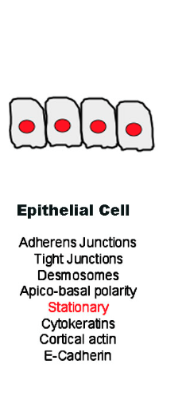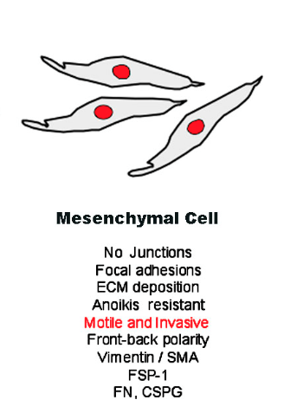

**Figure 1. Characteristics of epithelial and mesenchymal cells.** Adapted from Figure 2 of Ref 5.

A potential strategy for inhibiting cancer proliferation through a mesenchymal-epithelial transition builds around a central process necessary for cancer cell survival. Cancer cells exhibit a unique modification to their metabolism, thought either to be a side-effect or a causative role in their continued replication and growth. This special metabolic process, termed the Warburg effect, describes the metabolic rerouting to lactate fermentation and other biosynthetic processes over mitochondrial oxidation, even with a sufficient oxygen supply present.8 **Fig. 2** illustrates this process, showing specifically what happens in cancer cell metabolism that gives its advantage for survival and proliferation. For example, with the cell producing excessive amounts of lactate, it creates an acidic environment of low pH in which an immune response is ineffective. Additionally, inhibiting mitochondrial oxidation reduces production of reactive oxygen species that prevent metastasis. A previous study showed that inducing an epithelial-mesenchymal transition resulted in this metabolic rerouting, so it is speculated that intervening at a critical point that disrupts normal cancer metabolism may be sufficient to reverse this transition.9,10

Several enzymes and signaling factors are involved in the overall joint effort to alter cell metabolism. A central enzyme involved in this effort is pyruvate dehydrogenase (PDH), which interconnects glycolysis and the tricarboxylic acid (TCA) cycle. Normally, while a cell has produced enough ATP, PDH is inhibited by phosphorylation by pyruvate dehydrogenase kinase (PDK). Inhibition of PDH leads to a lack of acetyl-CoA production and a resulting buildup of pyruvate, which either undergoes gluconeogenesis or lactate fermentation. Cancer cells are especially good at taking advantage of this process by increasing expression of PDK.9 Therefore, inhibiting PDK might function to disrupt cancer metabolism at its core.

**Normal Cell**

glucose

pyruvate

TCA

PDH

ROS

ATP

**Cancer Cell**

glucose

pyruvate

TCA

PDH

ROS

ATP

PDK

biosynthesis

metastasis

proliferation

lactate

ATP

**Figure 2.** **Difference in Cell Metabolism.** Adapted from Figure 1 of Ref. 9

Zhang et al. (2016) speculated that since pyruvate acts as a negative feedback molecule to PDK1, synthesizing structural analogues to pyruvate may produce inhibitory outcomes. Upon testing antiproliferative activity in the human lung adenocarcinoma cell line (A549) and breast cancer cell line Michigan Cancer Foundation-7 (MCF-7), they identified three hit compounds that completely inhibited the growth of the cancer cells at 40 μM.11 The authors further tested these compounds to find out their role on mitochondrial bioenergetics in the MCF-7 cell lines. In order to identify a change in cancer cell metabolism via PDK1 inhibition, the authors measured oxygen consumption rate (OCR), extracellular acidification rate (ECAR), and proton production rate (PPR), key indicators that mitochondrial oxidation increased and lactate production decreased. The authors found that all three compounds increased OCR and reduced ECAR and PPR significantly compared to the control MCF-7 cell lines, consistent with the role for a PDK inhibitor altering cancer metabolism.

Takaishi et al. (2016) were interested in measuring the change between mesenchymal and epithelial cell types upon introduction of reprogramming factors.7 They tested this idea by performing an experiment in which reprogramming factors expressed in a vector system were introduced into HOC313 and OSC-19 human cell lines and signature genes were tracked using quantitative real-time reverse-transcriptase-PCR (real-time qRT-PCR). The cells were first induced to a mesenchymal-type cell before introduction of reprogramming factors. While monitoring the effects of the reprogramming factors, the authors identified upregulation of epithelial signature genes CDH1, DSC 2, DSP, TGM1, and JUP and downregulation of mesenchymal signature genes TGFB1, TGFBR2, SNAI1, and SNAI2.

In theory, a disruption in cancer metabolism should provide the conditions for decreased cell proliferation and metastasis, and ultimately a reverse transition of metastatic mesenchymal cells to normal epithelial type cells. The purpose of the experiment described in this proposal is to test whether this is the case.

1. **Experiment**

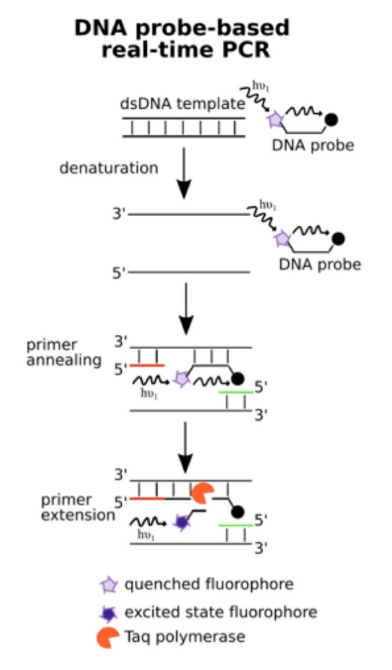

**Figure 3. Principle Behind real-time qRT-PCR.** PCR amplifies double-stranded DNA, so mRNA needs to be reverse-transcribed into cDNA using reverse transcriptase enzyme. The cDNA can then be primed by gene-specific forward and reverse primers and the subsequent extension by a polymerase generates the first double-stranded DNA molecule. The gene-specific primer probes are constructed with a fluorescent label covalently attached to one end of the probe and a quencher tagged to the opposite end. The fluorescent tag constantly produces a signal, and while in close vicinity, the quencher tag absorbs the fluorescence. Only when the two are separated by primer extension is there a resulting fluorescent signal that the thermocycler machine picks up. (Adapted from Ref 13.)

The aim of this experiment is to determine the relative expression of epithelial and mesenchymal signature genes in human pancreatic ductal adenocarcinoma cells (HPDAC) upon introduction of a PDK1 inhibitor, using glycolytic signature genes as confirmation of successful metabolic alteration. If the PDK1 inhibitor is successful in inducing a mesenchymal-epithelial transition and redirected metabolism in HPDAC cells, then I would expect an upregulation of epithelial signature genes and a downregulation of mesenchymal signature genes in conjunction with an upregulation of glycolytic signature genes.

1. A Quantitative real-time RT-PCR

In order to monitor the relative rates of signature gene expression, real-time qRT-PCR will be used, as illustrated by **Fig 3**. This process allows researchers to observe a real-time change in mRNA transcription as a result of a stimulus, in this case PDK1 inhibition. The PCR primers for epithelial and mesenchymal signature genes have been designed by Takaishi et al. (2016) and were successful in gene expression analysis.7 The primers for glycolytic signature genes will be self-designed, an example of which is shown in **Fig 4**. Additionally, each signature gene will have a probe designed according to suggested guidelines ([Integrated DNA Technologies](http://www.idtdna.com/pages/decoded/decoded-articles/pipet-tips/decoded/2013/10/21/designing-pcr-primers-and-probes)). During a cycle of PCR, the gene-specific primers bind to their respective strands, with the probe also binding to a strand. As polymerase extends from the primers, the probe is removed base-by-base and replaced with DNA, resulting in the separation of the quencher and fluorophore to produce fluorescence (**Fig. 3**). However, there is a threshold of fluorescence that must be reached before the thermocycler can detect a signal as shown by **Fig 5**. Thus, if there is a greater starting concentration of mRNA, the fluorescence threshold will be reached after fewer cycles of PCR than that of a lower starting concentration.

LDHA

5’-AGATGATGGATCTCCAACATGGCAGCCTTTTCCTTAGAACACCAAAGATTGTCTCTGGCAAAGACTATAATG

3’-TCTACTACCTAGAGGTTGTACCGTCGGAAAAGGAATCTTGTGGTTTCTAACAGAGACCGTTTCTGATATTAC

TAACTGCAAACTCCAAGCTGGTCATTATCACGGCTGGGGCACGTCAGCAAGAGGGAGAAAGCCGTCTTAATTTGG-3’

ATTGACGTTTGAGGTTCGACCAGTAATAGTGCCGACCCCGTGCAGTCGTTCTCCCTCTTTCGGCAGAATTAAACC-5’

GGATCTCCAACATGGCAGCCTT

TCGTTCTCCCTCTTTCGGCAGA

**Figure 4. Primer Design.** Primers are selected of length between 18-30 nucleotides, and target sequence amplification around 130 nucleotides. The yellow highlighted portions of the lactate dehydrogenase A gene are the target forward and reverse sequences. The boxed items represent the designed primers with their sequences.

Forward Primer: 5’-GGATCTCCAACATGGCAGCCTT-3’

Reverse Primer: 3’-TCGTTCTCCCTCTTTCGGCAGA-5’

1. B Real-time qRT-PCR analysis of PDK1 Inhibition in HPDAC

The HPDAC cells will first be induced to a mesenchymal-type cell before introduction of a previous identified PDK1 inhibitor (2,2-Dichloro-N-(4-chloro-3 (trifluoromethyl)phenyl)- acetamide).11,12 Real-time qRT-PCR will be used to measure for an increased ratio of mesenchymal to epithelial signature genes. The ratio of glycolytic to TCA signature genes will also be taken as a baseline. These signature genes are DSP and TGM1 for epithelial identification, TGFB1 and SNAI1 for mesenchymal identification, and LDHA and PDHB for glycolytic identification. The PDK1 inhibitor will then be introduced into the cells and ensuing gene expression alterations with be monitored via real-time qRT-PCR. The total reaction mixture will be prepared according to the QIAGEN® OneStep protocol.14

10 20 30 40

Rounds of PCR

Threshold of detection

Fluorescence Intensity

**Figure 5. Fluorescence detection based on relative expression rates.** These hypothetical results of real-time qRT-PCR show the green fluorescence reaching threshold earlier than the other two, indicating higher starting concentration of mRNA and ultimately, higher gene expression.

1. **Discussion**

If the experiment goes well, the real-time qRT-PCR results will show earlier fluorescence signal of epithelial and glycolytic signatures and later fluorescence signal of mesenchymal signature genes. From this information, I may be inclined to draw a conclusion that there is a clear interaction between PDK1 inhibition and mesenchymal-epithelial cell type transition. As much as these results might imply this conclusion, it may be difficult to determine causation since no direct mechanism of action was identified. The proposed experiment was intended to provide a potential correlation upon which further research may build.

While real-time qRT-PCR is a useful tool, the use of target-specific primers for reverse transcription poses a disadvantage in that it requires careful experimental design and optimization of reaction conditions for optimal representation of data. Since multiple primers are used in the reactions, they are expected to have the same characteristics so that they all function properly and accurately without any undesired deactivation. However, the advantage to using target-specific primers is great sensitivity to quantitative assays and accurate representation of gene expression, which is specifically useful for this experiment. Another primer option for reverse transcriptase is the use of random primers, which are used approximately 30% of the time. This approach was avoided due to the fact multiple origins are primed along the mRNA template, hence producing more than one cDNA target per original mRNA target. This could produce an overestimated amount of mRNA copies by 19-fold, which would highly skew the results compared to target-specific primers.15 Hence, the use of random primers was avoided. Although target-specific primers are preferred in this experiment, the designed primers may prove to be poorly designed if minimal PCR reaction occurs.

Despite these problems, real-time qRT-PCR can provide a general understanding of altered gene expression through a rough estimate of relative mRNA transcription. With careful experimental design and primer selections, the results can point towards an interaction between PDK1 inhibition and mesenchymal-epithelial transition that may be integral to preventing cancer proliferation and metastasis.

**References**

1. National Cancer Institute. Cancer Statistics. (https://www.cancer.gov/about-cancer/understanding/statistics; Accessed April 25, 2017)
2. Kenyon, M., Mayer, D. K., & Owens, A. K. (2014). Late and Long‐Term Effects of Breast Cancer Treatment and Surveillance Management for the General Practitioner. *Journal of Obstetric, Gynecologic & Neonatal Nursing,43*(3), 382-398. doi:10.1111/1552-6909.12300
3. Chakraborty, S., & Rahman, T. (2012). The difficulties in cancer treatment. *Ecancermedicalscience*, *6*(16). doi.org/10.3332/ecancer.2012.ed16
4. Wei, S. C., Fattet, L., & Yang, J. (2015). The forces behind EMT and tumor metastasis. *Cell Cycle,14*(15), 2387-2388. doi:10.1080/15384101.2015.1063296
5. Lee, J. M., Dedhar, S., Kalluri, R., & Thompson, E. W. (2006). The epithelial–mesenchymal transition: new insights in signaling, development, and disease. *The Journal of Cell Biology,172*(7), 973-981. doi:10.1083/jcb.200601018
6. Mani, S. A. et al. (2008).The epithelial-mesenchymal transition generates cells with properties of stem cells. *Cell,133*(4), 704–715, doi:10.1016/j.cell.2008.03.027
7. Takaishi, M., Tarutani, M., Takeda, J., & Sano, S. (2016). Mesenchymal to Epithelial Transition Induced by Reprogramming Factors Attenuates the Malignancy of Cancer Cells. *Plos One,11*(6). doi:10.1371/journal.pone.0156904
8. Upadhyay, M., Samal, J., Kandpal, M., Singh, O. V., & Vivekanandan, P. (2013). The Warburg effect: Insights from the past decade. *Pharmacology & Therapeutics,137*(3), 318-330. doi:10.1016/j.pharmthera.2012.11.003
9. Lu, J., Tan, M., & Cai, Q. (2015). The Warburg effect in tumor progression: Mitochondrial oxidative metabolism as an anti-metastasis mechanism. *Cancer Letters,356*(2), 156-164. doi:10.1016/j.canlet.2014.04.001
10. Liu, M., Quek, L., Sultani, G., & Turner, N. (2016). Epithelial-mesenchymal transition induction is associated with augmented glucose uptake and lactate production in pancreatic ductal adenocarcinoma. *Cancer & Metabolism,4*(1). doi:10.1186/s40170-016-0160-x
11. Zhang, S., Hu, X., Zhang, W., & Tam, K. Y. (2016). Unexpected Discovery of Dichloroacetate Derived Adenosine Triphosphate Competitors Targeting Pyruvate Dehydrogenase Kinase To Inhibit Cancer Proliferation. *Journal of Medicinal Chemistry,59*(7), 3562-3568. doi:10.1021/acs.jmedchem.5b01828
12. Tang, Y., Herr, G., Johnson, W., Resnik, E., & Aho, J. (2013). Induction and Analysis of Epithelial to Mesenchymal Transition. *Journal of Visualized Experiments,* (78). doi:10.3791/50478
13. Nair, U., & Magub, S. (2016, June 22). The Real-Time PCR Digest. Retrieved April 29, 2017, from http://bitesizebio.com/29508/real-time-pcr-digest/
14. QIAGEN® OneStep RT-PCR Kit. https://www.qiagen.com/gb/resources/resourcedetail?

id=7276b2a6-aa15-4a83-b380-073fffbc2afe&lang=en; Accessed April 29, 2017)

1. Bustin, S. A. (2005). Quantitative real-time RT-PCR - a perspective. *Journal of Molecular Endocrinology,34*(3), 597-601. doi:10.1677/jme.1.01755