Determination of Short, Amyloid Beta Derived Peptides
Which Inhibit Binding of Amyloid Beta to Apolipoprotein E

I. Introduction

Alzheimer’s disease is a neurological disorder which affects the ability of the brain to store and retrieve memories. It is estimated that 5.4 million Americans currently have Alzheimer, and projections have estimated that by the middle of the century, that number is expected to grow to 13.8 million¹. Unfortunately for those diagnosed, there is no known cure for Alzheimer’s. There are drugs that are able to slow advancement of the disease, such as acetylcholinesterase inhibitors², but they can only slow the inevitable. However, as research on the development of Alzheimer’s continues, new pathways have been discovered that present possible targets for drug therapy.

One such pathway that has been proposed is the amyloid cascade hypothesis (ACH) ³, which states that the cause of Alzheimer’s is the build-up of Aβ in the brain. When the brains of those who die of Alzheimer’s are studied, one of the commonalities that researchers have found is the presence of plaques composed of amyloid beta (Aβ) fibrils, fibrils being threadlike fibers composed of proteins. The length of Aβ varies from 36 to 43 residues, with the two most common peptides in plaques being Aβ1-40 and Aβ1-42⁹. Aβ’s function is not well known; it seems to have various functions, as silencing its activity can lead to neuronal cell death⁸. It is formed from the cleavage of amyloid precursor protein (APP), which is an integral membrane protein present mainly in neurons. APP’s function is also not well known, with its most notable characteristic being that it is the protein cleaved to form Aβ. This build-up of Aβ results in fibrilization, with fibrils then aggregating into plaques. These plaques lead to neuronal injury and death. While the ACH is still being tested, one of the biggest questions in the field of Alzheimer’s is what causes the aggregation of Aβ.

One protein that has been implicated in Aβ aggregation is Apolipoprotein E (APOE)⁴. APOE is normally a lipid transporter in the brain, serving as the principal transporter of cholesterol⁵. It exists in three different isoforms, APOE2, APOE3, and APOE4. Of these isoforms, APOE4 demonstrates the strongest binding affinity to Aβ of the three⁶. These variations of APOE are looked for in genetic screenings as risk factors for developing Alzheimer’s, with the presence of APOE4 being associated with an increased risk of developing Alzheimer’s. The presence of APOE2 correlates to a decreased risk, while APOE3 is the “neutral” variant¹. Due to variants of APOE affecting one’s risk of developing Alzheimer’s and its mediation of Aβ aggregation, it is thought that APOE may play a key role in the aggregation of Aβ which leads to development of Alzheimer’s. A proposed mechanism by which APOE facilitates Aβ aggregation is shown in Figure 1.
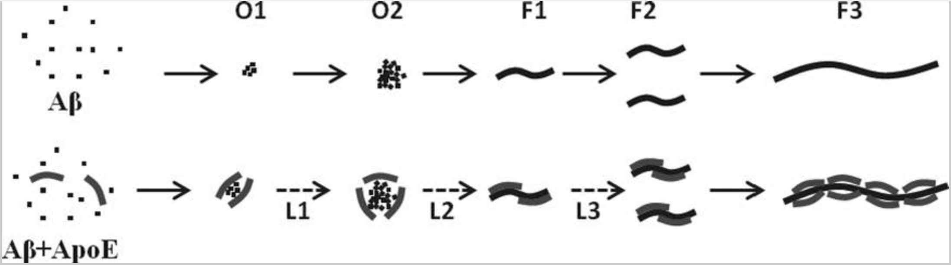
Figure 1. A proposed mechanism by which APOE facilitates Aβ aggregation. APOE allows Aβ to aggregate and form fibrils. It can then transport the fibrils, furthering aggregation. From Garai et. al (2014).
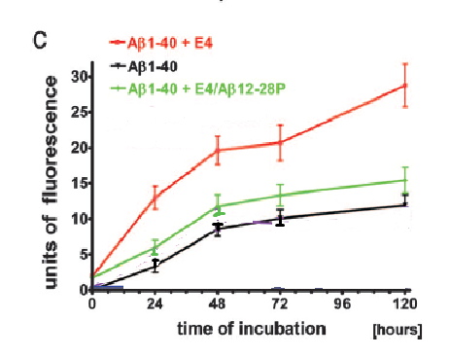
Because of APOEs ability to facilitate Aβ aggregation, inhibiting the APOE-Aβ binding complex presents a possible path for disrupting aggregation. When competitive inhibitors are present to interrupt binding of APOE and Aβ, aggregation levels are reduced. One such inhibitor is Aβ12-28, a peptide consisting of Aβ residues 12-28⁷. These residues correspond to the portion of Aβ that binds APOE¹⁰. In Sadowski et. al (2006), the authors demonstrated the effect of an inhibitor based on Aβ12-28. They used Aβ12-28P, which replaces a valine at residue 18 with a proline. This change made the peptide nonfibrillogenic by disrupting the hydrophobic region. The presence of Aβ12-28P almost completely abolished the effect that APOE4’s presence had on aggregation. Another study done by Hao et. al (2010) tested the inhibiting ability of Aβ20-29. Their experiment resulted in the effect of APOE4 and APOE3 on aggregation being almost abolished in the presence of Aβ20-29¹⁴. This result suggests that though residues 12-28 are the binding site, smaller portions of the binding site may be capable of binding APOE competitively.
Figure 2. An aggregation assay which used Thioflavin T as a fluorescent tag to measure levels of amyloid beta aggregation. Fluorescence was highest when Aβ1-40 and APOE4 (E4) were combined, but that fluorescence was cut almost in half if APOE4 Aβ12-28P (a variant with a V P mutation at residue 18) was introduced. From Sadowski et. al (2006).

While the ability of peptides to inhibit the binding of APOE and Aβ is effective in vitro, peptide inhibitors usually have stability problems when they are used as drugs¹¹. These problems interfere with efficient delivery in the body, including passing through the blood brain barrier or being properly digested. Peptides also have stability issues once they enter the biological system. One way around these problems is structure-based drug design. This process takes the known structure of a peptide and uses it to design a non-peptide chemical similar to the peptide (ex.: size, steric interaction with binding site). Peptides can be small or large, but smaller peptides about 6-8 residues in length are easier to model after.

If a small Aβ peptide chain shows strong inhibiting capabilities, then it may be a good candidate for structure-based drug design. Given that the binding site of amyloid beta is residues 12-28, it seems rational to focus on these residues for finding a short peptide inhibitor. The purpose of the following proposed experiment is to determine if short, 6-8 residue sections within Aβ12-28 are capable of inhibiting the APOE-Aβ binding complex.

II. Experiment

The goal of this experiment is to find a short section or multiple short sections of 6-8 residues within Aβ12-28 that will inhibit the APOE-Aβ binding complex. In order to do this, portions of Aβ12-28 will be used which represent the C-terminal, N-terminal, or center. This will allow for prediction of sections which may be more likely to inhibit aggregation levels in the future. For example, if Aβ12-17 and Aβ17-22 are able to reduce aggregation at higher levels than Aβ18-23 and Aβ23-28, then a future direction of research may focus on residues within Aβ12-22. The peptides being tested and their lengths are as follows:
Table 1: The Aβ12-28 derived peptides being tested in the aggregation assays.
Peptides | Number of Residues
Aβ12-17, Aβ17-22, Aβ18-23, Aβ23-28 | 6
Aβ12-18, Aβ17-23, Aβ22-28 | 7
Aβ12-19, Aβ28-21 | 8

An aggregation assay is a technique used to test levels of protein aggregation in the presence of a specific compound. In this case, an aggregation assay will be used to test Aβ aggregation levels in the presence of APOE. To visualize aggregation levels, fluorescent tags can be used and then fluorescent intensity of a sample can be measured to measure aggregation levels. This technique was utilized by Sadowski et. al (2006) and Hao et. al (2010), with both studies using fluorescent intensity as the measurement for aggregation.
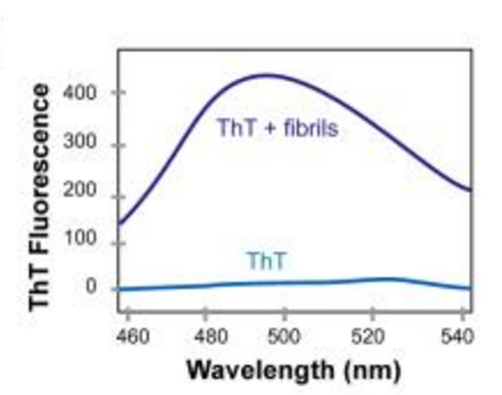
In this experiment Thioflavin T, which binds to amyloid-beta aggregations, will be used as the fluorescent tag. Thioflavin T (ThT) is a benzathiole compound which selectively binds to amyloid fibrils¹². As shown in Figure 2, the fluorescent intensity given off by ThT in the presence of amyloid fibrils shows a large increase. While the mechanism is not completely understood at this point, it is thought that this fluorescent emission is thought to be due to how ThT interacts with the beta sheets in amyloid fibrils. Usually, ThT has a kind of “rotor” movement, with free rotation occurring around the carbon bond between the rings of the molecule. As long as ThT is able to rotate, its electrons will not easily enter an excited state when exposed to photon excitation. Thus, fluorescent intensity remains low when ThT is alone. One leading prediction as to the cause of fluorescent emission when bound to amyloid fibrils is that the molecule becomes “locked,” which allows the electrons to enter an excited state. This in turn leads to an enhancement in fluorescent intensity.
Figure 2: When ThT is in the presence of amyloid fibrils, it shows an increase in fluorescent intensity. From Biancalana and Koide (2010).

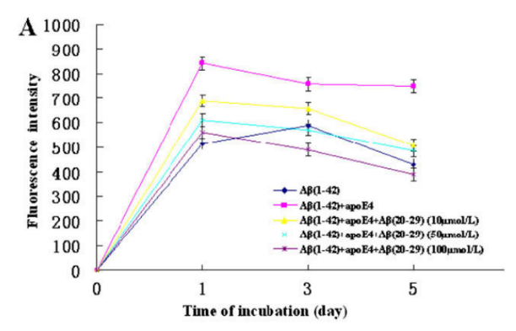
Aggregation Assays with Aβ Derived Peptides
Because APOE4 has been shown to cause higher levels of aggregation than the other two isoforms, it will be used in the aggregation assays. Additionally, both Aβ1-40 and Aβ1-42 aggregation levels will be tested. The assays prepared will test the ability of the Aβ12-28 derived peptides to inhibit the interaction of APOE4 and Aβ1-42. In order to establish a baseline for comparison of aggregation in the presence of the derived peptides, there will be controls: an aggregation assay of just Aβ1-42 or Aβ1-40, an aggregation assay of APOE4 and Aβ1-42 or APOE4 and Aβ1-40, an aggregation assay of each Aβ12-28 derived peptide by itself, and an aggregation assay of just APOE4. Modeling after protocol set forth by Hao et. al (2010), each peptide will be tested at varying concentrations in order to determine if a specific concentration is needed to inhibit. The concentrations will be 10, 50, or 100 µM. Every six hours for 120 hours, a sample will be taken. ThT will be added to the sample and a period of incubation will take place. Following incubation, a spectrofluorometer will be used to measure the level of fluorescence of the sample. This will be done for all of the samples and the controls. At the end of the 120 hour period, fluorescent intensity from the controls and the test assays will be compared. These comparisons will show if the presence of Aβ derivative peptides reduced aggregation levels when compared to the control assays.
Figure 3. Fluorescence levels from aggregation assays testing aggregation of Aβ1-42. Aggregation is tested individually, in the presence of APOE4, and in the presence of APOE4 and three varying concentrations of Aβ20-29.The presence of inhibitors results in decreased fluorescent intensity. From Hao et. al (2010).

III. Discussion

The ideal result of this experiment is that the presence of the peptides being tested for inhibiting capabilities will result in fluorescence intensities which are lower than those measured in assays of Aβ and APOE. These results would suggest that the peptides display some ability to reduce aggregation. However, the world is not always ideal and so there are two other possibilities which should be addressed. It is possible that none of the peptides affect fluorescent intensity at all, which would suggest no change in aggregation levels. The other possibility is that the presence of the peptides increases fluorescent intensity, suggesting that the peptides likely add to or promote aggregations.

If the ideal result is obtained, then the research question will have been satisfied. The purpose of the experiment is to determine if there are 6-8 residue sections within Aβ12-28 that are capable of inhibiting the Aβ-APOE binding complex. If any sections are found, then they could be used as a starting point for structure-based drug design. This result could also shed new insight into the binding of Aβ and APOE, showing that certain residues may bind more strongly to APOE. If peptides retaining more residues on the N-terminal end show greater inhibition abilities then those results, in addition to results from Hao et. al (2010), would lend support to focusing on cutting from the C-terminal when creating shorter peptides from Aβ12-28.

Alternatively, the research question would not be satisfied with the other two results. If no 6-8 residue section of Aβ12-18 is found to decrease aggregation levels, then they are likely not inhibitors. If 6-8 residue sections increase aggregation levels, then they also are not likely to be inhibitors. However, these results may expand knowledge of the aggregation pathways of Aβ. If the peptides increase aggregation levels, then they may shed light on key residues in the development of fibrils.

When measuring fluorescent intensity, conditions for Thioflavin T staining must be carefully controlled. While ThT is referred to as the “golden standard”¹² of amyloid fibril detection, this is only because it is better than other dyes. It will still bind to other molecules, namely the hydrophobic regions of globular proteins¹⁵. While this may be more relevant in in vivo experiments, extra precaution should be taken so that ThT does not bind materials used during the experiment.

The peptides tested in this experiment were used because they were even cuts from Aβ12-18 that were 6-8 residues long. However, this study is limited in that it does not test all 29 possible residues which are 6-8 residues in length. What it does is take a sample by taking equal portions from Aβ12-28 in such a way that nine possible peptides are produced which range from 6-8 residues in length. As mentioned above, this may lead to suggestions on whether to focus on using residues from the C-terminal, N-terminal, or middle in future experiments.

This study is also limited to in vitro analysis. While this allows for controlled interactions between only Aβ and APOE, the human body does not control their interactions. There are many complex biological factors that cannot be taken into account in vitro that future studies would need to take into account. The usage of mouse models was utilized in Sadowski et. al (2006) in order to measure the effect of Aβ12-28 on Aβ aggregations in the brain. If this experiment were to be expanded, a similar set of experiments using mouse models would be done in order to test the capabilities of the peptides in vivo.

Despite these limitations, finding a way to inhibit the Aβ-APOE binding complex may be a large step in the fight against Alzheimer’s. It is known that APOE promotes aggregation, and it is also known that those with the APOE4 variant have a higher risk of developing Alzheimer’s. However, there currently exist no treatments that focus on inhibiting this interaction in humans. By continuing research into effective ways to block this interaction, a large step towards greatly reducing the number of those who suffer from Alzheimer’s may be taken.

References
1. Alzheimer’s Association. 2016. 2016 Alzheimer’s disease facts and figures. Alzheimer’s & Dementia: The Journal of the Alzheimer’s Association, 12(4): 459-509.
(https://www.ncbi.nlm.nih.gov/pubmed/27570871#)

2. Kumar, A., Singh, A., Ekavali. 2014. A review on Alzheimer’s disease pathophysiology and its management: an update. Pharmacological Reports, 67(2): 195-203.
(http://www.sciencedirect.com.proxy.library.vcu.edu/science/article/pii/S1734114014002886)

3. Barageb, S.H., Sonawane, K.D. 2015. Amyloid cascade hypothesis: Pathogenesis and therapeutic strategies in Alzheimer’s disease. Neuropeptides, 52: 1-18.
(http://www.sciencedirect.com/science/article/pii/S0143417915000657)

4. Castano, E.M., Prelli, F., Wisniewski, T., Golabek, A., Kumar, R.A., Soto, C., Frangione, B. Fibrillogenesis in Alzheimer's disease of amyloid beta peptides and apolipoprotein E. Biochemical Journal, 306(2): 599-604.
(http://www.biochemj.org/content/306/2/599)

5. Puglielli, L., Tanzi, R.E., Kovacs, D.M. 2003. Alzheimer’s disease: the cholesterol connection. Nature Neuroscience, 6: 345-351.

6. Garai, K., Verghese, P. B., Baban, B., Holtzman, D. M., & Frieden, C. 2014. The Binding of Apolipoprotein E to Oligomers and Fibrils of Amyloid-β Alters the Kinetics of Amyloid Aggregation. Biochemistry, 53(40), 6323–6331.
(https://www.ncbi.nlm.nih.gov/pmc/articles/PMC4196732/)

7. Sadowski, M. J., Pankiewicz, J., Scholtzova, H., Mehta, P. D., Prelli, F., Quartermain, D., & Wisniewski, T. (2006). Blocking the apolipoprotein E/amyloid-β interaction as a potential therapeutic approach for Alzheimer's disease. Proceedings of the National Academy of Sciences of the United States of America, 103(49), 18787–18792.
(http://www.pnas.org/content/103/49/18787.full)

8. Hardy, J., & Higgins, G. (1992). Alzheimer's Disease: The Amyloid Cascade Hypothesis. Science, 256(5054), 184-185.
(http://www.jstor.org /stable/2876981)

9. Marsden, I. T., Minamide, L. S., & Bamburg, J. R. (2011). Amyloid-β-induced amyloid-β secretion: A possible feed-forward mechanism in Alzheimer disease. Journal of Alzheimer’s Disease : JAD, 24(4), 681–691.
(https://www.ncbi.nlm.nih.gov/pmc/articles/PMC4447202/)

10. Strittmatter, W. J., Weisgraber, K. H., Huang, D. Y., Dong, L. M., Salvesen, G. S., Pericak-Vance, M., … Roses, A. D. (1993). Binding of human apolipoprotein E to synthetic amyloid beta peptide: isoform-specific effects and implications for late-onset Alzheimer disease. Proceedings of the National Academy of Sciences of the United States of America, 90(17), 8098–8102.
(https://www.ncbi.nlm.nih.gov/pmc/articles/PMC47295/)

11. Adessi, C.; Soto, C. 2002. Converting a Peptide into a Drug: Strategies to Improve Stability and Bioavailability. Current Medicinal Chemistry, 9(9): 963-978.
(http://www.ingentaconnect.com/contentone/ben/cmc/2002/00000009/00000009/art00005)

12. Biancalanaa, M., Koide, S. Molecular mechanism of Thioflavin-T binding to amyloid fibrils. Biochimica et Biophysica Acta – Proteins and Proteomics, 1804(7): 1405-1412.
(http://www.sciencedirect.com/science/article/pii/S1570963910000993)

13. Wolfe, L. S., Calabrese, M. F., Nath, A., Blaho, D. V., Miranker, A. D., & Xiong, Y. (2010). Protein-induced photophysical changes to the amyloid indicator dye thioflavin T. Proceedings of the National Academy of Sciences of the United States of America, 107(39), 16863–16868.
(https://www.ncbi.nlm.nih.gov/pmc/articles/PMC2947910/)

14. Hao, J., Zhang, W., Zhang, P., Liu, R., Liu, L., Lei, G., Su, C., Miao, J., Li, Z. 2010. Aβ20–29 peptide blocking apoE/Aβ interaction reduces full-length Aβ42/40 fibril formation and cytotoxicity in vitro. Neuropeptides, 44(4): 305-313.
(http://www.sciencedirect.com/science/article/pii/S0143417910000296)

15. Groenning, M., Olsen, L., van de Weer, M., Flink, J.M., Frokjaer, S., Jørgensen, F., S. 2007. Study on the binding of Thioflavin T to β-sheet-rich and non-β-sheet cavities, Journal of Structural Biology 158(3): 358-369. (http://www.sciencedirect.com/science/article/pii/S1047847706003923)

