Defining Epidermal Growth Factor Receptor exon 20 mutant sensitivity to tyrosine kinase inhibition
- Introduction
Lung cancer is a leading cause of cancer related death. There are two types of lung cancer, small cell and non small cell. Non small cell lung cancer is the more common, accounting for 85% of all lung cancer cases in the United States (Molina et al, 2009). One cause of non small cell lung cancer is attributed to mutations in the Epidermal Growth Factor Receptor (EGFR) gene.
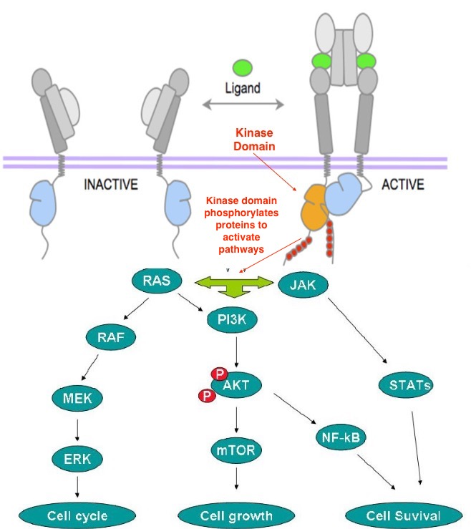
EGFR, also known as ErbB-1, is one receptor in a family of four receptor tyrosine kinases. When bound to the epidermal growth factor ligand, it undergoes a conformational change and forms a dimer. Once in the dimerized state, tyrosine residues on the intracellular kinase domain of the receptor are phosphorylated by ATP. This allows the receptor to initiate signaling pathways by phosphorylating secondary messengers (Yarden 2001). EGFR stimulates cell growth and proliferation by activating pathways such as PI3K/AKT, STATs, and ERK. Two main types of EGFR mutations result in uncontrolled cell proliferation. EGFR is either mutated to be constitutively (continuously) active, or over expressed in the cell membrane (Gazdar 2009).

Fig 1.
Adapted from Gazdar et al. Shows the inactive and active states of EGFR before and after ligand binding. Tyrosine kinase domain below the purple membrane changes conformation to initiate pathways.
Constitutively active mutant EGFR is generally attributed to mutations in exons 18-21, which code for part of the kinase domain of the receptor. The kinase domain of EGFR has two lobes, a smaller N lobe composes the top half of the domain and a larger C lobe composes the bottom half. When dimerized, the C lobe of one domain pushes up against the N lobe of the other. This causes the C-helix to undergo a conformational change, shifting closer to the active site. In this state, a glutamic acid residue (E762) on the C-helix can help stabilize ATP binding. Activating mutations alter the structure of the kinase domain, shifting the C-helix close to the active site independent of dimerization and therefore activating it in the absence of a ligand. (Kumar et al, 2008).
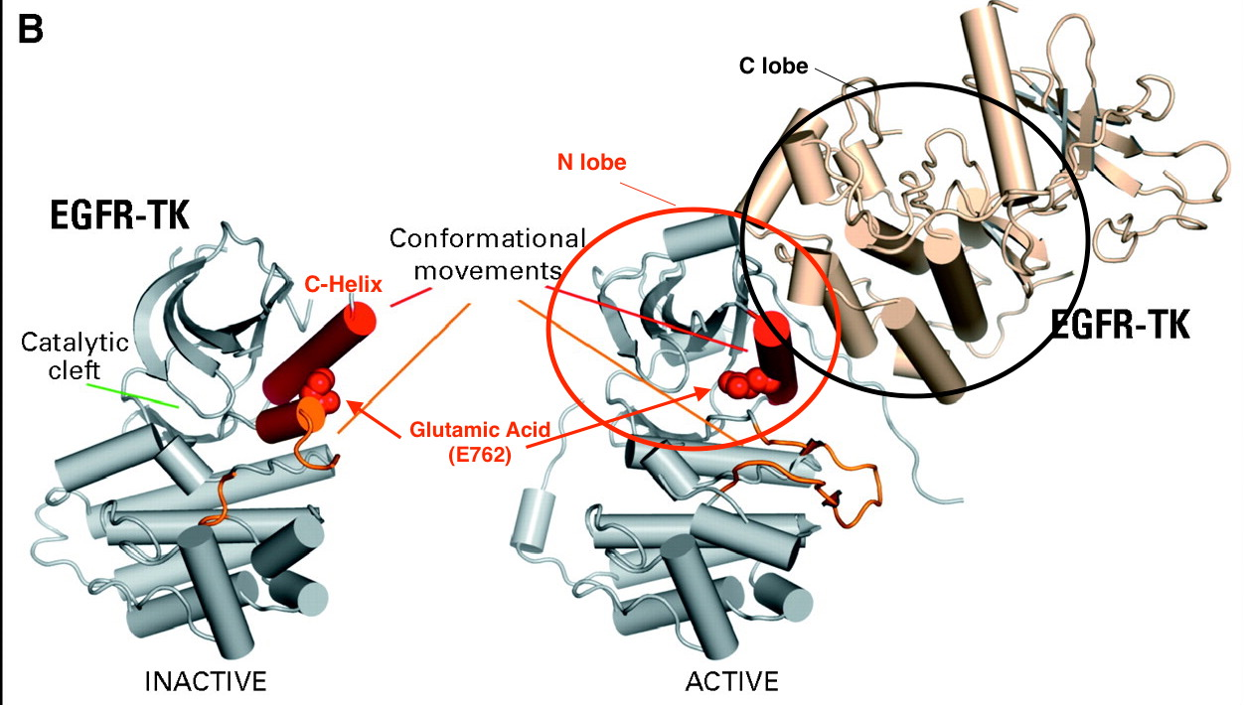
Fig. 2
Adapted from Kumar et al, 2008. On the left, the inactive conformation of the kinase domain with C-helix, catalytic cleft and glutamic acid residue labeled. On the right, conformational change induced by dimerization, C lobe to N lobe pushes C helix closer to catalytic cleft.
Currently, the most effective therapies for activating EGFR mutations are small molecule inhibitors that structurally resemble ATP and competitively bind to the active site of the kinase domain. Some common tyrosine kinase inhibitors (TKIs) include drugs Gefitinib and Erlotinib. These drugs, however, have been shown to mainly be effective for exon 19 deletions and exon 21 substitutions. These mutants have a higher affinity for tyrosine kinase inhibitors than they do for ATP, making the drugs an effective treatment. Other mutations, especially those in exon 20, are resistant to TKIs (Sharma et al, 2007) The mechanism of this resistance is not well understood and poses an obstacle for treatment.
Exon 20 of EGFR codes for amino acid residues 762-823. Mutations in exon 20 are highly variable. The single most common mutation, an insertion of three amino acids between residues 770 and 771, only occurs around 22% of the time (Arcila et al 2013). Insertions between residues 769-775 have generally been characterized as resistant to tyrosine kinase inhibition (Arcila et al 2013 and Yasuda et al 2012). These insertions occupy the loop following the C helix. However, mutations between residues 762-768 are less well characterized (Arcila et al 2013). These mutations directly affect the C-helix and the two residues following it (767-768).
Yasuda et al (2013) investigated resistance of exon 20 mutations. They created seven different cell lines, each expressing a different exon 20 mutation. These cell lines were then exposed to the TKI, Erlotinib. Response of EGFR was measured by Western blotting of EGFR and downstream proteins, AKT and ERK. While six of the seven mutations were resistant to Erlotinib, one displayed sensitivity. After exposure to Erlotinib, no phosphorylated EGFR was detected by Western Blotting (Fig 3). This mutation was an insertion of four amino acids, FQEA, between residues A763 and Y764 which lie directly within the C-helix. 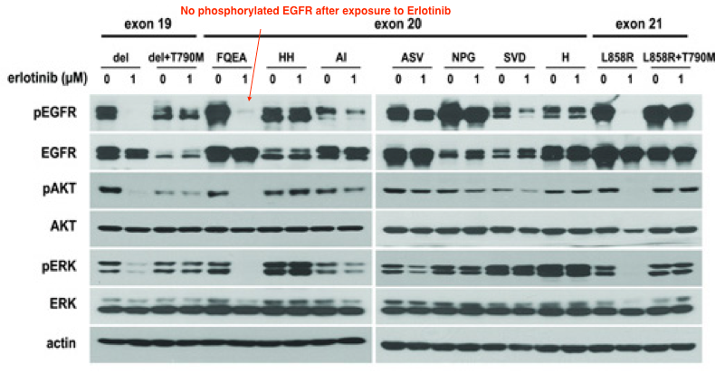
Fig. 3
Adapted from Yasuda et al 2013. No phosphorylated EGFR is detected after exposure to Erlotinib for the A763_Y764insFQEA mutant.
There is currently no comprehensive study of all resistant or sensitive exon 20 mutations (Russo et al, 2015). The purpose of this study is to investigate whether there are other exon 20 mutations with sensitivity to tyrosine kinase inhibitors.

- The Experiment
This experiment seeks to test exon 20 mutations between amino acid residues 762-768 for sensitivity to Erlotinib in vitro. Exon 20 mutations will be chosen based on the criteria that they lie between the aforementioned residues, and have not previously been shown to be resistant to tyrosine kinase inhibitors in vitro. Catalog of somatic mutations in cancer (COSMIC) is a database containing information on somatic mutations in oncogenes such as EGFR. Data is gathered from publications of whole genome screenings and reports of mutations. From this data, viable mutations include: A767_S768insTLA, p.V765M and p.S768I. The first is an insertion of three amino acids, Threonine, Leucine and Alanine between residues 767 and 768. The last two are point mutations at residues 765 and 768.
Plasmids containing constructs of each mutation will be created by site-directed mutagenesis. This plasmid will then be transfected into Ba/F3 cells using a retrovirus. Cells stably expressing mutant EGFR will be exposed to Erlotinib for 6 hours at a concentration of 1_{μM} (Yasuda et al 2013). Cells will then be exposed to EGF, lysed and target proteins will be visualized by Western Blotting. If phosphorylated EGFR is present after exposure to Erlotinib, the mutation is not TKI-sensitizing.

Expression of mutant EGFR
First, a plasmid is created containing the wild type EGFR gene. This can be achieved by transcribing the mRNA of the wild type EGFR gene and using the enzyme reverse transcriptase to obtain the complementary DNA sequence. The complementary DNA sequence can then be amplified using PCR, and transformed into a plasmid using specific restriction enzymes. Mutant constructs are then created by site-directed mutagenesis (Yasuda et al 2013). Forward and reverse primers are created for each desired mutation. These primers anneal to the complementary strands of the parent plasmid containing wild type EGFR and PCR initiates DNA synthesis. Once completed, a new plasmid with a mutated version of the target gene, in this case wild type EGFR, has been created.
These plasmids can then be transfected into cells using a retrovirus. Transfection by definition is the introduction of nucleic acids into a cell, in this case the introduction of a plasmid or a viral vector (Kim et al 2010). This viral vector contains the genetic information for the target protein (mutant EGFR cloned by site-directed mutagenesis) as well as the information for a selective marker. This selective marker will help distinguish which cells have been successfully transfected. The MigR1 retroviral vector expresses a green fluorescent protein when successfully integrated into the host cell’s DNA (Pear et al 1998). The MigR1 viral vector can be transiently transfected into Bosc23, a packing cell line. When Bosc23 cells are transfected with a viral vector, they synthesize all proteins necessary to produce an infectious virus since the viral vector cannot replicate itself (Liebert 1990). This allows for the creation of a large number of retroviruses, ready to transfect cells stably.
The retrovirus can then transfect Ba/F3 cells and the viral vector will combine with the cells genome. Ba/F3 cells that have been successfully transfected will express the green fluorescent protein as well as the desired mutant EGFR. Ba/F₃ cell growth is dependent on Interleukin Factor (IL₃). Since constitutively active EGFR causes uncontrolled cell proliferation, successful transfection will also be indicated by cell growth in the absence of IL₃ (Warmuth et al 2007). This makes Ba/F3 a good option for measuring inhibition of mutated kinase receptors, as it is easy to know if the cell has been successfully transformed.

Western Blotting to determine sensitivity
Once Ba/F3 cell lines are stably expressing the EGFR mutations, they will be exposed to Erlotinib for six hours at a concentration of 1 μM. The cells will then be exposed to the Epidermal Growth Factor (EGF) ligand in order to stimulate EGFR. Ba/F3 cells will then be lysed and analyzed by Western Blotting. Proteins visualized will be EGFR and others that play a role in the signaling pathways controlling growth and proliferation, such as AKT and ERK.
Western blotting technique involves denaturing proteins to their primary structure so they can be separated by size and charge on SDS-polyacrylamide gel. Proteins are then transferred from the gel to a solid polyvinyl fluoride or nitrocellulose membrane. Each protein is tagged by a specific primary and secondary antibody (Mahmood and Yang, 2012). The primary antibody binds directly to the protein at a specific residue. For EGFR, the antibody binds to the phospho-tyrosine 1068 residue. Akt is identified by the pS473 residue, and ERK ½ by the pT202 and pY204 (Yasuda et al 2013). Each protein will require two types of primary antibodies. One phospho-antibody that binds to phosphorylated residues, and another antibody that binds un-phosphorylated residues. The secondary antibody binds to the primary antibody and is visualized by film.

- The Discussion
It is possible that this experiment will identify at least one exon 20 mutation that displays in vitro sensitivity to Erlotinib, there by opening conversation for new treatment options regarding that mutation. However, it is also possible that none of the mutations in question will be TKI-sensitizing. If this is the case, the positive outcome is that a subset of exon 20 mutations will be better characterized. Mutations tested in this experiment along with the three mutations, Y764_V765insHH, M766_A767insAI, A767_V769dupASV, previously shown to be resistant (Yasuda et al 2013), will define mutations in the 762-768 region as TKI resistant with the exception of A763-Y764.
Sensitivity to Erlotinib in the form of EGFR inhibition does not necessarily indicate the TKI as a viable treatment. Any mutation found to be sensitive should be subject to a follow up study assessing dose response. It is important that the mutation have a higher affinity for TKI than wild type EGFR in order to create a therapeutic window for treatment (Yasuda et al 2013). It would be useful to determine the Km of an exon 20 mutation that displayed in vitro sensitivity to Erlotinib.
For the future treatment of exon 20 mutations, it will be necessary to find a tyrosine kinase inhibitor capable of binding the mutant with high affinity. Currently second and third generation tyrosine kinase inhibitors are being developed to target the less sensitive mutations. Robichaux et al 2017 report a small, flexible, irreversible kinase inhibitor with the ability to bind sterically hindered exon 20 mutations with higher affinity. More studies are needed to asses the efficacy of similar drugs.

References:
Molina JR., Yang P., Cassivi S.D., Schild S.E., and Adjei A.E. 2008. Mayo Clin Proc. 83(5) Non–Small Cell Lung Cancer: Epidemiology, Risk Factors, Treatment, and Survivorship. https://www.ncbi.nlm.nih.gov/pmc/articles/PMC2718421/

Yarden Y. 2001. European Journal of Cancer. 37(4). Pg 3-8. The EGFR family and its ligands in human cancer: signaling mechanisms and therapeutic opportunities. http://www.sciencedirect.com.proxy.library.vcu.edu/science/article/pii/S0959804901002301

Gazdar A.F. 2009. Oncogene. 28(1). Activating and resistance mutations of EGFR in non-small-cell lung cancer: role in clinical response to EGFR tyrosine kinase inhibitors. https://www.ncbi.nlm.nih.gov/pmc/articles/PMC2849651/#R46

Kumar A., Edward TP., Halmos B., Boggon T.J. 2008. 26(10). J. Clin Onco. The Structure and Clinical Relevance of the EGF Receptor in Human Cancer. https://www.ncbi.nlm.nih.gov/pmc/articles/PMC3799959/
Sharma S.V., Bell D.W., Settleman J. and Haber D.A. Nature Reviews Cancer. 2007. 168-191. Epidermal growth factor receptor mutations in lung cancer. https://www.nature.com/nrc/journal/v7/n3/full/nrc2088.html#B18

Arcila M. E. et al. Mol Cancer Ther. Feb 2013. 12(2): 220-229. EGFR Exon 20 Insertion Mutations in Lung Adenocarcinomas: Prevalence, Molecular Heterogeneity, and Clinicopathologic Characteristics https://www.ncbi.nlm.nih.gov/pmc/articles/PMC3714231/

Yasuda H. et al. Sci Transl Med. Dec 18, 2013. 5(216). Structural, biochemical and clinical characterization of epidermal growth factor receptor (EGFR) exon 20 insertion mutations in lung cancer https://www.ncbi.nlm.nih.gov/pmc/articles/PMC3954775/

Pao W. et al. PLoS Med. Mar, 2005. 2(3). Acquired Resistance of Lung Adenocarcinomas to Gefitinib or Erlotinib Is Associated with a Second Mutation in the EGFR Kinase Domain https://www.ncbi.nlm.nih.gov/pmc/articles/PMC549606/
Oxnard G.R., Lo P.C., Nishino M., Dahlberg S. E., Lindeman N. I., Butaney M., Jackman D. M., Johnson B. E., Jänne P. A. Journal of Thoracic Oncology. 2013. 8(2). 179-184. Natural History and Molecular Characteristics of Lung Cancers Harboring EGFR Exon 20 Insertions. http://www.jto.org/article/S1556-0864(15)32739-8/fulltext#tbl1

Pear W. S., Nolan G. P. Scott M. L., and Baltimore D. Production of high-titer helper-free retroviruses by transient transfection. 1993. Proc Natl Acad Sci. Vol 90. http://www.pnas.org/content/90/18/8392.full.pdf

Kim T. K., Eberwine J. H. 2010. Anal Bioanal Chem. 397(8). Mammalian cell transfection: the present and the future. https://www.ncbi.nlm.nih.gov/pmc/articles/PMC2911531/

Mahmood T., Yang P. C. 2012. N Am J Med. 4(9). Western Blot: Technique, Theory, and Trouble Shooting. https://www.ncbi.nlm.nih.gov/pmc/articles/PMC3456489/

Jiang J, Greulich H, Jänne PA, Sellers WR, Meyerson M, Griffin JD. 2005. Cancer Res. 65 (19). Epidermal Growth Factor–Independent Transformation of Ba/F3 Cells with Cancer-Derived Epidermal Growth Factor Receptor Mutants Induces Gefitinib-Sensitive Cell Cycle Progression. https://www-ncbi-nlm-nih-gov.proxy.library.vcu.edu/pubmed/16204070?dopt=Abstract&holding=npg

Russo A. et al. Oncotarget. Sep 29, 2015. 6(29): 26814-26825. A decade of EGFR inhibition in EGFR-mutated non small cell lung cancer (NSCLC): Old successes and future perspectives
Lichun Ma, Wang D. D., Huang Y., Yan H., Wong M. P. and Lee HF. 2015. BMC Bioinformatics. EGFR Mutant Structural Database: computationally predicted 3D structures and the corresponding binding free energies with gefitinib and erlotinib. https://bmcbioinformatics.biomedcentral.com/articles/10.1186/s12859-015-0522-3

Warmuth M, Kim S, Gu XJ, Xia G, Adrián F. Curr Opin Oncol. 2007. 19(1) Ba/F3 cells and their use in kinase drug discovery. https://www.ncbi.nlm.nih.gov/pubmed/17133113

Robichaux J., Tan Z., Nilsson M., Zhang S. Wong K., Heymach J. Journal of Thoracic Oncology. Vol 12. Drug Repurposing to Overcome De Novo Resistance of Non-Traditional EGFR Mutations. http://www.jto.org/article/S1556-0864(16)31752-X/pdf

Yasuda 2012- list of mutations from population sample
http://www.sciencedirect.com.proxy.library.vcu.edu/science/article/pii/S1470204511701292
Asp761_Glu762insGluAlaPheGln†(2) | 2 | 1·6% | 46 ; 47
763 | Ala763_Tyr764insPheGlnGluAla† (1) | 1 | 0·8% | S1
764 | Tyr764-Val765insHisHis (1) | 1 | 0·8% | 10
765 | − | .. | .. | ..
766 | Met766_Ala767insAlaIle (1) | 1 | 0·8% | 48
767 | Ala767_Val769dupAlaSerVal‡ (2), Ala767_Ser768insThrLeuAla (1) | 3 | 2·5% | 25; 46 ; 48
768 | Ser768_Asp770dupSerValAsp§ (5), Ser768_Val769insValAlaSer (1), Ser768_Val769insAlaTrpThr
EGFR c.? EGFR p.S768I...
p.V819A *
p.V802I
P794H...
p.V786M..
p.V765M...

Uncommon EGFR mutations in advanced non-small cell lung cancer- review exon 20 mutations
http://www.sciencedirect.com/science/article/pii/S0169500217303033

Functional Analysis of Epidermal Growth Factor Receptor (EGFR) Mutations and Potential Implications for EGFR Targeted Therapy- 30 mutations including S768I
http://clincancerres.aacrjournals.org/content/15/2/460

