The effect of duplication of the variable region stem loops on sfRNA virulence in the dengue virus
I. Introduction
The dengue virus has found an ingenious way to survive amidst its diminishing host population and habitat reduction: evolving to prefer humans over animals as their natural host¹. Incidentally, outbreaks of dengue are becoming more and more common with over 2.3 million cases of dengue being reported last year in the Americas alone². Symptoms of dengue can vary from high fever to shock syndrome, but while it can’t be spread from person to person, the dengue virus is primarily transmitted through mosquitoes³.
There are four serotypes of dengue virus, each distinguished by the antigens expressed on its surface, DEN-1, DEN-2, DEN-3, and DEN-4; recovery from the infection of one serotype grants immunity to that specific strain, but unfortunately, not to the other serotype³. The transmission of the dengue virus is controlled by the feeding preferences of mosquitoes; the organisms that mosquitoes feed on are the same organisms the dengue virus has access to and can potentially infect. Originally, mosquitoes primarily fed on mammals and thus, the transmission cycle of the dengue virus was between mosquitoes and wild animals¹. But as more humans inhabit the natural habitats of mosquitoes and reduce the wildlife populations, mosquitoes have begun to be anthropophilic: they prefer to feed on humans⁴. As a result, the dengue virus was transmitted to humans and eventually, the dengue virus switched their hosts to humans¹.
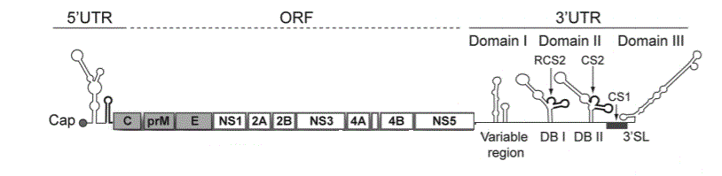
Before the dengue virus can infect humans, it needs to successfully infect and survive in mosquitoes first. Mutations in the dengue genome can allow for the virus to defend against the immune systems of both species⁵. The dengue genome consists of an open reading frame with a 5’ and 3’ untranslated region (Figure 1)⁶. The untranslated regions (UTR) contain specialized structures that are necessary for viral replication⁶. The 3’UTR is divided into three domains, all of which contain hair pin structures or stem loops that can enhance viral processes⁷. Mutations in the sequences of the 3’UTR structures can allow a dengue virus to successfully infect a host⁸ such as a mosquito. However, these mutations are often species-specific, or are only advantageous in a specific host; as a result, when the dengue virus is transmitted to a different host, it cannot survive⁹.
Figure 1: Depiction of the dengue genome with labeled 3’untranslated region (UTR) domains; ORF stands for open reading frame. Domain I consists of the variable region that can have one or two hair pin loops, Domain II consists of two dumb bell structures, and Domain III consists of a 3’stem loop.
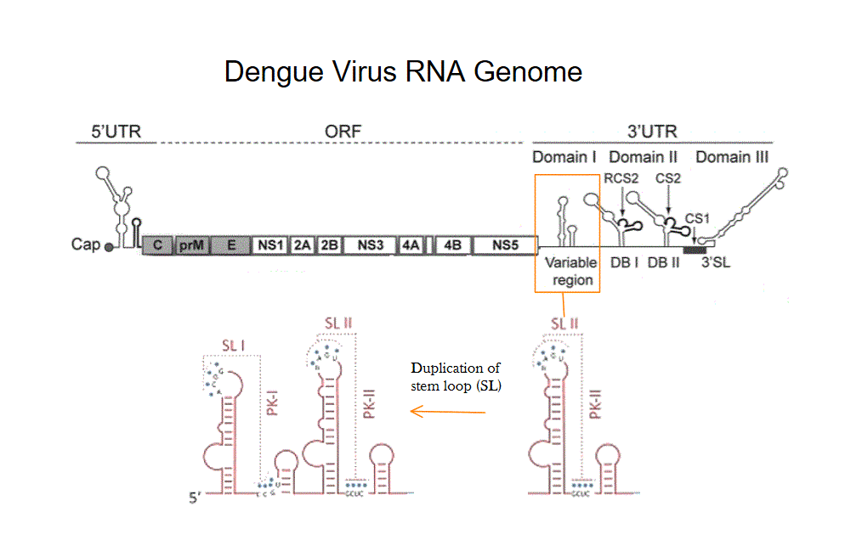
In order to counter-act the effects of a species-specific mutation, dengue viruses can have duplications of the stem loops of the 3’UTR, specifically, a duplication of the stem loops of the variable region (Figure 2)⁸. Viruses that have two hosts usually have two stem loops while viruses that only have one host will have one stem loop⁹.
The sequences of duplicated stem loops are similar giving them the same functions in humans, however, in mosquitoes, each stem loop has a specific function⁸. The duplication of the stem loops allows the dengue virus to adapt to the human environment despite having mutations that are adapted to mosquitoes because the second stem loop mutes the effect of those mutations⁸. This doesn’t work, however, the other way around: the second stem loop does not mute mutations that favor humans for a dengue virus present in mosquitoes⁸.
Figure 2: Duplication of the hair pin or the stem loop structure of the variable region of the 3’UTR.
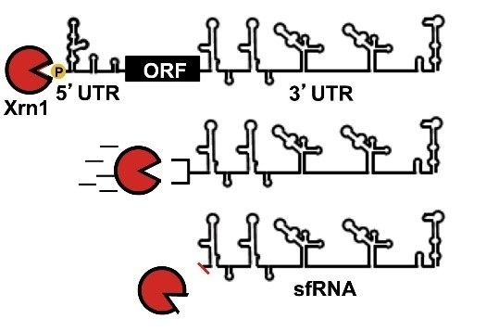
Stem loops are also important because they can form small RNA molecules that are called subgenomic flavivirus RNA, or sfRNA⁸. These RNA molecules are created when a host exoribonuclease (XRN1) a protein that degrades RNA, fails to fully degrade the dengue virus genome. XRN1 stalls at the stem loop and cleaves the remaining RNA which will form sfRNA (Figure 3)¹⁰.
sfRNA can inhibit interferons, antiviral signaling proteins that are a part of the host’s immune response that detect viruses and can reduce viral replication^{11, 12}. Inhibition of such proteins can increases the virulence of the virus^{13, 14}.
Figure 3: Creation of sfRNA. XRN1 cannot fully degrade the dengue virus genome because it stalls at the stem loop of the 3’UTR. The remaining RNA forms subgenomic flavivirus RNA (sfRNA). Adapted from Figure 1 of Source 10.
Chapman et al (2014) tested to see if a viable or stable sfRNA could be produced if it was cleaved at a different stem loop or at any of the other structures of the 3’UTR¹⁰. To do so, they tested the resistance of each structure to XRN1; if a stem loop wasn’t resistant, then the XRN1 would be able to completely degrade the viral genome. They used a fluorescence-based assay in which they attached a fluorescent hair pin loop at the end of the 3’UTR to show XRN1 resistance (Figure 4). If XRN1 couldn’t fully degrade the RNA, the hair pin would remain and show fluorescence. If the RNA was degraded, then there would be no fluorescence. Chapman et al found that sfRNA that either started with the first stem loop or the second stem loop were both stable and XRN1 resistant. They suggested that having two stem loops might be a “back-up” plan for the dengue virus to ensure that sfRNA will be produced¹⁰.
The duplication of stem loops allows for the dengue virus to cycle between two hosts⁸ and Chapman’s et al research shows that sfRNA can be produced using either stem loop¹⁰. But, does the virulence of sfRNA change if a mosquito-adapted dengue viral genome were placed in human cells? For a dengue to be adapted to mosquitoes, its stem loops will have mutations that support replication in mosquitoes. A duplication of the stem loop would allow for it to infect human cells successfully because the presence of a second stem loop mutes the effects of the mutated first stem loop. But, how would the duplication affect the production of sfRNA in human cells? Would sfRNA with only one stem loop have no effect in human cells?
II. Experiment
The purpose of this experiment is to examine the effect the duplication of stem loops has on the virulence of sfRNA of a dengue virus that has switched from a mosquito to a human. Since the dengue virus started in mosquitoes, the virus should have mutations that aids in its infection and replication in mosquito cells. Duplication of stem loops does provide an advantage over strains with only one stem loop, but the sequences of the stem loops or the duplication of stem loops should not have an effect on the production of sfRNA. They might, however, have an effect on the virulence of sfRNA.
A. Generation of sfRNA
The Jamaica/N.1409 strain of DEN-2 will be used to infect Aedes albopictus C6/36 mosquito cells. The viral populations will then be serially passaged in the same cell line for 10 passages; this will allow for strains to develop mutations that enhance its survival in mosquito cells. After 10 passages, the RNA in passage 10 will be extracted from C6/36 cells. The 5’ end will be ligated by an RNA ligase and be used as template for reverse transcription using the primer AVG42 (GCTGTTTTTTGTTTCGGG)¹⁵. The resulting cDNA molecules will be replicated with PCR using a different set of primers; the DNA will then be gel purified and sequenced using the Sanger method, in which a specific dye is used to label each nucleotide of the DNA¹⁵. The main concern of this experiment will be the 3’UTR, so the sequence of the mapped genome will be used to construct sfRNAs.
B. Test for resistance
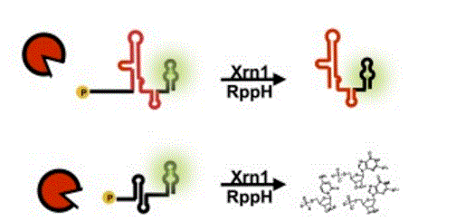
Two sfRNAs will be designed both of which will resemble the 3’UTR portion of the genomes of mosquito-adapted dengue viruses. One sfRNA will have one stem loop, stem loop II, while the second sfRNA will have two stem loops: stem loop I and II. The two sfRNAs will be created by VCU Nucleic Acid Research Facilities. To test for its viability or exoribonuclease resistance, an XRN1 resistance assay will be done. Each sfRNA will have a 40 nucleotide long malachite green fluorescent aptamer downstream the RNA and a leader sequence upstream the RNA (Figure 4)¹⁰. The sfRNA will be replicated using PCR and the sfRNA will be placed in solution with malachite green dye and rppH (an enzyme that removes phosphate from mRNA and triggers its degradation)¹⁶ and XRN1 will be added¹⁰.
Figure 4: XRN1 resistance assay. If sfRNA shows resistance, fluorescence will be maintained. If resistance is not shown (bottom), the sfRNA will be degraded and fluorescence lost. Adapted from Fig 6C from Source 10
If the solution is not fluorescent after the XRN1 has been added, then the sfRNA and the MG aptamer has been degraded; in other words, the sfRNA was not XRN1 resistant and was not a viable sfRNA. If, however, fluorescence is maintained, then the sfRNA is resistant to XRN1. If both of the created sfRNA are shown to be viable, then the sfRNA will be treated for virulence. If not, it means that both sfRNA will be degraded in human cells and therefore, will not be virulent.
C. Test for virulence
Type I interferons are responsible for the antiviral response and are often induced by viruses¹². If the virus is able to infect cells, then toll-like receptors, proteins that play a role in the innate immune response, can recognize conserved viral structures (such as sfRNA), which can then lead to the secretion of interferons¹⁷. RNA-binding proteins can control and enhance the immune response by Toll-like receptors¹⁸. RNA-binding proteins recognize and regulate the decay of target RNA molecules¹⁹; they also regulate cytokine production¹⁸. sfRNA inactivates RNA-binding proteins and thereby, inhibits the expression of interferon genes¹¹. To test for virulence, the two designed sfRNA will be assessed to see if they can bind to RNA-binding proteins and causes a decrease in IFN-β, a cytokine produced by interferons.
sfRNA will be transfected into human dendritic cells¹⁵ using a TransIT-mRNA Transfection Kit²⁰. Once in the dendritic cells, Toll-like receptors, in particular, Toll-like receptor 3, should recognize sfRNA and secrete interferons²¹. The interferons then will produce cytokine IFN-β²¹. As a part of this response, RNA-binding proteins will attempt to degrade sfRNA, and if it can, there will be high levels of IFN-β. However, if sfRNA can inhibit RNA-binding proteins, then the RNA-binding proteins cannot enhance the immune response and therefore, there will be low levels of IFN-β.
IFN-β levels in the serum will be calculated using ELISA, an enzyme-linked immunosorbent assay that can detect the presence of antibodies, peptides, or proteins²². The ELISA kit will include detection antibodies to measure IFN-β levels. If IFN-β levels are high, this means that the sfRNA could not successfully inhibit interferons but if the IFN-β are low, then the sfRNA were successful.
III. Discussion
If the experiment goes as expected, then the sfRNA with two stem loops will be XRN1 resistant and will show low IFN-β levels in the serum since this sfRNA has the advantage of the second stem loop, which mutes the effects of the mosquito-adapted mutations. The sfRNA with one stem loop, on the other hand, will also be XRN1 resistant, but will show high IFN-β levels. In this case, the mosquito-adapted mutations will prove to be detrimental and prevent successful inhibition. However, there is a chance that the sfRNA with one stem loop might also show low IFN-β levels. This would mean that the duplication of stem loops has no effect on sfRNA virulence. Additionally, there is the possibility that no sfRNA decreases IFN-β levels suggesting that either the sfRNA produced were not fit for human environments (the sfRNA were degraded by the interferons) or that perhaps these sfRNA were not responsible for inhibiting the interferons present in the dendritic cells.
It would be of interest to see the effects of sfRNA when transferred from humans to mosquitoes. Both stem loops serve a purpose in mosquitoes⁸, so deleting one loop would certainly have an effect on viral replication or inhibition of the interferon response. Additionally, since the host exoribonuclease XRN1 is responsible for generating sfRNA, a next step would be to find a way to enhance XRN1 to be able to fully degrade the dengue virus genome, thereby reducing viral replication²⁴. Also, if one-stem loop sfRNA shows a high level of IFN-β, then it would also be of interest to find a molecule that could degrade or cleave off one of the loops of the sfRNA, thereby diminishing the function of the molecule.
Dengue is not a problem limited to the tropics because for over the past fifty years, the virus has spread to countries which never had incidences of the disease before²⁵. And as the human population continue to increase, the dengue virus and many other related viruses will fully adapt to humans. As of now, there isn’t fully developed and viable vaccine for the dengue virus; dengue can only be prevented through the means of insecticides and mosquito traps³. A treatment for dengue would reduce the number of outbreaks or potentially cure those diagnosed with dengue.

References
- Holmes, E. C. & Twiddy S. S. (2003). The Origin, Emergence, and Evolutionary Genetics of Dengue Virus. Infection, Genetics, and Evolution: Journal of Molecular Epidemiology and Evolutionary Genetics in Infectious Diseases, 3, 19-28. Retrieved from: https://www.ncbi.nlm.nih.gov/pubmed/12797969
- Dengue and severe dengue. (2017, April) Retrieved from http://www.who.int/mediacentre/factsheets/fs117/en/
- Mackenzie, J. S., Gubler, D. J., & Petersen, L. R. (2004). Emerging flaviviruses: the spread and resurgence of Japanese encephalitis, West Nile, and dengue Viruses. Nature Medicine Supplement. 10, S98-109. Retrieved from http://www.nature.com/nm/journal/v10/n12s/full/nm1144.html
- Steiger, M. D., Ritchie A. S., & Laurance G.W. S. (2016). Land use influences mosquito communities and disease risk on remote tropical islands: a case study using a novel sampling technique. The American Journal of Medicine and Hygiene, 94, 314-321. doi: 10.4269/ajtmh.15-0161
- Göertz. G. P., Fros, J. J., Miesen, P., Vogels, C. B., van der Bent, M. L., Geertsema, C.,…Pijlman, G.P. (2016). Noncoding Subgenomic Flavivirus RNA is Processed by the Mosquito RNA Interference Machinery and Determines West Nile Virus Transmission by Culex pipiens Mosquitoes. Journal of Virology, 90, 10145-10159. Retrieved from: https://www.ncbi.nlm.nih.gov/pubmed/27581979
- Alvarez, D. E., De Lella Ezcurra, A. L., Fucito, S., & Gamarnik A. V. (2005). Role of RNA Structures Present at the 3’UTR of Dengue Virus on Translation, RNA Synthesis, and Viral Replication. Virology, 339, 200-212. Retrieved from: https://www.ncbi.nlm.nih.gov/pubmed/16002117
- Gebhard, G. L., Filomatori, C.V., & Gamarnik, A. V. (2011). Functional RNA Elements in the Dengue Virus Genome. Viruses, 3. doi: 10.3390/v3091739. Retrieved from: https://www.ncbi.nlm.nih.gov/pmc/articles/PMC3187688/
- Villordo, S. M, Filomatori, C. V., Sánchez-Vargas, I., Blair, C. D., & Gamarnik, A.V. (2015). Dengue Virus RNA Structure Specialization Facilitates Host Adaptation. PLOS Pathology, 11. doi: 10.1371/journal.ppat.1004604. Retrieved from: https://www.ncbi.nlm.nih.gov/pubmed/25635835
- Villordo, S. M., Carballeda, J. M., Filomatori, C. V., & Gamarnik, A. V. (2016). RNA Structure Duplications and Flavivirus Host Adaptations. Trends in Micriobiology, 24, 270-283. Retrieved from: https://www.ncbi.nlm.nih.gov/pubmed/26850219
- Chapman, E. G., Moon, S. L., Wilusz, J., & Kieft, J. S. (2014) RNA Structures that Resist Degradation by Xrn1 Produce a Pathogenic Dengue Virus RNA. Elife, 1, doi: 10.7554/eLife.01892. Retrieved from: https://www.ncbi.nlm.nih.gov/pubmed/24692447
- Bidet, K., Dadlani, D., & Garcia-Blanco, M. A. (2014). G3BP1, G3BP2, CAPRIN1 are Required for Translation of Interferon Stimulated mRNAs and are Targeted by a Dengue Virus Non-Coding RNA. PLOS Pathology, 10, doi: 10.1371/journal.ppat.1004242. Retrieved from: https://www.ncbi.nlm.nih.gov/pubmed/24992036
- Samuel, C. E. (2001). Antiviral Actions of Interferons. Clinical Microbiology Reviews, 14, 778-809. Retrieved from:https://www.ncbi.nlm.nih.gov/pmc/articles/PMC89003/
- Funk, A., Truong, K. Nagasaki, T., Torres, S., Floden, N., Balmori Melian, E.,…Khromykh, A. A. (2010). RNA Structures Required for Production of Subgenomic Flavivirus RNA. Journal of Virology, 84, 11407-11417. Retrived from: https://www.ncbi.nlm.nih.gov/pubmed/20719943
- Diamond, M. S. (2009). Mechanisms of Evasion of the Type I Interferon Response by Flaviviruses. Journal of Interferon & Cytokine Research, 29. doi:10.1089/jir.2009.0069
- Filomatori, C.V., Carballeda, J.M., Villordo, S.M., Aguirre, S, Pallarés, H. M., Maestre, A. M.,…Gamarnik, A.V. (2017). Dengue Virus Genomic Variation Associated with Mosquito Adaptation Defines the Pattern of Viral Non-coding RNAs and Fitness in Human Cells. PLOS Pathogens, 13. doi: 10.1371/journal.ppat.100625. Retrieved from: https://www.ncbi.nlm.nih.gov/pubmed/28264033
- Deana, A., Celesnik, H., & Belasco, J. G. (2008). The Bacterial Enzyme RppH Triggers Messenger RNA Degradation by 5’ pyrophosphate Removal. Nature, 451, 355-358. Retrieved from: https://www.ncbi.nlm.nih.gov/pubmed/18202662
- Toll-Like Receptors and Innate Immunity. (2008). Retrieved from: http://www.sabiosciences.com/pathwaymagazine/pathways7/toll-like-receptors-and-innate-immunity.php
- Lai, Y., Yi, G., Chen, A., Bhardwaj, K., Tragesser, B. J., Valverde, R. A.,…Kao, C.C. (2011). Viral Double-Strand RNA-Binding Proteins Can Enhance Innate Immune Signaling by Toll-Like Receptor 3. Plos One, 6, doi: 10.1371/journal.pone.0025837. https://www.ncbi.nlm.nih.gov/pmc/articles/PMC3189932/
- Newman, R., McHugh J., & Turner, M. (2016). RNA Binding Proteins as Regulators of Immune Cell Biology. Clinical and Experimental Biology, 183, 37-49. https://www.ncbi.nlm.nih.gov/pubmed/26201441
- TransIT-mRNA Transfection Kit – Mirus Bio LLC. Retrieved from: https://www.mirusbio.com/assets/protocols/ml036_transit_mrna_transfection_kit.pdf
- Liang, Z., Wu, S., Li, Y., He, L., Minhao, W., Jiang, L.,…Huang, X. (2011) Activation of Toll-Like Receptor 3 Impairs the Dengue Virus Serotype 2 Replication through Induction of IFN-β in Cultured Hepatoma Cells. Plos One, 6, doi: 10.1371/journal.pone.0023346. https://www.ncbi.nlm.nih.gov/pmc/articles/PMC3150425/
- Overview of ELISA. Retrieved from: https://www.thermofisher.com/us/en/home/life-science/protein-biology/protein-biology-learning-center/protein-biology-resource-library/pierce-protein-methods/overview-elisa.html
- IFN Beta Human ELISA Kit. Retrieved from: https://www.thermofisher.com/order/catalog/product/414101?gclid=Cj0KEQjw6LXIBRCUqIjXmdKBxZUBEiQA_f50PsLQjov0CkRXEJtDqg_6-VvywuJdGypEhwe3mFQ2hEcaAkDo8P8HAQ&ef_id=V3lRmwAAAfIzbfyw:20170507042649:s
- Manokaran, G., Finol, E., Wang, C., Gunaratne, J. Bahl, J., Ong, E. Z.,…Ooi E. E. (2015). Dengue Subgenomic RNA Binds TRIM25 to Inhibit Interferon Expression for Epidemiological Fitness. Science, 350, 217-221. Retrieved from: https://www.ncbi.nlm.nih.gov/pubmed/26138103
- Medlock J. M. & Leach S. (2015). Effect of climate change on vector-borne disease risk in the UK. The Lancet Infectious Diseases. 15, 721-730. doi: 10.1016/S1473-3099(15)70091-5.

