Furin-Enhanced In Vivo Production of Factor IX
BNFO 300 - Dr. Jeffrey Elhai
Aarthi Prakash
May 6, 2017

Introduction

Hemophilia B
Hemophilia B (HB), also called Christmas disease, is an X-linked recessive genetic disorder that causes a mutated or reduction of factor IX (FIX), which is a coagulation protein. This life-long condition affects approximately one in 30,000 males (Franchini et al., 2013). Depending on the severity, the condition can be treated transiently or could require a more aggressive prophylactic type treatment. HB can be divided into three types: severe, less than one percent of FIX production and is about 60% of cases, moderate, in which about one to five percent FIX is present in about 15% of cases, and mild is when about six to 30 percent of FIX is produced in about 25% of cases (Hemophilia B., 2015). Often patients bleed longer than normal even with minor trauma and in severe cases can have frequent spontaneous internal bleeding. The frequency and severity are based on FIX levels and can be prevented by intravenous injections of FIX.

FIX and Furin/PACE
Factor IX (FIX) is a clotting factor and a serine protease zymogen, which when activated is converted to the active serine protease (Liu et al., 2014). Mature FIX is known to have four distinct domains: N-terminal Gla-domain which is a region of glutamic acid residues, EGF-like domain that contains an epidermal growth factor like that is conserved, AP domain which is the activating protein, and the C terminal serine protease domain that is the FIX catalytic domain (Liu et al., 2014). As like many other proteins, FIX requires various posttranslational modifications to become fully functional. This includes cleavage, addition of sulfates, hydroxylation, glycosylation, phosphorylation, etc. as shown in Figure 1B. One of the posttranslational modifications is $γ$-carboxylation of glutamic acid residues, which is required for phospholipid and calcium bonding (Wasley et al., 1993). Similarly Furin/PACE cleavage within FIX is important for converting the profactor (inactive) to mature FIX (active). Figure 1A shows a schematic representation of FIX with the domains and figure 1B shows the amino acid sequence of the protein.
Furin is a serine endoprotease that belongs to the substilin-like proprotein convertase family, which are enzymes that convert zymogens into their biologically active forms (Wasley et al., 1993). It is also called a Paired Amino Acid Cleaving Enzyme (PACE) because it cleaves proteins at their PACE cleavage sites ( and is ubiquitously expressed in hepatocytes (liver cells). This enzyme has been shown to be active in HIV mechanisms and the gene is believed to play a role in tumor progression as well (Denault & Leduc, 1995).

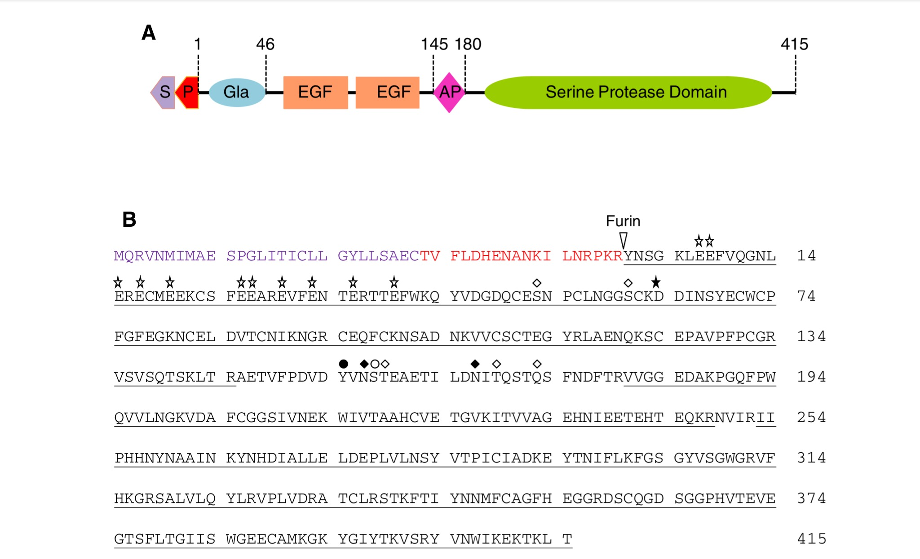
Figure 1. (A) Schematic drawing of FIX. S is the signal peptide, P is the propeptide, Gla is the domain with the glutamic acid residues, EGF is the epidermal growth factor like domains, AP is the activating protein domain, and there is the Serine Protease Domain. (B) This is the amino acid sequence of FIX and shows where Furin cleaves the protein. The shapes above the amino acids represent the posttranslational modifications the protein undergoes.
Current Treatments
Current treatments for HB have been found to be short term with recombinant FIX while long-term treatments require extensive monitoring, have adverse side effects, or have not been developed. Prophylactic treatments are thhe most common and are administered every few days using a recombinant or plasma-derived FIX gene product (Franchini et al., 2013). These have been found to be transient and have reduced efficacy as well. Viral approaches, which are beneficial to the replacement of the defective FIX gene, have been used in gene therapy methods that avoid contamination by West Nile Virus/SARS or even prion diseases has not been investigated. Preclinical trials using an adenoviral approach is the most promising, however, adverse effects resulting in an increase in the immune response as shown by T-cells activation, limits the prospect of the replacement therapy (Dietrich et al., 2013).

Previous Research
Previously the co-expression of Furin and FIX has been shown to be effective in converting profactor FIX to mature FIX in Chinese Hamster Ovary Cells (CHO). Liu et al. (2014) looked at the co-expression of FIX with enzymes known to have posttranslational effects on the profactor and the amount of recombinant FIX (rhFIX) produced. Liu et al. (2014) found that the co-expression of Furin and FIX produced an active rhFIX with a completely and precisely excised propeptide of rhFIX. Previous co-expression experiments have been shown to produce variable results however Liu and colleagues determined that optimal conditions must be carefully curated for co-expression methods. In vivo studies in Hemophilia B mice and dog models done by Harding et al. (2004) found that AAV vectors administering optimized recombinant plasmids containing human FIX (hFIX) intravenously produced higher amounts of FIX. This presented that AAV vectors are a plausible method of gene therapy to have stable FIX production in vivo compared to prophylactic treatments in specific situations. The developed vector with an added $β$-globin intron was found to increase FIX production and decrease the possibility of spontaneous bleeding in the HB models.

Purpose
This research proposal aims to explore the possibility of Furin co-expression with FIX through AAV recombinant vector infusion in Hemophilia B mice to improve the processing efficiency of FIX. This method could improve the bleeding phenotype and increase the conversion of profactor FIX to mature FIX.

Experiment

Hemophilia B (HB) Mice
Mice will be developed as FIX deficient to mimic Hemophilia B conditions as previously described by Wang et al. (1997). They will be developed using a FIX targeting vector that will generate FIX-deficient mice through disruption of the gene.

Vector Development
The AAV vector will be derived as described by Harding et al. (2004) with human FIX (hFIX), Furin, and a strong liver-specific enhancer/promoter (LSP). The derivative will be constructed from an adeno-associated virus, the pAAV-LSP-hFIX vector parent vector as described with the addition of Furin cut from a human Furin AAV such as one from Vector Biolabs. Once digested and ligated into the appropriate identical sites on the pAAV-LSP-hFIX vector. This could be done by the restriction enzymes AflII and EcoRV for example as described by Liu et al. (2014). Figure 2 shows the potential pAAV-LSP-hFIX-Furin vector. The sequence will be verified using DNA sequencing to verify the plasmid. This developed vector will be injected intravenously into the HB mice.

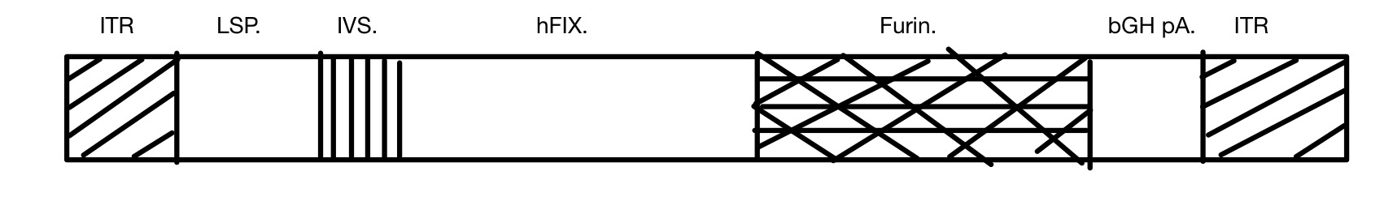
Figure 2. Schematic drawing of the pAAV-LSP-hFIX-Furin vector. ITR is the inverted translated region, LSP is the liver-specific enhancer/promoter, IVS is an inverted sequence that is part of the original vector, hFIX is human FIX, Furin is the serine protease, bGH pA is the boving growth hormone polyadenylation, which is the terminal sequence for the expression vector.

Western Blot
A Western Blot analysis will be used to detect the profactor FIX and mature FIX as they both differ in size. This technique is more specific than an ELISA and can separate the proteins by size, however it is not as effective in quantifying the protein as an ELISA. This will be done using mouse or human plasmas as the sample. The primary antibody will be determined as an anti-hFIX antibody similar to the ELISA below. The western blot will use two antibodies, one that detects mature FIX and another that can detect the pro-factor FIX as previously described by Bristol et al. (1993) work on FIX antibodies. This procedure will determine specifically if the profactor and the mature FIX are in the plasma sample from co-expression. The visual density of the bands will indicate approximately if both the profactor and mature FIX are present as well as how much approximately is in the given sample.

ELISA
An enzyme linked immunosorbent assay (ELISA) will be used to quantify profactor FIX and mature FIX using monoclonal anti-human FIX antibodies for example rabbit instead of mouse because the mouse antibodies could have interference from the mouse itself. In this procedure, an antibody coating captures the specific protein (FIX), coated with a detection antibody that attaches to the protein, reacted with a Streptavidin-enzyme conjugate that reacts with a substrate to produce a color. This colorimetric reaction is analyzed through absorbance in an ELISA reader machine. This method is less specific than the Western Blot, however it is more efficient in the quantification of the two proteins. This will be done as referenced by Harding et al. (2004). Previously Wang et al. (1999) has used this method to quantify FIX however this proposal will use an antibody that is anti-hFIX specific to the mature FIX protein and another one specific to the profactor FIX.

Chromogenic FIX activity assay
A chromogenic activity assay will be used specifically to detect active FIX (mature) in the sample. This procedure will use the plasma sample to have the functional FIX to react with a reaction mixture that produces a derivative of FIX to activate another factor, such as factor X (FX) derivative. Once the reaction is done, the amount of FX derivative produced is reacted with a nitroanilide substrate that is then photometrically measured by absorbance. This absorbance is directly proportional to the amount of functional FIX in the sample (Moser & Funk, 2014). This procedure will be done using a premade assay kit such as one form BIOPHEN as described by Liu et al. (2014).

Tail Clip Test
To analyze the phenotypic effect of FIX and Furin co-expression, the mice will be subject to a Tail Clip test similar to Wang et al. (1997). A tail clip test will be done by putting a small cut on the mouse-tail and measuring the bleeding time. The bleeding times will be characteristic in analyzing the ability of the co-expression to alleviate HB.

Discussion

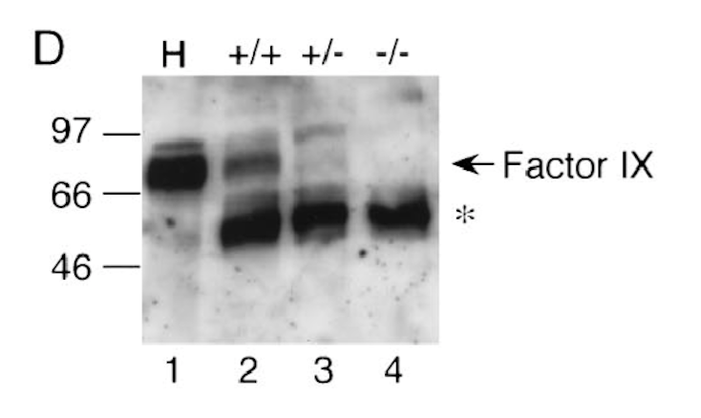
Figure 3. The western blot from Wang et al. (1999). H is the human plasma that was used as a control. This homozygous FIX expressing mice are in lane 2, heterozygous mice in lane 3, and the factor IX deficient mice are in lane 4. The star is the protein in mouse plasma that cross reacted with rabbit anti-hFIX antibody. This figure shows the Factor IX band in each of the mice models.

We expect the vector plasmid to be developed properly but could have some complications with the ligation of the cut segments. The Western Blot analysis should show similar results as Figure 3 above with relation to the mice developed. The lanes should have somewhat strong bands for FIX and could have varying density with regards to the amount of FIX produced. We would like to find the gel to be stained and have similar estimated amounts to the ELISA. We expect the ELISA to show that there is sufficient hFIX being produced similar to previously described amounts. We hope to see consistent mature hFIX being produced and reduced but consistent amounts of profactor FIX produced. The chromogenic activity assay for FIX should show increased quantities of active hFIX with the Furin processing which would confirm that Furin does produce increased quantities of active FIX in vivo.
There is a possibility to have incorrect or outlier bands in the Western Blot indicating incorrect binding to the antibody or another mechanism interference. If there is inconsistent amounts of FIX in the controls that could indicate incomplete vector transfer into the liver cells or there could be a contamination in the controls. With regards to the vector, the development could have improperly cut genes or incorrectly placed genes in the derived vector. The ELISA could also have contamination causing discrepancies in the procedure. During the chromogenic activity assay method there could be a reaction with inhibitors or repressors that can decrease the FIX activity process. The tail clipping method could be too broad of a measure as well because it focuses on the phenotypic expression and possible not give bleeding types that are consistent with hemophilia B characteristics.
During experimentation there could be an immune response to the antibodies that are developed causing interference. There is possible interference by other processing events from outside or earlier in the secretory pathway. The biggest pitfall with gene therapy experiments is the possibility of uncontrolled mutations during the gene transfers and transcriptions since mRNA does not have a proofreading ability. Gene therapy transfections of the vectors are not always incorporated into the genomes and therefore require isolation of the transfected cells to determine incorporation.
Furthermore this experiment poses some limitations as it only represents a minor amount of how much can be implicated with hFIX processing. There are possible complications in health for the animals or in humans when put in clinical trials because they are voluntary. Following certain guidelines of animal experiments could ameliorate this complication. The antibodies developed are uncertain and the extent of their effect is hard to determine. With regards to the mice, each mouse could react differently depending on their breeding and epigenetic relationships or interactions with inherent mouse proteins such as during the knockdown of Furin as well as factor IX.
The multiple complications could possibly be controlled however some of them are unpredictable. Through this experiment we hope to see implications for improving current gene therapy methods for better-processed hFIX and for better development of recombinant hFIX production for long-term treatment options.

References

Bristol, J.A., Furie, B.C., & Furie, B. (1993). Propeptide Processing during Factor IX Biosynthesis. The Journal of Biological Chemistry. 268 (10), pp. 7577-7584

Buchlis, G., Podsakoff, G.M., Radu, A., Hawk, S.M., Flake, A.W., Mingozzi, F., & High, K.M. (2011). Factor IX expression in skeletal muscle of a severe hemophilia B patient 10 years after AAV-mediated gene transfer. Blood. 119(13). Doi: 10.1182/blood2011-09-382317.

Cardo, L.J. (1991). Human Factor IX for the Treatment of Hemophilia. JAMA, 266(6). Pp. 794

Children’s Hospital of Philadelphia. (2016, October 17). In crafting new treatments for hemophilia, a ‘less is more’ approach. ScienceDaily. Retrieved April 6, 2017 from www.sciencedaily.com/releases/2016/10/161017140552.htm.

Dietrich, B., Schiviz, A., Hoellriegl, W., Horling, F., Benamara, K., Rottensteiner, H., Turecek, P.L., Schwarz, H.P., Scheiflinger, F., & Muchitsch, E. (2013). Preclinical safety and efficacy of a new recombinant FIX drug product for treatment of hemophilia B. The Japanered Society of Hematology, 98, pp 525- 532. Doi: 10.1007/s12185-013-1448-z.

Franchini, M., Frattini, F., Crestani, S., Sissa, C., & Bonfanti, C. (2013) Treatment of hemophilia B: focus on recombinant factor IX. Biologics: Targets and Therapy,(7), pp. 33-38. Doi: 10.2147/BTT.S31582

Harding, T.C., Koprivnikar, K.E., Tu, G.H., Zayek, N., Lew, S., Subramanian, A., Sivakumaran, A., Frey D., Ho, K., VanRoey, M.J., Nichols, T.C., Bellinger, D.A., Yendluri, S., Waugh, J., McArthur, J., Veres, G., &Donahue, B.A. (2004). Intravenous administration of an AAV-2 vector for the expression of factor IX in mice and a dog model of hemophilia B. Gene Therapy, (11), pp 204-213.

Hemophilia B. (2015, July 15). Retrieved February 22, 2017, from https://www.hemophilia.org/Bleeding-Disorders/Types-of-Bleeding- Disorders/Hemophilia-B

Leblond, J., Gaudreau, S., Grondin, F., Laprise, M., Dubois, C.M. (2004). Release of an Endogenous Inhibitor of the Proprotein Convertase Furin in Activated Human Platelets. Cardiovascular Pathology, pp s153.

Liu, J., Jonebring, A., Hagstrom, J., Nystron, A., & Lovgren, A. (2014) Improved Expression of Recombinant Human Factor IX by Co-expression of GGCX, VKOR, and Furin. The Protein Journal. 33. Doi: 10.1007/s10930-014-9550-5.

Nathwani, A.C., Tuddenham, E.G.D., Rangarajan, S., Rosales, C., McIntosh, J., Linch, D.C., Chowdary, P., Riddel, A., Pie, A.J., Harrington, C., O’Beirne, J., Smith, K., Pasi, J., Glader, B., Rustagi, P., Ng, C.Y.C., Kay, M.A., Zhou, J., Spence, Y., Morton, C.L., Allay, J., Coleman, J., Sleep, S., Cunningham, J.M., Srivastava, D., Basner- Tschakarjan, E., Mingozzi, F., High, K.A., Gray, J.T., Reiss, U.M., Nienhuis, A.W., & Davidoff, A.M. (2011). Adenovirus-Associated Virus Vector-Mediated Gene Transfer in Hemophilia B. The New England Journal of Medicine. 365(20). Doi: 10.1056/NEJMoa1108046.

Nathwani, A.C., Reiss, U.M., Tuddenham, E.G.D., Rosales, C., Chowdary, P., McIntosh, J., Della Peruta, M., Lheriteau, E., Patel, N., Raj, D., Riddell, A., Pie, J., Rangarajan, S., Bevan, D., Recht, M., Shen, Y.M., Halka, K.G., Basner- Tschakarjan, E., Mingozzi, F., High, K.A., Allay, J., Kay, M.A., Ng, C.Y.C., Zhou, J., Cancio, M., Morton, C.L., Gray, J.T., Srivastava, D., Neinhuis, A.W., & Davidoff, A.M. (2014). Long-Term Safety and Efficacy of Factor IX Gene Therapy in Hemophilia B. The New England Journal of Medicine, 371(21). Doi: 10.1056/NEJMoa1407309.

Rehemtulla, A., & Kaufman, R.J. (1992). Protein processing within the secretory pathway. Current Opinion in Biotechnology, (3), pp 560-565.

Siner, J.O., Samelson-Jones, B.J., Crudele, J.M., French, R.A., Lee, B.J., Zhou, S., & Arruda,V.R. (2016). Circumventing Furin enhances factor VIII biological activity and ameliorated bleeding phenotypes in hemophilia models. JCI Insight, 1(16). doi: 10.1172/jci.insight.89371.

Wang, L., Takabe, K., Bidlingmaier, S.M., Ill, C.R., & Verma, I.M. (1999). Sustained correction of bleeding disorder in hemophilia B mice by gene therapy. Proceedings of the National Academy of Science, 96, pp.3906-3910.

Wang, L., Zoppe, M., Hackeng, T.M., Griffin, J.H., Lee, K., & Verma, I.M. (1997). A factor IX-deficient mouse model for hemophilia B gene therapy. Proceedings of the National Academy of Science, 94, pp. 11563-11566.

Wasley, L.C., Rehemtulla, A., Bristol, J.A., & Kaufman, R.J. (1993). PACE/Furin Can Process the Vitamin K-dependent Pro-factor IX Precursor within the Secretory Pathway. The Journal of Biological Chemistry, 268(12), pp. 8458- 8465.

Wootla, B., Christophe, O.D., Mahendra, A., Dimitrov, J.D., Repesse, Y., Ollivier, V., Friboulet, A., Borel-Derlon, A., Levesque, H., Borg, J., Andre, S., Bayry, J., Calvez, T., Kaveri, S.V., & Lacroix-Desmazes, S. (2010). Proteolytic antibodies activate factor IX in patients with acquired hemophilia. Blood, 117 (7). Pp. 2257-2264 Doi: 10.1128/blood-2010-07-296103.

Zhang, G., Shi, Q., Fahs, S.A., Kuether, E.L., Walsh, C.E., & Montgomery, R. R. (2010). Factor IX ectopically expressed in platelets can be stored in $α$-granules and corrects the phenotype of hemophilia B mice. Blood, 116(8), pp. 1235-1243. Doi: 10.1182/blood-2009-11-255162.

