Blockage of the S1PR1 receptor using S1P modulator Fingolomid on T cells compared to the silencing of MicroRNA miR-155

Rachel Miller
BNFO 300 Spring 2017
Introduction

Among the United States population, 23.5 million suffer from an autoimmune disease. An autoimmune disease is where the immune system does not do its job in protecting your body from outside pathogens and diseases, but instead attacks the body itself (National Institute of Health, 2012). Autoimmune diseases can cause any part of the body to attack itself including the gastrointestinal (GI) tract; these are called inflammatory bowel diseases or IBDs. IBDs cause unregulated inflammation in the intestinal tract causing severe epithelial damage. IBDs consists of two main diseases, Crohn’s and Ulcerative Colitis. Crohn’s disease and Ulcerative colitis differ in one major way: location. Ulcerative colitis occurs only in the large intestine while Crohn’s can occur throughout the GI tract (Guan & Zhang, 2017).
Not much is known about the cause of these diseases, especially Crohn’s. There have been theories that say the cause is a combination of many factors including the host’s genetic susceptibility, the intestinal microbiome, environmental factors as well as defects in the immune system (Guan & Zhang, 2017). Currently, there are a few treatments for Crohn’s disease and other autoimmune disease such as Humira. however, these drugs have drawbacks. Humira and most other Crohn’s disease treatments are tumor necrosis factor-α (TNF-α) inhibitors. TNF-α is a cell signaling protein or cytokine produced by macrophages and plays a vital role in the inflammatory response. These drugs are highly successful, but have many dangerous side effects. TNF-α also plays a role in protecting the body from outside bacteria or disease such as tuberculosis without it, the body has little protection (Andersen & Jess, 2014).

S1P and S1PR receptors

A possible new treatment for Crohn’s disease is the hindrance of sphingosine-1-phosphate receptors or S1PR receptors in the immune system. Sphingoosine-1-phosphate (S1P) is a sphingolipid that is a vital part of many cell-signaling processes in the body. When phosphorylated by sphingosine kinases (SphKs) they exit cells and regulate many physiological processes including cell trafficking. S1P binds to sphingosine-1-phosphate receptors (S1PR), which consist of 5 different receptors that are involved in many physiological processes (Olivera et al., 2014). Focusing on these receptors and the binding of S1P have been a growing focus in autoimmune and cancer research. S1PR1 is the main receptor that is involved in the migration of dendritic cells, which are messengers in the immune system, and the production of T cells, lymphocytes that participate in the immune response.
Researchers have shown possible courses of treatment for autoimmune diseases and stomach cancer, using the reduction of S1P or hindrance of the S1P receptors which causes a great decrease in the inflammatory response (Degagné & Saba, 2014). Such a treatment that has been developed is the S1P modulator, FTY720 or Fingolomid. This modulator, when phosphorylated by sphingosine kinase acts as an agonist to the S1PR receptor and then after placement causes the receptor to downregulate, reducing its ability to take in stimuli. This method is the first S1P modulator to be approved by the FDA for multiple sclerosis, another autoimmune disease (Brinkmann et al., 2002). Another important aspect to analyze when treating autoimmune diseases such as Crohn’s, is to see the genetic make-up that is displayed in these inflamed cells such as microRNAs.
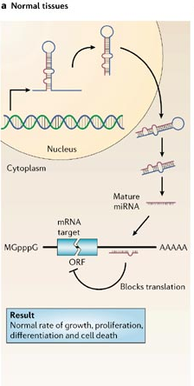
Figure 1: Transcription, processing and binding of microRNA in suppression of target genes in normal cells (Image from Esquela-Kerscher & Slack, 2006).

MicroRNAs and siRNAs

MicroRNAs are single strand, non-coding RNAs that are roughly 22 nucleotides long and are gene regulators in many different types of cells (Figure 1). The microRNA is transcribed by RNA Polymerase II and once outside in the cytoplasm a RNAse II enzyme called Dicer processes the miRNA, splitting the loop shape in to a mature miRNA. This allows the strand to bind to mRNA and inhibit gene expression using imperfect complementary block targeting (Esquela-Kerscher & Slack, 2006). There has been evidence showing that microRNAs have a role in cancer and autoimmune diseases due to their presence in the cell regulation and immune response (Okoye et al., 2014).
In the process called RNA interference or RNAi is the use of short interfering RNAs or siRNAs. siRNAs are used in silencing genes while integrated in biological pathways. This technique has been used as possible treatment in gene-therapy finding new heights in HIV and cancer control (Klemm et al., 2016). Since microRNAs and siRNAs have been seen to have success in control of genes and biological pathways, the question that this proposal hopes to answer is if there is a reduction of MicroRNAs in exosomes, which are extracellular vesicles that is released from plasma and T cells from inflamed tissues caused by Crohn’s, and can it be caused by the blockage of the S1PR1 receptor using the S1P modulator Fingolomid or is simply correlated in a much larger sequence of events?

Experiment

First Experiment

For this experiment, it is important to note that a previous experiment must be conducted to test the validity of these results. Due to the proposal criteria of describing only one experiment, and my choice to focus on the more interesting second experiment, I will give a brief overview of the first. In a mouse model named SAMP1, where there is onset of ileitis, which is similar to Crohn’s, the blockage of the S1PR1 receptor using Fingolomid is done to see its effects on the development of the ileitis in the mice. To analyze the effects, the modulator has on the microRNAs of the intestines, the microRNAs from the exosomes of the inflamed tissue and T cells are analyzed to see the number of microRNAs present and which ones (Mikulski et al., 2015). Exosomes and T cells are analyzed because both contain microRNAs and will also provide as a biomarker for the ileitis. For this proposal experiment to have context, this previous experiment, will have results that showed the decrease in microRNA numbers when the S1p modulator Fingolomid was present. The experiment for this proposal aims to find the reason why Fingolomid reduced the number of microRNAs, for this to be done it is necessary to see that this reduction of microRNAs does take place, did occur in the first experiment. This raises the question previously stated that is the reduction of MicroRNA caused by the blockage of the S1PR1 receptor using the S1P modulator Fingolomid or correlated.

Overview

For this experiment a cell line that imitates Crohn’s will hold a T cell, Fingolomid will be added to down regulate the S1PR1 receptor. Next, S1P will be added to stimulate the receptor and the number of the microRNA miR-155 will be calculated using qPCR. miR-155 was chosen because it has a role in the inflammatory response and is present in T cells and dendritic cells of the immune system. As well as miR-155, quantitative results will also be taken of the cytokines that are developed due to the stimulation of the S1PR1 receptor, primarily the cytokines IL-2, IL-17 and IFN-gamma will be detected using ELISA. This process is repeated where instead of the addition of Fingolomid, the miR-155 microRNA is silenced using siRNA. From there S1P is added to stimulate the S1PR1 receptor and quantitative data of cytokines is taken using ELISA. Examples of results for ELISA and qPCR are seen in Figure 3 and 4 respectively.
Figure 2: ELISA Indirect assay. Ag is for the target antigen and E is to represent the enzyme conjoined to the second antibody. Image taken from https://www.studyread.com/types-of-elisa
ELISA and qPCR

In this experiment the methods mainly involve the detection in the number of a specific microRNA and cytokines produced by the signaling of S1P. The detection of microRNAs is done using real-time PCR or qPCR. This method is used rather than regular PCR because qPCR has a higher sensitivity and has a large dynamic range making it a popular method for quantifying microRNAs (Chugh & Dittmer, 2012). The methodology of qPCR is the same as normal PCR except when the RNA is isolated, it is then reverse transcribed into complementary DNA or cDNA. Once this is done cDNA is added to the Master Mix used in real time PCR of the cDNA samples. As the cDNA is amplified and seen in Figure 4, the number of cycles of PCR it takes to reach full amplification is recorded by the fluorescent signals given off by the product due to the fluorescent tag, which is added to the qPCR mixture before amplification, on the cDNA. The primers that will be used in this experiment are from Applied Biological Materials (ABM) Inc. and will be mmu-miR-155 primers with the nucleotide sequence ‘UUAAUGCUAAUUGUGAUAGGGGU’ as the forward primer and a universal reverse primer.
The method of quantifying the cytokines is ELISA, which stands for enzyme-linked immunosorbent assay. ELISA is a tool that is used to analyze the number of a substance, protein etc. using antibodies. For this experiment the ELISA assay will be conducted indirectly, which is different from direct involving two antibodies for detection, one that binds to the target antigen and a second to bind to the primary antibody. This gives better results due to the increased sensitivity and reduction of possible errors. The T cells from the experiment is placed in wells of a microtiter plate before a primary antibody is added to the wells to bind to the target antigen. The wells are washed with buffer to remove unbound antibodies and the process is repeated with a second antibody that has an enzyme, typically Horseradish peroxidase (HRP), attached. The wells are washed again and a substrate is added, which gives off a color product when the substrate comes in contact with the enzyme present on the secondary antibody. The color change will indicate the presence of the antigen being present in the wells. This process is repeated for every antigen tested, in this case being IL-2, IL-17 and IFN-gamma (Figure 2). For IL-2, the primary antibody will be a Rat JES6-5H4, a IL-2 Monoclonal Antibody and for IL-12 as a primary antibody Rat IL-12 p70 Monoclonal Antibody (9A5) is used. For the secondary antibody, an anti-Rat IgG2b Secondary Antibody with conjugated enzyme HRP will be used. For the cytokine IFN gamma, a Rat IFN gamma Monoclonal Antibody (AN-18) will be used as a primary antibody with an anti-Rat IgG1 Secondary Antibody with conjugated enzyme HRP. All antibodies and substrates used will be obtained from Thermo Fisher Scientific Inc. For all three ELISA assays HRP will be detected with 3,3’,5,5’-Tetramethylbenzidine or TMB substrate and give off a blue color when detected. An example of the assay can be seen in Figure 3, where the optical density (OD), on the y axis, is taken using wavelength absorbance at 450nm because TMB is detected at that level of absorbance. On the x-axis is the concentration of the target antigen, and from these results the standard curve can be calculated and the precise amount of the antigen present is calculated.

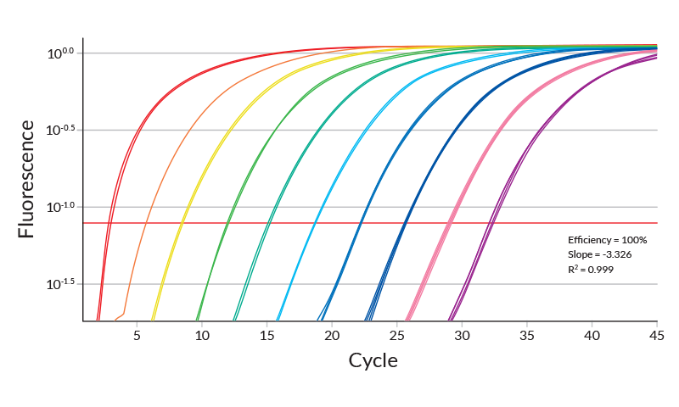
Figure 4: Example of the results from real-time PCR. Image taken from https://www.kapabiosystems.com
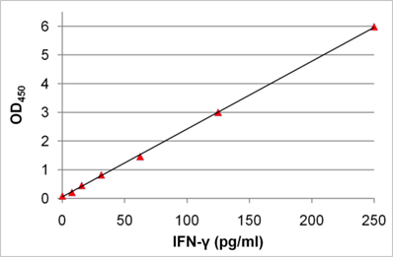
Figure 3: Example of the ELISA analysis of target protein. Image taken from https://www.immunology.org
Discussion

If all is done without error, the best possible result is to see the number of cytokines present while miR-155 is silenced is equivalent to when the S1P modulator Fingolomid is used on the S1PR1 receptor. This indicates my experiment is a step in the right direction for autoimmune research and the use of S1P modulators in treating Crohn’s disease. However, if the opposite of this occurs and there is not causation between the two, then further studies need to be done to find the connection between the blocking of the S1PR1 receptor and microRNAs in the immune system. This experiment can be conducted with different microRNAs to see if the results are the same for all microRNAs present in the immune system. If so, this can also be done with different S1P modulators and agonists to see if results differ.
In either case, the exploration into the therapeutic potential using S1P signaling for autoimmune diseases is definitely a step in the right direction (Aoki et al, 2016). The use of these molecular pathways can be of great benefit with people who suffer from cancer and autoimmune diseases Finding more ways to treat Crohn’s allows there to be more available help and treatments for patients early in life and so they do not have to resort to invasive surgery for treatment. With the use of S1P signaling and the analysis of microRNAs, we can see a more expanded treatment in the near future using these methods.

References

Andersen, N. N., & Jess, T. (2014). Risk of infections associated with biological treatment in inflammatory bowel disease. World Journal of Gastroenterology : WJG, 20(43), 16014–16019.

Aoki, M., Aoki, H., Ramanathan, R., Hait, N. C., & Takabe, K. (2016). Sphingosine-1-Phosphate Signaling in Immune Cells and Inflammation: Roles and Therapeutic Potential. Mediators of Inflammation, 2016, 8606878.

Brinkmann, V. et. Al. (2002). The Immune Modulator FTY720 Targets Sphingosine 1-Phosphate Receptors. Journal of Biological Chemistry, 277(24), 21453-21457.

Chugh, P., & Dittmer, D. P. (2012). Potential Pitfalls in microRNA Profiling. Wiley Interdisciplinary Reviews. RNA, 3(5), 601–616.

Degagné, E., Saba, J. (2014). S1pping fire: Sphingosine-1-phosphate signaling as an emerging target in inflammatory bowel disease and colitis-associated cancer. Clinical and Expreimental Gastroenterology, 7, 205-214.

Esquela-Kerscher, A., & Slack, F. J. (2006). Oncomirs — microRNAs with a role in cancer. Nature Reviews Cancer,6(4), 259-269.

Guan, Q., & Zhang, J. (2017). Recent Advances: The Imbalance of Cytokines in the Pathogenesis of Inflammatory Bowel Disease. Mediators of Inflammation, 2017, 4810258.

Klemm, V., Mitchell, J., Cortez-Jugo, C., Cavalieri, F., Symonds, G., Caruso, F., … Ahlenstiel, C. (2016). Achieving HIV-1 Control through RNA-Directed Gene Regulation. Genes, 7(12), 119.

Mikulski, Z., Johnson, R., Shaked, I., Kim, G., Nowyhed, H., Goodman, W., Chodaczek G., Pizarro T., Cominelli F., Ley, K. (2015). SAMP1/YitFc Mice Develop Ileitis via Loss of CCL21 and Defects in Dendritic Cell Migration. Gastroenterology, 148, 783-793.

National Institutes of Health. (2012). Autoimmune Diseases [PDF]. Research Triangle Park: National Institutes of Health.

Okoye, I. S., Coomes, S. M., Pelly, V. S., Czieso, S., Papayannopoulos, V., Tolmachova, T., … Wilson, M. S. (2014). MicroRNA-Containing T-Regulatory-Cell-Derived Exosomes Suppress Pathogenic T Helper 1 Cells. Immunity, 41(1), 89–103.

Olivera, A., Allende, M. L., & Proia, R. L. (2013). Shaping the landscape: Metabolic regulation of S1P gradients. Biochimica et Biophysica Acta, 1831(1), 193–202.

