Implementing CRISPR Type III-B in Human cell to Target RNA Encoded Viruses.
I. Introduction
The Rhinovirus, while often synonymous with the “common cold” has also been found to be a contributing factor for the occurrence of acute respiratory conditions such as asthma and inhibit effective infection resolution in at risk individuals. The average adult is impact 2-3 times a year while the average child can be infected 6-10 times a year. Children are also more likely to experience additional complications from a Rhinovirus infection such as ear infections, and in more severe cases, respiratory infections, chronic obstructive pulmonary disease, asthma and pneumonia². At this current time, an effective means of combating the Rhinovirus has not been established due their genetic diversity attributed to a high mutation rate resulting from the low fidelity of RNA- dependent RNA polymerase that lacks proof-reading activity (these errors have been estimated to be between 10⁻³ and 10⁻⁴) and their genetic recombination¹⁴. Treatment options that have been available are limited to addressing the replication prevention and the physical symptoms of the virus versus providing treatment to address the virus itself.
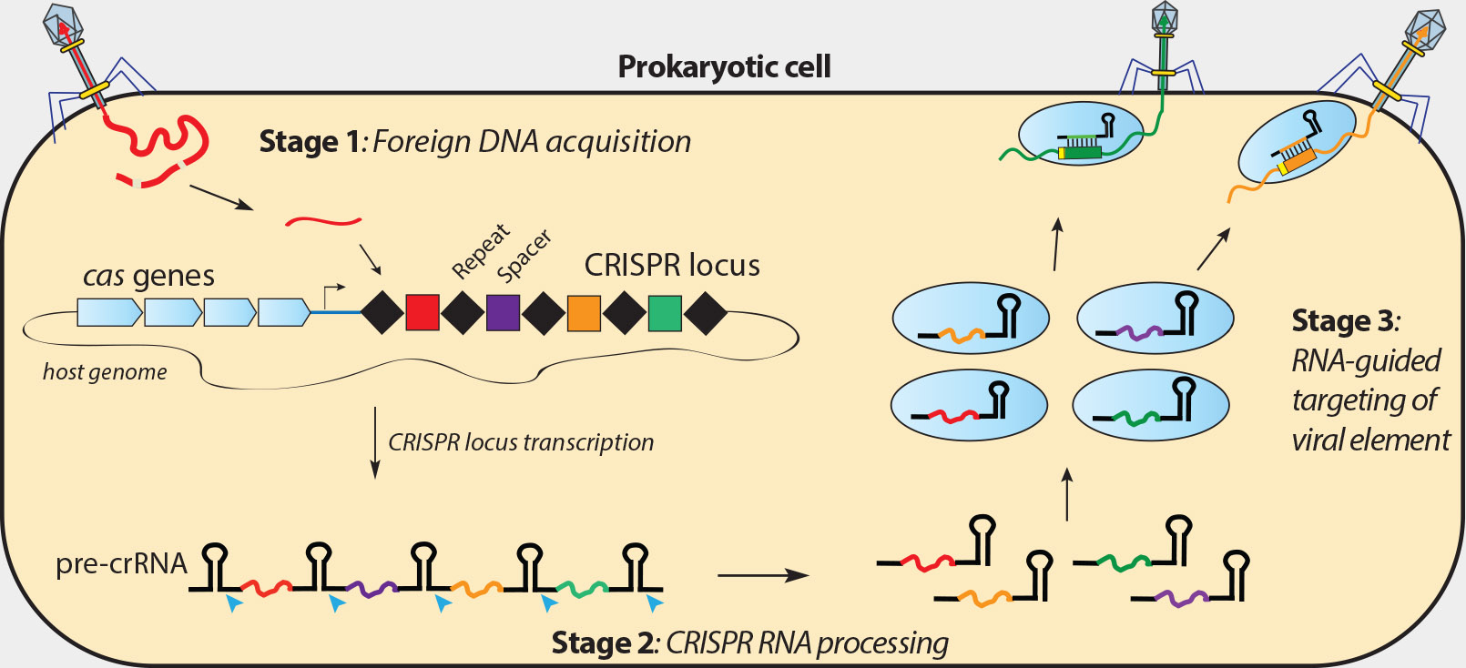
Clustered Regularly Interspaced Short Palindromic Repeats (CRISPR) complexes, is a biological defense mechanism against bacterial viruses and plasmids that functions by using an RNA-based ‘memory’ of past infections to target and recognize a specific sequence to induce breaks in the targeted nucleic acid of the invader⁵. The current developments being made to apply CRISPR to targeting of exogenous sequence offers the potential for an anti-viral intervention to address the sequence diversity of Rhinovirus strains circulating among humans.
Figure 1. CRISPR Type III Mechanism within Prokaryotic Cell. Stage 1) Foreign DNA acquisition. Stage 2) CRISPR RNA processing. (Stage 3) RNA- guided targeting of viral element (Adapted from 12).

To understand the potential of CRISPR complexes to combat viral infections, it is imperative to examine how CRISPR targets specific viral strains. Currently, there are three distinct types and six unique subtypes of CRISPR systems. The categorization of the main types is based upon the CRISPR associated types of protein complexes (Cas, Cms, Cmr) used for binding and cleavage of DNA or RNA target substrates, as well as the CRISPR RNA (crRNA) that acts in CRISPR interference⁷.
The result of these variations creates functional differences between the subtypes. All three types rely on the binding of crRNA to a target sequence and cleavage of those target sequences with an endonuclease. Type I is comprised of crRNA that is associated with a multitude of Cas proteins which will create the CRISPR associated complex used for antiviral defense. Type II utilizes Cas9, a single multifunctional protein, to target and degrade DNA sequences⁸. Type III however is unique regarding the ability to target both complimentary DNA and RNA sequences through the use of Csm (type III-A) or Cmr (type III-B) (Figure 1) protein complexes⁴. However, Type I and II systems act upon DNA sequences and therefore cannot be utilized to target the Rhinovirus as this it is comprised of RNA. For this reason, CRISPR Type III-B will be used as a tool to evaluate the binding and cleavage of Rhinovirus RNA sequences, as it is the only system that has been found to directly target and cleave RNA³
Figure 2. Illustration of organization of Cmr Complex (Adapted from Hale et al.). Cmr proteins are represented by the colored spheres, and crRNA is illustrated as the black and orange line.
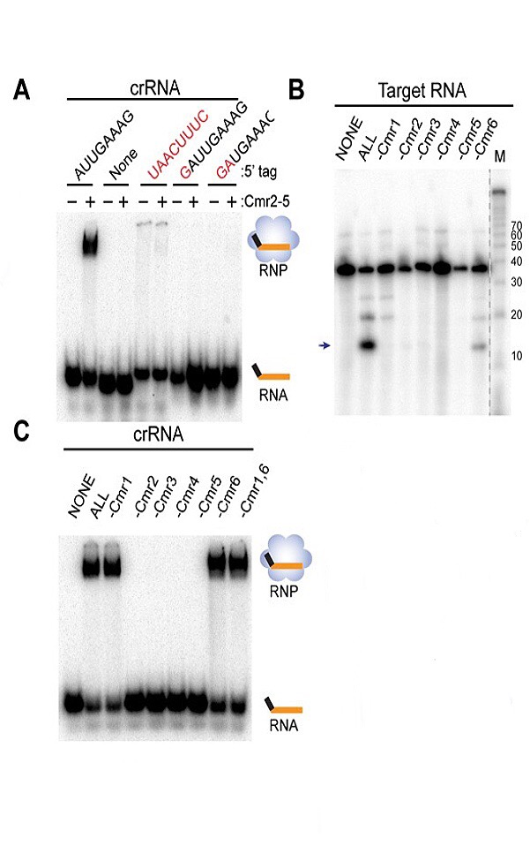
CRISPR Type III-B was discovered in Archaea¹¹, but has also possibly been found in Firmicutes¹²(Table S2, supplementary information, unable to find specific source). This type of CRISPR possesses 6 different Cmr proteins, some with multiple copies (Figure 2). Although the exact functional role of every Cmr protein is not fully known, for CRISPR Type III-B complexes derived from Pyrococcus furiosus (P. furiosus) multiple Cmr 4 proteins form the backbone that is bound to crRNA and, with Cmr 2, are involved in the cleavage of the target RNA^{9,1}, while the Cmr 1 and Cmr 6 appear to be linked to binding target RNA. There is currently limited knowledge about the functions of Cmr 3 and Cmr 5. However, all Cmr proteins are essential to achieve binding reactions against the target RNA³.
Figure 3. Cleavage and Binding Requirements of Type III – B Cmr proteins to a target RNA substrate.
The precedence of successful application of CRISPR Type III- B complex in vivo is limited; and was achieved only with Sulfolobus islandicus when the Cmr complex was able to invade the nucleic acid at the RNA and DNA levels. In this case it was also shown that for DNA targeting in vivo, a directional transcription of the protospacer was required¹³. An in vitro assay has been developed to examine the mechanism and substrate requirements of Type III-B CRISPR. crRNA has an 8 nucleotide repeat tag (5’-AUUGAAG-3’, black line in Figure 2), that is required for binding of crRNA to the Cmr complex (Figure 3 - C). The guide region (orange line in Figure 2), must be complementary to the target RNA to obtain successful cleavage. Furthermore, the 5’-end of the crRNA needs an OH group termini and the 3’-end requires a Phosphate. This guide region can be delineated to accommodate varying target RNA³. Based on these crRNA requirements, the guided region for this experiment will utilize GC content and will be modeled after the GC content that comprised the guided region used by Hale et al. This assay will be used as a model to test the tolerance of this system for non-archaeal virus sequences.

II. Experiment
The proposed experiment will involve CRISPR Type III-B complex derived from a purified form of P. furiosus Cmr complex in combination with custom RNA substrates created through in vitro transcription reactions. Key materials for this experiment are expected to be crRNA, target RNA, purified Cmr protein complexes, and reagents required for binding and cleavage assays targeting Rhinovirus RNA sequences. The crRNA binding assays and Target RNA cleavage assays will be created through the methods and procedures modeled by Hale et al.
Cmr protein complex purification: Purification of recombinant Cmr proteins will be achieved through a process involving the expression of proteins from either Luria broth or Terrific broth. The next step in purification involves sonication and thermal precipitation at 70°C, followed by continued purification through columns that will contain Ni-NTA or a Talon cobalt resin. After dialysis is achieved, the concentrations will be determined utilizing Qubit protein assays with purity verified by Coomassie staining and SDS- PAGE.
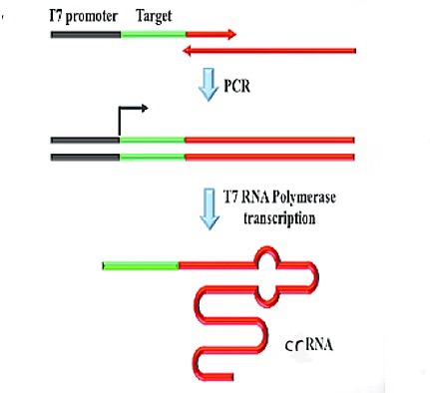
In vitro transcription assay: In vitro transcription will be used to create crRNA and target RNA substrates. The MAXIscript kit will be utilized for transcribing unlabeled RNA. The kit contains the following: RNA Polymarase enzyme mix (containing Ribonuclease Inhibitor Protein), 10 X Transcription Buffer, ATP solution, CTP solution, GTP solution, UTP solution, TURBO DNase, Gel loading buffer II, Nuclease –free water and pTRI-®-actin-Mouse. Single stranded DNA substrates (Tables 1 and 2), will be utilized for PCR primers that contain T7 as well as RNA polymerase promoter in vitro transcription. The template will be comprised of double stranded 19-23 as a base promoter and subsequently mixed with corresponding ribonucleic proteins (rNTPs), transcription buffer and RNA polymerase. The mixture will then be incubated at 37°C. The RNA polymerase will first bind to the double stranded DNA promoter before separating into two DNA strands, using the available 3’ to 5’ strand to serve as a template for synthesizing a complementary 5’ to 3’ end from the DNA template. Initiation of transcription will be a rate limiting regarding in vitro transcript reactions. It is expected at the phage RNA polymerases will have a significant specificity to the respective promoters. Due to the high rate of promoter specificity of RNA polymerases, both strands of the template are ably to be transcribed without involving cross talk from the promotor located on the opposite strand (Figure 4).
Figure 4. PCR in vitro transcription.
crRNA binding assay: The binding assay will be used to verify crRNA binding with altered guide region sequences to Cmr proteins. For the crRNA binding assay Cmr proteins will be incubated with 5000 counts per minute (cpm) of ³²P-radiolabeled crRNA substrates at 70ºC for 30 minutes in Hepes (buffer), KCl, glycerol, MgCl₂ and DTT. Some of the reactions will be added to nondenaturing gel which will be run at 110V for a total of 70 minutes, then dried and phosphorimaged. These gels will contain a mixture of TBE, acrylamide and glycerol. A shift in the band position of the radiolabeled crRNA to a position higher in the gel will indicate mobility is slowed by protein binding.
Target cleavage assay: The target cleavage assay will be used to perform cleavage of target RNAs derived from Rhinovirus sequences. Cleavage reactions will be assembled with Cmr proteins and synthetic crRNA for 30 minutes at 70ºC to establish the Cmr complex before the addition of 5000 cpm of the 5’-radiolabeled target RNA. The target RNA cleavage samples will be subjected to phenol extraction and ethanol precipitation to remove reaction components. The samples will be separated by electrophoresis on denaturing TBE-urea sequencing-sized polyacrylamide gels that can separate nucleic acid sequences with small differences in size. The target RNA will be 37 nucleotides in length. Observations to determine the presence of cleavage will be made through gel electrophoresis, with visualization made possible via phosphorimaging and autoradiography.
Substrate selection: The substrates were selected based in the matching GC content with the Hale et al. substrates, in this case the GC content is 54%. For this selection, using Biobike, the genome of Human Rhinovirus A was sliced every 37 nucleotide sequences, which were analyzed by GC content and picked at random based on the percentage matching said percentage above. All the sequences were picked from the coding region of the Rhinovirus DNA. The crRNA sequences were then created, from the reverse complement DNA target sequences and complementary to the + strand of the Rhinovirus RNA sequences. As seen in Table 1 and 2, the sequences are represented as DNA since they will be used to make a substrate for in vitro transcription.
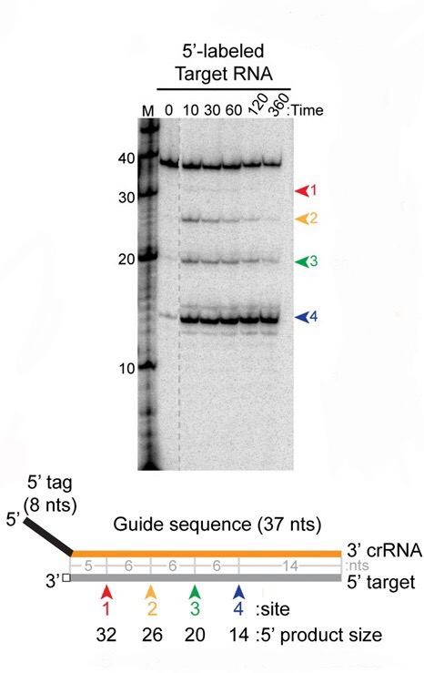
III.Potential Results and Discussion
Figure 5. Expected cleavage results.
The demonstrated ability of the CRISPR Type III-B complex to bind and cleave the viral RNA of the Rhinovirus would set a precedent toward expanding this research to target similar RNA based viruses and plasmids. If the required criteria that was addressed in Table 2 is met, the likelihood of achieving favorable results toward additional target RNA is probable (Figure 5).
A limitation of utilizing the CRISPR Type III- B complex is the fact that the functions of the Cmr proteins will vary depending upon what purified form of bacteria is utilized. P. Furiosus, although the first CRISPR Type III-B created, can be derived from a multitude of bacteria and possess similar or dissimilar Cmr proteins as P. Furiosus³. It could be argued however that the variation of Cmr protein functions within the differing bacterial bases would increase the likelihood of effectiveness. For example, if the Cmr proteins of P. furiosus were not able to create a functional tag with a targeted virus, the Cmr proteins of another bacteria may be more effective.
Another possible limitation is regarding viral mutations. Most of the research that has been made available addresses wild type viruses and has not clearly addressed whether or not viral mutations would limit the effectiveness of the CRISPR Type III- B complex. Further research is needed to explore if the Cmr complexes will still be effective if complementary pairing of the tag is not 1:1. In addition, since CRISPR Type III-B complex is a relatively new finding, the current amount of available research is limited and thus certain functions of Cmr proteins remain ambiguous.
The potential for a means of addressing RNA based viruses can revolutionize what is known regarding molecular biology. It is only through the creation of ideas and proposals that discoveries can be found, and if the results of this experiment are supportive of the efficacy of the CRISPR Type III- B complex, the applications for the CRISPR Type III-B complex may become numerous. Impacting not only the fields of biology, but the fields of medicine and genetic engineering.

Supplemental Tables

Table 1. crRNA Sequences (5’-> 3’)
GGCAATTTCCACCACCATCCAGATGAGGCACATGTCC
GGCTAGCACTAACCCATGGTACAACTAGTGAGGCGGT
CGGGGACAGGTGCTCCTGGGGGTACATACATAAATTG
TTGTCCAATCCACTCTAGCCCACGTGCTGCGTTACTC

Table 2. Target Sequences (5’ -> 3’)

Promoter-tag- 37nt sequence | GC Content | Coordinates
TAATACGACTCACTATAGGGAGACTTTCAATGGACATCTGCCTCATCTGGATGGTGGTGGAAATTGCC | 54% | 1073
TAATACGACTCACTATAGGGAGACTTTCAATACCGCCTCACTAGTTGTACCATGGGTTAGTGCTAGCC | 54% | 2146
TAATACGACTCACTATAGGGAGACTTTCAATCAATTTATGTATGTACCCCCAGGAGCACCTGTCCCCG | 54% | 2812
TAATACGACTCACTATAGGGAGACTTTCAATGTGTAACGCAGCACGTGGGCTAGAGTGGATTGGACAA | 54% | 3996

References

1.Estrella M.A., Kuo F., Bailey S. (2016). RNA-activated DNA cleavage by the Type III-B CRISPR-Cas effector complex. Genes and Development, 30(4): 460-470. DOI: 10.1101/gad.273722.115
2. Foxman, E., Iwasaki, A (2011). Genome-virome interactions: examining the role of common viral infections in complex disease. National Review of Microbiology, 9(4): 254-264. Doi: 10.1038/nrmicro2541
3. Hale C. R., Cocozaki A., Hong L., Terns R.M., & Terns M. P. (2014) Target RNA capture and cleavage by the Cmr type III-B CRISPR-Cas effector complex. Genes and Development (28):2432-2443. DOI: 10.1101/gad.250712.114

4. Tamulaitis G., Venclovas C., Siksnys V. (2017) Type III CRISPR-Cas Immunity: Major differences Brushed Aside. Trends in Microbiology 25(1): 49-61. DOI: 10.1016/j.tim.2016.09.012

5. Taylor D.W., Zhu Y., Staals R.H., Kornfeld J. E., Shinkai A., van der Oost J., Nogales E., Doudna J. (2015) Structures of the CRISPR-Cmr complex reveal mode of RNA target positioning. Science 348(6234): 581-585. DOI: 10.1126/science.aaa4535

6. Wright A.,Nunez J., Doudna (2016).Biology and applications of CRISPR systems: harnessing
nature’s toolbox for genome engineering. Cell 164(1–2):29–44

7. Van der Oost J, Westra ER, Jackson RN, Wiedenheft B. (2014). Unravelling the structural and mechanistic basis of CRISPR–Cas systems. National Review of Microbiology. 12(7): 479–92

8. Jiang F., Doudna J. (2015).The structural biology of crispr-Cas systems. Current Opinion Structural Biology. 30: 100-111. Doi: 10.1016/j.sbi.2015.02.002

9. Zhu X., Ye K. (2015) Cmr4 is the slicer in the RNA- targeting Cmr CRISPR complex
Nucleic Acids Research, 43(2): 1257-1267. Doi: https://doi.org/10.1093/nar/gku1355

10. Makorva K., Grishen N., Shabalina S., Wolf Y., Koonin W. (2006). Putative RNA-I interference-based immune system in prokaryotes: computational analysis of the predicted enzymatic machinery, functional analogies with eukaryotic RNAi, and hypothetical mechanisms of action. Biology Direct 1:7 doi: 10.1186/1745-6150-1-7

11. Lange S., Alkhnbashi O., Rose D., Will S., Backofen R, (2013) CRISPRmap: an automated classification of repeat conservation in prokaryotic adaptive immune systems. Nucleic Acids Research, 41(7): 8034-8044. Doi: 10.1093/nar/gkt606

12. Doudna Lab (2012).CRISPR systems in prokaryotic immunity. Retrieved from: http://rna.berkeley.edu/crispr.html

13. Han W., Li Y., Deng L., Feng M., Peng W., Hallstrom S., Zhang J., Peng N., Liang Y., White M., She Q. (2017). A type III-B CRISPR-Cas effector complex mediating massive target DNA destruction Nucleic Acids Research, 45 (4): 1983-1993. Doi:
https://doi.org/10.1093/nar/gkw1274
14. Waman V., Kolekar P., Kale M., Kulkarni-Kale U., Singh N (2014). Population structure and evolution of Rhinoviruses. PLoS One 9(2): doi 10.1371/journal.pone.0088981

