Jared Mann
Downregulation of Sox2 with CBD via AMPK
- Introduction
Medicinal drugs derived from the marijuana plant have become valid forms of cancer treatment due to the emerging research behind cannabinoids. Cannabidiol (CBD), a non psychoactive constituent of cannabis has been found to have many antitumor pathways¹, and gives a fighting chance against Glioblastoma (GBM) multiforme, the most common, and most malignant, brain tumor. The prognosis for GBM is bleak, with a median survival rate of 14.6 months with the current treatment available². One reason for the malignancy of GBM has been shown to be the abundance if cancer stem cells (CSCs) within GBM tumors that aid in initiation of the cancer, as well as treatment resistance³.
CSCs contain transcription factors that serve as markers for the “stem-like” properties of the cell. What this means is that they are always present in higher than normal amounts, and have been linked to contributing to the properties of stemness, such as pluripotency. Pluripotency accounts for a cell being able to differentiate into other types of cells, which is common in normal stem cells, but when cancer cells become pluripotent, they increase invasiveness. One of the transcription factors found in GBM is Sox2, a protein of the SOX family. Sox2 increases stemness by coupling with two other regulator proteins and orchestrating a path of pluripotency⁴. As mentioned before, CBD has many antitumor pathways. One of these pathways is the downregulation of Sox2 via increased production of reactive oxygen species⁵ (ROS), a byproduct of the electron transport chain (ETC) in the mitochondria. Theoretically, if one wanted to reduce the effect that CBD has on oxidative stress levels, one could take an antioxidant like vitamin E. When it comes to GBM patients, however, this increase in ROS is a method of treatment and is intended.
I.A. ROS/AMPK/p38 Pathway
After ingestion, metabolism of CBD increases levels of nicotinamide adenine dinucleotide (NADH)⁶, which enters the mitochondria, and undergoes oxidation/reduction reactions at the complex I site of the inner mitochondrial membrane⁷. This is the first mechanism of the electron transport chain, and kicks off the initial flow of electrons through the subsequent complexes. During this flow, free electrons can break loose and get caught by passerby oxygen, forming one of the most common forms of ROS, superoxide (O₂⁻). This formation occurs both inside of the mitochondria, and outside in the cytosol⁸. With this increased level of ROS, intracellular censors, such as ATM, respond directly to oxidative stress within the cell, and activates AMPK via an LKB1 catalyzed downstream pathway⁹. AMP-activated protein kinase (AMPK) is a multi-functional enzyme that has three subunits within its complex. Phosphorylation of AMPK by AMP occurs within the alpha subunit (AMPKα) at the Thr172 location¹⁰. AMPK activation has been shown to be a downstream product of two kinases, LKB1 and CaMKK, via an imbalanced ratio of ATM/ATP, but has been shown to activate through oxidative stress alone^{11, 12}.
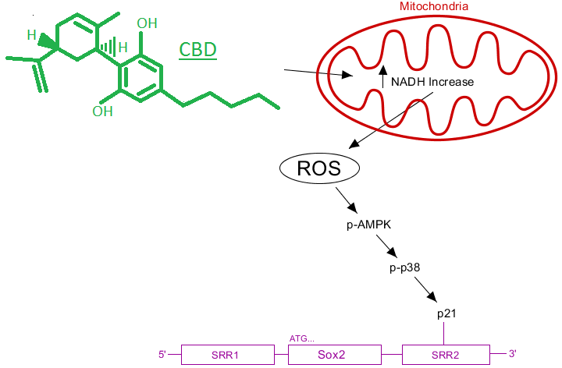
The known mechanisms for CBD’s downregulation of Sox2 include p38 MAP Kinase⁵. P38 does not interact with Sox2 directly, however the p38 pathway has downstream products, such as p21, for which it increases production and phosphortylates¹³. P21 is not a transcription factor, but rather a kinase inhibitor, and can form an inhibitory bond with a downstream promotor of Sox2, called the SRR2 Box. The only connection left to be made is AMPK in relation to p38/p21. It turns out that AMPK can be involved in the activation of p38 MAPK, via the TAB1 protein, which provides evidence for the assumption that AMPK is upstream of p38^{15, 16}. Figure 1 to the right illustrates the proposed mechanism by which CBD would downregulate Sox2. Proving the activation of AMPK is involved in this pathway would be vital to understanding the mechanism of this antitumor pathway.
Figure 1: Proposed pathway of Sox2 downregulation
Further proof of whether CBD’s downregulation of Sox2 would do so via activation of AMPK can be gained through observation of Physcion. Physcion is a pigmentation molecule found in lichen plants indigenous to eastern Asia, is used for medicinal purposes, and has similar effects on cancerous cells as CBD such as increased production of ROS. Physcion has been shown to downregulate Sox2 via an activated AMPK mechanism dependent on ROS in colorectal cancer^{17, 18}. It can be implied that CBD should have this same effect in GBM, due to its known production of ROS in cancerous cells.
CBD enters the cell and increases NADH with its metabolism. This causes an activation of the ETC and an increase in ROS, which activates AMPK. AMPK has downstream products, such as p-38^{MAPK} and p21, that downregulate Sox2 by binding to the SRR2 promotor.
AMPK has proved to be a target for cancer therapy drugs due to its interaction with p38¹⁹. CBD is a viable drug for the treatment of cancer, but there are still steps that need to be taken to understand the mechanisms by which CBD works on these tumors. Understanding the antitumor mechanism of CBD within GBM multiforme, and proving that CBD activates AMPK in a GBM cell line would be most beneficial to the research.
The purpose of this experiment is to show the extent to which CBD, a non-psychoactive cannabinoid, downregulates the expression of the pluripotent Sox2 transcription factor in human multiforme GBM via AMP Kinase.
- Experiment
To determine if CBD will activate AMPK while downregulating Sox2 in human GBM, an in vivo experiment aimed at measuring protein content will be performed. This experiment will, in many ways, be modeled after Soroceanu et al.²⁰ and their experiment to show downregulation of Id-1 through CBD. GBM cell lines will be grown, maintained, and separated into one of four groups. The first group will contain no drugs meant to alter the protein content within the cell, and will be evaluated as a control. The other groups will be treated with CBD at different levels, and will be evaluated as variables. Western analysis will show the content of AMPK, p-AMPK, and Sox2. A densitometry analysis on the western blot will show quantification. With this information, it can be determined if CBD has a downregulation effect on Sox2 via AMPK.
II.A. Neurosphere Culture and Variables
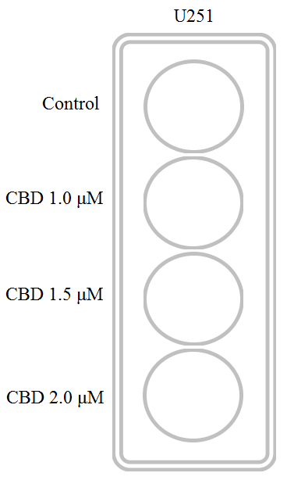
U251 glioma stem-like cells will be obtained and used for this experiment. U251 cell lines have been shown to have high levels of Sox2¹⁵, and will be useful for determining the expression levels in this experiment. A neurosphere culture will be created using U251 cell lines cultured in neuro basal media mixed with 10% fetal bovine serum (FBS). The cells will be maintained in this media for the preliminary phase of the experiment and will be replaced daily. After two days, or until they reach confluence, the cells will be suspended in trypsin-EDTA and no longer allowed to interact. This suspension will occur in 12-welled plates that contain 100 cells per well. CBD diluted in ethanol will be added in three different concentrations. The first will be a vehicle control. The second will contain 1.0 micro moles (μM), the third will contain 1.5 μM and the fourth will contain 2.0 μM. Figure 2 to the right shows how the cells will be separated into their respective groups. The purpose of using different levels of CBD diluted in ethanol is to answer the question, “to what extent does CBD increase phosphorylation of AMPK and downregulates Sox2?” Vehicle and CBD dilutions will be changed every day for three days. After day three, the protein analysis will be conducted.
This experiment will involve multiple levels of CBD, which will allow for stronger evidence for or against the hypothesis
Figure 2: Experiment Variables
II.B. Western Analysis
Cell lysis will take place from centrifugation and use of enzymes. Next, a breaking down of the proteins in the cell by means of SDS/PAGE will be conducted. SDS is a detergent that denatures proteins by unfolding them after binding one SDS per two amino acids. This charges the protein which moves the protein along the polyacrylamide gel after an electric current is induced²¹. Smaller proteins will move farther along the gel, toward the anode, while larger proteins will not move as far and will stay toward the back of the gel. This process is known as electrophoresis.
Transfer of the protein from the gel to the membrane will be completed via electroblotting. After soaking the gel in a methanol containing transfer buffer, the polyacrylamide gel will be placed directly against the membrane, and between two pieces of filter paper to create a transfer stack. In this case, an Immobilon-P membrane will be used in this experiment. This membrane has been chosen based off of its durability and resilience, as well as its ability to be probed multiple times²². Again, an electric current will be used with the cathode on the side of the gel, and the anode on the side of the membrane. This will cause the protein to transfer to the membrane, due to the negative charge of the proteins. Because the next stage will require two sets of membranes, electrophoresis and electroblotting will be done twice to give two membranes to work with.
After the proteins have been transferred to the membrane, probing with primary antibodies will take place. On the first membrane, polyclonal antibodies, which bind to multiple sites, will be used to detect for AMPK, Sox2 and Actin. The antibodies corresponding to these proteins are rabbit polyclonal anti Sox2 and anti AMPK. Anti actin will also be used to show CDB’s effect on housekeeping proteins, which should be nonexistent. The use of actin is also for the benefit of the western blot itself. Actin provides a similarity in analysis between the wells which proves the gel worked in the experiment. On the second membrane, a monoclonal antibody will be introduced. Anti-p-AMPK, which binds to the Thr-172 location if a phosphate is present, will detect for phosphorylation of AMPK.
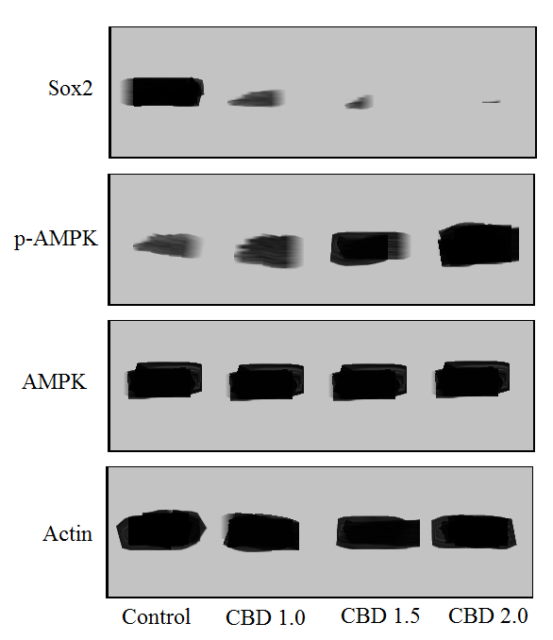
Secondary rabbit antibodies will next be used to probe the primary antibodies, which bind to the primary and add horseradish peroxidase (HRP). Incubation of the blot with Thermo Super Signal West Femto Substrate, a chemiluminescent substrate, will interact with HRP and allow for visualization by emission of chemiluminescent light. Film can be developed in a dark room to show exactly where the bands are in terms of the protein.
Figure 3: Faux Western Blot Results
This procedure will be completed four times to account for the differing levels of CBD. Figure 3 to the right shows the expected results. Although a western blot can be visually judged, a quantitative analysis on densitometry will be conducted using imageJ software²³. The point of this analysis is to show how the levels of each protein changed, as well as the amount of phosphorylation. As CBD increases, the density of the bands pertaining to actin should stay the same. Higher levels of CBD should decrease levels of Sox2 while increasing the levels of p-AMPK. Levels of AMPK and actin should not change.
If all goes well, CBD should mimic this faux western blot, showing more content of p-AMPK and less content of Sox2 as CBD levels increase.
- Discussion
The antitumor pathway proposed is that CBD enters the cell, increases ROS with its metabolism, and through LKB1 catalyzed phosphorylation, and activates AMPK. AMPK can then go on to activate the p38 pathway, which has downstream products such as p21 that downregulate Sox2 via an inhibitory bond to the SRR2 downstream promoter. The purpose of this experiment was to show that CBD activates AMPK, and also show the extent to which that activation occurs.
If the bands in the western analysis corresponding to p-AMPK increase in their darkness parallel to increase in CBD content, this shows that CBD activates AMPK relative to its concentration. If levels of Sox2 decrease, this shows the experiment was successful in recreating Singer et al.⁵ and Soroceanu et al.²⁰, the previous experiments showing downregulation of Sox2 with CBD. AMPK levels should stay the same, as CBD should not increase production of AMPK, just activate it.
There are other possible outcomes to this experiment, however. If AMPK does not increase phosphorylation with increased levels of CBD, this shows that CBD does not activate AMPK, but does downregulate Sox2 through other means. If, as CBD levels increase, Sox2 does not decrease by any means, or somehow manages to increase, then there was a problem along the ling in recreated the already existing evidence that CBD downregulates Sox2, and is highly unlikely. It is much more likely, however, that as CBD levels increased, Sox2 will reach a limit of reduction, and will no longer decrease. This would imply there must be some kind of limit to how much Sox2 p-AMPK can deactivate. CBD may benefit from use coupled with a synergistic drug that activates similar pathways to continue Sox2 downregulation. It is also not out of the realm of possibility that levels of AMPK could increase. This would imply that CBD increases production of AMPK in general, and while the idea is not impossible, the mechanism for that increase is not described in this proposal.
CBD treatment shows promising news. In a recent clinical analysis, treatments including CBD have been shown to increase one-year survival rate in GBM multiforme by 83%²⁴. The statistics showing CBD to be a viable treatment for GBM should inspire more research to be proposed in this field, which could potentially prolong the lives of those afflicted. Understanding the pathways by which CBD, a non-psychoactive cannabinoid, downregulates expression of the Sox2 gene, which expresses a transcription factor shown to increase stem-ness and pluripotency in GBM, could lead to a better understanding of the drug and more efficient treatment of GBM through CBD.

References
- McAllister, S. D., Soroceanu, L., & Desprez, P. Y. (2015). The antitumor activity of plant-derived non-psychoactive cannabinoids. Journal of Neuroimmune Pharmacology, 10(2), 255-267.
(https://www.ncbi.nlm.nih.gov/pmc/articles/PMC4470774/)
- Ray, S., Bonafede, M. M., & Mohile, N. A. (2014). Treatment Patterns, Survival, and
Healthcare Costs of Patients with Malignant Gliomas in a Large US Commercially Insured Population. American health & drug benefits, 7(3).
(https://www.ncbi.nlm.nih.gov/pmc/articles/PMC4070631/)
- Lathia, J. D., Mack, S. C., Mulkearns-Hubert, E. E., Valentim, C. L., & Rich, J. N. (2015). Cancer stem cells in glioblastoma. Genes & development, 29(12), 1203-1217.
(https://www.ncbi.nlm.nih.gov/pmc/articles/PMC4495393/)
- Fong, Y. W., Inouye, C., Yamaguchi, T., Cattoglio, C., Grubisic, I., & Tjian, R. (2011). A DNA repair complex functions as an Oct4/Sox2 coactivator in embryonic stem cells. Cell, 147(1), 120-131.
(http://www.cell.com/abstract/S0092-8674(11)01008-7)
- Singer, E. Judkins, J. Salomonis, N. Matlaf, L. Soteropoulos, P. McAllister, S. Soroceanu, L. (2015). “Reactive oxygen species-mediated therapeutic response and resistance in glioblastoma”. Nature Publishing Group. DOI: 10.1038/cddis.2014.566.
https://www.ncbi.nlm.nih.gov/pmc/articles/PMC4669764/
- Usami, N., Yamamoto, I., & Watanabe, K. (2008). Generation of reactive oxygen species during mouse hepatic microsomal metabolism of cannabidiol and cannabidiol hydroxy-quinone. Life sciences, 83(21), 717-724.
(http://www.sciencedirect.com/science/article/pii/S0024320508003809)
- Valvassori, S. S., Bavaresco, D. V., Scaini, G., Varela, R. B., Streck, E. L., Chagas, M. H., ... & Quevedo, J. (2013). Acute and chronic administration of cannabidiol increases mitochondrial complex and creatine kinase activity in the rat brain. Revista Brasileira de Psiquiatria, 35(4), 380-386.
(http://www.scielo.br/scielo.php?script=sci_arttext&pid=S1516-44462013000400380&lng=en&nrm=iso&tlng=en)
- Murphy, M. P. (2009). How mitochondria produce reactive oxygen species. Biochemical Journal, 417(1), 1-13.
(https://www.ncbi.nlm.nih.gov/pmc/articles/PMC2605959/)
- Alexander, A., & Walker, C. L. (2011). The role of LKB1 and AMPK in cellular responses to stress and damage. FEBS letters, 585(7), 952-957.
(http://www.sciencedirect.com/science/article/pii/S0014579311001608)
- Wang, W., & Guan, K. L. (2009). AMP‐activated protein kinase and cancer. Acta Physiologica, 196(1), 55-63.
(http://onlinelibrary.wiley.com/doi/10.1111/j.1748-1716.2009.01980.x/full)
- Mackenzie, R. M., Salt, I. P., Miller, W. H., Logan, A., Ibrahim, H. A., Degasperi, A., ... & Dominiczak, A. F. (2013). Mitochondrial reactive oxygen species enhance AMP-activated protein kinase activation in the endothelium of patients with coronary artery disease and diabetes. Clinical science, 124(6), 403-411.
(https://www.ncbi.nlm.nih.gov/pmc/articles/PMC3903000/)
- Emerling, B. M., Weinberg, F., Snyder, C., Burgess, Z., Mutlu, G. M., Viollet, B., ... & Chandel, N. S. (2009). Hypoxic activation of AMPK is dependent on mitochondrial ROS but independent of an increase in AMP/ATP ratio. Free Radical Biology and Medicine, 46(10), 1386-1391.
(https://www.ncbi.nlm.nih.gov/pmc/articles/PMC3326346/)
- El Alami, M., Vina-Almunia, J., Gambini, J., Mas-Bargues, C., Siow, R. C., Penarrocha, M., ... & Vina, J. (2014). Activation of p38, p21, and NRF-2 mediates decreased proliferation of human dental pulp stem cells cultured under 21% O 2. Stem cell reports, 3(4), 566-573.
(https://www.ncbi.nlm.nih.gov/pmc/articles/PMC4223702/)
- Lanna, A., Henson, S. M., Escors, D., & Akbar, A. N. (2014). AMPK-TAB1 activated p38 drives human T cell senescence. Nature immunology, 15(10), 965.
(https://www.ncbi.nlm.nih.gov/pmc/articles/PMC4190666/)
- Li, J., Miller, E. J., Ninomiya-Tsuji, J., Russell, R. R., & Young, L. H. (2005). AMP-activated protein kinase activates p38 mitogen-activated protein kinase by increasing recruitment of p38 MAPK to TAB1 in the ischemic heart. Circulation research, 97(9), 872-879.
(http://circres.ahajournals.org/content/97/9/872.long)
- Lanna, A., Henson, S. M., Escors, D., & Akbar, A. N. (2014). AMPK-TAB1 activated p38 drives human T cell senescence. Nature immunology, 15(10), 965.
(https://www.ncbi.nlm.nih.gov/pmc/articles/PMC4190666/)
- Han, Y. T., Chen, X. H., Gao, H., Ye, J. L., & Wang, C. B. (2015). Physcion inhibits the metastatic potential of human colorectal cancer SW620 cells in vitro by suppressing the transcription factor SOX2. Acta Pharmacologica Sinica.
(https://www.ncbi.nlm.nih.gov/pmc/articles/PMC4753366/)
- Chen, X., Gao, H., Han, Y., Ye, J., Xie, J., & Wang, C. (2015). Physcion induces mitochondria-driven apoptosis in colorectal cancer cells via downregulating EMMPRIN. European journal of pharmacology, 764, 124-133.
(http://www.sciencedirect.com/science/article/pii/S0014299915301369)
- Kim, I., & He, Y. Y. (2013). Targeting the AMP-activated protein kinase for cancer prevention and therapy. Frontiers in oncology, 3, 175.
(https://www.ncbi.nlm.nih.gov/pmc/articles/PMC3711071/)
- Soroceanu, L., Murase, R., Limbad, C., Singer, E., Allison, J., Adrados, I., ... & Khan, S. (2013). Id-1 is a key transcriptional regulator of glioblastoma aggressiveness and a novel therapeutic target. Cancer research, 73(5), 1559-1569.
(https://www.ncbi.nlm.nih.gov/pmc/articles/PMC3594064/)
- Al-Tubuly, A. A. (2000). SDS-PAGE and western blotting. Diagnostic and Therapeutic Antibodies, 391-405.
(https://www.ncbi.nlm.nih.gov/pubmed/21337110)
- Immobilon® Membranes, Sandwiches and Blotting Filter Paper. (2005). Immobilon. EMD Millipore, Billerica, Massachusetts.
https://www.emdmillipore.com/US/en/product/Immobilon-Membranes%2C-Sandwiches-and-Blotting-Filter-Paper,MM_NF-C3117#overview
- Schindelin, J., Rueden, C. T., Hiner, M. C., & Eliceiri, K. W. (2015). The ImageJ ecosystem: an open platform for biomedical image analysis. Molecular reproduction and development, 82(7-8), 518-529.
http://onlinelibrary.wiley.com/doi/10.1002/mrd.22489/abstract
- GW Pharmaceuticals. (2017). GW Pharmaceuticals Achieves Positive Results in Phase 2 Proof of Concept Study in Glioma [Press Release].
https://www.gwpharm.com/about-us/news/gw-pharmaceuticals-achieves-positive-results-phase-2-proof-concept-study-glioma

