Amanda Luong May 2017
Identifying the Protein Interactions
Responsible for LIN52 Degradation

- Introduction:

In 2016, an estimate of 1,685,210 people were diagnosed with cancer, and unfortunately, 595,690 individuals died from a form of this disease (National Cancer Institute). Cancer is an enigma among the medical field with many researchers racing to solve the puzzle through various approaches. Ultimately, the common goal is to defeat it. Cancer develops as a result of deregulated cell growth. These cells are able to by-pass signals for cell cycle arrest and disregard entry into quiescence (G₀). The entry of a cell into quiescence amid its cell cycle may be crucial in preventing such deleterious proliferation. Failure to do so will lead to progression through mitotic division, and ultimately give rise to cancer. Further understanding of the driving force that transitions a cell between its active cell cycle and its quiescent state will allow greater understanding of the development of cancer.
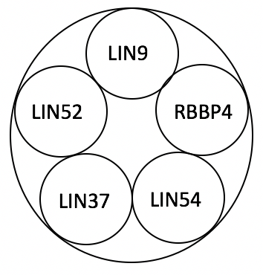
A defining mechanism that determines a cell’s entry into the cell cycle or quiescence is dependent on a protein complex known as the MuvB core, a transcriptional regulatory complex (Sadasivam et al. 2013). The MuvB core consists of five protein subunits – LIN52, LIN9, RBBP4, LIN54, and LIN37 (Litovchick et al. 2007). Based on its binding partners, MuvB can form two protein complexes, either DREAM (dimerization partner, RB-like, E2F, and MuvB) or MMB (Myb-MuvB) (Sadasivam et al. 2013). These complexes will bind to specific DNA sequences at regulatory regions and affect levels of transcription.
Figure 1. Representation of MuvB core
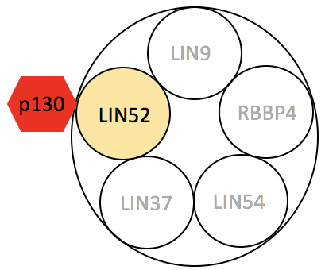
The DREAM complex corresponds to the quiescent state. It involves other proteins such as retinoblastoma (RB) tumor suppressors which inhibit transcriptional factors found at the promoter regions of DNA (Litovchick et al. 2007). Its overall differentiating factor is the binding of an RB protein known as p130 to its LIN52 subunit (Litovchick et al. 2007).

Figure 2. Representation of the DREAM complex
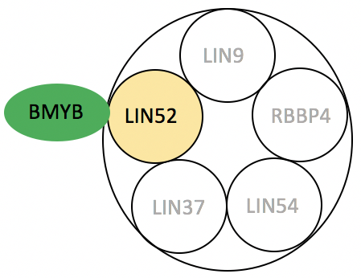
On the contrary, the MMB complex is often found to be present during the active growth stages of the cell cycle (Sadasivam et al., 2013). It consists of the MuvB core and a BMYB protein attached to the LIN52 subunit. BMYB is a sequence-specific transcription factor that binds near promoters responsible for upregulating the transcription of active cell cycle genes (Sadasivam et al., 2013).
Figure 3. Representation of the MMB complex

The MuvB core member, LIN52, will be the focus of this study. LIN52 is the specific subunit which binds either p130 or BMYB (Guiley et al. 2015). During quiescence, LIN52 binds p130 for DREAM formation to repress cell cycle genes. Meanwhile, when LIN52 binds BMYB and forms MMB, this upregulates the expression of cell cycle genes and causes entry into the cell cycle. Without the formation of DREAM, cell proliferation may occur in a deregulated, harmful manner (Forristal et al. 2014).
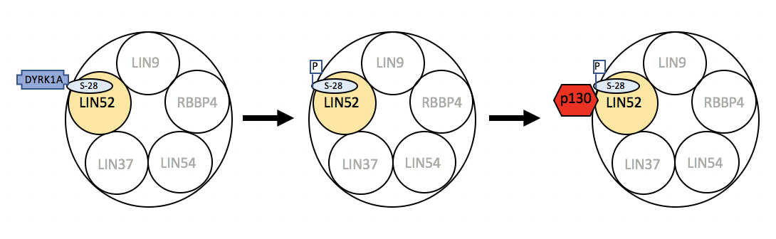
In a recent experiment, it was determined that a specific protein kinase, DYRK1A, was responsible for phosphorylating LIN52 at position serine-28 (S28) (Litovchick et al. 2011). The phosphorylation of LIN52 is necessary for the attachment of p130 to MuvB in order to form DREAM (Litovchick et al. 2011). On the contrary, BMYB has a higher affinity for LIN52 than p130, and it can bind all forms of LIN52 for MMB formation (Litovchick et al. 2011).
Figure 4. Representation of DYRK1A phosphorylation of LIN52 for DREAM formation

Studies have shown that the loss of DYRK1A function leads to increased levels of LIN52 stability (Litovchick, unpublished). Without the phosphorylation of LIN52-S28 that catalyzes the binding of p130 to form DREAM, the MMB complex may be formed in a premature and unregulated manner due to BMYB’s affinity to LIN52 (Litovchick et al. 2011). A potential defense mechanism against the premature formation of the MMB complex could be through the degradation of LIN52.
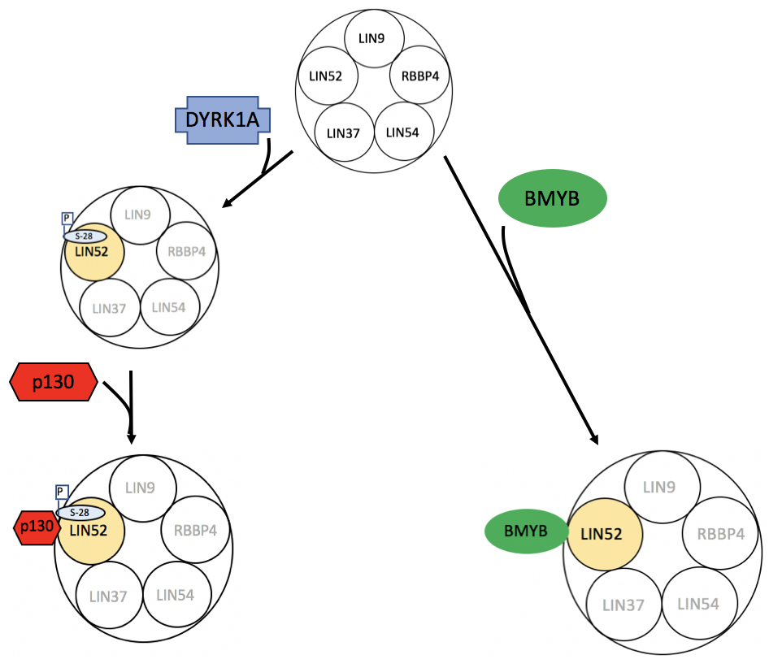
Figure 5. Representation of MuvB core fates. With DYRK1A, the DREAM complex is formed by p130 binding LIN52, and the cell enters quiescence. Without any accessory mechanisms, BMYB can readily bind to LIN52 to assemble the MMB complex for cell cycle entry.
LIN52 has also been shown to undergo ubiquitination at position lysine-106 (K-106) (Litovchick, unpublished). Ubiquitin is a 76-amino acid protein that is involved in the regulation various cellular processes such as protein degradation, cell cycle progression, and DNA repair (Iconomou et al. 2016). The protein acts as a tag that specifically signals for certain processes depending on how its molecules are arranged (Iconomou et al. 2016). With LIN52 undergoing ubiquitination, the ubiquitin may act as a signal within a greater Ubiquitin Proteasome System (UPS) that is responsible for the degradation of LIN52 (Chen et al. 2010).
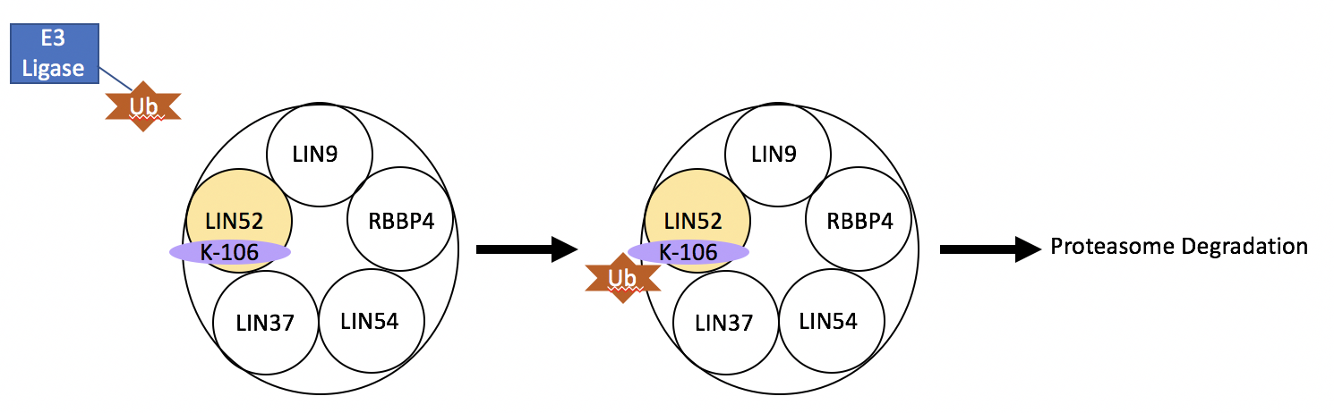
The last enzyme involved in UPS is categorized as an E3 ligase, and these are responsible for catalyzing the transfer of ubiquitin to a target specific protein (Nakagawa et al. 2015). Since E3 ligases are target specific, several hundreds of them exist within cells to regulate various proteins (Chen et al. 2010). Overall, this suggests that an E3 ligase is responsible for ubiquitinating LIN52-K106.
Figure 6. Adaptation of the Ubiquitin Proteasome System

Beyond this, little is known about the ubiquitination of LIN52-K106 and the exact mechanism of LIN52 degradation. The aim of this experiment is to identify the protein(s) involved in the ubiquitination of LIN52 in order to further understand LIN52 as a component of the MuvB core, and how its regulation may influence the formation of DREAM and MMB.

- Experiment:
The overall purpose of this experiment is to identify the potential proteins involved in the ubiquitination of LIN52-K106. A possible method to approaching this will include co-immunoprecipitation and mass spectrometry. Co-immunoprecipitation will isolate a sample of LIN52 and its interacting proteins, and mass spectrometry will be used to identify the peptides which make up the proteins.

- Co - Immunoprecipitation:

Co-Immunoprecipitation utilizes antibodies to capture a targeted protein (Mann 2001). The molecules that are not attached to the antibody will be eluted out. Thus, this method is efficient in studying purified protein-protein interactions (Antrobus et al. 2011). By using co-immunoprecipitation techniques, this process will provide a protein sample to be further analyzed.
Similar to the Litovchick et al. (2011) experiment where a protein kinase of LIN52 was identified, cell lysates for this experiment will be derived from cell line, T98G, which originates from human glioblastoma cells. To isolate the target proteins, antibodies selecting against the protein will be utilized (Antrobus et al. 2011). These antibodies are attached to agarose beads that allow for the antibodies to precipitate together upon centrifugation (Antrobus et al. 2011). For the purpose of this experiment, antibodies that select against LIN52 are needed. After allowing the antibodies to incubate within the protein mixture to develop a precipitate, the irrelevant proteins can be washed away. This technique will isolate LIN52 and its interacting proteins that are to be identified.
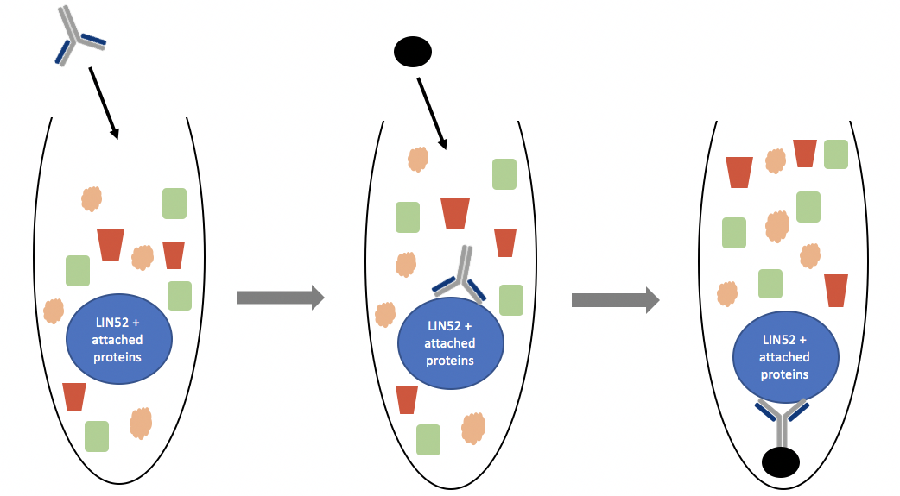
Figure 7. Simplified representation of the co-immunoprecipitation of LIN52 and its attached proteins. First, antibodies are used to target specific proteins, then they are paired to agarose beads to be precipitate a sample.

- Mass Spectrometry / Multidimensional Protein Identification Technology (MudPIT):

Having obtained a protein sample of LIN52 and its interacting proteins, the proteins need to be identified in order to understand their function. This can be done using a highly specific mass spectrometry technique known as Multidimensional Protein Identification Technology (MudPIT). In order to do this, the protein mixture must first be digested into smaller peptides using proteases (Washburn Lab).
MudPIT consists of two components, a two-dimensional high performance liquid chromatography (HPLC) component and a mass spectrometry component (Washburn 2004). The HPLC component will be based on strong cation exchange chromatography and reverse phase chromatography which will separate the peptides based on its charge and polarity (Washburn 2004). These peptides are then subject to mass spectrometry to determine their mass to charge ratio.
Mass spectrometry can be categorized into three main components – an ion source, a mass analyzer, and a detector (Yerlekar 2014). Upon peptide separation via HPLC, the sample will undergo electrospray ionization (ESI), providing the ion source (Yerlekar 2014). The ions will accelerate through an electromagnet where its charge will cause a deflection that the detector will use to determine its mass to charge ratio (Washburn Lab). By comparing the quantities returned by the mass spectra to known peptide database values, the identity of the peptides and its’ potential proteins can be determined. With the current knowledge regarding the degradation of LIN52 potentially engaging in a UPS, the focus of the mass spectra results is to identify E3 ligases.
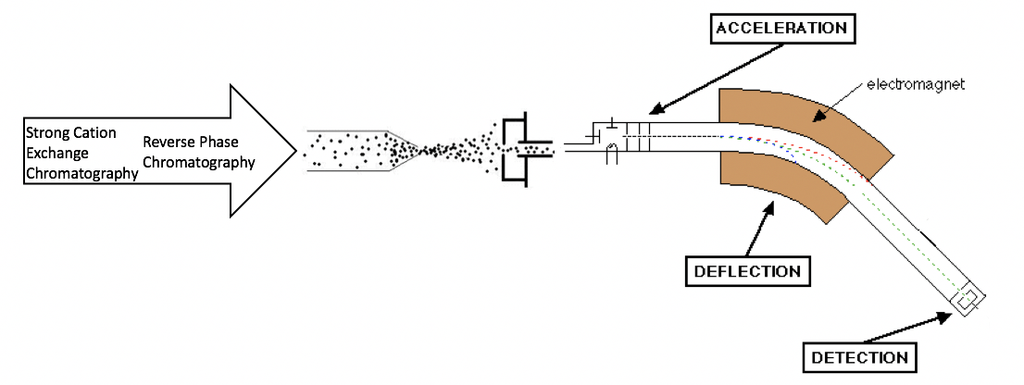
Figure 8. Generalized representation of MudPIT. Peptide sample is separated with two-dimensional chromatography base on charge and polarity. The sample then undergoes electrospray ionization before mass spectrometry.

- Discussion

Proteins tagged with ubiquitin are subject to proteasome degradation or other mechanisms of cellular growth regulation (Chen 2010). Recent studies determined that LIN52-K106 is a site of ubiquitination; therefore, it is suggested that the protein involved in the degradation of LIN52 is a protein within a Ubiquitin Proteasome System (UPS) (Litovchick unpublished). This mechanism could be essential in preventing the premature formation of the MMB complex. To signal degradation, E3 ligases facilitate the ubiquitination of a targeted substrate, and in this case, the target substrate is LIN52 (Chen 2010). Although the results of the mass spectra may return thousands of proteins, there will be a focus on identifying proteins categorized as E3 ligases.
In the event of MudPIT detecting a large range of potential E3 ligases, this experiment will require a greater analysis to validate the results (Washburn 2004). The proteins identified by MudPIT can be confirmed using small interfering RNA (siRNA) knockdowns that allow for further observation of the relationship between the selected protein and the presence of LIN52. The purpose of an siRNA knockdown is to silence the function of a selected protein (Ramaswamy 2002). This method will inhibit a candidate E3 ligase, and it would be expected to result in an increase in LIN52 since the protein is no longer being tagged for degradation. These results can be visualized using techniques such as western blotting.
A potential limitation of this experiment is the lack of greater knowledge regarding the MuvB core. It is unknown how this core interacts or even exists outside of cellular regulation mechanisms. With current understandings, MuvB is seen as a unifying intermediate between DREAM and MMB (Sadasivam 2013). Outside of these regulatory protein complexes, little is known about MuvB and its subunits.
Understanding the protein interactions that may lead to the degradation of LIN52 provides greater knowledge on the potential transitional mechanisms between the DREAM and MMB complexes. Ultimately, this relates to understanding the transition between cellular quiescence and progression through the cell cycle. Due to the nature of cancer proliferation, the observations obtained from this experiment may be influential in understanding the progression of cancer and lead to better methods of treatment.

References

Antrobus, R., Borner, GH. (2011). Improved Elution Conditions for Native Co-Immunoprecipitation. PLoS ONE, 6(3), e18218.
Chen, D., Dou, P. (2010). The Ubiquitin-Proteasome System as a Prospective Molecular Target for Cancer Treatment and Prevention. Current Protein & Peptide Science, 11(6), 459 – 470.
Clark, J. (2015). The Mass Spectrometer. Retrieved from http://www.chemguide.co.uk/analysis/masspec/howitworks.html
Forristal, C., Henley, SA., MacDonald, JI., Bush, JR., Ort, C., Passos, DT., Talluri, S., et al. (2014). Loss of Mammalian DREAM Complex Deregulates Chondrocyte Proliferation. Molecular and Cellular Biology, 34(12), 2221 – 2234.
Guiley, KZ., Liban, TJ., Felthousen, JG., Ramanan, P., Litovchick, L., and Rubin, SM. (2015). Structural mechanisms of DREAM complex assembly and regulation. Genes & Dev, 29(9), 961 – 974.
Iconomou, M., Saunders, DN., (2016). Systematic approaches to identify E3 ligase substrates. Biochemical Journal, 473, 4083 – 4101.
Kienast, W., Barron, AR., (2011). Protein Analysis using Electrospray Ionization Mass Spectrometry. Retrieved from https://cnx.org/contents/EVvGGGh0@1/Protein-Analysis-using-Electro
Link, A., Washburn, MP. (2014). Analysis of Protein Composition Using Multidimensional Chromatography and Mass Spectrometry. Current Protocols in Protein Science, 78(23), 23.1.1 – 23.1.25
Litovchick, L., Florens, LA., Swanson, SK., Washburn, MP., and DeCaprio, JA. (2011). DYRK1A protein kinase promotes quiescence and senescence through DREAM complex assembly. Genes & Development, 25, 801 – 813
Litovchick, L., Sadasivam, S., Florens, L., Zhu, X., Swanson, SK., Velmurugan, S., Chen, R., Washburn, MP., Liu, XS., DeCaprio, JA. (2007). Evolutionarily Conserved Multisubunit RBL2/p130 and E2F4 Protein Complex Represses Human Cell Cycle-Dependent Genes in Quiescence. Molecular Cell, 26, 539 -551.
Mann, M., Hendrickson, RC., Pandey, A. (2001). Analysis of Proteins and Proteomes By Mass Spectrometry. Annual Review of Biochemistry, 701(1), 437 – 473.
Nakagawa, T., Nakayama, K. (2015) Protein monoubiquitylation: targets and diverse functions. Genes to Cells, 20, 543 – 562.
National Cancer Institute. (2017). Cancer Statistics. Retrieved from https://www.cancer.gov/about-cancer/understanding/statistics.
Ramaswamy, G., Slack, FJ. (2002). siRNA: A Guide for RNA Silencing. Chemistry & Biology, 9, 1053 – 1057.
Sadasivam, S., DeCaprio JA. (2013). The DREAM complex: master coordinator of cell cycle-dependent gene expression. Nature Reviews Cancer.
Washburn Lab. (n.d.). Deeper into the MudPIT. Retrieved from http://research.stowers.org/proteomics/MassSpec.html
Washburn, MP. (2004). Utilisation of proteomics datasets generated via multidimensional protein identification technology (MudPIT). Briefings in Functional Genomics and Proteomics, 3(3), 280 – 286.
Yerlekar, A., Kshirsagar, MM. (2014). A Review on Mass Spectrometry: Technique and Tools. International Journal of Engineering Research and Applications, 4(4), 17-23.

