Proposal
EJ Kochis
BNFO 300
Differences in GTPase Hydrolysis rates of developmentally regulated rRNAs of Plasmodium Falciparum
Malaria is a serious disease affecting millions of people worldwide each year. The CDC estimates that Malaria infects 212 million people each year, most of whom live in developing countries (CDC 2016). This disease is as deadly as it is costly, incurring over 15 billion dollars in healthcare costs annually (CDC 2016). While there has been extensive research on malaria, there is still no universal vaccine and many types of malaria are resistant to conventional treatment approaches (Teklemariam et al 2017).
Malaria is caused by the Plasmodium parasite that is carried by mosquitos and transferred to humans when they are bitten. As research methods progress scientists continue to learn more about this harmful parasite. Plasmodium Falciparum is a deadly strain of the disease that infects millions (Teklemariam et al 2017). Better understanding of plasmodium and its cellular mechanisms could help doctors and scientists fight this disease. The plasmodium life cycle includes several stages through insect and vertebrate hosts. The mosquito stages are when sexual reproduction occurs while the vertebrate phases involve asexual reproduction. This is significant because different genes are expressed during these different stages (Li et al 1997). Plasmodium has the ability to switch certain genes on and off during the sexual and asexual phases (Cui et al 2014).
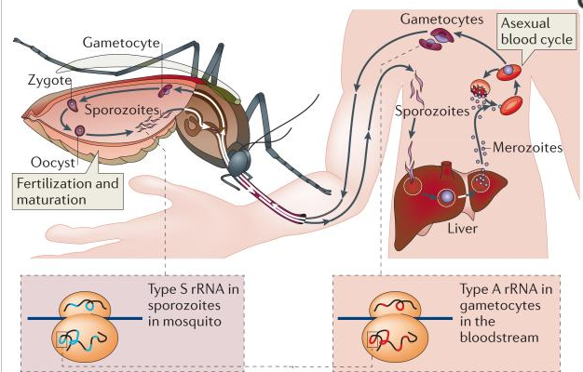
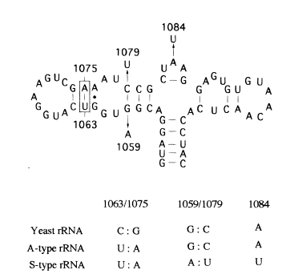
The rRNA gene expression in plasmodium is especially unusual. There are two different rRNA genes expressed at any given time in plasmodium, yet the significance of these different rRNA’s is not fully understood. There is an A type rRNA gene expressed when the parasite is in its asexual (schizogony), phases and then an S type (sporozoite) rRNA expressed in the sexual phase (Xue et al 2012) . The A type genes can be seen in the blood stages of hosts humans infected with malaria and the S type is found in the salivary glands of infected mosquitos (Fig 1). While the sequences of the A type and S type are 90%+ conserved, they have differences in the domain that codes for GTPase site in the ribosome(Velichutina et al 1998). This difference at a GTPase has prompted questions as to if the A type and S type genes change ribosome functionality see figure 2 for differences. (Velichutina et al 1998).
Figure 1- Shows a visualization of when A and S types are present in plasmodium. The S type, is present in the sexual form in the mosquito, then when bitten the parasite is transferred to the human host where the A type is mostly present in the asexual form
Velchuntina et al, attempted to discern the differences in function between the A type and S type rRNAs by replacing wild type yeast with either A or S type and observing the ramifications. They had groups of mostly A type, mostly S type and then a mix of both. They found that the wild type mix and A type showed little to no growth inhibition while the group with mostly S type rRNA was severely growth inhibited. This lead them to believe that there is some functional difference at the GTPase site between the two types of rRNA. However, the differences in GTP usage was not further investigated (Velichutina et al 1998).
Figure 2 This figure is from Velichutina showing the GTAase site of the 28s RNA Plasmodium and the differences between the A and S types with the single mutation at a crucial point.
In nature, Malaria always contains a mix of A and S type rRNA but if one of these types of rRNA is essential to the function of the parasite then knocking it out could be a potential target for drug research (Spaendonk et al 2001). Building upon the work of Velchuntina et al, this experiment will attempt to discern whether there is a difference in GTPase hydrolysis rate in A type vs S type rRNA in plasmodium.

Experiment
In this experiment, we will be measuring the GTP hydrolysis rates of ribosomes made from A type and S type rRNA genes in Malaria. Yeast will be used as a vector for the A and S types and then a GloAssay (promega) will be used to measure the rate of GTP usage under each condition. There will be 3 conditions, an only A type group, an only S type group, a mix of both A and S. A PCR will be done on the cloned products to first verify successful cloning and then determine the relative amounts of A and S ribosomes will be measured as a reference. After the products are verified and measured then the GTP rates will be measured.
Cloning of rRNA into Yeast
The procedure for the cloning will use similar methods to that used by Velchuntina et al. The rRNA genes to be used for this experiment were sequenced by Rogers et all 1996 with the genbank accession number U21939, see appendix 1 for full sequence (Rogers et al 1996). The isolated genes will then be cloned into yeast shuttle vectors using E.coli ColE1 as the origin of replication. The yeast strain used will be L1521 these were constructed by Chernoff et al 1994 (Chernoff et al 1994). They were chosen because L1521 it has a complete deletion of rDNA. Since it has no rDNA of its own the yeast will be kept alive with a wild type plasmid that carries the URA3 gene necessary for transformation selection later on. The wild type yeast rRNA gene will be cloned into L1521 in order to grow it then the A and S types will both be cloned into L1521. The wild type yeast plasmids will contain a URA3 gene that will later be used as a selection target to isolate the experimental A and S rRNA. The type A and S plasmids will not contain the URA3 gene, they will carry TRP1 and LEU2-d, this will allow them to grow in -Trp and -Leu mediums. For the full list of yeast genotype see appendix 2 (Velichutina et al 1998).
In order to select for A or S type plasmids, the colonies will be incubated in a FOA+ medium, this medium selects against the wild type cells containing the URA3-plasmid. This should leave an isolate of only A type or S type plasmids present.
Once the colonies are grown we will need to confirm the presence of the A and S type rRNA genes. This can be done in a few steps. First, RiboGreen fluorescent dye from ThermoFisher Scientific (ThermoFisher 2017). This will tell us if there is RNA and the amount present. This should give a baseline for amount of RNA. Next the RNA will be isolated with methods described in Schmitt et al 1990. After isolation, the RNA will be sequenced it using primer extension methods with oligonucleotides primers. These primers are shown in figure 3. Primer extension works using complementary DNA that anneals to the RNA and is synthesized using reverse transcriptase. This method is used to map the 5’ end of the RNA. After sequencing and amplification, the presence of wild type, A and S type can be verified via PCR. The ideal PCR products are displayed in Figure 3.
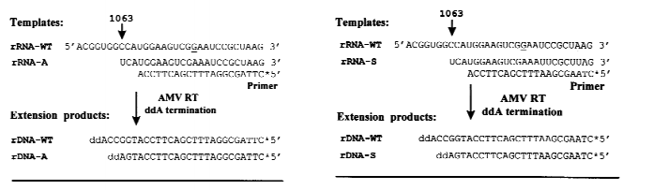

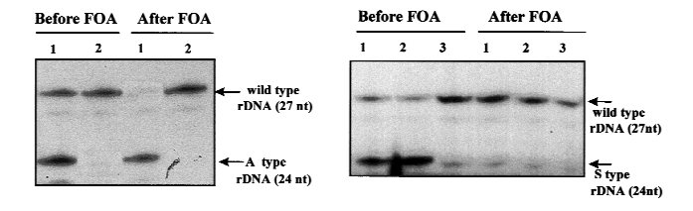
Figure 3 The top picture is the primers used for the primer extension anaylsis. There is a 3 nucleotide difference built into the primer in order to distinguish A and S from the wild type. The bottom picture is displaying the ideal PCR products with the wildtype yeast not present in the A and S types due to FOA+ selection (Velichutina et al 1998).

Measuring GTP Activity
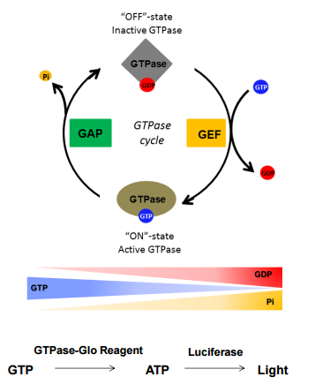
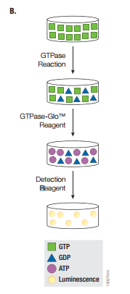
GTPases are used for many functions including cell signaling and proliferation. On the ribosome GTPases are used to signal for protein synthesis and elongation. They are essential to proper function. After the wild type, A type and S type have been isolated this will allow us to measure GTP activity of the ribosomes. This will be done using a GloAssay GTPase activity kit from Promega. During the GTPase cycle, a GTP will bind to a GTPase cite in order to activate it, eventually when the signal inactivates the GTP dissociates into GDP and Pi (inorganic phosphate). This is done with the help of guanine exchange factors (GEF) and GTPase activating proteins (GAP) (Figure 4a). Although GAP and GEF can also be measured by the GLoAssay, we will not be measuring them for this experiment. The GloAssay works by converting any leftover GTP into ATP. Once the ATP is formed it is detected using a luciferase recombinant (Fig 4b). For example, low GTPase activity would leave a lot of leftover GTP and therefore high amounts of ATP will be formed, generating more light. The opposite will be true for high GTPase rate, there will be less GTP to ATP and less light (Mondal et al 2015). Because GTPase react at an inherently slow rate, the reaction will be left to incubate for 2 hours in order to get quality data .
Figure 4(b) – This is a visualization of the GLoassay turning leftover GTP into ATP and then using a detection reagent to measure the light levels of the luciferase.

Discussion
There are two different rRNA genes expressed at in plasmodium, an A type rRNA gene expressed when the parasite is in its asexual (schizogony), phases and then an S type (sporozoite) rRNA expressed in the sexual phase. While these rRNAs are mostly conserved, there are differences at the functional GTPase domain between nucleotides 1052-1112 (by Velchuntina et al 1998). This region of the has been shown to be of functional importance in GTP hydrolysis in plasmodium. However, the ramifications of this these sequence differences are largely unknown. This experiment set out to determine if the different rRNA genes have an effect on the GTP hydrolysis rates of plasmodium ribosomes.
Figure 4(a) – This is a visual of the GTPase cycle showing the GTP in the active ‘on’ state bound to the GTPase site and then dissociating into GDP and Pi in the ‘off’ state
During this experiment, the rRNA genes of yeast cells were replaced with A type and S type rRNA from plasmodium falciparum, and then the GTP hydrolysis rates were measured via a GloAssay, in an attempt to determine if one type of rRNA gene has high efficiency in plasmodium.
Measurement of GTPase activity in A type vs S type rRNA

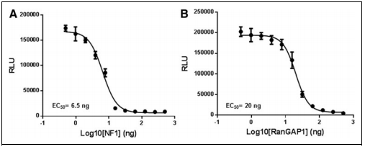
The results of this experiment are expected to show that hydrolysis rates are likely equal or close to equal. This would make the most sense considering the parasite is able to survive and replicate in nature using both. Figure 5 shows a possible result from the GLoassay showing similar GTPase rates over 3 hours. The A and the S type are similar in rate in this example. The downward slope of the curve is consistent with the GTP levels being high at first then, as it is used by the GTPase the levels of light decline. However, in nature there is always a mix of A and S type, never only one. These results could show if one type is more efficient. On the other hand, one ribosome type could be far more efficient, this could display that the difference in GTPase center is functionally importance for the success of the organism. For example, if the A type is shown to have twice the efficiency of the S type then it could be a good target for drug treatment. By disabling the most efficient type of ribosome it could seriously affect the fitness of the parasite.
Figure 5 There are sample results showing similar rates of reaction for type A and S. The downward slope of the curve is consistent with the GTP levels being high at first as it is used by the GTPase the levels of light decline. This would be a similar results to our expected results.
S Type rRNA
A Type rRNA
One confounding variable of this entire experiment is using yeast as a vector for the rRNA genes. By introducing another organism into the experiment, it leaves room for more variability. While this should not affect the measurement of GTPase hydrolysis, it could hinder the purity, growth and cultivation of the plasmids. Another possible problem of this experiment is that Velchuntina et al were not able to get a pure S type rRNA sample to grow with their yeast. This could have been an error on their part or a fundamental problem with the experiment. If it is a fundamental error, our results will not be able to show A type vs S type hydrolysis but they will still be able to measure A type.

Appendix
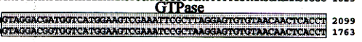
- This is the full sequence from the Rogers et al 1996 showing the GTPase site of the A type rRNA.

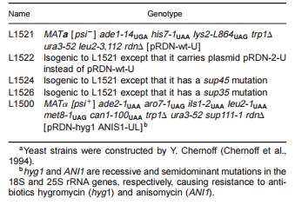
- Displaying the yeast strains and their genotype. L1521 will be the strain used in this experiment.
References

CDC. "CDC and Malaria." Internal Medicine News 38.4 (2016): 68.CDC and Malaria. Web. 29 Apr. 2017.
Chernoff YO, Vincent A, Liebman SW+ 1994+ Mutations in eukaryotic 18S ribosomal RNA affect translational fidelity and resistance to aminoglycoside antibiotics+ EMBO J 13:906–913+

Cui, Liwang, Scott Lindner, and Jun Miao. "Translational Regulation during Stage Transitions in Malaria Parasites." Annals of the New York Academy of Sciences1342.1 (2014): 1-9. Web.
Li, Jun, Robin R. Gutell, Simon H. Damberger, Robert A. Wirtz, Jessica C. Kissinger, M.john Rogers, Jetsumon Sattabongkot, and Thomas F. Mccutchan. "Regulation and Trafficking of Three Distinct 18 S Ribosomal RNAs during Development of the Malaria Parasite." Journal of Molecular Biology 269.2 (1997): 203-13. Web.
Mondal, Subhanjan, Kevin Hsiao, and Said A. Goueli. “A Homogenous Bioluminescent System for Measuring GTPase, GTPase Activating Protein, and Guanine Nucleotide Exchange Factor Activities.” Assay and Drug Development Technologies 13.8 (2015): 444–455. PMC. Web. 16 Mar. 2017.
Spaendonk, R. M. L. Van, J. Ramesar, A. Van Wigcheren, W. Eling, A. L. Beetsma, G.-J. Van Gemert, J. Hooghof, C. J. Janse, and A. P. Waters. "Functional Equivalence of Structurally Distinct Ribosomes in the Malaria Parasite, Plasmodium Berghei."Journal of Biological Chemistry 276.25 (2001): 22638-2647. Web.

Teklemariam, M., A. Assefa, H. Mohamed, and H. Mamo. "Therapeutic Efficacy of Artemether- lumefantrine against Uncomplicated Plasmodium Falciparum Malaria in a High-transmission Area in Northwest Ethiopia." PloS One 12.4 (2017): n. pag.Pubmed. Web. 29 Apr. 2017.
ThermoFisher. "The Basics: RNA Isolation." Thermo Fisher Scientific. N.p., n.d. Web. 29 Apr. 2017.

Rogers MJ, Gutell RR, Damberger SH, Li J, McConkey GA, Waters AP, McCutchan TF+ 1996+ Structural features of the large subunit rRNA expressed in Plasmodium falciparum sporozoites that distinguish it from the asexually expressed subunit rRNA+ RNA 2:134– 145+
Velichutina, Irina V., M. John Rogers, Thomas F. Mccutchan, and Susan W. Liebman. "Chimeric RRNAs Containing the GTPase Centers of the Developmentally Regulated Ribosomal RRNAs of Plasmodium Falciparum Are Functionally Distinct."Rna 4.5 (1998): 594-602. Web.
Xue, Shifeng, and Maria Barna. “Specialized Ribosomes: A New Frontier in Gene Regulation and Organismal Biology.” Nature reviews. Molecular cell biology 13.6 (2012): 355–369. PMC. Web. 16 Feb. 2017

