Measurement of Changes in Force Generation of Cardiomyocytes through the Down Regulation of Vinculin using CRISPR-Cas Gene Editing
Fadi Hijaz ¹
Virginia Commonwealth University ¹

- Introduction

The study of mechanical forces on cells has recently become an increasingly interesting and growing field of research. The notion that cells are only stimulated by external stimuli which are then biochemically transmitted using diffusion mediated events to impact transcription and cell function has been remodeled. The new stance includes the fact that biochemical signaling pathways are also induced by mechanoreceptors at the cell surface. Cells have been accepted to be intrinsically mechanosensitive, with mechanical force effects being studied in cellular homeostasis, disease, and development. External forces such as fluid shear stress, stretch, pressure, and extra cellular membrane (ECM) contraction can all remodel and have structural effects on the ion channels, cadherin/integrin adhesions, and cytoskeletal structures of an organism’s cellular organization.

With the cytoskeleton (CSK) being a highly dynamic construct allowing for rapid reorganization in response to external/internal signaling and changes many have considered it the most vital cellular component for the study and understanding of force transmission. Cardiac cells (cardiomyocytes) are a prime subject for researchers to analyze and perform CSK experimentation on in order to better understand the regulators and moderators of mechanobiology. This is true because cardiomyocytes are constantly under mechanical stress through active stretching and self-generated mechanical force (Jacot 2009).

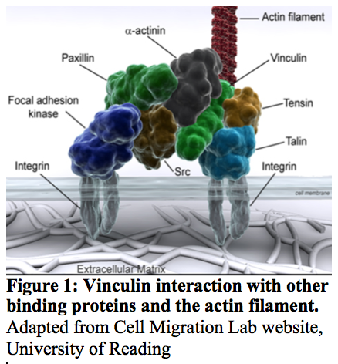
Cardiac proteins which mediate attachment of CSK to the ECM and other cells are key players in not only structure but also development, propagation, and survival of the vital organs which they constitute (Wolfgang 2008). Mutations to these proteins, a recently studied example being Titin, have been found to cause fatal cardiovascular conditions such as Dilated cardiomyopathy (DCM). DCM is characterized by left ventricular dilation and systolic dysfunction (Hinson 2015). The disease is associated with sudden cardiac death and in cases where autoimmune disease has been eliminated it is believed to be caused by genetic mutations (Jefferies 2010). One mutation that has been recorded to have a gene-phenotype relationship with DCM was found to be the cytoskeletal protein Vinculin (Olson 2002).

Vinculin is a ubiquitously expressed and highly conserved intracellular protein which is a crucial part of the cell adhesion complex. The 117- kDa protein is composed of eight four-helix bundles that are then organized into four tandem pairs (Bakolitsa 2004). These eight bundles make up for the globular head, a proline rich region (“strap”), and a tail domain which comprise the binding sites for protein interactions. The vinculin head (V_{H}) contains talin, α-actinin, and α- and β- catenin binding sites. The tail (V_{H}) consists of actin, paxilin, and phosphatidylinositol 4,5-biphosphate while in the strap vasodilator-stimulated phosphoprotein (VASP), actin-related protein 2/3 (Arp2/3), and vinexin binding sites dwell (Dumbauld 2013). Figure 1 above illustrates a few of these interactions in relation to the actin filament and integrins of the ECM. Activation of vinculin occurs through head-tail binding to proteins of the actin-based cytoskeleton aforementioned (Ziegler 2008). Once activated it is recruited to focal adhesions and enhances integrin stimulation thus strengthening the binding of cells to ECM ligands and allowing for resistance from forces applied to the cell surface (Zemljic-Harpf 2007). Vinculin-deficient cells have been shown to have a reduced cortical CSK stiffness along with decreased cell adhesive strength (Dumbauld 2013). Although research has shown that vinculin plays an in important role in the vitality of cardiomyocytes, functional analysis of the protein deficiency has yet to be tested so that contractile performance and its possible ramifications could be analyzed.

Hinson et al (2015) performed this functional testing on another protein that was associated with DCM, titin. They speculated that mutations to the gene in induced pluripotent stem cell-derived cardiomyocytes would result in a decreased contractile force of the cell and lead to a pathogenic response. The researchers implemented pre-mature protein truncations to vital segments of the genome that coded for titin and grew the cells between two polydimethylsiloxane pillars through which functional studies of contractile performance could be measured. Their findings demonstrated that mutant titin protein in the cardiomyocytes resulted in sarcomere insufficiency, impaired response to mechanical stress, and weakened cell signaling stimulation.

Conceivably a mutation to vinculin in cardiomyocytes would induce a similar result, which is the purpose of experimentation suggested in this proposal. By using the CRISPR-Cas mechanism to generate a vinculin (Vcl) knockout genotype, cells expressing the phenotype in cardiomyocyte will be grown on polydimethylsiloxane pillars, through the methodology described in Dumbauld et al. Functional analysis will be used to show that mutations to the vinculin protein is a cause of DCM.

- Experiment

The aim of this experiment is to provide functional analysis of cardiomyocytes which have had the expression of vinculin mutated (preferably eradicated) using a Type II CRISPR-Cas gene editing system. Analysis will be conducted by testing traction force measurement with a microfabricated postarray deflection device (mPAD). Vinculin (k.o.) cells will be compared to vinculin (w.t.) cells, if the cells were properly mutated to lack vinculin then I would expect the contractile force generation of knockout cardiomyocytes to be significantly less than that of wildtype cells. The gene editing will be conducted in mouse embryos and then transferred to female oviducts. Vinculin mutations do cause developmental issues thus it is expected that not all affected mice will survive; this issue will be circumnavigated by conducting a large amount of trials to ensure sufficient numbers of experimental knockout mice and their cardiomyocytes will be available for testing (Xu 1998).

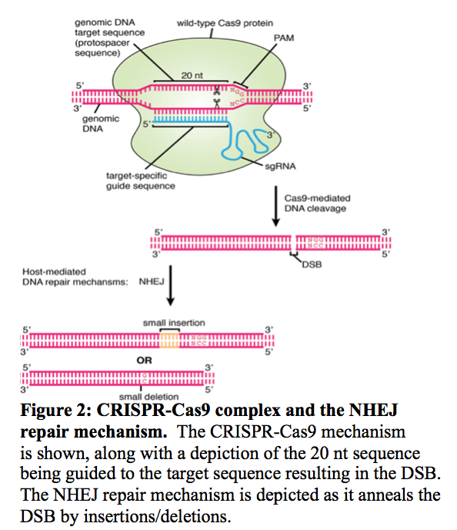
II.A. Generation of a Vinculin Knock Out Cell Line using CRISPR-Cas

In order for cardiomyocytes of differing vinculin expression to be compared, gene specific editing must be performed. This could be accomplished through a number of different genomic engineering methods that have been established including Zinc-finger nucleases (ZFNs) and transcription activator-like effector nucleases (TALENs) but the method chosen for this proposal was clustered regulatory interspaced short palindromic repeats/ CRISPR-associated (Cas) system (Gaj 2014). CRISPR has been employed to produce a surplus of gene editing functions that include gene knockout and knock in. In order to down regulate the vinculin expression of cardiomyocytes a knockout system will be performed in embryonic cells due to the postnatal nature of the cardiac cells.

First realized as an adaptive immune response in bacteria and archaea CRISPR-Cas9 has rapidly been employed in experimentation and research for the purpose of genome editing. The system is made up of several components which will allows for the creation of the desired animal model. The Cas9 protein is the moniker of this system, it contains two active domains which constitute its endonuclease activity (RuvC-like and HNH domains). The Cas9 protein is responsible for forming a complex with trans-activating crRNA (tracrRNA) and crRNA that binds to the DNA of interest on the genome (Singh 2017). The crRNA-tracrRNA is recognized as the single guide RNA (sgRNA), which is made up of a 20-25 nucleotide long region that matches the target region (“spacer”) and a 42-nucleotide long hairpin that binds to Cas9 (“scaffold”) (Dueber 2009).

Specific considerations have to be taken into account when choosing the target region including that the sequence be unique to the genome and that a protospacer adjacent motif (PAM) be immediately upstream. The PAM sequence (5’-NGG-3’) is necessary for target binding of the Cas9 complex. The PAM sequence is also the guide for where HNH and RuvC nucleases cut the target DNA; between the 3rd and 4th nucleotides from PAM (Brounus 2008). This cut results in a double-strand break (DSB) which is then repaired by non-homologous end joining (NHEJ). The NHEJ repair pathway is very active and rapid but has a propensity to insert and delete nucleotides at the DSB site. The knockout system this proposal is recommending utilized this fault.

By effectively cleaving the mouse DNA and repairing it with nucleotide insertions and deletions (InDels) a mutation to the protein will likely occur to either hinder it or remove it from the cell line. The tendency of NHEJ to cause InDels allows for in-frame amino acid deletions, insertions, and possible frameshifts. All of these will cause for mutations such as a premature stop codon, loss of a vital amino acid residue, or insertion of an amino acid that impedes essential vinculin function (Jinek 2012). It is through this system (Streptococcus pyogenes (SP) CRISPR-Cas9) and the methodology outlined in Chen et al. (2016) that vinculin expression in the cells of knockout mouse will be executed.

Utilizing the target regions considerations that were mentioned in Qin et al. and Wettstein et al. a 20-nucleotide unique sequence was chosen from the coding region of vinculin as the sequence was found in the NCBI Genes and Expressions Database and run through an online sgRNA tool (as recommended by Singh et al. (2017)) which gave back functional sequences for the spacer. Several of these functional sequences were generated thus different trials employed different spacers in order ot ensure effective gene modification to the target site.

sgRNA was synthesized utilizing a T7 promoter, the 20-nucleotide sequence guide, and a sgRNA scaffold, with reference to Chen 2016. The sgRNA was then incubated with purified Cas9 protein. Fertilized mouse zygotes were collected into which the sgRNA/Cas9 complex would be introduced. Chen et al applied an electroporation method (CRISPR-EZ) they found to be more effective in delivery of the complex into the zygotes than typical microinjection.

Once introduced with the complex embryos were then transferred into the oviduct of females where the transgenic modification could propagate and form a viable offspring. In the cell’s nucleus, the sgRNA guides the Cas9 to specified areas where it will then mediate DNA cleavage as a double break within the target DNA. The small nucleotide insertions that occur as a result of the non-homologous end joining pathway’s efficient and error-prone repair allows for gene mutations (insertions, deletions, or frameshifts) to occur and thus effect the genotypic and phenotypic outcome of the mouse (Chen 2016). Assuming that the inserted embryo was able to differentiate and mature into viable pups, genotypic and phenotypic analysis is then conducted upon labor to identify the affected mouse and ensure proper gene editing occurred (Chen 2016).

The method for insuring the lack of vinculin expression in the knockout line of mice will be the Western Blot Test. This analytical technique allows for identification for the presence and lack of specific proteins from a complex mixture. By accomplishing separation by size through gel electrophoresis and marking of target proteins by antibodies, the western blot technique can be effectively used to test for the existence of vinculin in the cardiomyocyte cells being collected (Mahmood 2012).

CRISPR-Cas 9 Vcl knockout does not appear in research but biological supply companies have provided the sgRNA specific plasmid for sale and use (SCBC). Once the gene has been implemented the functional analysis testing of the cardiac cells has to be studied, for which Lemmon et al (2005) have described a method to effectively accomplish the task (Lemmon 2005)

II.B. Functional Analysis by Traction Force Measurements

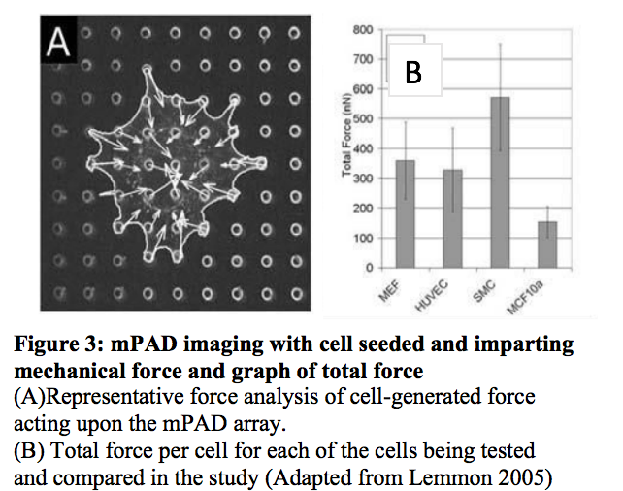
Cardiomyocytes expressing the vinculin gene and those that previously had the protein knocked out will then be collected via a biopsy and seeded to the top surface of microfabricated postarray deflection devices. The mPADs will be constructed of polydimethylsiloxane (PDMS) and the cardiomyocytes introduced as previously described (Chen 2016). The cells will then be stained utilizing vinculin specific antibodies for immunofluorescent and direct staining (Galie 2015). After being seeded on mPADs the cells are placed into a LIVECELL chamber to maintain temperature and CO₂ levels (37˚C and 10% respectively). In order to calculate the direction and magnitude of tip deflection, images were collected and processed through Matlab code as it was previously described (Lemmon 2005).

The principle by which the Matlab code was written and functional analysis was conducted was explained in Sniadecki et al. (2007). Each micropost in an mPAD array has the mechanical function of a cantilever beam (being fixed on the bottom end and flexible on the top). Applying the theory of slender beam bending the Matlab code that was utilized accounted for a relationship between force (F) and tip displacement (x) by an equation (as shown below) that considered the elastic modulus (E) of the PDMS (which lies at 2.0-2.5 MPa), the diameter (D) and the height (L) of the micropost. With this value being incorporated and compared to the spring constant of the beam, the code could then create a conversion from displacement to traction force which allowed for the analysis of the cultured cells contractile ability (Sniadecki 2007).

$$F=\frac{3π{ED}^{4}}{64L^{3}}x$$

Comparison of cell-generated force for the two cell lines will then be conducted. The representative force analysis for the vinculin wt and vinculin ko cardiomyocytes will show the total force (nN) per cell for each cell type. Figure 4 shows an example of the data that will be produced from the analysis along with immunofluorescence images of cells imparting mechanical forces on the top surface of a mPAD.

- Discussion

If all goes well, the cardiomyocytes that were genetically modified to not express the protein will clearly exhibit less total force upon the mPAD array when compared to wildtype cardiac cells collected from the same species of mouse. The lack of expression will have been confirmed from genotypic and phenotypic analysis but the results of the traction force measurement will be able to convey the difference in force generation between the two cell lines. Such a finding would lead to results much like that found in Hinson et al (2015) in which it could be indicated that vinculin mutations cause DCM by disrupting linkage structure and adaptive remodeling (Hinson 2015).

Although these results are the ideal, possible issues may arise that do not support the predicted hypothesis. It is possible that cell remodeling and compensation for loss of the vinculin would occur and a significant difference in the force generation would not be measured. It is also possible that given the structure and lack of ECM in the mPAD array upon which the cells were seeded that vinculin did not have a significant effect on actin binding and overall mechanical strength of the cell. Another possibility is that the lack of vinculin is not the reason for decreased force generation but instead it is a structural issue of the cardiac cells. It was proposed to me by my mentor that gap junctions tend to be affected by altercations to cytoskeletal changes. Thus, when studying the calcium release of rhythmic heart beats the electropotential tendency of the cells are compromised and begin to release calcium in an un organized and sporadic manner, better known as Calcium sparks. It is a strong possibility that DSM is not caused solely by the loss of protein and its stabilizing/strengthening factor but also its ability to maintain structure among the lattice of cells it constitutes.

The knowledge assessed and tested by this proposal could possibly lead to further studies of cells which generate and conduct force. Potentially certain defects can be identified by their functional analysis of generated force or resistance to it. From that information and the incorporation of iPs driven cells, a non-invasive method of assessing heart health, muscle viability, and any number of factors could be tested for in order for people to be better informed about what is going on inside of their bodies.

References

- Bakolitsa, C., Cohen, D. M., Bankston, L. A., Bobkov, A. A., Cadwell, G. W., Jennings, L., Critchley, D. R., Craig, S. W., Liddington, R. C. Structural basis for vinculin activation at sites of cell adhesion. Nature 430: 583-586, 2004.

- Brouns SJ, Jore MM, Lundgren M, et al. Small CRISPR RNAs guide antiviral defense in prokaryotes. Science. 2008;321(5891):960-4.

- Chen S, Lee B, Lee AY, Modzelewski AJ, He L. Highly Efficient Mouse Genome Editing by CRISPR Ribonucleoprotein Electroporation of Zygotes. J Biol Chem. 2016;291(28):14457-67.

- Dueber JE, Wu GC, Malmirchegini GR, et al. Synthetic protein scaffolds provide modular control over metabolic flux. Nat Biotechnol. 2009;27(8):753-9.

- Dumbauld DW, Lee TT, Singh A, et al. How vinculin regulates force transmission. Proc Natl Acad Sci USA. 2013;110(24):9788-93.

- Gaj T, Gersbach CA, Barbas CF. ZFN, TALEN, and CRISPR/Cas-based methods for genome engineering. Trends Biotechnol. 2013;31(7):397-405.

- Galie PA, Byfield FJ, Chen CS, Kresh JY, Janmey PA. Mechanically stimulated contraction of engineered cardiac constructs using a microcantilever. IEEE Trans Biomed Eng. 2015;62(2):438-42.

- Grashoff C, Hoffman BD, Brenner MD, et al. Measuring mechanical tension across vinculin reveals regulation of focal adhesion dynamics. Nature. 2010;466(7303):263-6.

- Hinson JT, Chopra A, Nafissi N, et al. HEART DISEASE. Titin mutations in iPS cells define sarcomere insufficiency as a cause of dilated cardiomyopathy. Science. 2015;349(6251):982-6.

- Jacot JG, Martin JC, Hunt DL. Mechanobiology of cardiomyocyte development. J Biomech. 2010;43(1):93-8.

- Jinek M, Chylinski K, Fonfara I, Hauer M, Doudna JA, Charpentier E. A programmable dual-RNA-guided DNA endonuclease in adaptive bacterial immunity. Science. 2012;337(6096):816-21.

- John Lynn Jefferies, Jeffrey A Towbin, Dilated cardiomyopathy, The Lancet, Volume 375, Issue 9716, 27 February–5 March 2010, Pages 752-762, ISSN 0140-6736, https://doi.org/10.1016/S0140-6736(09)62023-7.

- Lemmon, Christopher A. Et al. Cell Traction Forces Direct Fibronectin Matrix Assembly. Biophysical Journal, Volume 96 , Issue 2 , 729 – 738

- Mahmood T, Yang P-C. Western Blot: Technique, Theory, and Trouble Shooting. North American Journal of Medical Sciences. 2012;4(9):429-434. doi:10.4103/1947-2714.100998.

- Qin W, Kutny PM, Maser RS, et al. Generating Mouse Models Using CRISPR-Cas9-Mediated Genome Editing. Curr Protoc Mouse Biol. 2016;6(1):39-66.

- Singh V, Braddick D, Dhar PK. Exploring the potential of genome editing CRISPR-Cas9 technology. Gene. 2017; 599:1-18.

- Sniadecki NJ, Chen CS. Microfabricated silicone elastomeric post arrays for measuring traction forces of adherent cells. Methods Cell Biol. 2007; 83:313-28.

- Wettstein R, Bodak M, Ciaudo C. Generation of a Knockout Mouse Embryonic Stem Cell Line Using a Paired CRISPR/Cas9 Genome Engineering Tool. Methods Mol Biol. 2016; 1341:321-43.

- Xu W, Baribault H, Adamson ED. Vinculin knockout results in heart and brain defects during embryonic development. Development. 1998;125(2):327-37.

- Zemljic-harpf AE, Miller JC, Henderson SA, et al. Cardiac-myocyte-specific excision of the vinculin gene disrupts cellular junctions, causing sudden death or dilated cardiomyopathy. Mol Cell Biol. 2007;27(21):7522-37.

- Ziegler WH, Gingras AR, Critchley DR, Emsley J. Integrin connections to the cytoskeleton through talin and vinculin. Biochem Soc Trans. 2008;36(Pt 2):235-9.

