Neel Gohil

The role of phospholipase C-β1 in intracellular calcium release

Introduction:
Calcium ions (Ca2+) play an essential role in the cell. Ca2+ in is the primary signal to activate skeletal, cardiac and smooth muscle contraction, beta cell insulation secretion, and neuron excitability. Calcium is also needed for fertilization, proliferation, metabolism, and secretion (2). Calcium concentration within the cytosol in resting cells is maintained around 100nM (1). Stimulation of cells with an agonist, such as acetylcholine (ACh) increases the intracellular concentration of Ca2+ which promotes cell function. Increase in cytosolic Ca2+ regulates function directly or indirectly via binding to calcium sensors such as calmodulin in smooth muscle contraction.
This figure refers to the voltage gated calcium channel
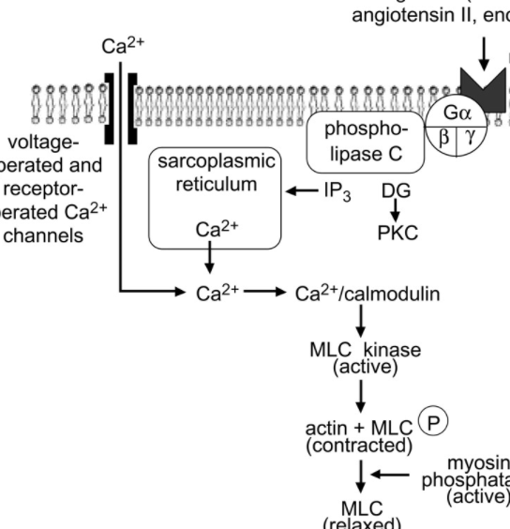
Calcium plays an important role in smooth muscle contraction. There are two systems that play a role in the increase of Ca2+ in the cytosol. The first system is a voltage gated channel. When a smooth muscle cell is depolarized (reduction in membrane potential making the cell less negative), it opens the voltage-gated (L-type) calcium channels (3). Depolarization occurs when a receptor is bound to its agonist (a chemical that binds to a receptor which results in a stimulus of a pathway). Opening of the L-type calcium channel causes influx of extracellular Ca2+, which then binds calmodulin (4). The Ca2+-calmodulin complex activates myosin light-chain kinase (MLCK), which phosphorylates the myosin in thick filaments. Phosphorylated myosin is able to form cross bridges (5) with actin thin filaments, and the smooth muscle cell contracts via the sliding filament mechanism. Phosphorylation, and thus contraction is terminated by myosin light chain phosphatase (MLCP) (6).
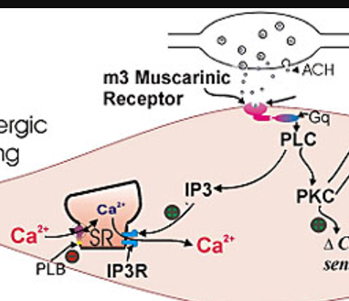
Membrane bound receptor recognizes external signal, that signal is converted into molecular information through a pathway that produces a second messenger that triggers Ca2+ release. The Ca2+ release from the sarcoplasmic reticulum to the cytoplasm is controlled by a Ca2+ pump which also inhibits the calcium release once the intracellular calcium levels have reached its maximum threshold (7). The Sarco/Endoplasmic Reticulum Calcium ATPase (SERCA) pump is a method in which the calcium ions get shifted back into the sarcoplasmic reticulum (SR). The SERCA pump exchanges two Ca2+ ions into the SR for [less than 3] H+ to the cytosol of the cell (8). This exchange caused by the hydrolysis of ATP to ADP.
Figure depicts acetylcholine induced signaling pathway that releases calcium from sarcoplasmic reticulum
Intracellular calcium release is mediated by the activation of phospholipase C (PLC). Binding of ACh to the cell surface receptor activates a PLC-β isoform. PLC-β hydrolyzes membrane lipid phosphotidyl-inositolbisphosphate (PIP2) into inositol 1,4,5-trisphosphate (IP3) and diacylglycerol (DAG) (9) . IP3 is a water soluble messenger that diffuses and binds its receptors (IP3 receptors) on the SR to release Ca2+ causing an increase in Ca2+ concentration in the cytoplasm of the cell (10). The aim of this experiment is to demonstrate the role of PLC-B1 in the release of intracellular calcium through the IP3 pathway.
Experiment Overview:
This experiment will be conducted on wildtype and PLC-β1 knockout mice. The small intestine of both mice will be removed and smooth muscle tissues will be extracted. Cells will be placed in a chamber of a slide and fluo-4 AM dye will be added on top of the cells. The dye will be washed off with a buffer solution and ACh will be added to activate the G-protein coupled receptor pathway. A microfluometer will be used to emit photons at the cells at a frequency of 485nm and fluorescence will be analyzed using inverted microscope with LCD screen. Minimum fluorescence will be measured using the Triton X-100 and BAPTA combination. Using the microfluometer, the laser will once again be set to 485nm and images will be analyzed using inverted microscope with LCD screen. In order to find the maximum fluorescence (F_{max}), calcium in the form of CaCl₂ will be added to saturate the BAPTA molecule so that calcium is once again bound to the fluo-4 dye. The importance of measuring F_{min} and F_{max} is because it sets boundaries between which the fluorescence signals can vary. The fluorescence signals cannot go over F_{max} and cannot go below F_{min}.
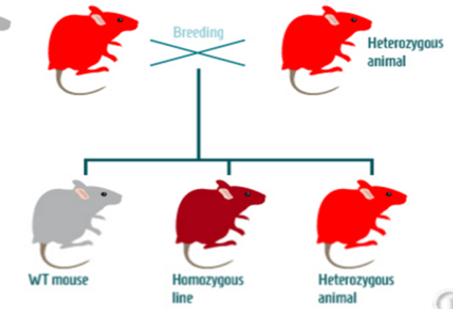
Methods:

Animals:
PLC-β1 knockout KO mice will be obtained online with the null mutation on a C57Bl6 background strain (11).Absence of PLC-β1 transcript and protein will be examined by PCR (RT-PCR) and western blot analysis as done in (13). KO mice will be obtained from http://www.findmice.org/summary?gaccid=MGI:97613.
Mice heterozygous with the PLC-β1 knock out can be breed to produce homozygous with the knock out, these mice do not produce the PLC-β1 gene.
(from http://paperv.com/story/2415/gene-targeted-mouse-model-tool-creator-creative-animodel/

Colonic myocyte isolation
The wildtype and PLC-β1 mice will be killed by cervical dislocation. The small intestine will be immediately removed and transferred to an oxygenated saline solution as described in (12). From this tissue single smooth muscle cells will be enzymatically isolated, and used the same day.

Fluo-4 dye
Cytoplasmic Ca²⁺ concentration will be measured as fluorescence using fluo-4 Acetoxymethyl ester (fluo-4AM) dye. Fluo-4AM dye will be purchased from https://www.thermofisher.com/order/catalog/product/F14201 to perform this assay. Fluo-4 dye cannot naturally permeate the cell membrane due to its four negative charges, that is why the fluo-4AM dye will be used due to no ionization. The Fluo-4 AM dye will be mixed with a buffer solution and will be placed aside for 5 minutes so that the dye to properly mix. The colonic myocytes will be added on a chamber of a slide and the fluo-AM dye mixture will be added on top of the myocytes. Once the dye is placed, the cells will be incubated for an hour (14) in the dark because the dye is light sensitive. During the incubation process, the dye will slowly permeate through the cell membrane and into the cytoplasm of the myocytes. Cells contain non-specific esterase’s that are in the cytoplasm and will cleave the acetoxymethyl ester links in the fluo-4AM dye. Thus, the dye will return to its original fluo-4 conformation. Because the dye is back to its original conformation, it will be ionized and therefore, cannot exit the cell membrane. This procedure will be done on the wildtype cell line and the gene KO cell line.
Minimum and Maximum fluorescence (F_{min} / F_{max})
The myocytes will be taken out of incubation after an hour and will be ready to be treated with ACh that binds to its receptors and activates G protein-dependent PLC-β1, generates IP3 release and increases IP3-dependent Ca2+ release. Before the addition of agonist, the cells will be washed with a buffer solution so that fluo-4 dye that has not entered the cell membrane will be washed away and not give false reports during image analysis. In this experiment, the agonist will be ACh. ACh will be added first to the chamber slide and will be placed on an equipment called a microfluorometer (17). This will be used to emit photons at the well at an excitation frequency of 485nm. This will then record the emission frequency which should be higher than the excitation which indicates a longer wavelength. The fluorescence will be imaged using inverted microscope with LCD instead of oculars. A 485nm excitation laser will be pointed at the myocytes at linescan mode. Linescans are going to be taken from the middle of the cell to avoid measurement of the cell’s circumference. Fluorescence intensity will be analyzed using ImageJ software and cells will be disposed once multiple images are taken.
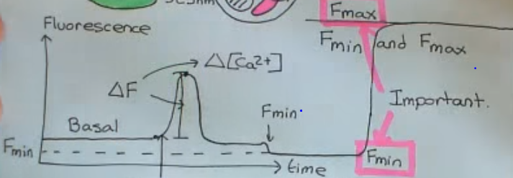
A detergent called Triton X-100 (15) will be added shortly after to mix the water and fat molecules and lyse the myocytes. This will destroy the cell structure and turn it into free solution. Once the free solution is formed, a calcium binding agent called BAPTA (16) will be introduced to the free solution and will bind to all of the calcium ions so that there is no calcium in the free solution. This will result in a decrease in the florescence signal because all of the fluo-4 molecules will no longer have calcium bounded to them. The microfluorometer will then record its frequency output. This is the F_{min} of the experiment because this will be the lowest concentration of calcium recorded. In order to find the F_{max}, a high concentration of calcium, usually in the form of calcium chloride (CaCl₂) (15), will be added to the free solution so that the BAPTA molecule will be saturated and therefore, the fluo-4 dye will once again be bound to calcium. This will increase the fluorescence signal to its peak and stay there. Once again, the microfluorometer will be used to measure its maximum fluorescence.
This figure first depicts the initial calcium concentration at its basal rate. Once the well has been exposed to ACh, fluorescence increases and drops back down to its basal state. Once Triton X-100 and BAPTA have been added, calcium concentration is dropped because of the absence of calcium being bounded to fluo-4 dye (F_{min}). Once a high concentration of CaCl₂ has been added, graph spikes up due to calcium being bound to the dye.

Discussion
The experiments using colonic myocytes from wild type and PLC-β1 KO mice will demonstrate the role of PLC-β1 in the generation of IP3 and IP3-dependent Ca2+ release from the intracellular Ca2+ stores. The contractile agonist, acetylcholine acts via muscarinic m3 receptors that are coupled to activation of G protein-coupled to PLC-β1, IP3 generation and IP3-dependent Ca2+ release. It is anticipated that there will be an increase in Ca2+ release in myocytes from wild type mice in response to ACh and that there will be no Ca2+ release in myocytes from PLC-β1 KO mice. This is because there will be no PIP2 hydrolysis, and IP3 release in PLC-β1 KO mice. Lack of Ca2+ release in myocytes from PLC-β1 KO mice could also be due to damage to the intracellular stores. This notion will be examined using permeabilized analogues of IP3 (IP3 analogues that can enter cell and release Ca2+). Exogenous addition of IP3 should bypass the need of PLC-b1 activation to release Ca2+. Similar increases in Ca2+ in response to exogenous IP3 in myocytes from wild type and PLC-β1 KO mice imply that the stores are intact in PLC-β1 KO mice. The possibility of increase in Ca2+ release due to Ca2+ influx can be tested by placing the cells in medium lacking extracellular Ca2+. An increase in intracellular Ca2+ in response to ACh in the absence of extracellular Ca2+ will be implied due to release of intracellular Ca2+ only. Another approach to test the involvement of IP3 generation and IP3 receptors in the increase in intracellular Ca2+ is by employing IP3 receptor antagonist (e.g., xestaspongin) (18). Thus, in the presence of xestaspongin, it is anticipated that the increase in Ca2+ release in myocytes from wild type mice will be reduced. As there are several isoforms of PLC-β (β1-4), an increase in intracellular Ca2+ in PLC-β1 mice, despite the absence of PLC-β1 transcripts and protein, would suggests that other isoforms (such as PLC-β2, 3 or 4) may be involved in the generation of IP3 and IP3-dependent Ca2+ release in response to ACh. If this notion is correct, IP3 receptor antagonist would block Ca2+ release in myocytes from both wild type and PLC-β1 KO mice.
This experiment will hopefully further our understanding of the role of PLC-β1 in smooth muscle contraction. Understanding the role of these enzymes will help us understand the regulation of smooth muscle contraction and how to address problems related to lack of or unregulated contraction of the smooth muscle.

Bibliography
- Clapham, David E. "Calcium Signaling: Cell." Cell. N.p., 14 Dec. 2007. Web. 7 May 2017.
- Berridge, Michael J. "The Inositol Trisphosphate/Calcium Signaling Pathway in Health and Disease." Physiological Reviews. American Physiological Society, 01 Oct. 2016. Web. 07 May 2017.
- Karnam Murthy “Smooth Muscle I and II.” VCU Medical Center. Richmond. 4 April 2017.
- Lierop‡§, Jacquelyn E. Van, David P. Wilson‡§¶, Jonathan P. Davis‖, Svetlana Tikunova‖, Cindy Sutherland‡, and Michael P. Walsh‡** And. "Jacquelyn E. Van Lierop." Journal of Biological Chemistry. N.p., 22 Feb. 2002. Web. 07 May 2017.
- Walsh MP. Calmodulin and the regulation of smooth muscle contraction. Mol Cell Biochem. 1994;135(1):21-41.
- Brozovich, Frank V. "Myosin Light Chain Phosphatase - circres.ahajournals.org." Circulation Research. American Heart Association, 2002. Web. 7 May 2017.
- Bootman, Martin, Hywel L. Rodrick, and Jane Hanson. "Cell Signalling: IP3 Receptors Channel Calcium into Cell Death." Science Direct. Current Biology, 9 Nov. 2004. Web. 7 May 2017.
- Brini, Marisa, and Ernesto Carafoli. "Calcium Pumps in Health and Disease." Physiological Reviews. American Physiological Society, 01 Oct. 2009. Web. 07 May 2017.
- Putney JW, Tomita T. Phospholipase C signaling and calcium influx. Adv Biol Regul. 2012;52(1):152-64.
- Berridge, Michael J., Martin D. Bootman, and Hywel L. Roderick. "Calcium signaling: Dynamics, homeostasis and remodeling ..." Research Gate. Laboratory of Molecular Signalling, Aug. 2003. Web. 7 May 2017.
- McOmish, C. E., E. Burrows, M. Howard, E. Scarr, D. Kim, H-S Shin, B. Dean, M. Van Den Buuse, and A. J. Hannan. "Phospholipase C-|[beta]|1 knockout mice exhibit endophenotypes modeling schizophrenia which are rescued by environmental enrichment and clozapine administration." Nature News. Nature Publishing Group, 31 July 2007. Web. 07 May 2017.
- Tokita, Yohei. "Contraction of gut smooth muscle cells assessed by fluorescence imaging." Science Direct. Japanese Pharmacological Society, Mar. 2015. Web. 07 May 2017.
- Li J, Zhao X, Wang D, et al. Up-regulated expression of phospholipase C, β1 is associated with tumor cell proliferation and poor prognosis in hepatocellular carcinoma. Onco Targets Ther. 2016;9:1697-706.
- Luo J, Zhu Y, Zhu MX, Hu H. Cell-based calcium assay for medium to high throughput screening of TRP channel functions using FlexStation 3. J Vis Exp. 2011;(54)
- Konieczny, Vera, Stephen C. Tovey, Stefania Mataragka, David L. Prole, and Colin W. Taylor. "Cyclic AMP Recruits a Discrete Intracellular Ca2 Store by Unmasking Hypersensitive IP3 Receptors." Cell Press. N.p., n.d. Web
http://www.cell.com/cms/attachment/2081925924/2072608444/mmc1.pdf
- Yano(1), Masafumi, and Roque El-Hayek(1) And. "Masafumi Yano." Journal of Biological Chemistry. N.p., 25 Aug. 1995. Web. 07 May 2017
- Macmillan D, Mccarron JG. The phospholipase C inhibitor U-73122 inhibits Ca(2+) release from the intracellular sarcoplasmic reticulum Ca(2+) store by inhibiting Ca(2+) pumps in smooth muscle. Br J Pharmacol. 2010;160(6):1295-301.
- Miyamoto S, Izumi M, Hori M, Kobayashi M, Ozaki H, Karaki H. Xestospongin C, a selective and membrane-permeable inhibitor of IP(3) receptor, attenuates the positive inotropic effect of alpha-adrenergic stimulation in guinea-pig papillary muscle. Br J Pharmacol. 2000;130(3):650-4.

