Using CRISPR/cas9 to determine the involvement of two novel NRAP variants in alpha-dystroglycan glycosylation and pathogenicity
By Ryan Duong
Introduction
Muscular Dystrophies (MD) are a group of over 30 inherited muscular diseases characterized by increased skeletal muscle weakening and degeneration over time. Though there is wide variability in onset and severity across different types, all muscular dystrophies are characterized by a compromised sarcolemma and defective basement membrane in myocytes³.
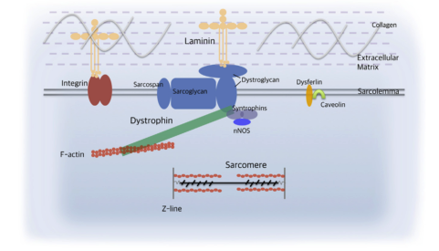
Figure 1: Alpha-dystroglycan in the dystrophin complex which is key in bridging the cytoskeleton and ECM in striated myocytes. Adapted from Li et al.³
Dystroglycanopathies are a common group of MD that represent a large spectrum of both neurologic and physical impairment. This group of MD is associated with reduction of a-dystroglycan (a-dg) glycosylation.² A-dg is a basement membrane receptor in striated muscle cells and is part of the dystrophin complex, a transmembrane protein complex responsible for anchoring the cytoskeleton to the extracellular matrix.¹⁻³ (Fig 1). A-dg functions in a diverse range of myocyte cellular processes through binding with ligands such as laminin, Agrin, and Perlecan.^{2,3} Binding of a-dystroglycan is dependent on its glycosylation status¹, so, it is not surprising that genes associated with dystroglycanopathies encode glycosylation-related proteins². To date, mutations in 18 genes have been associated with dystroglycanopathy diseases with varying phenotypes⁴⁻²⁰ (Table 1). However, it is estimated that only about 50% of dystroglycanopathy cases can be attributed to mutations in these 18 genes²¹. Remaining dystroglycanopathy-associated genes are yet to be discovered.

Disease(s) | Associated genes
Walker-Warburg Syndrome  And Muscle Eye Brain | B3GLNT2, B4GAT1, DAG1, FKRP, FKTN, GMPPB, ISPD, LARGE, POMGNT1, POMGNT2, POMT1, POMT2, TMEM5
Fukuyama Congenital Muscular Dystrophy | FKTN
Congenital Muscular Dystrophy with or without Cognitive Impairment | POMT1, FKRP, FKTN
Limb Girdle Muscular Dystrophy with or without cognitive Impairment | FKRP, POMT1, FKTN, POMT, POMGNT1, ISPD

Table 1: Dystroglycanopathy diseases with associated genes⁴⁻²⁰
Recently, a human case study presented with classic muscle eye brain (MEB) phenotype of muscular dystrophy. Immunohistochemical analysis revealed little to no glycosylated a-dg in the sarcolemma consistent with dystroglycanopathy²². Initial genetic screening for mutations in the 18 dystroglycanopathy-associated genes identified no pathogenic variants, but subsequent exome sequencing revealed two variants in NRAP protein²²(Fig 2A-B). One variant was a single nucleotide polymorphism (SNP) in the first nucleotide of intron 4-5 which created a splice site mutation completely excising exon 4 from the translated protein (Fig 2C). The other variant created the missense mutation A1270T. Parental NRAP sequencing confirmed that the father was heterozygous for the splice mutation and the mother was heterozygous for the missense mutation resulting in a doubly heterozygous splice/missense patient²²(Fig 2B).
A.
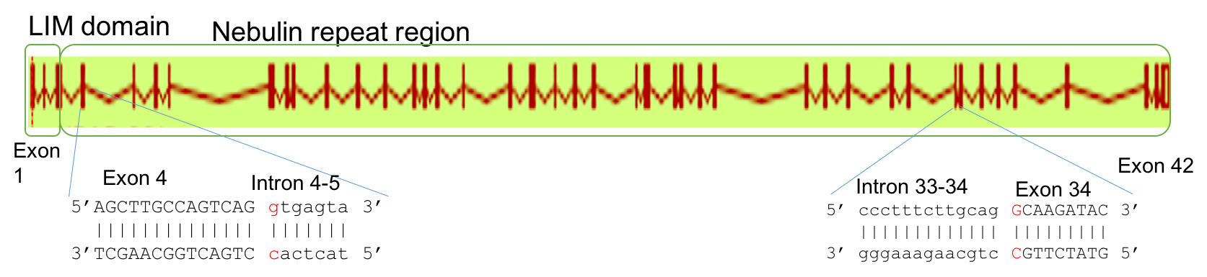
B.
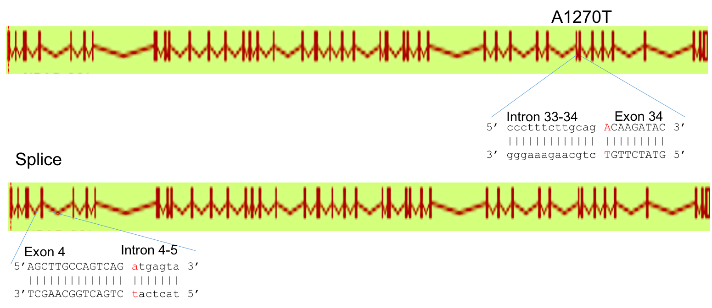
C.
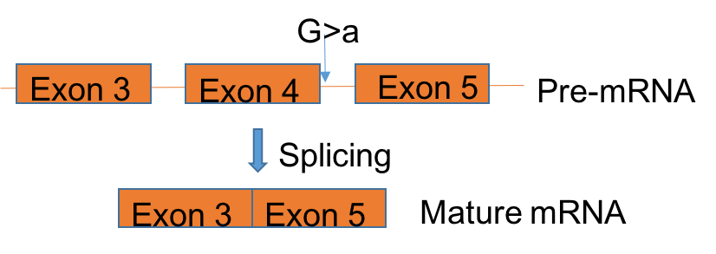

Figure 2: Gene organization of A) WT NRAP³³ and B) doubly heterozygous missense(A1270T) and splice (360+1G>A ) NRAP genotype found in the human case study²² with mutation loci shown and SNP site in red. Both variants are the cause of a G>A SNP C) G>A SNP in the splice variant results in complete excision of exon 4 when introns are spliced from the pre-MRNA creating a protein product about 100 amino acids lighter than the WT.
NRAP is a large actin binding protein expressed in muscle tissues and localized to the sarcolemma²⁴. Functionally, NRAP has been suggested to anchor terminal actin filaments in myofibrils to the membrane.²⁵ It has also been shown that NRAP acts as an organizing center through sequential recruitment of binding partners a-actinin, filamin, and krp1 during the early steps of myofibril assembly²³. Given NRAP’s high binding affinity for actin⁴⁰, it has been hypothesized to interact with the dystrophin complex through actin.³⁹⁻⁴⁰ However, no link between NRAP and pathogenicity has previously been established, and further research on NRAP’s function is needed. It would be interesting to examine the causative effects between the novel doubly heterozygous NRAP genotype and dystroglycanopathy.
Model organisms are a useful resource to study causative genetic agents of disease. However, most animal models to date are complete knock-out models whereby a gene is rendered non-functional. While these knock-out models give some functional information about a gene, knock-in models mimic specific point mutations, provide a more analogous picture of human pathogenicity, and can establish a causation between a mutation and disease.
Figure 3: Mechanism of CRISPR/cas9 mediated double-stranded break and repair. The cellular mechanism can create indel mutations resulting in a knock-out loss-of-function mutant via NHEJ pathway or homologously swap donor DNA which contains the target mutation via HDR.
Technology in the Clustered Regulatory Interspaced Short Palindromic Repeats(CRISPR)/cas9 system offers a potential medium for the creation of knock-in mutations in an array of species from yeast to human³². The CRISPR/cas9 system is a heterologous target-specific endonuclease gene editing tool derived from bacterial adaptive immunity²⁸(Fig 3). The system comprises of a guide RNA sequence (gRNA) and cas9 protein. The gRNA binds to a specific target locus of a genome just upstream of the protospacer-adjacent motif (PAM) sequence, “NGG”. This sequence is recognized by the cas9 protein which creates a double stranded break (DSB) upstream of the PAM. To repair this DSB, the cellular DNA repair mechanism can utilize the non-homologous end joining (NHEJ) pathway whereby insertions or deletion mutations (indels) are created to ligate DNA together resulting in frameshifts and a loss-of-function knock-out. Alternatively, in the presence of exogenous donor DNA with homologous stretches on both sides of the DSB, the cell can use the homologous directed repair (HDR) strategy and fix the DSB via recombination with the homologous donor DNA. This HDR pathway is currently the pathway of choice for creating specific knock-in mutations because the exogenous DNA can be engineered to carry any mutation within its homologous sequence^{27,29,30}.
Establishing mutant animal models of the NRAP variants via CRISPR/cas9 HDR and comparing the phenotypes will determine which, if any, variants are involved in the pathogenicity of MEB dystroglycanopathy as suggested in the human case study²².
The Experiment
Overview
A
B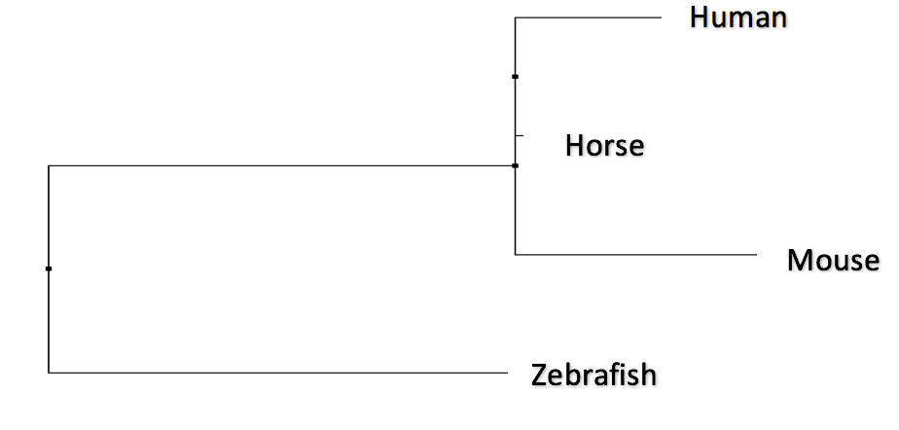
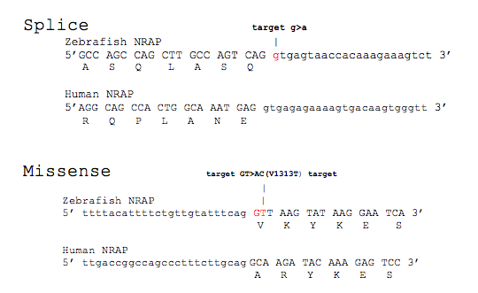
Figure 4: The NRAP protein is well conserved making zebrafish and appropriate model for studying its pathogenicity. A) Multiple sequence alignment of NRAP protein across multiple species³³ B) Sequence alignment of zebrafish³³ and human NRAP gene³³ identifying corresponding target mutations in a zebrafish model
This study aims to use CRISPR/cas9 to induce specific mutations in the zebrafish NRAP protein that model the two novel variants of NRAP recently found in human.²² The following three zebrafish NRAP lines will be created: WT/splice variant, WT/missense variant, and splice variant /missense variant. Each line will be immunohistochemically stained using an antibody that recognizes glycosylated a-dg. Based on the presence of glycosylated a-dg in the sarcolemma, we can determine which if any combination of NRAP variants is responsible for the development of dystroglycanopathy.
Using zebrafish as model organisms and discovering corresponding target mutations
Since the 2000’s, zebrafish have been a particularly useful model for the study of MD’s. At a cellular level, myofibril structure, contractile properties, and metabolic functions are similar between zebrafish and human skeletal muscle, and many genes currently associated with MD in humans are well conserved in zebrafish³. A multiple sequence alignment of zebrafish NRAP protein shows its conservation across species and confirms the appropriate use of zebrafish as a model organism³³ (Fig 4A). Sequence alignment of zebrafish and human NRAP genes reveal the corresponding target mutations in zebrafish NRAP needed to create the animal model³³ (Fig 4B).
Designing CRISPR/cas9 HDR components
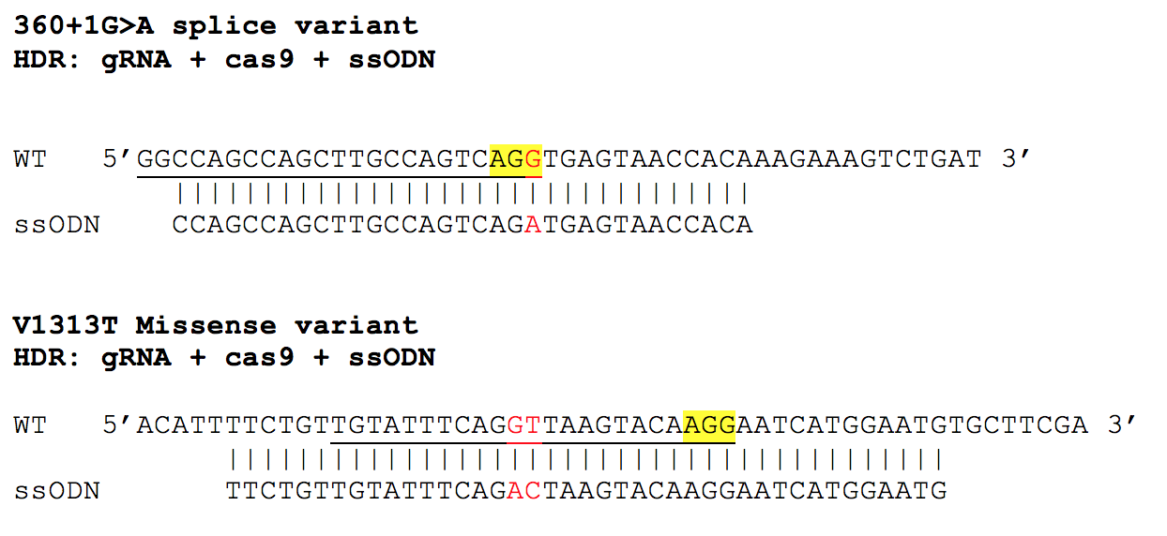
Figure 5: CRISPR/cas9 components for target HDR knock-in mutations. gRNA sequence is underlined suggesting it binds the WT strand complementary to the one shown. PAM sequence highlighted in yellow. Target mutation sites are highlighted in red. The ssODN will incorporate into the WT DNA through homologous recombination after a DSB is made upstream of the PAM.
CRISPR/cas9 remains most efficient method for creation of specific knock-in mutations^{27,31}. Within the HDR pathway, there are multiple cases of successful knock-in generation using different forms of donor DNA including short single stranded linear DNA (6-50bp), short double stranded circular DNA, and long double stranded linear DNA (up to 4kbp)³². Armstrong et al represents the most recent and effective CRISPR/cas9 mediated knock-in generation in zebrafish using single stranded oligodeoxynucleotides (ssODN) of lengths 23, 32, and 100 base pairs with 2.17%, 2.12%, and 3.90% efficiency respectively²⁹. Variables such as number of SNP target mutations and their orientation near the PAM sequence might call for differing ssODN lengths and sequences for maximum integration, but studies examining ssODN length effects and efficiency are deficient³². It is obvious the implementation of CRISPR/cas9 mediated knock-in mutation needs further refinement, but it can reasonably be hypothesized that ssODN’s centered at the DSB and with target mutation as close to the center as possible would create the highest efficiency in zebrafish given what we know about HDR recombination^{29,32}.
CRISPR/cas9 HDR requires the injection of three parts into F0 fish at the one cell stage: gRNA, cas9 mRNA, and ssODN²⁶ (Fig 5). gRNA sequences for both target mutations were obtained using an online bioinformatics database which finds a PAM sequence close to the target mutation and corresponding gRNA sequence with minimal similarity to other regions in the zebrafish genome to prevent potential off-target effects³⁴⁻³⁵. The ssODNs were designed to be centered a few base pairs upstream of the PAM and contain homology arm lengths correlating with the distance between target mutation and predicted DSB.
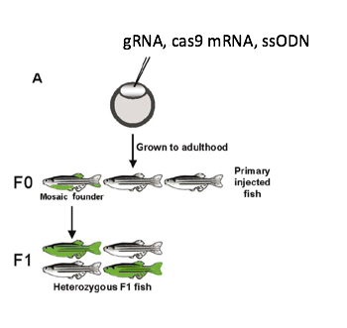

Figure 6: Injection and breeding strategy for the creation of heterozygous F1 zebrafish models for both NRAP variants. CRISPR/cas9 components are injected into the one-cell stage creating a mosaic founders which will be crossed with other mosaic founders with hopes that at least one contains the target mutation in the germ cells and transmits the mutation to the F1 generation. Figure adapted from Berghams et al.³⁸
Creation of model F1 zebrafish
CRISPR/cas9 does not work fast enough in a rapidly dividing single-celled embryo creating, at best, a mosaic F0 genotype in which some genes are mutated and some aren’t³⁰. Because of this, our overall strategy involves injecting many F0 fish, maturing them, and crossing mosaic-type F0’s with hopes that the correct mutation exists in the germ cells of at least one fish and will be passed to the F1 generation (Fig 6). After the creation of heterozygous F1 fish for both NRAP variants, those two lines will be crossed to produce the doubly heterozygous NRAP genotype. However, the frequencies of both NHEJ and HDR mediated mutations are low with NHEJ mediated knock-outs more common than HDR (about 20% versus 2%) even in presence of a ssODN²⁹. Thus, an early F0 screening process prior to maturing F0 generation fish can save time and money.
Using the proposed screening system (Fig 7), F0 fish will first be injected at the one-cell stage with only CRISPR/cas9 NHEJ components (no ssODN) and screened for successful gRNA target specificity using a T7 endonuclease assay^{36,27}. The T7 assay will prove if the proposed gRNA works at the intended mutation locus. A DNA sample of F0 embryos will be extracted and subjected to PCR with primers designed to amplify the target mutation locus. These PCR amplicons will be denatured and reannealed whereby some mutated amplicons will reanneal with WT amplicons creating a hetero-duplex, a WT strand base paring with a mutant strand. The amplicons will then be subjected to T7 endonuclease which is an enzyme that recognizes and cleaves only hetero-duplex DNA³⁶. The presence of this cleavage, which can be elucidated on a gel, will indicate successful gRNA-directed cleavage.
After successful gRNA specificity is established for both mutations, the effectiveness of HDR-mediated knock in mutations with our designed ssODN’s will be tested by injecting a new F0 generation with gRNA, cas9 mRNA, and ssODN and then screening via restriction digest²⁹. DNA amplicons of the target mutation locus from these F0 embryos will be subjected to a specific restriction enzyme. Restriction enzymes cleave double stranded DNA at enzyme-specific recognition sequences. The restriction enzymes chosen for this screen will contain a recognition sequence that incorporates the target mutation such that a restriction enzyme will cut only amplicons in which the targeted mutation was successfully integrated. Therefore, if any DNA cleavage is seen on a gel, we can establish that our ssODN was successfully integrated into at least one cell of a F0 mosaic fish. (Fig 8). It is important to note that in designing primers, the WT amplicon sequence was examined to ensure it did not already contain the restriction recognition sequence prior to target mutation integration.
Figure 7: F0 Screening process to ensure gRNA specificity (via T7) first then ssODN integration (via restriction) second. 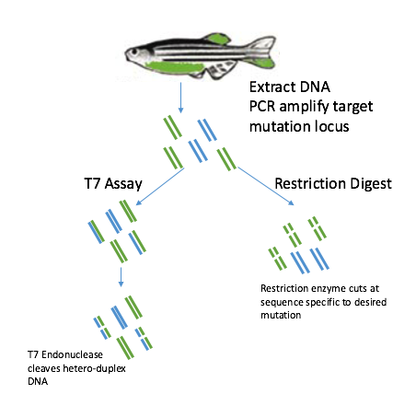
Using this screening process, we can at least determine if our gRNA and ssODN work in general. If they do, we can justify maturing a given F0 generation and crossing the mosaic fish. If we cannot identify T7-mediated cleavage, we might design a different gRNA sequences to minimize off-target effects and maximize target specificity. If we cannot identify restriction enzyme-mediated cleavage, we might design different ssODN sequences or attempt a different HDR mechanism using plasmid donor DNA³⁰⁻³².
Staining of glycosylated a-dg for each NRAP variant line
The 3 zebrafish NRAP models will be immunohistochemically stained for glycosylated a-dg using the antibody IIH6²³. Staining will follow the same protocol as the Lin et al paper which previously demonstrated the fukutin gene’s involvement in dystroglycanopathy using a zebrafish model³⁷. The fukutin knock-out muscle immunostain will serve as a disease control in comparing the presence of glycosylated a-dg in our three zebrafish NRAP models.
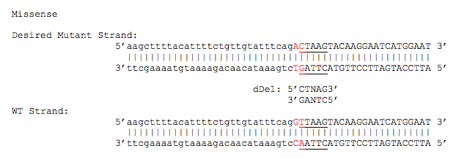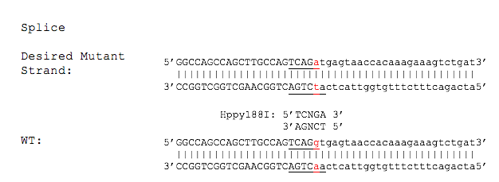
Figure 8: Specific restriction enzymes dDe1 and Hppy188I will only cut PCR amplicons from mutant cells carrying the specific targeted mutations representing the missense and splice variant respectively. No cuts will be seen in WT amplicons because the recognition sequence depends on the target mutations
Discussion
The results of this investigation will give insight into the involvement of NRAP variants in pathogenicity. If immunostaining of the zebrafish doubly heterozygous line shows decreased glycosylated a-dg in the sarcolemma similar to the fukitin mutant³⁷, a pathogenic link exists between the human NRAP genotype and MEB phenotype of dystroglycanopathy²³. If only one of the two zebrafish WT/variant models shows the dystroglycanopathy phenotype, only that specific variant is the cause for the patient’s disease. Because both mutations affect the LIM domain which has high affinity for actin³⁹, a pathogenic link between any combination of NRAP variants might suggest NRAP involvement with the dystrophin complex by mediating actin-binding. Alternatively, if staining all three models show no deficient a-dg glycosylation, then the novel NRAP variants are not the involved in human disease and there must exist some other undiscovered causative agent in the patient.
Some potential concerns with this investigation are CRISPR/cas9 issues with low efficiency and mosaic models previously addressed via careful design of CRISPR/cas9 components and implementation of a F0 screening system. However, another concern is whether a g>a SNP in intron 4-5 will result in a complete excision of exon 4 in the zebrafish NRAP protein. To date, there are no tools for comparing the splice patterns and sites of zebrafish NRAP gene with the human NRAP gene. NRAP protein analysis from the splice/WT model will be needed to determine if exon 4 was effectively removed from the zebrafish protein product using our current approach. If this is not the case, other HDR mechanisms might be utilized using exogenous donor DNA with extremely long homology arms of up to 2kbp on each side that simply skips over exon 4 in its sequence though the predicted efficiency of this approach is lower.²⁶
If established, a pathogenic link between a mutated NRAP genotype and dystroglycanopathy can open the door for future research characterizing NRAP’s biochemical interaction with the dystrophin complex. Our creation of zebrafish NRAP lines in this investigation can provide a convenient model for future experiments. Furthermore, successful creation of a knock-in model using CRISPR/cas9 HDR will add further insight into optimization of this developing genetic technology.
References
- Kanagawa M, Michele DE, Satz JS, Barresi R, Kusano H, et al. (2005) Disruption of perlecan binding and matrix assembly by post-translational or genetic disruption of dystroglycan function. FEBS Lett 579:4792-4796.
- Brown SC, Winder SJ (2012) Dystroglycan and dystroglycanopathies: report of the 187th ENMC Workshop 11-13 November 2011, Naarden, The Netherlands. Neuromuscul Disord 22: 659-668.
- Li, M., Hromowyk, K. J., Amacher, S. L., & Currie, P. D. (2017). Muscular dystrophy modeling in zebrafish. Methods in Cell Biology, 138, 347–380.
- Juan-Mateu J, Gonzalez-Quereda L, Rodriguez MJ, Verdura E, Lazaro K, et al. (2013) Interplay between DMD point mutations and splicing signals in Dystrophinopathy phenotypes. PLoS One 8:e59916.
- Beltran-Valero de Bernabe D, Currier S, Steinbrecher A, Celli J, van Beusekom E, et al. (2002)Mutations in the O-mannosyltransferase gene POMT1 give rise to the severe neuronal migration disorder alker-Warburg syndrome. Am J Hum Genet 71: 1033-1043.
- van Reeuwijk J, Janssen M, van den Elzen C, Beltran-Valero de Bernabe D, Sabatelli P, et al. (2005) POMT2 mutations cause alpha-dystroglycan hypoglycosylation and Walker- Warburg syndrome. J MedGenet 42: 907-912.
- Yoshida A, Kobayashi K, Manya H, Taniguchi K, Kano H, et al. (2001) Muscular dystrophy and neuronal migration disorder caused by mutations in a glycosyltransferase, POMGnT1. Dev Cell 1: 717-724.
- Kobayashi K, Nakahori Y, Miyake M, Matsumura K, Kondo-Iida E, et al. (1998) An ancient retrotransposal insertion causes Fukuyama-type congenital muscular dystrophy. Nature 394: 388-392.
- Brockington M, Blake DJ, Prandini P, Brown SC, Torelli S, et al. (2001) Mutations in the fukutin related protein gene (FKRP) cause a form of congenital muscular dystrophy with secondary laminin alpha2 deficiency and abnormal glycosylation of alpha-dystroglycan. Am J Hum Genet 69: 1198-1209.
- Longman C, Brockington M, Torelli S, Jimenez-Mallebrera C, Kennedy C, et al. (2003) Mutations in the human LARGE gene cause MDC1D, a novel form of congenital muscular dystrophy with severe mental retardation and abnormal glycosylation of alpha- dystroglycan. Hum Mol Genet 12: 2853-2861.
- Garcia-Silva MT, Matthijs G, Schollen E, Cabrera JC, Sanchez del Pozo J, et al. (2004) Congenital disorder of glycosylation (CDG) type Ie. A new patient. J Inherit Metab Dis 27: 591-600.
- Yang AC, Ng BG, Moore SA, Rush J, Waechter CJ, et al. (2013) Congenital disorder of glycosylation due to DPM1 mutations presenting with dystroglycanopathy-type congenital muscular dystrophy. Mol Genet Metab 110: 345-351.
- Barone R, Aiello C, Race V, Morava E, Foulquier F, et al. (2012) DPM2-CDG: a muscular dystrophy-dystroglycanopathy syndrome with severe epilepsy. Ann Neurol 72: 550-558.
- Lefeber DJ, Schonberger J, Morava E, Guillard M, Huyben KM, et al. (2009) Deficiency of Dol-P Man synthase subunit DPM3 bridges the congenital disorders of glycosylation with the dystroglycanopathies. Am J Hum Genet 85: 76-86.

- Lefeber DJ, de Brouwer AP, Morava E, Riemersma M, Schuurs-Hoeijmakers JH, et al. (2011) Autosomal recessive dilated cardiomyopathy due to DOLK mutations results from abnormal dystroglycan O-mannosylation. PLoS Genet 7: e1002427.
- Willer T, Lee H, Lommel M, Yoshida-Moriguchi T, de Bernabe DB, et al. (2012) ISPD loss-of function mutations disrupt dystroglycan O-mannosylation and cause Walker- Warburg syndrome. NatGenet 44: 575-580.
- Cirak S, Foley AR, Herrmann R, Willer T, Yau S, et al. (2013) ISPD gene mutations are a commoncause of congenital and limb-girdle muscular dystrophies. Brain 136: 269-281.
- Roscioli T, Kamsteeg EJ, Buysse K, Maystadt I, van Reeuwijk J, et al. (2012) Mutations in ISPD cause Walker-Warburg syndrome and defective glycosylation of alpha- dystroglycan. Nat Genet 44: 581- 585.
- Manzini MC, Tambunan DE, Hill RS, Yu TW, Maynard TM, et al. (2012) Exome sequencing and functional validation in zebrafish identify GTDC2 mutations as a cause of Walker-Warburg syndrome. Am J Hum Genet 91: 541-547.
- Vuillaumier-Barrot S, Bouchet-Seraphin C, Chelbi M, Devisme L, Quentin S, et al. (2012) Identification of mutations in TMEM5 and ISPD as a cause of severe cobblestone lissencephaly. Am J Hum Genet 91: 1135-1143.
- Stevens E, Torelli S, Feng L, Phadke R, Walter MC, et al. (2013) Flow cytometry for the analysis of alpha-dystroglycan glycosylation in fibroblasts from patients with dystroglycanopathies. PLoS One 8: e68958
- Lu, Q., Sparks, S., Dollar, J., Keramaris-virantsis, E., Lu, J., Lavigne, J., … Harper, A. (n.d.). NRAP - Potential New Dystroglycanopathy Gene TITLE PAGE Muscle Eye Brain Phenotype Associated with Compound Heterozygous Variants in the NRAP ( Nebulin Anchor Related Protein ) Gene and Reduced NRAP Protein Expression in Muscle : A Potential New Dystrogly, 1–34.
- Lu, Q., Sparks, S., Dollar, J., Keramaris-virantsis, E., Lu, J., Lavigne, J., … Harper, A. (n.d.). NRAP - Potential New Dystroglycanopathy Gene TITLE PAGE Muscle Eye Brain Phenotype Associated with Compound Heterozygous Variants in the NRAP ( Nebulin Anchor Related Protein ) Gene and Reduced NRAP Protein Expression in Muscle : A Potential New Dystrogly, 1–34.
- Mohiddin, S. A., Lu, S., Cardoso, J. P., Carroll, S., Jha, S., Horowits, R., & Fananapazir, L. (2003). Genomic organization, alternative splicing, and expression of human and mouse N-RAP, a nebulin-related LIM protein of striated muscle. Cell Motility and the Cytoskeleton, 55(3), 200–212.
- Luo G, Leroy E, Kozak CA, Polymeropoulos HM, Horowits R (1997) Mapping of the gene (NRAP) encoding N-RAP in the mouse and human genomes. Genomics 45: 229-232.
- Kawahara, A., Hisano, Y., Ota, S., & Taimatsu, K. (2016). Site-specific integration of exogenous genes using genome editing technologies in zebrafish. International Journal of Molecular Sciences, 17(5), 9–11.
- Ata, H., Clark, K. J., & Ekker, S. C. (2016). The zebrafish genome editing toolkit. Methods in Cell Biology, 135, 149–170.
- Gasiunas, G., Barrangou, R., Horvath, P., & Siksnys, V. (2012). Cas9-crRNA ribonucleoprotein complex mediates specific DNA cleavage for adaptive immunity in bacteria. Proceedings of the National Academy of Sciences of the United States of America, 109(39), E2579-86.
- Armstrong, G. A. B., Liao, M., You, Z., Lissouba, A., Chen, B. E., & Drapeau, P. (2016). Homology directed knockin of point mutations in the zebrafish tardbp and fus genes in ALS using the CRISPR/Cas9 system. PLoS ONE, 11(3), 1–10. https://doi.org/10.1371/journal.pone.0150188
- Hoshijima, K., Jurynec, M. J., & Grunwald, D. J. (2016). Precise Editing of the Zebrafish Genome Made Simple and Efficient. Developmental Cell, 36(6), 654–667.
- Varshney, G. K., Sood, R., & Burgess, S. M. (2015). Understanding and Editing the Zebrafish Genome. Advances in Genetics, 92, 1–52.
- Salsman, J., & Dellaire, G. (2016). Precision Genome Editing in the CRISPR Era. Biochemistry and Cell Biology, 201(September 2016), bcb-2016-0137.
- Yates, A., Akanni, W., Amode, M. R., Barrell, D., Billis, K., Carvalho-Silva, D., … Flicek, P. (2016). Ensembl 2016. Nucleic Acids Research, 44(D1), D710–D716.
- Kornel Labun; Tessa G. Montague; James A. Gagnon; Summer B. Thyme; Eivind Valen. (2016). CHOPCHOP v2: a web tool for the next generation of CRISPR genome engineering. Nucleic Acids Research;
- Tessa G. Montague; Jose M. Cruz; James A. Gagnon; George M. Church; Eivind Valen. (2014). CHOPCHOP: a CRISPR/Cas9 and TALEN web tool for genome editing. Nucleic Acids Res. 42. W401-W407
- Vouillot, L., Thelie, A., & Pollet, N. (2015). Comparison of T7E1 and surveyor mismatch cleavage assays to detect mutations triggered by engineered nucleases. G3 (Bethesda), 5(3), 407–415.
- Lin, Y. Y., White, R. J., Torelli, S., Cirak, S., Muntoni, F., & Stemple, D. L. (2011). Zebrafish fukutin family proteins link the unfolded protein response with dystroglycanopathies. Human Molecular Genetics, 20(9), 1763–1775.
- Berghmans, S., Jette, C., Langenau, D., Hsu, K., Stewart, R., Look, T., & Kanki, J. P. (2005). Making waves in cancer research: New models in the zebrafish. BioTechniques, 39(2), 227–237.
- Luo, G., Herrera, A. H., & Horowits, R. (1999). Molecular Interactions of N-RAP, a Nebulin-Related Protein of Striated Muscle Myotendon Junctions and Intercalated Disks. Biochemistry, 38(19), 6135–6143.
- Moore, C. J., & Winder, S. J. (2017). The inside and out of dystroglycan post-translational modification. Neuromuscular Disorders, 22(11), 959–965.

