Measurement of the p38 signaling pathway in the Pro253Arg mutation of FGFR2 in regulation of bone development in Apert Syndrome
Kaivalya Dandamudi

I. Introduction

Birth defects are a severe problem that affect 1 in every 33 newborns in the U.S. and account for 20% of all infant deaths, making it the leading cause of infant mortality in the United States. They can vary from being mild to severe structural changes that occur in any part of the body and affect how the body looks, functions, or both. Depending on the severity of the birth defect, it can not only lead to infant mortality, but it can also lead to disability and a significant reduction of a child’s lifespan (Center for Disease Control and Prevention, 2016).
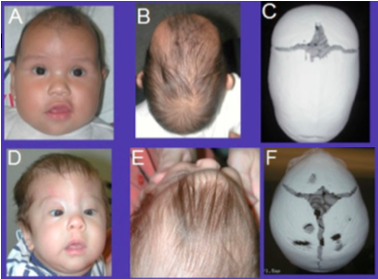
Craniofacial defects account for almost one-third of all birth defects. Of these, Craniosynostosis (CS) is one of the most common craniofacial anomalies that occurs in approximately 1 in 2,500 live births. CS is characterized by the premature fusion of one or more cranial sutures in the skull, which can result in abnormal head shapes due to restricted skull growth. It can be classified as primary CS, resulting from intrinsic genetic causes, or secondary CS, resulting from disorders affecting the developing sutures (Figure 1). Primary CS can further be classified as nonsyndromic or syndromic. Nonsyndromic CS has no additional abnormalities or developmental delay and occurs in approximately 75% of patients with CS. On the contrary, syndromic CS is associated with other abnormalities and/or developmental delay and occurs in the remaining 25-30% of patients (Lattanzi, Barba, Di Pietro, & Boyadjiev, 2017).
Figure 1 Craniofacial features of individuals with metopic and sagittal (A,B,C) and metopic (D,E,F) craniosynostosis.
(Lattanzi, Barba, Di Pietro, & Boyadjiev, 2017)
Bones are formed through two processes known as intramembranous ossification, which generates bone tissue, or endochondral ossification, which generates cartilage tissue. Abnormalities in these processes are what lead to diseases such as CS. Apert syndrome (AS), one of the most severe forms of syndromic CS, accounts for around 4.5% of all CS cases (Yin, et al., 2008). Its symptoms can include abnormalities of the brain, skin, and visceral organs, depressed nasal bridge, oral deformities, syndactyly of the digits, mental retardation, and respiratory complications (Chen, Li, Li, Engel, & Deng, 2003). The majority of AS is caused by mutations in adjacent amino acids- a Ser252Trp mutation or Pro253Arg mutation in the fibroblast growth factor receptor 2 (FGFR2) gene. (Chen, et al., 2014). A typical FGFR consists of an extracellular ligand-binding domain, a transmembrane region, and a divided intracellular domain. When a fibroblast growth factor ligand (FGF) binds and activates FGFRs, dimerization and autophosphorylation occurs- target proteins are brought to the intracellular domain and phosphorylated, leading to the activation of the several signaling pathways (Su, Jin, & Chen, 2014). The two mutations mentioned above both increase the affinity and alter the specificity of FGF ligand binding (Chen, et al., 2014).
FGFs and their receptors are known to play an important role in endochondral bone formation. FGFR2, specifically, is responsible for activating the mitogen-activation protein kinase (MAPK) pathway, which includes the Erk1/2 and p38 signaling pathways. Since endochondral bone formation is dependent on the MAPK pathway, mutations in FGFs and FGFRs cause abnormalities in bone formation, resulting in disorders such as AS (Chen, et al., 2014). Although recent studies suggest that the MAPK signaling pathway plays a role in bone development, the specific signaling mechanisms that cause the effects of the Ser252Trp and Pro253Arg mutation in FGFR2 remain unclear.
Chen, et al. (2014) investigated the role of the Erk1/2 and p38 signaling pathways in bone development using bone mesenchymal stem cells (BMSCs) of a mouse model with the FGFR2 Ser252Trp mutation mimicking AS. It was thought that these pathways play a role in the resulting phenotypes caused by the mutation. Their experiments found that both the Erk1/2 pathway and p38 pathway were activated. In addition, they were also able to conclude that the Erk1/2 pathway promotes the late stage of chondrogenic, or cartilage, differentiation of BMSCs and that the p38 pathways influences the entire endochondral ossification process, making the latter signaling pathway more important in pathogenesis of AS.
Similarly, Yin, et al. (2008) investigated the involvement of the Erk1/2 signaling pathway in the pathogenesis of bone abnormalities in a mouse model mimicking AS, except with the Pro253Arg FGFR2 mutation. Using the in vivo mouse model, they found that inhibiting the Erk1/2 pathway prevented the premature closure of coronal sutures and partially recovered the retarded endochondral ossification in the mice. These findings suggest that the Erk1/2 pathway is involved in the abnormal bone development induced by the Pro253Arg FGFR2 mutation.
As described above, the involvement of the Erk1/2 signaling pathways has been investigated in the Ser252Trp and Pro253Arg mutation of FGFR2. The role of the p38 signaling pathway has also been explored, but only in the FGFR2 Ser252Trp mutation. The purpose of the experiment described in this proposal is to determine if the p38 signaling pathway is involved in the regulation of bone development in the Pro253Arg mutation of FGFR2.

II. Experiment

The aim of this experiment is to determine if the p38 signaling pathway is involved in the pathogenesis of AS, specifically in the regulation of bone development with the Pro253Arg mutation of FGFR2. In order to do this, BMSC’s from mouse models with the Pro253Arg will be extracted and used in a western blot analysis to measure the levels of activation and concentration of p38. This experiment is modeled after a western blot technique used by Chen, et al. (2014).
Figure 2 Western Blot Results
WT= wild type mice
MT = mutant mice
(Chen, et al., 2014)
A. Model Experiment
Chen., et al. (2014) used cultured BMSC’s from mice with the Ser252Trp mutation. The protein concentrations of all the proteins in the culture were determined in order to load the same amount for the gel electrophoresis in the next step. These proteins were separated by size through gel electrophoresis and then transferred onto a membrane. The target proteins were detected using antibodies specific for p38 and phospho-p38. The results showed increased protein levels of phospho-p38 compared to p38 in mutant cells, signifying that the p38 signaling pathway was indeed activated due to the Ser252Trp mutation (Figure 2).

B. Cells obtained from mouse models
Mice are commonly used in preclinical studies because their genome is highly similar to the human genome, which provide a means to study disease mechanisms in complex organisms (Vandamme, 2014). Their small size also makes them a cost efficient model because they allow for large scale and high quantity studies. Using a mouse model, for this experiment in particular, allows us to reproduce organisms with the desired traits (FGFR2 Pro253Arg mutation) and provides a method to understanding the pathways underlying AS.
In order to conduct this experiment, mouse models with with the Pro253Arg mutation will be used, specifically six to eight week old mice. In order to generate mice with this mutation, males with the Pro253Arg mutation will be crossed with females of EIIa-Cre mice, mice without the mutation, to generate offspring with the Pro253Arg mutation. This procedure is modeled after the procedure used in Chen., et al. (2014). Bone marrow from the tibiae and femora of the mice will be flushed out and cultured for 14 days to use in the western blot analysis. The control for the western blot analysis will be cultured BMSCs taken from wild type mice without the mutation in the same method stated above.

C. Western Blot Analysis
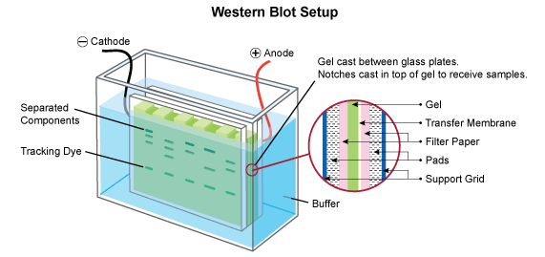
Western blots are used to separate and specifically identify protein from a mixture of various proteins that are also extracted from particular cells. After culturing, the BMSCs will be extracted and the protein concentrations in the lysate will be determined using a nanodrop. Knowing the protein concentrations will ensure that equal amounts of each protein are loaded in each well of the gel for gel electrophoresis. Before loading, each protein sample is mixed with a loading buffer, which allow them to sink into the wells easily, and a tracking dye, which will help visualize how far the separation has progressed (Figure 3). The samples are then heated to denature the proteins so that they carry a net negative charge. This allows them to move in an electric field that is present during gel electrophoresis. In this process, the molecules migrate in to the gel by an electric field that separates them based on size- smaller molecules will travel further down the gel and larger molecules will travel less far.
Figure 3 Western Blot Setup (Leinco Technologies, 2017)
The size separated proteins on the gel will then be transferred onto a polyvinylidene fluoride (PDVF) membrane, a process known as electrophoretic transfer because the negatively charged proteins are transferred onto a positively charged membrane again by an electric current (Figure 3). The membrane will be blocked with bovine serum albumin (BSA) to prevent any nonspecific binding of antibodies to the surface. The target proteins, p38 and phospho-p38, are then hybridized with their appropriate primary antibodies, rabbit antibody #9212 and rabbit antibody #9211 respectively, which are both from Cell Signaling Technologies. The secondary antibody, an anti-rabbit IgG HRP-linked antibody, is then added onto the membrane to bind to the primary antibody (Figure 4).
This method is called an indirect detection method and is used for the western blot instead of a direct method because there are more advantages to it. The primary advantage is that using a secondary antibody does not inhibit target binding of the primary antibody and allows for the option of multiple detection methods. There is also a large selection of secondary antibodies and there is signal amplification by the secondary antibody. (ThermoFisher, 2016).
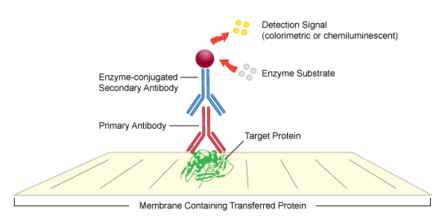
Figure 4 Indirect detection method in Western Blots
(Leinco Technologies, 2017)

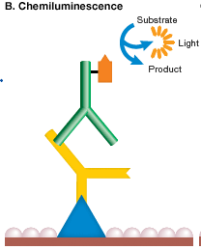
Following the addition of antibodies, the membrane will be washed to remove any unbound antibodies. The target protein will then be detected using a chemiluminescence detection method. The secondary antibody is detected with horseradish peroxidase (HRP) by the signal it produces. HRP will bind to the secondary antibody and produce binding signals that emit light (Bio-Rad Laboratories, 2017). The signals produced correspond to the position of p38 and phospho-p38 and can be captured on a film. The film is then developed in a dark room to visualize the protein concentrations. The results of this experiment will show the relative protein levels of p38 and phospho-p38. A densitometer can be used to measure the density of the two proteins in order to determine the final ratio between phosphor-p38 and p38.
Figure 5 Chemiluminescence Detection Method
(Bio-Rad Laboratories, 2017)

III. Discussion
One possible outcome of this experiment is that the western blot will show increased protein levels of phospho-p38 compared to p38 in the mutant BMSCs compared to the BMSC’s taken from the wild type mice. This result would suggest that the p38 signaling pathway is activated with the Pro253Arg mutation due to the higher levels of the phosphorylated p38 protein, and would mean that this signaling pathway is indeed somehow involved in the regulation of bone development in AS. On the other hand, the results of the western blot could also show that there is no difference in the protein levels of phospho-p38 and p38, suggesting that the p38 signaling pathway is not involved in the regulation of bone development in the
Pro253Arg mutation of FGFR2.
After completing this experiment and determining whether the p38 signaling pathway is increased in the Pro253Arg mutation, potential next steps could include figuring out how the pathway is involved in bone development and what exactly in bone development this pathway affects, such as chondrogenic differentiation or endochondral ossification. Knowing whether the p38 signaling pathway is activated and involved in the Pro253Arg mutation of FGFR2 could also pave the path for discovering new treatment methods involving p38 modulators in the treatment of Apert syndrome and craniosynostosis.

Works Cited

Bio-Rad Laboratories. (2017). Detection Methods. Retrieved May 6, 2017, from BIO-RAD: http://www.bio-rad.com/en-us/applications-technologies/detection-methods

Center for Disease Control and Prevention. (2016, October 11). Birth Defects. Retrieved April 25, 2017, from Center for Disease Control and Prevention: https://www.cdc.gov/ncbddd/birthdefects/facts.html

Chen, L., Li, D., Li, C., Engel, A., & Deng, C.-X. (2003, April 8). A Ser250Trp substitution in mouse fibroblast growth factor receptor 2 (Fgfr2) results in craniosynostosis. Bone, 33, 169-178.

Chen, P., Zhang, L., Weng, T., Zhang, S., Sun, S., Chang, M., . . . Zhang, L. (2014, January 28). A Ser252Trp Mutation in Fibroblast Growth Factor Receptor 2 (FGFR2) Mimicking Human Apert Syndrome Reveals an Essential Role for FGF Signaling in the Regulation of Endochondral Bone Formation. PLoS ONE, 9(1), e87311.

Du, X., Xie, Y., Xian, C. J., & Chen, L. (2012, February 16). Role of FGFs/FGFRs in Skeletal Development and Bone Regeneration. Journal of Cellular Physiology, 227, 3731-3743.

Lattanzi, W., Barba, M., Di Pietro, L., & Boyadjiev, S. A. (2017, January 6). Genetic advances in craniosynostosis. American Journal of Medical Genetics, 173(A), 1406-1429.

Leinco Technologies. (2017). General Western Blot Protocol. Retrieved May 2, 2017, from Leinco Technologies Inc.: http://www.leinco.com/general_wb

Mahmood, T., & Yang, P.-C. (2012, September). Western Blot: Technique, Theory, and Trouble Shooting. North American Journal of Medical Sciences, 4(9), 429-434.

Martinez-Abadias, N., Heuze, Y., Wang, Y., Jabs, E. W., Aldridge, K., & Richtsmeier, J. T. (2011, October 28). FGF/FGFR Signaling Coordinates Skull Development by Modulating Magnitude of Morphological Integration: Evidence from Apert Syndrome Mouse Models. PloS ONE, 6(10), e26425.

Su, N., Jin, M., & Chen, L. (2014, April 29). Role of FGF/FGFR signaling in skeletal development and homeostasis: learning from mouse models. Bone Research, 2.

ThermoFisher. (2016). Overview of Western Blotting. Retrieved from ThermoFisher Scientific: https://www.thermofisher.com/us/en/home/life-science/protein-biology/protein-biology-learning-center/protein-biology-resource-library/pierce-protein-methods/overview-western-blotting.html

Vandamme, T. F. (2014, March). Use of rodents as models of human diseases. Journal of Pharmacy & Bioallied Sciences, 6(1), 2-9.

Wilkie, A. O., Patey, S. J., Kan, S.-h., van den Ouweland, A. M., & Hamel, B. C. (2002, June 4). FGFs, Their Receptors, and Human Limb Malformations: Clinical and Molecular Correlations. American Journal of Medical Genetics, 112, 266-278.

Yin, L., Du, X., Li, C., Xu, X., Chen, Z., Su, N., . . . Chen, L. (2008, January 31). A Pro253Arg mutation in fibroblast growth factor receptor 2 (Fgfr2) causes skeleton malformation mimicking human Apert syndrome by affecting both chondrogenesis and osteogenesis. Bone, 42, 631-643.

