Cannabinoid-receptor interacting protein 1a (CRIP1a) effect on CB1 inverse agonists
I. Introduction
Plants from the Cannabis genus, colloquially known as marijuana, have been used for centuries by people for various reasons, however the two predominate uses are for medical and recreational purposes¹. In recent years, states throughout the US have begun the process of legalizing marijuana, the most recreationally used drug, despite it being federally illegal². As the DEA has labeled the psychotropic chemicals of marijuana as schedule I, which is given to drugs that have a high abuse potential and have no accepted medical use, research on marijuana and how it affects humans is limited³. What is known is that phytocannabinoids, the chemicals derived from the plant, act upon the endocannabinoid system in organisms¹.
The endocannabinoid system is an innate network of receptors, cannabinoid receptor (CB) 1 and CB2, and endogenous cannabinoids, which are the signaling molecules created by the body to interact with the cannabinoid receptors. The CB1 receptor is prominently expressed in the central nervous system (CNS) and much less throughout the rest of the body, while CB2 expression is more prominent in the immune system, and limited within the CNS^{1,5}. CB1 receptors are G-protein coupled receptors (GPCRs) which perform a wide range of signaling to regulate cellular targets downstream. The C-terminal tail of GPCRs is a prominent site for protein to protein interactions, such as protein binding and post-translational modification, and have a significant amount of variability in the sequence, which provides selectivity in the protein-protein interactions⁴.
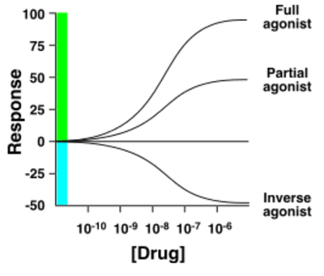
A novel protein isolated in 2007 by Niehaus et al. that interacts with the C-terminal tail of the CB1 receptor is the globular protein, cannabinoid receptor interacting protein 1a (CRIP1a)⁶. Not much is known about CRIP1a, however it is found throughout vertebrates and is mostly expressed in the brain, however it has been observed in other tissues throughout the body to a lesser degree⁴. While it is known the last 9 amino acids of CB1’s C-terminus tail are the minimum required for CRIP1a to interact with CB1 receptors, it is currently unknown precisely the site on CRIP1a that binds to the C-terminus tail⁶. Studies performed on CRIP1a suggest it has possibly key functions in many different physiological systems, ranging from colorectal cancers to seizure activity⁷.
Figure 1. Different kinds of agonists relative to basal activity. Full agonists completely increase activity of a receptor above basal activity. Partial agonists increase activity of a receptor above basal activity, but much less than a full agonist. Inverse agonists decrease activity of a receptor below basal activity.
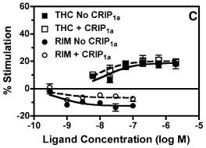
Smith et al. (2015) did an extensive study on CRIP1a and CB1 interaction which indicated that CRIP1a is a negative regulator of CB1 function, as it inhibits constitutive CB1 receptor activity and downregulation of CB1 receptors⁷. Within the study a [³⁵S]GTPγS binding assay was performed with four full agonists, three partial agonists, and one inverse agonist. The difference between full agonists, partial agonists, and inverse agonists are explained in Figure 1. CRIP1a had an effect on CB1 stimulation with the four full agonists and the inverse agonist, but CRIP1a did not have an effect on the three partial agonists. CB1 stimulations was measured by the number of receptors bound with [³⁵S]GTPγS while in the presence of a ligand compared to [³⁵S]GTPγS bound to receptors due to basal binding. Figure 2 is the concentration vs CB1 stimulation curves of Δ⁹-tetrahydrocannabinol (THC), the classic phytocannabinoid, and of SR141716A, the inverse agonist, and exemplifies the reduction of the inverse agonism caused by SR141716A and the lack of change in CB1 stimulation by THC while in the presence of CRIP1a⁷. These findings suggest CRIP1a has a functional role in the modulation of CB1 stimulation.
Figure 2. Effect of CRIP1a expression on concentration effect curves. Results obtained from [³⁵S]GTPγS binding in cells with and without stable transfection of CRIP1a. Ligands used: Δ⁹-tetrahydrocannabinol (THC) and SR141716A (RIM). (Adapted from Ref 7)
The criteria which triggers CRIP1a to modulate CB1 stimulus could conceivably be completely dependent upon the efficacy of the ligand stimulating CB1, as Smith et al. (2015) observed CRIP1a modulation of CB1 occurring for the four full agonist and the inverse agonist, while not the partial agonists⁷. However, as full agonists and inverse agonists evoke more extreme stimulation outcomes of CB1 receptors, CRIP1a modulation could possibly be triggered when CB1 stimulation exceeds a particular threshold. This will be measured by assessing the difference between percent stimulation in both cell lines. The purpose of the experiment in this proposal is to test whether ligand type or stimulus beyond a range is the trigger for CRIP1a modulation of CB1.
II. Experiment
The aim of this experiment is to determine if CRIP1a modulates CB1 stimulation in the presence of inverse agonists by the type of ligand or has a range in which it does not affect CB1 stimulation. If CRIP1a modulation is dependent upon the ligands intrinsic efficacies, then CRIP1a would reduce the inverse agonism of the ligands equally. However if CRIP1a modulates based upon a range of CB1 stimulation, then CRIP1a would have less effect on CB1 stimulation in the presence of the less potent ligands. This will be determined by the difference between percent stimulation in each cell line for each inverse agonist. If the difference in percent stimulation between the CRIP1a negative cell line and CRIP1a positive cell line is the same between each inverse agonist, then CRIP1a modulation is triggered by the type of ligand. If the difference in percent stimulation between the CRIP1a negative cell line and CRIP1a positive cell line is different between each inverse agonist, with the difference between the two cell lines decreasing with the decreasing potency of the inverse agonists, then CRIP1a modulation is triggered by a threshold.

II.A. [³⁵S]GTPγS binding assay
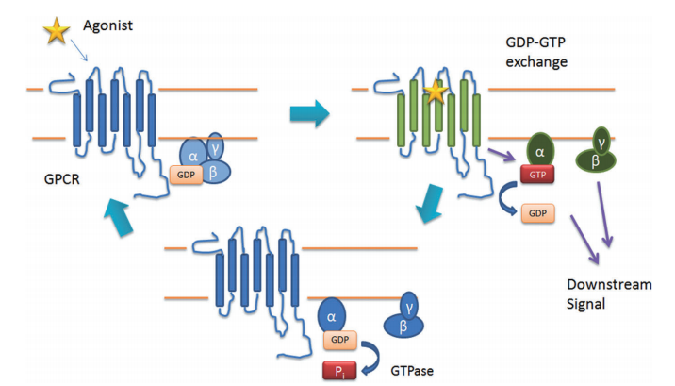
To assess CB1 stimulation, CB1 receptor activation while in the presence of the ligands would need to be quantified. The [³⁵S]GTPγS binding assay accomplishes this task by preventing deactivation of the receptor. Figure 3 shows the mechanism of GCPR activation. When [³⁵S]GTPγS is introduced in place of GTP, the radioactive gamma sulfur in [³⁵S]GTPγS effectively interferes with deactivation of the receptor by preventing hydrolysis by GTPase and forcing the receptor to remain turned on⁸. The reactions would be terminated with vacuum filtration to remove the unbound [³⁵S]GTPγS, while trapping both bound and unbound CB1 receptors in the filter for analysis. The quantity of CB1 bound with [³⁵S]GTPγS is assessed by measuring the radioactivity present with a scintillation counter.
Figure 3. GCPR activation. Agonist binding to the receptor leads to the exchange of GDP for GTP on the α subunit of the GCPR; downstream effects are activated by the Gα-GTP and Gβγ subunits. GTPase hydrolyses the GTP in the Gα-GTP subunit to GDP, thus turning off the receptor and allowing the subunits, Gα and Gβγ to reassociate and the receptor to be turned off. (Adapted from Ref 1.)
II.B. [³⁵S]GTPγS experiment
In order to assess CRIP1a modulation of CB1, Human Embryonic Kidney (HEK) cells first need to be transfected to stably express either CB1 (hCB1-HEK) or CB1 and CRIP1a (hCB1-HEK-CRIP1a). Receptor density for these cell lines would be assessed by [³H]SR141716A binding assay to ensure both cell lines have a similar receptor density. Basal binding, which is the constitutive activity of a receptor without ligands present, would need to be assessed for both cell lines with the [³⁵S]GTPγS binding assay without any ligands present for calculation of percent stimulation of CB1 when in the presence of the ligands⁷.
The main experiment is [³⁵S]GTPγS binding assay performed on the CB1 receptor in both of the cell lines while in the presence of the ligands. The three ligands used are SR141716A, AM251, and AM281, which are all inverse agonist and therefore reduce constitutive activity of the receptor. These ligands were selected because AM251 and AM281 are both structural analogs of SR141716A, which was the first CB1 selective inverse agonist developed, and are three and eight times less potent, respectively, than SR141716A. Figure 4 shows the structural differences of the three ligands⁹. The ligands would be introduced to both hCB1-HEK and hCB1-HEK-CRIP1a cell lines and allowed to interact for a period of time, at which point the reaction would be terminated and radioactivity from [³⁵S]GTPγS bound to CB1 would be measured. To compare the stimulation of CB1 caused by the ligands, percent stimulation is calculated by (net stimulation of the receptor / basal binding) X 100%. Net stimulation is calculated by ligand stimulation – basal binding⁷.
III. Discussion
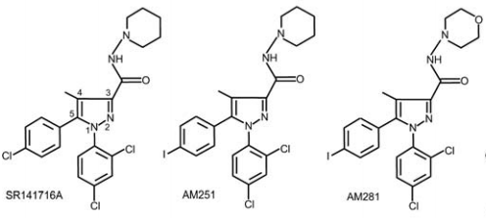
If CRIP1a modulation of CB1 stimulation is triggered based upon the type of the ligand, the receptor in hCB1-HEK-CRIP1a cells will be stimulated more than the receptor in hCB1-HEK cells to an equal degree for all ligands, as Smith et al. (2015) observed CRIP1a reducing the inverse agonism caused by SR141716A⁷. If CRIP1a modulation of CB1 stimulation is triggered when CB1 stimulation expands past a range, then CRIP1a’s effect on stimulation levels would be less pronounced with the less potent ligand. CRIP1a would be expected to reduce inverse agonism of SR141716A the most, followed by AM251, and AM281 inverse agonism would be reduced the least.
Figure 4. Structures of CB1 inverse agonists used. The structures, from left to right are SR141716A , AM251, and AM281. AM251 and AM281 are structural analogs of SR141716A and are three and eight times less potent, respectively, than SR141716A. (Adapted from Ref 9.)
Current research has observed CRIP1a playing a regulatory role upon CB1. The determination of what triggers CRIP1a to modulate CB1 stimulation is a necessary component to expanding the knowledge of CRIP1a’s regulatory nature. With the limited knowledge gathered to date, there is much unknown about CRIP1a and much that needs to be understood. If CRIP1a’s modulation is triggered by exceeding a range of CB1 stimulation, the next step is to find the exact range of stimulation required to trigger CRIP1a to modulate CB1. Future experimentation would be beneficial in uncovering the interactions between CRIP1a and CB1 receptors, as this would continue to expand the understanding of the endocannabinoid system as a whole.

IV. References
- Smith TH, Sim-Selley LJ, and Selley DE (2010) Cannabinoid CB1 receptor-interacting proteins: novel targets for central nervous system drug discovery? Brit J Pharmacol 160: 454-466.
- Centers for Disease Control and Prevention, Marijuana and Public Health. Frequently Asked Questions. (https://www.cdc.gov/marijuana/faqs.htm; Accessed April 2017)
- Drug Enforcement Administration; Diversion Control Division. Title 21 United States Code (USC) Controlled Substances Act. (https://www.deadiversion.usdoj.gov/21cfr/21usc/812.htm; Accessed April 2017)
- Niehaus JL, Liu Y, Wallis KT, Egertova M, Bhartur SG, Mukhopadhyay S, Shi S, He H, Selley DE, Howlett AC, Elphick MR, and Lewis DL (2007) CB1 cannabinoid receptor activity is modulated by the cannabinoid receptor interacting protein CRIP 1a. Mol Pharm 72:1557-1566.
- Howlett AC, Blume LC, and Dalton GD (2010) CB1 cannabinoid receptors and their associated proteins. Curr Med Chem 17:1385-1393.
- Ahmed MH, Kellogg GE, Selley DE, Safo M, and Zhang Y (2014) Predicting the CRIP1a-cannabinoid 1 receptor interactions with integrated molecular modeling approaches. Bioorg Med Chem Lett 24: 1158-1165.
- Smith TH, Blume LC, Straiker A, Cox JO, David BG, Secor Mcvoy JR, Sayers KW, Poklis JL, Abdullah RA, Egertova M, Chen CK, Mackie K, Elphick MR, Howlett AC, and Selley DE (2015) Cannabinoid receptor-interacting protein 1a modulates CB1 receptor signaling and regulation. Mol Pharm 87:747-765.
- Harrison C and Traynor JR (2003) The [³⁵S]GTPγS binding assay: approaches and applications in pharmacology. Life Sciences 74: 489-508.
- Pertwee RG (2003) Parmacological actions of cannabinoids. Handb Exp Pharmacol 2005: 1-51.

