Alina Afzal
Final Draft
05/05/2017

Can Vitamin C prevent the mtDNA in the aged induced pluripotent stem cell?

Introduction
With the 8.5 percent of the world population represented by the elderly, and disproportionate distribution of health-care resources among this subpopulation, aging is an issue worth the attention of the scientific community (He et al.,2016). Aging is defined as a decline in energy, which occurs due to the cellular changes that happen over an organism’s lifespan. One of the irreversible cellular changes that occur over the lifespan is damage to the cell organelle, mitochondria. Mitochondria are responsible for making the energy in a cell, and due to that energy we are able to perform daily tasks efficiently. With age, mutations in mitochondrial DNA increases, causing mitochondrial dysfunction and hence resulting in diseases such as aging and neurodegeneration (Bratic & Larsson, 2013). One of the most recognized sources of these DNA mutations is reactive oxygen species (ROS), such as superoxide and peroxide (Sanz et al., 2008).

ROS species are produced inside mitochondria, during the oxidative phosphorylation process (Tuppen et al., 2010). These hazardous species are produced due to premature and incomplete reduction of oxygen in the electron transport chain (Tuppen et al., 2010). In order to counteract the harmful effects of free radical species, the body produces enzymes like superoxide dismutase, which either add or remove the electron from the ROS and change it to less damaging specie. However, with increasing age, the body is unable to maintain a balance between the production of free radical species and the superoxide dismutase., which leads to DNA damage in the cell. Mitochondrial DNA is found to be more damaged with age as compared to nuclear damage (Sharma et.al, 2012). According to free radical theory of aging, mitochondria is the vulnerable target for free radicals, ROS (Sanz et al., 2008). ROS attack on mitochondria leads to mtDNA damage and mutation, which is major contributing factor in aging (Sanz et al., 2008). ROS damages the DNA either by damaging the DNA base by adding -OH over double bonds or by damaging the sugar by abstracting hydrogen from deoxyribose (Sharma et.al, 2012).

In order to study these mutations in mitochondrial DNA, induced pluripotent stem cells can be used. Earlier in order to the study human diseases, embryonic stem cells, obtained from inside the embryo at blastocyst stage were used since these cells can be differentiated to other specialized cells (Takahashi et al., 2006). However, there are many ethical concerns associated with the study of embryonic stem cells (Takahashi et al., 2006). An alternate to embryonic stem cells is the use of induced pluripotent stem cells, iPSCs. In fibroblast skin cells, only the genes responsible for making the skin cells are active, and all other genes responsible for other proteins are inactive. Induced pluripotent stem cells are made from these fibroblasts with the help of transcription factors, which turn on the genes to dedifferentiate the cells and convert it to more general cells (Takahashi et al., 2006). More specifically, transcription factors such as Oct 4, Sox 2, c-Myc and Klf 4 are found to be responsible for the dedifferentiation of fibroblast cell to the stem cell (Takahashi et al., 2006). Genes encoding the transcription factors are brought into the cells by means of a retrovirus, and DNA produced by reverse transcriptase goes into the nucleus of cell (Takahashi et al., 2006). There, integrase cuts the cell DNA, and retrovirus DNA is inserted into the cell DNA. When the transcription factors are introduced to the fibroblast cells, the tightly packed inactive chromosomes starts unwinding and the transcription factors get attached to them, thereby increasing transcription of stem cell-specific genes (Takahashi et al., 2006). This increase in specific genes transcription leads to the production of embryonic stem cell proteins (Takahashi et al., 2006). These proteins create an embryonic environment for the cell. The induced pluripotent stem cells are very similar in morphology and function to the embryonic stem cells. Besides, iPSCs do not have any ethical issues associated with them and thus can be used to study various diseases, including neurodegenerative and age related diseases. When a fibroblast cell undergoes reprogramming, the mitochondrion, which has its own genetic material, also undergoes some changes to meet the energy demands of the pluripotent state (Zhang et al., 2012). A recent study showed that fewer mtDNA mutations were found in iPSCs obtained from fibroblast cells of adults as compared to fibroblasts taken from older people (Kang et al., 2016).

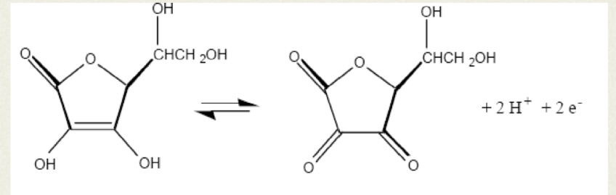
During production of iPSCs, efficiency and yield were two major limitations, so various attempts were made in the direction to improve yield and efficiency of these cells. It was believed that during reprogramming the level of ROS increases and causes DNA damage (Carolina et al., 2014). In 2010, it was found that vitamin C increases the reprogramming efficiency of the fibroblast skin cells to about 1-2% induced pluripotent stem cells as compared to 0.01% by traditional methods (Esteban et al., 2010). ROS is found to damage the mitochondrial DNA and hence result in increasing mtDNA mutations with age (Sanz et al., 2008). Vitamin C is an anti-oxidant which has a free electron present, and holds the potential to bind to the ROS, and this it can act as an ROS quencher and can prevent it from going out to the matrix (Figure.1) (Kawashima et al., 2015). From these observations, I propose that anti-oxidant Vitamin C can reduce the incidence of mtDNA mutations in the aged induced pluripotent stem cells which are reprogramed from the fibroblast skin cells.
Figure 1. Structure of ascorbic acid (vitamin C). The two free electrons are shown, which can form a bond with reactive oxygen species.
Source: "Ascorbic acid content of fruit juice - GCSE Science - Marked by Teachers.com." Web. <http://www.markedbyteachers.com/gcse/science/ascorbic-acid-content-of-fruit-juice.html>.

Experimental method
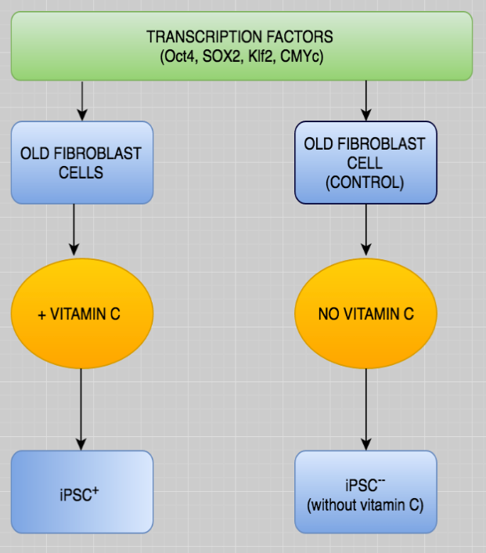
For the study, fibroblast cells will be obtained from subjects of age group of ~80 years. They will be sub-group by experimental and control cells. The transcription factors will be transduced in both the subgroups. Vitamin C will be added to the the experimental group cells and nothing will be added in the control group cell (Fig.2). The ROS level and the mutation in the mtDNA in the control and experimental induced pluripotent stem cells will be observed.
Figure 2. The flow diagram of the experimental design.

The fibroblast cells obtained from subject will be cultured in two groups in separate culture dishes labeled as control and experiment. In both the cultures, the fibroblast skin cells in six well dishes will be transduced with human encoded pMX-based retrovirus containing the transcriptional factors Oct4, Sox2, Klf4 and c-Myc (Esteban et al., 2010). After 3 days, anti-oxidant Vitamin C will be added in the experimental fibroblast culture, while nothing will be added to the control fibroblast culture.

The transduced fibroblast cells will be cultured in the embryonic feeder cells (Polak et al, 2012). Within 5-10 days, the iPSC colonies will start emerging and within 14-28 days, the iPSC colonies will be ready for isolation (Polak et al., 2012).

After the fibroblast cells will be reprogrammed to iPSCs, their ROS level will be determined by the following procedure. The oxidized probes will be used to measure ROS level, which enter the cell as non-fluorescent element and becomes fluorescent upon oxidation by ROS (Carolina et al., 2014).

To examine mutations in the iPSC cells, DNA will be extracted by using the QIAGEN Gentra cell kit (Kang et al., 2016). The Gentra cell kit will extract the DNA by first performing cell lysis using an anionic detergent, and then degrading RNA and protein using RNA digesting enzymes and salt precipitation (Dhaliwal, 2016). It will then isolate the DNA by ethanol precipitation and will yield high quality genomic DNA (Dhaliwal, 2016).). The genomic DNA will be then centrifuged at different speeds to separate the nuclear DNA from the mitochondrial DNA, as the nuclear DNA is larger in size as compared to mtDNA.

The extracted mtDNA will be amplified by PCR using primers F-2120 and R-2119, which will specifically recognize the mitochondrial DNA and will differentiate it from the nuclear DNA (Kang et al., 2016). Primers F- 2120 is GGACACTAGGAAAAAACCTTGTAGAGAGAG and R-2119 is
AAAGAGCTGTTCCTCTTTGGACTAACA (Kang et al., 2016). From the NCBI Blast, it was found that the position of the sequence for the forward primer is 2120-2149 and the reverse primer is 2119-2093 (Figure.3).
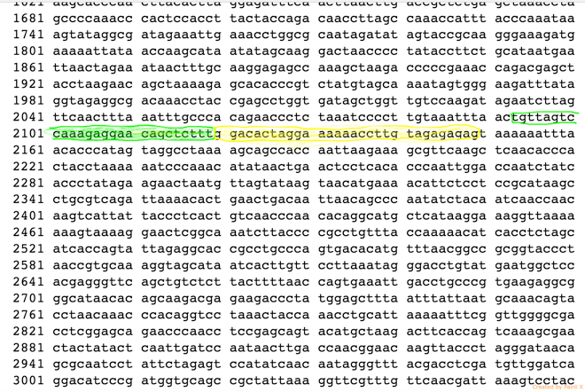
Figure 3. Section of mitochondrial DNA sequence. The green highlight shows the reverse primer binding site and yellow shows the forward primer binding sight. The forward strand is same sequence as the primer F2120, as the mtDNA sequence above is single stranded, and this primer will bind to the complement strand of the above sequence. The reverse primer R2119will bind to its complementary sequence, which is shown with the green highlight.
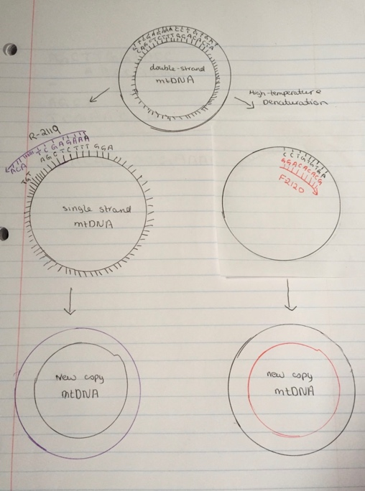
Source: "Homo sapiens mitochondrion, complete genome - Nucleotide - NCBI." National Center for Biotechnology Information. U.S. National Library of Medicine, n.d. Web. <https://www.ncbi.nlm.nih.gov/nuccore/NC_012920.1?&feature=CDS >

In PCR, first the strands will be denatured by high temperature. Primer F2120 and R2119 will bind to the complementary sequence present on the mitochondria genome template (Figure.4). After the primers are attached to the template, new copy of mtDNA will be synthesized by thermo stable TAKARA LA Taq polymerase (MA et.al, 2015). This polymerase is optimized for the very long DNA template amplification, it will add the dNTPs to the primer sequence and will run for 16 minutes to completely amplify the entire mtDNA (MA et.al, 2015).
Figure 4. PCR of the mtDNA. Double stranded mtDNA with the primer binding sight sequence are shown in the picture. After the primers are annealed to the mtDNA, TAKARA Taq LA polymerase will extend the primer sequence by adding dNTPs.

The amplified mtDNA will be sequenced using bioinformatics tools such as Next Generation sequencing (Kang et al. 2016). The principal behind the next generation sequencing is that first the libraries of mtDNA are prepared by fragmenting the mtDNA and adding specialized adapters ((Illumina). After that these fragments are loaded onto cell flow surface, where they are amplified to cluster by bridge amplification (Illumina). Then to those clusters the sequencing reagents and four different fluorescent dyes each corresponding to the unique mtDNA base are added. The laser light will and the will cause the molecule to fluoresce, and machine will detect the color and software will read the base corresponding to the color (Illumina).
After the mitochondrial DNA sequence is obtained, it will be aligned in reference to the revised Cambridge Reference Sequence (rCRS) of the human mtDNA, and the mutations in the sequence will be counted (Kang et al. 2016).

Expected Results

If significant difference in the mtDNA mutations of the control and the experimental group will be found, I will be tempted to conclude that in the experimental group vitamin C controlled the increasing level increasing of ROS and protected the proteins and mtDNA from further damage. I will conclude that the vitamin C might have a role to play in slowing down aging and also in obtaining the better quality of induced pluripotent stem cells, which can be used to study other neurodegenerative diseases.

Figure 5. The mtDNA mutation in the age group of 80 will be detected. The iPSC with the vitamin C will have 5% less mutations as compared to the iPSC without vitamin C.

It is found that reprogramming efficiency of the young and old fibroblast cells in the presence of vitamin C is higher as compared to the control group i.e. in the absence of vitamin C (Esteban et al., 2010). If this experiment is successful, it might lead to the way of improving the quality of the induced pluripotent stem cells with vitamin C as well.
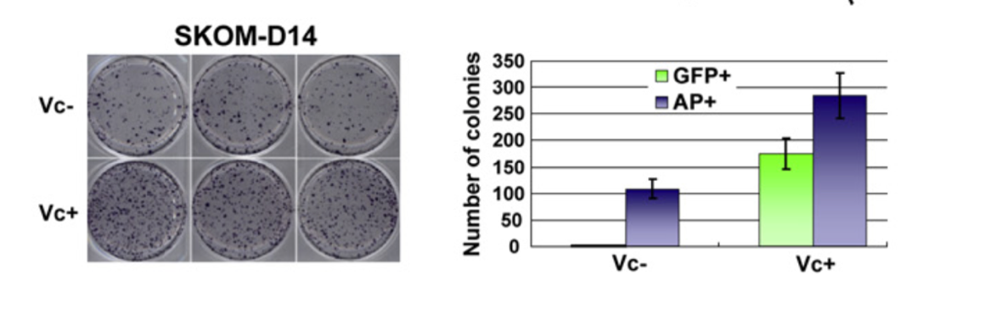
Figure 6. SKOM here are the four transcription factors SXO2, KlF4, OCT4 and c-MYC. The fibroblast cells treated with and without vitamin C are shown in the figure and on the right graphical representation of the results is given. It’s evident from the graph that vitamin C enhances the iPSC colonies. (Esteban et al.,2010).

Induced pluripotent stem cells are being used to study congenital cancer, premature aging diseases, so it is of utmost importance to obtain better quality induced pluripotent stem cells. If the study is successful, it may help scientists in making better quality induced pluripotent stem cell and also discovering a way to slow down the aging process.

References:

- "An Introduction to Next-Generation Sequencing Technology." Illumina. Web. < https://www.illumina.com/content/dam/illumina-marketing/documents/products/illumina_sequencing_introduction.pdf >

- "Ascorbic acid content of fruit juice - GCSE Science - Marked by Teachers.com." Marked by Teachers. Web. <http://www.markedbyteachers.com/gcse/science/ascorbic-acid-content-of-fruit-juice.html >.

- Bigarella, C. L., R. Liang, and S. Ghaffari. "Stem Cells and the Impact of ROS Signaling." Development 141.22 (2014): 4206-218. Web.<http://dev.biologists.org/content/develop/141/22/4206.full.pdf>

- Bratic, Ana, and Nils-Göran Larsson. "The Role of Mitochondria in Aging." Journal of Clinical Investigation J. Clin. Invest. 123.3 (2013): 951-57. Web. <https://www.jci.org/articles/view/64125>.

- Dhaliwal, Anandika. "DNA Extraction and Purification." Materials and Methods. N.p., 23 Oct. 2016. Web.< https://www.labome.com/method/DNA-Extraction-and-Purification.html >

- Esteban, Miguel Angel et al. "Vitamin C Enhances the Generation of Mouse and Human Induced Pluripotent Stem Cells." Cell Stem Cell 6.1 (2010): 71-79. Web. <http://www.sciencedirect.com/science/article/pii/S1934590909006249>.

- He, Wan, Daniel Goodkind, and Paul Kowal. "Library." An Aging World: 2015. N.p., 28 Mar. 2016. Web. < https://www.census.gov/library/publications/2016/demo/P95-16-1.html >

- "Humanity's Aging." National Institutes of Health. U.S. Department of Health and Human Services, n.d. Web. <https://www.nia.nih.gov/research/publication/global-health-and-aging/humanitys-aging>.

- Kawashima, Akihiro et al. “Vitamin C Induces the Reduction of Oxidative Stress and Paradoxically Stimulates the Apoptotic Gene Expression in Extravillous Trophoblasts Derived From First-Trimester Tissue.” Reproductive Sciences 22.7 (2015): 783–790. PMC. Web. < https://www.ncbi.nlm.nih.gov/pmc/articles/PMC4565473/ >

- Kang, Eunju, Xinjian Wang, Rebecca Tippner-Hedges, Hong Ma, Clifford D.l. Folmes, Nuria Marti Gutierrez, Yeonmi Lee, Crystal Van Dyken, Riffat Ahmed, Ying Li, Amy Koski, TomonariHayama, Shiyu Luo, Cary O. Harding, Paula Amato, Jeffrey Jensen, David Battaglia, David Lee, Diana Wu, Andre Terzic, Don P. Wolf, Taosheng Huang, and Shoukhrat Mitalipov. "Age-Related Accumulation of Somatic Mitochondrial DNA Mutations in Adult-Derived Human IPSCs." Cell Stem Cell 18.5 (2016): 625-36. Web.
< https://www.ncbi.nlm.nih.gov/pubmed/27151456>

- Ma, Hong, Clifford D. L. Folmes, Jun Wu, Robert Morey, Sergio Mora-Castilla, Alejandro Ocampo, Li Ma, Joanna Poulton, Xinjian Wang, Riffat Ahmed, Eunju Kang, Yeonmi Lee, Tomonari Hayama, Ying Li, Crystal Van Dyken, Nuria Marti Gutierrez, Rebecca Tippner-Hedges, Amy Koski, Nargiz Mitalipov, Paula Amato, Don P. Wolf, Taosheng Huang, Andre Terzic, Louise C. Laurent, Juan Carlos Izpisua Belmonte, and Shoukhrat Mitalipov. "Metabolic rescue in pluripotent cells from patients with mtDNA disease." Nature 524.7564 (2015): 234-38. Web.
< http://www.nature.com/nature/journal/v524/n7564/full/nature14546.html >.

- Mahmoudi, Salah, and Anne Brunet. “Aging and Reprogramming: A Two-Way Street.” Current opinion in cell biology 24.6 (2012): 744–756. PMC. Web. <http://www.ncbi.nlm.nih.gov/pmc/articles/PMC3540161/>

- Polak, Urszula et al. “Selecting and Isolating Colonies of Human Induced Pluripotent Stem Cells Reprogrammed from Adult Fibroblasts.” Journal of Visualized Experiments: JoVE 60 (2012): 3416. PMC. Web.<http://www.ncbi.nlm.nih.gov/pmc/articles/PMC3376935/>

- Sanz, Stefanatos. “The mitochondrial free radical theory of aging: a critical view.” Curr Aging Sci. (2008): 1(1):10-21.Web.< https://www.ncbi.nlm.nih.gov/pubmed/20021368>

- Sharma, Pallavi, Ambuj Bhushan Jha, Rama Shanker Dubey, and Mohammad Pessarakli. "Reactive Oxygen Species, Oxidative Damage, and Antioxidative Defense Mechanism in Plants under Stressful Conditions." Journal of Botany 2012 (2012): 1-26. Web. <https://www.hindawi.com/journals/jb/2012/217037/>

- Takahashi, Kazutoshi, and Shinya Yamanaka. "Induction of Pluripotent Stem Cells from Mouse Embryonic and Adult Fibroblast Cultures by Defined Factors." Cell 126.4 (2006): 663-76. Web. <http://www.sciencedirect.com/science/article/pii/S0092867406009767>.

- Tuppen, Helen A.L., Emma L. Blakely, Douglass M. Turnbull, and Robert W. Taylor. "Mitochondrial DNA Mutations and Human Disease." Biochimica Et BiophysicaActa (BBA) - Bioenergetics 1797.2 (2010): 113-28. Web. <http://www.sciencedirect.com/science/article/pii/S0005272809002618>.

- Zhang, Nuebel, Daley, Koehler, Teitell. “Metabolic regulation in Pluripotent Stem Cells during Reprogramming and Self-Renewal.” (2012): 11(5):589-595.Web.< https://www.ncbi.nlm.nih.gov/pmc/articles/PMC3492890/>

