Antirepressor Identification in Bacillus Bacteriophage phiCM3
DRAFT
I. Introduction

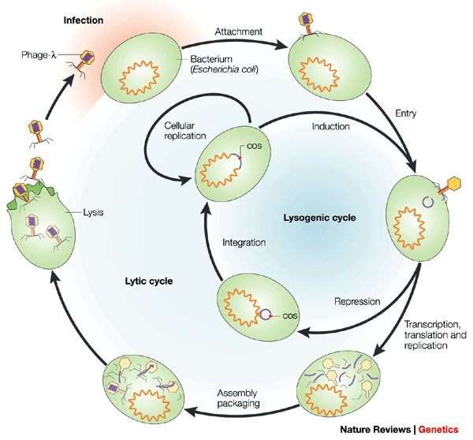
Since viruses infect all types of life, the prokaryotes are not immune from it. Viruses called bacteriophages, or phages, infect bacteria. There are two life cycles of phages, the lysogenic cycle and the lytic cycle. In the lytic cycle, the aim of the phage is to infect, rapidly reproduce inside of the host cell, and then kill the cell by causing it to lyse. When the host cell breaks open, all of the phages that were reproduced inside of the cell are released into the environment, and, in return, find more cells to infect. In the lysogenic cycle, the phage infects the cell, and then exists as a plasmid inside of the host, making the host express phage genes that are not typically expressed by that bacterium (Figure 1). The phage’s genetic information is then passed down to daughter cells, maintaining the lysogenic state in the reproduced cells.²
Figure 1. The lytic and lysogenic life cycles of phages.
Adapted from Ref. 1.

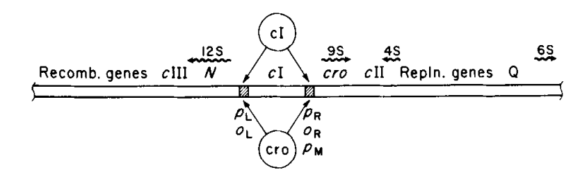
To regulate whether the phage will be undergoing the lytic or lysogenic cycle, transcription is either inhibited or aided. During transcription, the RNA polymerase enzyme translates the cell’s DNA to RNA, starting at the promoter region. Transcription can be inhibited by the repressor protein, or cI, which typically binds to the promoter region before RNA polymerase can. In bacteriophage lambda, there are two promoter regions, p_{L} and p_{R}. When cI is present, cI will bind to the p_{L} region and block it, thus causing RNA polymerase to bind to p_{R}. When this happens, the cell transcribes more cI to be synthesized, and the phage, in turn, undergoes the lysogenic cycle. However, if the antirepressor protein (often called cro) is present, cro will bind to p_{R} and RNA polymerase will bind to p_{L}, which will cause more cro proteins to be made, and the phage will undergo the lytic cycle (Figure 2).^{3,6} Typically the repressor binds directly to DNA, while the antirepressor can either bind to the DNA as well, or it can bind directly to the repressor, depending on its mechanism.
Figure 2. The regulation of transcription in bacteriophage lambda, cI and cro compete to bind to the promoter region. Adapted from Ref. 3.

It has become very common in recent years to rely on genome annotations to find the functions of certain proteins, even though most argue that genome annotations are often incorrect.⁴ Genome annotation is exactly what Yuan et al (2014) relied on to classify and characterize the genome of bacteriophage phiCM3, and to make assumptions on the whether proteins were highly conserved or not. According to the article, the antirepressor protein in phiCM3 is highly conserved compared to other proteins that might have adapted to be more suitable in their environment.⁵ Since the antirepressor protein is more highly conserved than other proteins, it can be assumed that the protein is likely to be the antirepressor of phiCM3. The purpose of this proposed experiment is to test if the genome analysis is correct, and the protein, gp37, is in fact the antirepressor of phiCM3.

II. Experiment

The aim of this experiment is to determine if the genomic analysis of phiCM3 was correct in identifying the antirepressor of the phage. In order to determine the antirepressor experimentally, the repressor first needs to be identified, and experimentally verified. However, the repressor protein was not identified in Yuan et al (2014), therefore, bioinformatics analysis will have to be performed on the genome in order to find a putative repressor protein to test.

II.A. Building the Expression Vectors to Test the Repressor
Once the putative repressor protein is found through comparative genomics, it will need to be cloned into an expression vector for testing. The pHTO1 plasmid will be used to clone the repressor protein at the BamHI site (Figure 3).⁷ The cloning will be done through a simple isothermal reaction in a test tube, better known as Gibson Assembly. During Gibson Assembly, the exonuclease “chews” back the DNA on the 5’ end of the strand on two overlapping DNA sequences, creating single-stranded DNA fragments that can anneal. This means that the DNA sequence from the plasmid and the putative repressor will have to overlap. Then DNA polymerase fills in any missing nucleotide gaps, followed by DNA ligase covalently joining the strand of the repressor gene to the plasmid.⁸
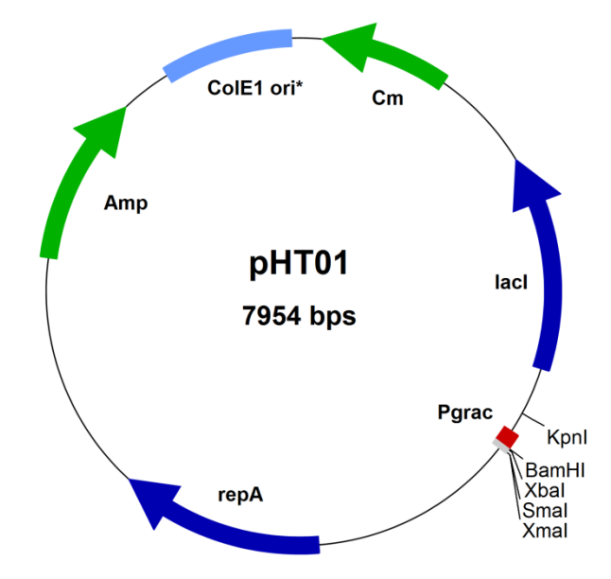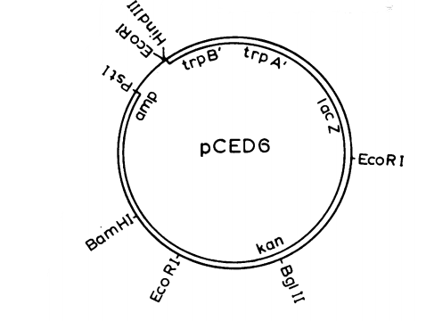
Figure 3.
pHT01 Bacillus subtilis expression vector. The repressor gene will be cloned at the BamHI site. Pgrac is the promoter region, and lacl is the gene to be expressed. Adapted from Ref. 7.

pCED6 Bacillus subtilis expression vector. The promoter will be added at the upstream HindIII site, and the downstream HindIII site will be destroyed. The lacZ gene will be added to the promoter region. Adapted from Ref. 10.
A second plasmid, pCED6, will be configured with the promoter added in at the upstream HindIII site. The downstream HindIII site will be destroyed so that the plasmid can be reopened at that particular site, and reconfigured for the later part of this experiment (Figure 3).¹⁰ The reporter gene that will be used in this experiment, lacZ, which will be fused to the promoter at the HindIII site as well.

II.B. IPTG Induction and ONPG Testing of the Repressor
Once both expression vectors are configured properly, the plasmid will be inside into the cell, and the cells will be allowed to replicate. To determine whether or not the repressor is, in fact, the repressor, an aliquot of the cells grown with plasmid will be taken and combined with IPTG to initiate transcription of the lac operon.⁹ IPTG induction will bind to the lacI repressor gene, starting transcription of the lac operon, which will, in response, trigger the expression of the lacZ gene. An added benefit of using IPTG is that it is not hydrolyzed by β-galactosidase, so the concentration of IPTG will remain constant.

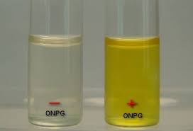
After waiting an appropriate amount of time allowing IPTG induction, ONPG will be used to test the expression of the lacZ gene. ONPG will be added to the IPTG induced cells. When β-galactosidase is present in the cell, or the lacZ gene is expressed, ONPG will be hydrolyzed into ONP and a galactose molecule. While ONPG is colorless, ONP is yellow. Therefore, when transcription is active, the mixture will turn yellow, called ONPG + (positive). However, if transcription is being repressed, the mixture will not turn yellow, called ONPG - (negative) (Figure 4). The typical wait time to determine if the mixture is ONPG - is 24 hours.^{11,12,13}
Figure 4. ONPG - vs. ONPG + results. Adapted from Ref. 13.

II.C. Testing the Antirepressor
Much like the repressor protein, the antirepressor will have to be added to a plasmid, however, the repressor will also have to be present. To do this, the pCED6 HindIII site will be reopened, and the repressor and promoter will be added after amplification, including the reporter gene. The antirepressor gene will then be added to the pHT01 expression vector at the BamHI site (Figure 3).^{7,10} The expression vectors will be added to the cells as before, and the cells will be allowed to replicate. Transcription will then be measured with IPTG induction and ONPG testing, similar to before. IPTG will be added to an aliquot of the cells, followed by ONPG. The color of the mixture will be recorded after 24 hours.^{11,12,13}

II. Discussion

After all is said and done, the ideal results would show that the annotation was correct in identifying the highly conserved antirepressor of phage phiCM3. For this to happen, the results of experiment should show that repressor gene is ONPG negative, meaning that the repressor held off transcription, and there was little to no β-galactosidase activity. Furthermore, this would mean that after undergoing the same ONPG test, the antirepressor should be ONPG positive. This would result in the yellowing of the antirepressor solution due to increased β-galactosidase activity because transcription was allowed to continue.

The ideal results almost rarely happen the first try. Most of the potential problems with this experiment would be with the annotations being incorrect. In the case that the repressor annotation was found to be incorrect, meaning that transcription occurred in the presence of the repressor gene, a new putative repressor gene would need to identified, and tested. This could also be the case for the antirepressor gene, and the solution would be the same. There could also be problems with the expression vectors, for some reason, which would mean that new expression vectors would need to be found, however incompatibility problems are unlikely since the antibiotic resistance parts and the origins of replication were both checked to ensure compatibility. Hopefully, none of these problems arise.

In the future, if this experiment is successful, the mechanism of the antirepressor could be identified in a similar experiment to Susskind et al. (1975), in which the authors hypothesized that the antirepressor was similar to phage lambda’s, meaning that it binds to DNA instead of to the repressor. Similarly, the putative antirepressor in phage phiCM3 has homology a domain that is known to bind to DNA, therefore, it is logical to hypothesize that the mechanism for the antirepressor is also similar to that of lambda.^{14,15} However, there is still a chance that the putative antirepressor may not actually be the antirepressor of the phage. Therefore, once the antirepressor is found, it may bind to the repressor protein instead, in which an experiment could be done to test this mechanism as well.

Phages have played an important role in the field of molecular biology so far, giving us insights into transcription and translation. Further studying of the antirepressors of phages could help us gain insight as to why some phages bind to the repressor protein and why others bind directly to the DNA to allow transcription. This would allow us to find out why there are multiple antirepressor mechanisms, and what environmental conditions caused these different mechanisms. By continuing these experiments, we can continue to use phages as tools to understand how all types of life work.

References:

- Campbell, Allan. "Opinion: The future of bacteriophage biology." Nature Reviews Genetics 4.6 (2003): 471-77. Web. <http://www.nature.com/nrg/journal/v4/n6/full/nrg1089.html>.
- Madsen, PL, AH Johansen, K. Hammer, and L. Brondsted. "The Genetic Switch Regulating Activity of Early Promoters of the Temperate Lactococcal Bacteriophage TP901-1." Journal of Bacteriology 181.24 (1999): 7430-438. Web. <https://www.ncbi.nlm.nih.gov/pubmed/10601198>.
- Takeda, Y., A. Folkmanis, and H. Echols. "Cro regulatory protein specified by bacteriophage lambda. Structure, DNA-binding, and repression of RNA synthesis." Journal of Biological Chemistry 252.17 (1977): 6177-183. Web. <https://www.ncbi.nlm.nih.gov/pubmed/330523?dopt=Abstract>.
- Koonin, E.V.; Galperin, M.Y. (2003). Sequence - Evolution - Function: Computational approaches in comparative genomics. Dordrecht: Springer Science+Business Media.
- Yuan, Y., M. Gao, Q. Peng, D. Wu, P. Liu, and Y. Wu. "Genomic analysis of a phage and prophage from a Bacillus thuringiensis strain." Journal of General Virology 95.Pt_3 (2014): 751-61. Web. <http://jgv.microbiologyresearch.org/content/journal/jgv/10.1099/vir.0.058735-0#tab2>.
- Fogg, P. C. M., Rigden, D. J., Saunders, J. R., McCarthy, A. J. & Allison, H. E. (2011). Characterization of the relationship between integrase, excisionase and antirepressor activities associated with a superinfecting Shiga toxin encoding bacteriophage. Nucleic Acids Res 39, 2116–2129.
- Molecular Biotechnology. "Bacillus sibtilis Expression Vectors." MoBiTec
GmbH (2017): n. pag. Web. <http://www.mobitec.com/cms/products/bio/04_vector_sys/bacillus_subtilis_expression.html?pdf=Bacillus_subtilis_Expression_Vectors-Handbook>.
- Gibson D.G., Young L., Chuang R.Y., Venter J.C., Hutchison 3rd C.A., Smith H.O. Enzymatic assembly of DNA molecules up to several hundred kilobases. Nat. Methods. 2009;6:343–345.
- Hansen, Knudsen, and Sorensen. "The effect of the lacY gene on the induction of IPTG inducible promoters, studied in Escherichia coli and Pseudomonas fluorescens." Current Microbiology 36.6 (1998): 341-47. Web. <https://www.ncbi.nlm.nih.gov/pubmed/9608745>.
- Donnelly, C E, and A L Sonenshein. “Promoter-Probe Plasmid for Bacillus Subtilis.” Journal of Bacteriology 157.3 (1984): 965–967. Print.
- Borralho T, Chang Y, Jain P, Lalani M, Parghi K: “Lactose induction of the lac operon in Escherichia coli B23 and its effect on the o-nitrophenyl β-galactoside assay.” Journal of Experimental Microbiology and Immunology 2002, 2: 117-123. Print.
- Nahary et al., 2009. “Isolation of scFvs that inhibit the NS3 protease of hepatitis C virus by a combination of phage display and a bacterial genetic screen.” Methods Mol. Biol., 562 (2009), pp. 115–132. Print.
- Pradhan, Prasil. "ONPG (o-Nitrophenyl-β-D-Galactopyranoside) test: Principle, Procedure, Result and Interpretation." Microbiology and Infectious Diseases, 27 Apr. 2016. Web.
- Iyer LM, Koonin EV, Aravind L. Extensive domain shuffling in transcription regulators of DNA viruses and implications for the origin of fungal APSES transcription factors. Genome Biol. 2002;3:RESEARCH0012
- Susskind MM, Botstein D. Mechanism of action of Salmonella phage P22 antirepressor. J. Mol. Biol. 1975;98:413–424.

