Sukhman Virk

Is Candidatus Mycoplasma girerdii dependent on Trichomonas vaginalis for survival?

- INTRODUCTION
Trichomonas vaginalis is the causative agent of Trichomoniasis, the most common non-viral sexually transmitted infection (STI) worldwide affecting around 3.7 million people every year (6). Trichomoniasis affects both men and women, but it is predominantly much more common in women with infections ranging from asymptomatic (producing or showing no symptoms) to severe vaginitis, sterility, pelvic inflammatory disease, pregnancy and postpartum complications (5). In comparison to other non- viral sexually transmitted infections, the prevalence of Trichomonas vaginalis infection increases with age, which 51-60 year old women are mostly affected (6).

T. Vaginalis lacks mitochondria (2) and necessary enzymes and therefore obtains its nutrients by internalizing membranes of the bacterial microbiota through phagocytosis. That being the case, the presence of T. Vaginalis results in vaginal dysbiosis of the urogenital tract microbiota by killing protective Lactobacilli bacteria and by hosting and transmitting higher proportions of harmful pathogenic mycoplasmas (5).

A number of studies have shown a strong symbiotic relationship between T. Vaginalis and Mycoplasma hominis. M. hominis is found in the genital tract of both men and women causing infections leading to pregnancy and postpartum complications (1,2). Bacteria in the genus Mycoplasma lack a cell wall around the cell membrane. They are the smallest self-replicating microorganisms that often depend on their host and adapt to most diverse environments despite having smaller genome size and being less complex (3). According to clinical research, a strong association has been shown between T. Vaginalis and two other mycoplasmas: Candidatus Mycoplasma girerdii and Mycoplasma hominis (5).

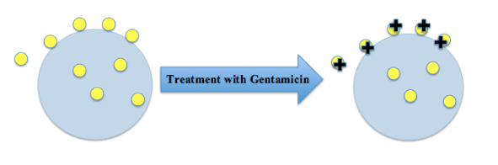
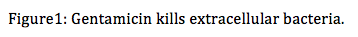
This interaction between T. vaginalis and M. hominis is the first ever symbiotic relationship that involves two obligate human pathogens which means they both live on the surface of other organisms (1). T. Vagianlis obtains its necesssary nutrients by internalizing membranes of bacteria (4), whereas M. hominis has the ability to enter T. Vaginalis which protects this pathogenic bacteria from the effects of the host immune response and antibiotics unable to cross cellular membrane (5). The location of M. hominis with respect to T. Vaginalis is investigated by Daniele et al (2005) where they used gentamicin protection assays. The results of this experiment showed that this bacteria is located and can survive inside the parasite (2). Gentamicin is an antibiotic that is used to treat bacterial infection and is unable to enter eukaryotic cells. In this case, T. Vaginalis protects the internalized M. hominis from the effects of gentamicin, whereas the drug kills the bacteria that is attached to the surface of T. Vaginalis (Figure1). This symbiont relationship provides the bacteria the capability to resist to host defense mechanism during human infection (2).Therefore understanding the mechanisms of how these two organisms benefit each other and impact disease pathology will have important clinical relevance.

In a recent study of the Vaginal Human Microbiome Project at VCU, Candidatus Mycoplasma girerdii was found exclusively in female urogenital tract that have been infected with T. Vaginalis pathogen and was rarely observed in women that were not infected with T. Vaginalis (3). Since this bacteria is still not cultivated, not a lot has been known about this mycoplasma but studies have suggested its possible association with T. Vaginalis. The genome of Ca. M. girerdii provides an understanding of its minimal metabolic strategies and its potential to contributing for virulence and inducing host inflammatory responses through innate immune mechanisms. It is still debated whether this mycoplasma is located on the surface or within the host cell (3). Therefore the goal of this experiment is to see if Ca. M. girerdii is dependent on T. Vaginalis for its survival.

II. MATERIALS AND METHODS:
The purpose of this experiment is to determine the cellular location of Candidatus Mycoplasma girerdii in respect to Trichomonais Vagianlis and therefore find out if the bacteria is dependent on the parasitic protozoa for survival. This association between the two organisms is going to be demonstrated by using gentamicin protection assays, double immunofluorescence and confocal microscopy.

Organisms and cultivation:
Mid vaginal swabs containing both T. Vaginalis and Ca. M. girerdii will be collected in this experiment. There will be two experimental groups included in this study. Both the groups will contain isolates of T. vaginalis, naturally infected with Ca. M. girerdii. Since it is not possible to cultivate Ca. M. girerdii in a lab, Fluorescence in situ hybridization (Figure 2) technique will be performed that uses fluorescent probes to detect and localize specific DNA sequences of Ca. M. girerdii from the vaginal swab. The vaginal swabs will be analyzed to detect Ca. M. girerdii using the protocol described in Fettweis et al (2014). Both the experimental groups will be incubated at 37 degrees celsius in Diamond’s TYM culture medium (2).

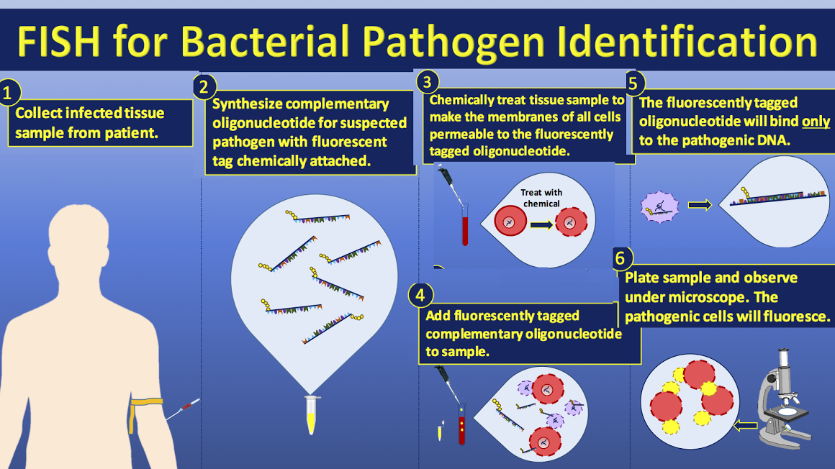
Figure 2: Fluorescence in situ hybridization

Gentamicin protection assay: One experimental group will be treated with a gentamicin concentration of 50 μg ml-1, which is bactericidal but should show no toxic effect on T. Vaginalis. The other group will be left untreated and be a control for the experiment.

Confocal Microscopy and double immunofluorescence assay: After one week of gentamicin treatment, both the groups will be compared by placing them under confocal microscopy. Using the procedure described in Dessi et al (2005), double immunofluorescence microscopy will be used to differentiate intracellular and extracellular Ca. M. girerdii with respect to T. Vaginalis. The two sample groups will be placed in 24-well plates with each plate containing a round 12mm- diameter coverslip incubated in Diamond’s TYM medium at 37 degrees Celsius.
- Extracellular Ca. M. girerdii will be detected by incubating impermeablized T. Vaginalis cells with anti- Ca. M. girerdii rabbit polyclonal antibodies for 1 hour at 4 degrees celsius and then again with rhodamine-conjugated anti-rabbit antibody for 30 mins at 4 degrees celsius.
- Fixation of T. Vaginalis cells will be done by adding 4% paraformaldehyde in PBS and then permeabilized with methanol to allow the diffusion of antibodies into the cells.
- After the cells are permeabilized, the cells will be incubated for the second time with Ca. M. girerdii rabbit polyclonal antibodies and FITC-labeled goat anti-rabbit. This will stain both the extracellular and intracellular mycoplasmas.
The slides will be observed and analyzed using confocal laser scanning microscopy.

III. DISCUSSION
The results of this experiment will provide evidence of the cellular location of Ca. M. girerdii with respect to T. Vaginalis. If the hypothetical experiment goes accordingly then the results should show if Ca. M. girerdii is located on the surface or within the host cell. In order to demonstrate how Ca. M. girerdii is able to be resistant against antibiotics, Gentamicin protection assay was used to show if T. Vaginalis can protect Ca. M. girerdii from the toxic effect of the antibiotic drug. When gentamicin is introduced in one of the samples, extracellular Ca. M. girerdii are killed whereas intracellular Ca. M. girerdii are protected from the effect because the drug is not able to enter trichomonad cells. On the other hand, the sample not treated with gentamicin will have both intracellular and extracellular bacteria still present in the sample. Double immunofluorescence was used in order to see the association between T. Vaginalis and Ca. M. girerdii and visually differentiate internalized Ca. M. girerdii from the one located on the outside of T. Vaginalis. Using confocal microscopy, if there is fluorescence observed inside the trichomonad cell this means that Ca. M. girerdii has the ability to enter T. Vaginalis. This association should also show that mycoplasmas are able to adapt to really diverse and unfavorable environments. If the Ca. M. girerdii is able to invade and survive within T. Vaginalis, this relationship can prove that the bacteria is capable to resist to host defense mechanism during human infection. Therefore examining the cellular location of this bacteria will contribute to a better understanding of a possibility of a symbiotic relationship between theses two microorganisms and further studies can be performed to determine if this bacteria plays an important and crucial role in transmitting non-viral sexually transmitted disease.

References

- Dessi, D, P. Rappelli, N. Diaz , P. Cappuccinelli and P. L. Fiori. Mycoplasma hominis and Trichomonas vaginalis: a unique case of symbiotic relationship between two obligate human parasites. Frontiers in Bioscience.J Virtual Libr 11: 2028–2034. (2006) doi: 10.2741/1944. Web.

- Dessi, D., G. Delogu, E. Emonte, M. R. Catania, P. L. Fiori, and P. Rappelli. "Long-Term Survival and Intracellular Replication of Mycoplasma Hominis in Trichomonas Vaginalis Cells: Potential Role of the Protozoon in Transmitting Bacterial Infection." Infection and Immunity 73.2 (2005): 1180-186. Web.

- Fettweis, J. M., M. G. Serrano, B. Huang, J. P. Brooks, A. L. Glascock, N. U. Sheth, Vaginal Microbiome Consortium, J. F. Strauss, K. K. Jefferson, and G. A. Buck. "An Emerging Mycoplasma Associated with Trichomoniasis, Vaginal Infection and Disease." PLoS ONE. Public Library of Science, 2014. 1-14.Web.

- Martin, D. H., M. Zozaya, R. A. Lillis, L. Myers, M. J. Nsuami, and M. J. Ferris. "Unique Vaginal Microbiota That Includes an Unknown Mycoplasma-Like Organism Is Associated With Trichomonas Vaginalis Infection." Journal of Infectious Diseases 207.12 (2013): 1922-931. Web.

- Margarita, V., P. Rappelli, D. Dessì, G. Pintus, R. P. Hirt, and P. L. Fiori. "Symbiotic Association with Mycoplasma Hominis Can Influence Growth Rate, ATP Production, Cytolysis and Inflammatory Response of Trichomonas Vaginalis."Frontiers in Microbiology. Frontiers Media S.A., 2016. 1-11. Web.

- Secor, W. E., E. Meites, K. A. Workowski, and M. C. Starr. "Neglected Parasitic Infections in the United States: Trichomoniasis." The American Journal of Tropical Medicine and Hygiene 90.5 (2014): 800-04. Web.

