Treating Ischemia and Reperfusion Injury by Inhibiting AIM2 in order to restore function of Cardiomyocytes

Introduction

Acute Myocardial Infarction (AMI), more commonly known as a heart attack, is a problem that affects over 700,000 Americans every year. Heart attacks most commonly occur due to blockages in the coronary arteries, either by blood clots, plaque build up, or coronary artery spasms. This causes loss of viable myocardium, or heart tissue, which leads to heart failure (HF) and death. Regardless of the reason of occlusion, the blockage leads to the inability of nutrition and, most importantly, oxygen to reach the cardiac cells, which causes the myocardial ischemia and cell death.
Right now, the standard approach to reduce the mortality and HF after AMI acute myocardial infarction is reperfusion of the area, through reopening of blocked coronary artery. Reperfusion helps re-establish the coronary blood flow and saves the cells at risk. However, a problem arises when reperfusion does occur. New reactive oxygen species (ROS) reacts with byproducts of the dying cell, which causes further injury in that cell. Therefore, the benefits of reperfusion are partially lost due to the reperfusion-associated injury. At the cellular level, when the cell is initially injured during ischemia, the electron transport chain (ETC) is damaged due to previous oxygen depletion. This results in increased production of ROS. An increase in ROS and mitochondrial calcium ions (Ca2+) can lead to the opening of the mitochondrial permeability transition pore (MPT). The opening of the MPT can, and more likely than not, compromises the energetics of the cell. As a consequence of this change in ion homeostasis and ATP deficiency due to the ischemia, the cell dies. However, as the cell is dying and ATP and other damage associated molecular patterns (DAMPs) are released from the dying cell triggers, the formation of the inflammasome, a multiprotein complex that is necessary for caspase-1 activity, initiates an inflammatory response in the cell and a new form of inflammatory cell death termed pyroptosis. There are many different inflammasomes that exist, and they depend on the type of the receptor activated, which is specific for the DAMPs produced by the injury. Caspase-1, the complex that is downstream of the activation of the inflammasome, is not the focus because its inhibitors have been found to have collateral effects.
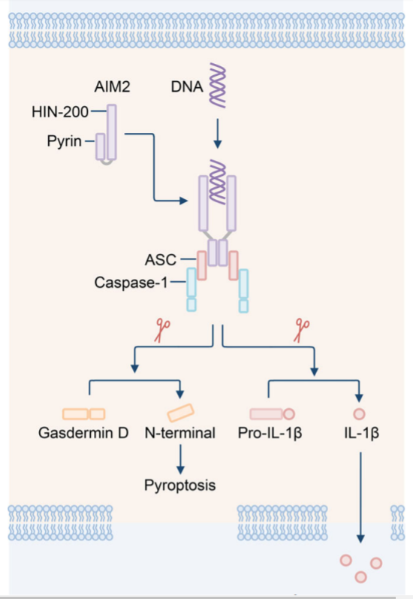
One such complex that is upstream of caspase-1 is AIM2. The complex AIM2 is a DNA sensor that forms the inflammasome that forms the inflammasome after detecting cytoplasmic double stranded DNA (dsDNA). AIM2 is made up of two main domains, the pyrin domain at the N-terminal and the HIN-200 at the C-terminal. Both of these domains make an intramolecular complex and are maintained in an autoinhibitory state. AIM2 recognizes cytoplasmic dsDNA of viral or bacterial origin in a sequence-independent manner. The cytoplasmic dsDNA activate AIM2, in which the HIN-200 domain indiscriminately interacts with the DNA by binding to the sugar-phosphate backbone, regardless of sequence. While this is happening, the pyrin domain at the N-terminal of AIM2 binds to the pyrin domain of ASC (apoptosis-associated speck like protein containing a carboxy-terminal CARD). The CARD at the C-terminal of ASC binds to the CARD of procaspase-1. These events lead to the formation of the AIM2 inflammasome. The activated caspase-1 drives the cleavage of pro-cytokines pro-IL-1ꞵ and pro-IL-18, and it cleaves the substrate gasdermin D. Gasdermin D is important because a fragment of its N-terminal induces pyroptosis, which allows for IL-1ꞵ and IL-18 to release from the cell. These events are illustrated in the figure to the right. (Fig 1)
A very important part of this whole mechanism is the cytoplasmic DNA that activates AIM2. That cytoplasmic DNA is the DNA released from the mitochondria. The mitochondrial DNA (mtDNA) that is derived from the damaged mitochondria enters the cytoplasm of cells that undergo myocardial ischemia reperfusion injury.
Since mtDNA is necessary to induce the activation of AIM2, the hypothesis was formulated around this information: The mtDNA acts as a DAMP and could lead to the activation of AIM2. Consequently, it is important to test to see if the reduction of the DAMPs that activate AIM2 reduce its expression, leading to reduced inflammatory response, and therefore better response to therapy by reperfusion.

Experiment

The overview of the experiment is to focus on three main parts. Firstly, the reduction of AIM2 needs to be reduced. This will be observed by looking for reduced mRNA concentration ([mRNA]) and protein turnover in the mouse. After reducing AIM2 expression, it would be necessary to confirm AIM2 inhibition. While doing that, it will also be necessary to keep a lookout for reduced caspase-1, as a readout of inflammasome formation, since its activation is downstream of inflammasome formation. Finally, the last part is to see the overall effect on quality of repair, by measuring infarct size and heart function.

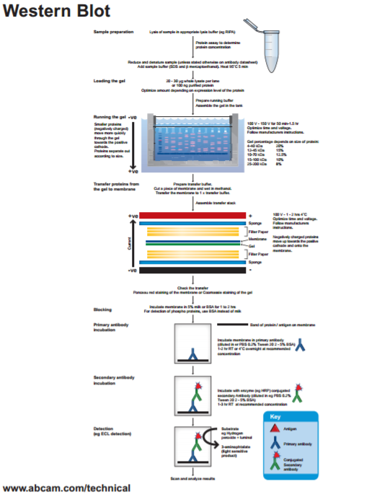
The first part of the experiment, as previously mentioned, is the reduction of AIM2 expression and the measurement to confirm if expression is in fact reduced. There are two methods to reduce AIM2. First, directed short interfering RNAs (siRNAs) can be used to specifically block the transcription of the AIM2 gene. After that, the presence of AIM2 would need to be confirmed by performing a Western blot. This would be following the standard Western Blot protocol, as found in the protocol booklet by AbCam. The purpose of the Western blot, as stated previously, is to confirm the reduction of AIM2, which is necessary to make sure the ischemic mechanisms are taking place, but without the binding to cytoplasmic mtDNA. Another way to reduce AIM2 is to just use commercially available AIM2 knockout mice. A western blot could be done with the heart cells from these mice, but more than likely they will have confirmed reduced AIM2 expression.

After confirming AIM2 reduction, it will be necessary to induce the myocardial ischemia and reperfusion injury in the mouse. This procedure is surgically based. The first step requires for a suture to be tied around a coronary artery, including a plastic tube inside the loop to compress the coronary artery. The artery is then closed of for about 30 minutes, and then it is opened by removing the plastic tube. This allows for reperfusion, which should be allowed to occur for 24 hours. After that period of 24 hours reperfusion has passed, a combination of stains should be used to observe the heart cells in the mice. The combination includes Triphenyl tetrazolium chloride (TTC) and Evan’s blue, which will help to see the unaffected cells, dead cells, and cells that were at risk.
Finally, it needs to be measured to see if the mitochondrial DNA is released into the cytoplasm. The best way to measure for this is through real time PCR (polymerase chain reaction). The protocol for the real time PCR is the standard protocol provided by ThermoFisher. The sample for the real time PCR will be from the mouse heart. From this, a mitochondrial and cytoplasmic extract should be prepared. The DNA from those should be precipitated. The real time PCR should be run on the cytoplasmic fraction to measure how much mitochondrial DNA can be found in the cytoplasm. After that, a quantitative analysis should be performed using a known amount of mtDNA to prepare a standard curve to use to quantify the DNA.

Discussion

After performing the aforementioned experiments, there are certain results that are hoped to be obtained in terms of the AIM2 and the Mitochondrial DNA. In terms of the mtDNA presence, the expected results would be that inhibited AIM2 sample would have intact mtDNA, as opposed to the mtDNA in the cells with AIM2 expression. These samples for the mtDNA will be reflected in the real time PCR results. In terms of the AIM2 silencing, or the knocking out, not much should have to be spent on the confirmation that AIM2 expression is reduced. However, it is definitely important to check to see if caspase-1 activity is reduced in response to the reduction of AIM2 expression. The small benchmarks would be the results from the Western blots. In the overall picture, this would be noted by the improvement in heart function and reduction of cell death after reperfusion due to lack of pyroptosis in the area affected during ischemia.
Although the hope is for the tests to yield clear results that would help to form conclusions, however there may be some issues that may arise. There may be other factors that weigh in on the pyroptotic response of the cell other than the AIM2 inflammasome, skewing the overall result of the reduced cell death and improved heart function. Additionally, it may be a possibility that the inhibition of AIM2 expression does not confirm the inability of inflammasome to assemble. This means that other inflammasome receptors other than AIM2 should be tested.
The final hopes for this proposal is that it would lead to the need of developing specific AIM2 inhibitors that could be used to reduce AIM2 activity following AMI. This would help to reduce injury in the heart after reperfusion, which would ultimately reduce infarct size in patients of AMI.

References

Buja, L.M. (2005) Myocardial ischemia and reperfusion injury. Cardiovascular Pathology, 14. 170-175. doi:10.1016/j.carpath.2005.03.006

Hausenloy, D., Yellon, D. (2013) Myocardial ischemia-reperfusion injury: a neglected therapeutic target. The Journal of Clinical Investigation, 123(1) : 92–100. doi:10.1172/JCI62874

Jabir, M., Hopkins, L., Ritchie, N., Ullah, I., Bayes, H., Li, D., Tourlomousis, P., Lupton, A., Puleston, D., Simon, A., Bryant, C., and Evans, T. (2015) Mitochondrial damage contributes to Pseudomonas aeruginosa activation of the inflammasome and is downregulated by autophagy. Autophagy, 11(1). pp. 166-182. http://dx.doi.org/10.4161/15548627.2014.981915

Lian, Q., Xu, J…..Geng, M. (2017) Chemotherapy-induced intestinal inflammatory responses are mediated by exosome secretion of double-strand DNA via AIM2 inflammasome activation. Springer Nature: Cell Research. 1-17. doi:10.1038/cr.2017.54

Mangino, M.J, Tian, T., Lindell, S.L. (2012). Ezring functionality and ischemia-reperfusion (I/R) injury in transplantation. The FASEB Journal, 26: 56.7. Retrieved from: http://www.fasebj.org/content/26/1_Supplement/56.7.short

Marchetti, C., Chojnacki, J., Toldo, S.,...Abbate, A. (2014) A novel pharmacologic inhibitor of the nlrp3 inflammasome limits myocardial injury following ischemia-reperfusion in the mouse. J Cardiovasc Pharmacol. 63(4): 316–322. doi:10.1097/FJC.0000000000000053.

Mezzaroma, E., Toldo, S.,....Abbate, A. (2011) The inflammasome promotes adverse cardiac remodeling following acute myocardial infarction in the mouse. PNAS, 108(49). 19725-19730. doi:10.1073/pnas.1108586108.

Ming Man, S., Karki, R., Kanneganti, T. (2016) AIM2 inflammasome in infection, cancer, and autoimmunity: Role in DNA sensing, inflammation, and innate immunity. European Journal of Immunology, 46. 269-280. DOI: 10.1002/eji.201545839

Murphy, E., Steenberg, C. (2008) Mechanisms underlying acute protection from cardiac ischemia-reperfusion injury. Physiology Review, 88. 581-609. doi:10.1152/physrev.00024.2007.

Toldo, S., Arrosa, J.F.,...Quader, M. (2016) Determination of optimal coronary flow for the preservation of “donation after circulatory death” heart. Circulation, (134): A18989. Retrieved from: http://circ.ahajournals.org/content/134/Suppl_1/A18989

Toldo, S., Marchetti, C.,..., Abbate, A. (2016) Inhibition of NLRP3 inflammasome limits the inflammatory injury following myocardial ischemia–reperfusion in the mouse. International Journal of Cardiology, 209: 215-220. doi: http://dx.doi.org/10.1016/j.ijcard.2016.02.043

Trankle, C., Thurber, C.J., Toldo, S., Abbate, A. (2016) Mitochondrial membrane permeability inhibitors in acute myocardial infarction: still awaiting translation. JACC: Basic To Translational Science, 1(6): 524-535. doi: http://dx.doi.org/10.1016/j.jacbts.2016.06.012

Protocols:
http://docs.abcam.com/pdf/protocols/general-western-blot-protocol.pdf

https://www.thermofisher.com/content/dam/LifeTech/Documents/PDFs/PG1503-PJ9169-CO019861-Update-qPCR-Handbook-branding-Americas-FLR.pdf

Protocol Image:
http://www.abcam.com/ps/pdf/protocols/Western_blot_diagram.pdf

