Determination of Short Fragments of Amyloid Beta
Which Are Able to Bind Apolipoprotein E

I. Introduction

Alzheimer’s disease is a neurological disorder which affects the ability of the brain to store and retrieve memories. It is estimated that 5.4 million Americans currently have Alzheimer, and projections have estimated that by the middle of the century, that number is expected to grow to 13.8 million¹. Unfortunately for those diagnosed, there is no known cure for Alzheimer’s. There are drugs that are able to slow advancement of the disease, such as acetylcholinesterase inhibitors², but they can only slow the inevitable. However, as research on the development of Alzheimer’s continues, new pathways have been discovered that present possible targets for drug therapy.

When the brains of those who die of Alzheimer’s are studied, one of the commonalities that researchers have found is the presence of plaques composed of amyloid beta (Aβ) fibrils, fibrils being threadlike fibers composed of amyloid beta. The length of Aβ varies from 36 to 43 residues, with the two most common peptides in plaques being Aβ1-40 and Aβ1-42⁹. Aβ’s function is not well known; it seems to have various functions, as silencing its activity can lead to neuronal cell death⁸. It is formed from the cleavage of amyloid precursor protein (APP), which is an integral membrane protein present mainly in neurons. APP’s function is also not well known, with its most notable characteristic being that it is the protein cleaved to form Aβ. The presence of Aβ in plaques led to the proposal of the amyloid cascade hypothesis (ACH)³. This hypothesis states that the cause of Alzheimer’s is the build-up of Aβ in the brain. This build-up results in aggregation into fibrils, which then aggregate into plaques. These plaques lead to neuronal injury and death.

One protein that has been shown to increase Aβ aggregation is Apolipoprotein E (APOE)⁴. APOE is normally a lipid transporter in the brain, serving as the principal transporter of cholesterol in the brain⁵. It exists in three different isoforms, APOE2, APOE3, and APOE4. Of these isoforms, APOE4 demonstrates the strongest binding affinity of the three⁶. These variations in APOE are looked for in genetic screenings as risk factors for developing Alzheimer’s, with the presence of APOE4 being associated with an increased risk of developing Alzheimer’s. The presence of APOE2 correlates to a decreased risk, while APOE3 is the “neutral” variant¹. A proposed mechanism by which APOE facilitates Aβ aggregation is shown in Figure 1.
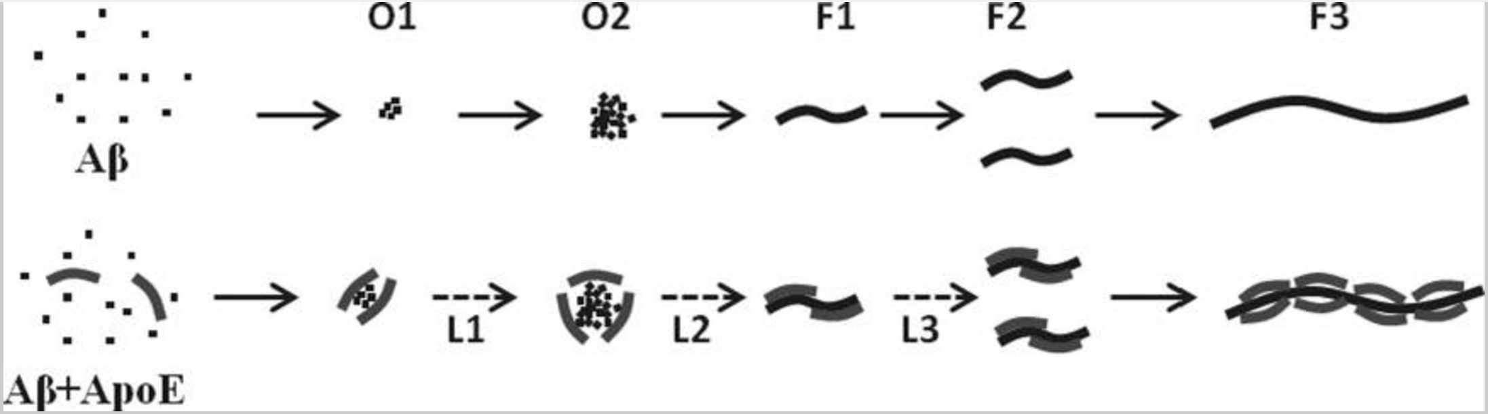
Figure 1. A proposed mechanism by which APOE facilitates Aβ aggregation. APOE allows Aβ to aggregate and form fibrils. It can then transport the fibrils, furthering aggregation. From Garai et. al (2014).
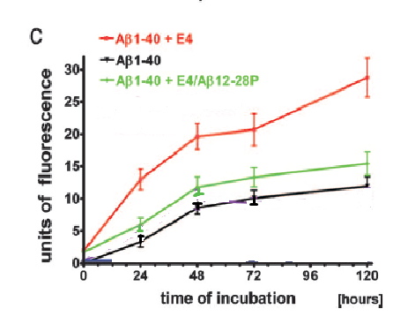
Because of APOEs ability to facilitate Aβ aggregation, inhibiting the APOE-Aβ binding complex presents a possible path for disrupting aggregation. When competitive inhibitors are present to interrupt the complex formation, aggregation levels are reduced. One such inhibitor that is used is Aβ12-28, a peptide consisting of Aβ residues 12-28⁷. These residues correspond to the portion of Aβ that binds APOE¹⁰. In Sadowski et. al (2006), the authors demonstrated the effect of an inhibitor based on Aβ12-28. They used Aβ12-28P, which replaces a valine at residue 18 with a proline. This change made the peptide nonfibrillogenic by disrupting the hydrophobic region. The presence of Aβ12-28P almost completely abolished the effect that APOE4’s presence had on aggregation. Another study done by Hao et. al (2010) tested the inhibiting ability of Aβ20-29. Their experiment resulted in reduced aggregation levels¹⁴. This result suggests that though residues 12-28 are the binding site, small portions of the binding site may be capable of binding Aβ competitively.
Figure 2. An aggregation assay which used Thioflavin T as a fluorescent tag to measure levels of amyloid beta aggregation. Fluorescence was highest when Aβ1-40 and APOE4 (E4) were combined, but that fluorescence was cut almost in half if APOE4 Aβ12-28P (a variant with a V P mutation at residue 18) was introduced. From Sadowski et. al (2006).

While the ability of peptides to inhibit the binding of APOE and Aβ is effective in vitro, peptide inhibitors usually have stability problems when they are used as drugs¹¹. These problems interfere with efficient delivery in the body, including passing through the blood brain barrier or being properly digested. One way around these problems is structure-based drug design. This process takes the known structure of a peptide and uses it to design a drug similar in structure. Peptides can be small or large, but smaller peptides about 6-8 residues in length are easier to model after.

If a small Aβ peptide chain shows strong inhibiting capabilities, then it may be a good candidate for structure-based drug design. Given that the binding site of amyloid beta is residues 12-28, it seems rational to focus on these residues for finding a shorter peptide inhibitor. The purpose of the following proposed experiment is to determine if short, 6-8 residue sections within Aβ12-28 are capable of inhibiting the APOE-Aβ binding complex.

II. Experiment

The goal of this experiment is to find a short section or multiple short sections of 6-8 residues within Aβ12-28 that will inhibit the APOE-Aβ binding complex. In order to do this, Aβ12-28 will be cut on each end by four amino acids. This product will then be cut again by one amino acid from each side, and then one from both sides. The peptides being tested and their lengths are as follows:

Peptides | Number of Residues
Aβ17-23 | 6
Aβ17-24, Aβ16-23 | 7
Aβ16-24 | 8

An aggregation assay is a technique used to test levels of protein aggregation in the presence of a specific compound. In some cases, fluorescent tags are used to visualize aggregation levels. This technique was utilized by Sadowski et. al (2006) and Hao et. al (2010), with both studies having using fluorescent intensity as the measurement for aggregation. Both studies took a measurements over a period of five days. In this experiment Thioflavin T, which binds to amyloid-beta aggregations, will be used as the fluorescent tag. Thioflavin T (ThT) is a benzathiole compound which selectively binds to amyloid deposits¹². This binding is thought to be due to how ThT interacts with layers of beta sheets, however the mechanism is not yet fully understood. Normally, ThT absorbs approximately 340 nm wavelengths of light. When interacting with amyloid-like structures this peaks to 440, which results in fluorescent enhancement¹³.

Aggregation Assays with Aβ Derived Peptides
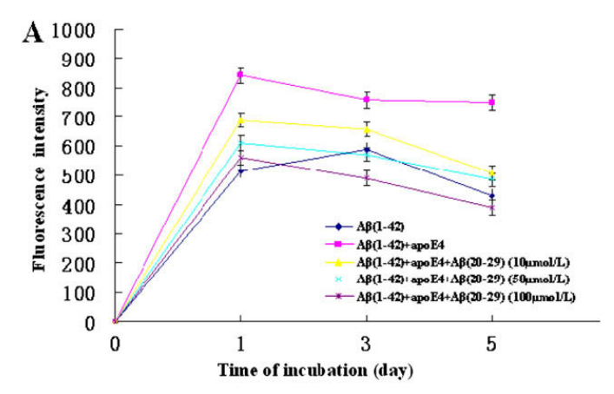
Because APOE4 has been shown to cause higher levels of aggregation than the other two isoforms, it will be used in the aggregation assays. Additionally, Aβ1-42 will be used in the aggregation assays. The assays prepared will test the ability of Aβ12-28 derived peptides to inhibit the interaction of APOE4 and Aβ1-42. In order to establish a baseline for comparison of aggregation in the presence of the derived peptides, there will be two controls: an aggregation assay of just Aβ1-42 and an aggregation assay of APOE4 and Aβ1-42. Modeling after protocol set forth by Hao et. al (2010), each peptide will be tested at varying concentrations in order to
Figure 3. Fluorescence levels from aggregation assays testing aggregation of Aβ1-42. Aggregation is tested individually, in the presence of APOE4, and in the presence of APOE4 and three varying concentrations of Aβ20-29.The presence of inhibitors results in decreased fluorescent intensity. From Hao et. al (2010).
determine if a specific concentration is needed to inhibit. Every six hours for 120 hours, a sample will be taken. ThT will be added to the sample and a period of incubation will take place. Following incubation, a spectrofluorometer will be used to measure the level of fluorescence of the sample. This will be done for all of the samples and the controls. At the end of the 120 hour period, fluorescent intensity from the controls and the test assays will be compared. These comparisons will show if the presence of Aβ derivative peptides reduced aggregations when compared to the control assays.

III. Discussion

The ideal result of this experiment is that the presence of the peptides being tested for inhibiting capabilities will result in fluorescence intensities which are lower than those measured in assays of Aβ and APOE. These results would suggest that the peptides display some ability to reduce aggregation. However, the world is not always ideal and so there are two other possibilities which should be addressed. The first is that the peptides’ presence does not affect fluorescent intensity at all, which would suggest no change in aggregation levels. The second possibility is that the presence of the peptides increases fluorescent intensity, suggesting that the peptides likely add to or promote aggregations.

If the ideal result is obtained, then the research question will have been satisfied. The purpose of the experiment is to determine if there are 6-8 residue sections within Aβ12-28 that are capable of inhibiting the Aβ-APOE binding complex. If any sections are found, then they could be used as a starting point for structure-based drug design. This result could also shed new insight into the binding of Aβ and APOE, showing that certain residues may bind more strongly to APOE. If peptides retaining more residues on the N-terminal end show greater inhibition, then those results in addition to results from Hao et. al (2010) would lend support to focusing on cutting from the C-terminal when creating shorter peptides from Aβ12-28. In addition, the way that cuts were made allows for suggestions of whether the C- or N-terminal should be focused on when considering residues to cut i.e. if Aβ16-28 showed greater inhibition capabilities than Aβ12-24, then future experiments might focus on cutting more from the C-terminal.

Alternatively, the research question would not be satisfied with the other two results. If no 6-8 residue section of Aβ12-18 is found to decrease aggregation levels, then they are likely not inhibitors. If 6-8 residue sections increase aggregation levels, then they also are not likely to be inhibitors. However, these results could still shed light onto the qualities of Aβ. If the peptides increase aggregation levels, then they may shed light on key residues in the development of fibrils.

When measuring fluorescent intensity, conditions for Thioflavin T staining must be carefully controlled. While ThT is referred to as the “golden standard”¹² of amyloid fibril detection, this is only because it is better than other dyes. It will still bind to other molecules, namely the hydrophobic regions of globular proteins¹⁵. While this may be more relevant in in vivo experiments, extra precaution should be taken so that ThT does not bind materials used during the experiment.

The peptides tested in this experiment were used because they were even cuts from Aβ12-18 that were 6-8 residues long. There are many other possible sections that are 6-8 residues long, and they all are just as legitimate of candidates. However, this study is limited in that it does not test all 29 possible residues which are 6-8 residues in length. What it does do is take a sample by cutting equally from the C- and N-terminals in such a way that five possible peptides are produced which range from 6-8 residues in length. As mentioned above, this may lead to suggestions on whether to cut from the C-terminals, N-terminals, or both.

This study is also limited to in vitro analysis. While this allows for controlled interactions between only Aβ and APOE, the human body does not control their interactions. There are many complex biological factors that cannot be taken into account in vitro that future studies would need to take into account. The usage of mouse models was utilized in Sadowski et. al (2006) in order to measure the effect of Aβ12-28 on Aβ aggregations in the brain. If this experiment were to be expanded, a similar set of experiments using mouse models would be done in order to test the capabilities of the peptides in vivo.

Despite these limitations, finding a way to inhibit the Aβ-APOE binding complex may be a large step in the fight against Alzheimer’s. It is known that APOE promotes aggregation, and it is known that some people have a higher risk of developing Alzheimer’s because of the isoform of APOE that is expressed in their bodies. However, there exist no treatments that currently focus on inhibiting this interaction in humans. By continuing research into effective ways to block this interaction, we may take a large step towards greatly reducing the number of those who suffer from Alzheimer’s.

References
1. Alzheimer’s Association. 2016. 2016 Alzheimer’s disease facts and figures. Alzheimer’s & Dementia: The Journal of the Alzheimer’s Association, 12(4): 459-509.
(https://www.ncbi.nlm.nih.gov/pubmed/27570871#)

2. Kumar, A., Singh, A., Ekavali. 2014. A review on Alzheimer’s disease pathophysiology and its management: an update. Pharmacological Reports, 67(2): 195-203.
(http://www.sciencedirect.com.proxy.library.vcu.edu/science/article/pii/S1734114014002886)

3. Barageb, S.H., Sonawane, K.D. 2015. Amyloid cascade hypothesis: Pathogenesis and therapeutic strategies in Alzheimer’s disease. Neuropeptides, 52: 1-18.
(http://www.sciencedirect.com/science/article/pii/S0143417915000657)

4. Castano, E.M., Prelli, F., Wisniewski, T., Golabek, A., Kumar, R.A., Soto, C., Frangione, B. Fibrillogenesis in Alzheimer's disease of amyloid beta peptides and apolipoprotein E. Biochemical Journal, 306(2): 599-604.
(http://www.biochemj.org/content/306/2/599)

5. Puglielli, L., Tanzi, R.E., Kovacs, D.M. 2003. Alzheimer’s disease: the cholesterol connection. Nature Neuroscience, 6: 345-351.

6. Garai, K., Verghese, P. B., Baban, B., Holtzman, D. M., & Frieden, C. 2014. The Binding of Apolipoprotein E to Oligomers and Fibrils of Amyloid-β Alters the Kinetics of Amyloid Aggregation. Biochemistry, 53(40), 6323–6331.
(https://www.ncbi.nlm.nih.gov/pmc/articles/PMC4196732/)

7. Sadowski, M. J., Pankiewicz, J., Scholtzova, H., Mehta, P. D., Prelli, F., Quartermain, D., & Wisniewski, T. (2006). Blocking the apolipoprotein E/amyloid-β interaction as a potential therapeutic approach for Alzheimer's disease. Proceedings of the National Academy of Sciences of the United States of America, 103(49), 18787–18792.
(http://www.pnas.org/content/103/49/18787.full)

8. Hardy, J., & Higgins, G. (1992). Alzheimer's Disease: The Amyloid Cascade Hypothesis. Science, 256(5054), 184-185.
(http://www.jstor.org /stable/2876981)

9. Marsden, I. T., Minamide, L. S., & Bamburg, J. R. (2011). Amyloid-β-induced amyloid-β secretion: A possible feed-forward mechanism in Alzheimer disease. Journal of Alzheimer’s Disease : JAD, 24(4), 681–691.
(https://www.ncbi.nlm.nih.gov/pmc/articles/PMC4447202/)

10. Strittmatter, W. J., Weisgraber, K. H., Huang, D. Y., Dong, L. M., Salvesen, G. S., Pericak-Vance, M., … Roses, A. D. (1993). Binding of human apolipoprotein E to synthetic amyloid beta peptide: isoform-specific effects and implications for late-onset Alzheimer disease. Proceedings of the National Academy of Sciences of the United States of America, 90(17), 8098–8102.
(https://www.ncbi.nlm.nih.gov/pmc/articles/PMC47295/)

11. Adessi, C.; Soto, C. 2002. Converting a Peptide into a Drug: Strategies to Improve Stability and Bioavailability. Current Medicinal Chemistry, 9(9): 963-978.
(http://www.ingentaconnect.com/contentone/ben/cmc/2002/00000009/00000009/art00005)

12. Biancalanaa, M., Koide, S. Molecular mechanism of Thioflavin-T binding to amyloid fibrils. Biochimica et Biophysica Acta – Proteins and Proteomics, 1804(7): 1405-1412.
(http://www.sciencedirect.com/science/article/pii/S1570963910000993)

13. Wolfe, L. S., Calabrese, M. F., Nath, A., Blaho, D. V., Miranker, A. D., & Xiong, Y. (2010). Protein-induced photophysical changes to the amyloid indicator dye thioflavin T. Proceedings of the National Academy of Sciences of the United States of America, 107(39), 16863–16868.
(https://www.ncbi.nlm.nih.gov/pmc/articles/PMC2947910/)

14. Hao, J., Zhang, W., Zhang, P., Liu, R., Liu, L., Lei, G., Su, C., Miao, J., Li, Z. 2010. Aβ20–29 peptide blocking apoE/Aβ interaction reduces full-length Aβ42/40 fibril formation and cytotoxicity in vitro. Neuropeptides, 44(4): 305-313.
(http://www.sciencedirect.com/science/article/pii/S0143417910000296)

15. Groenning, M., Olsen, L., van de Weer, M., Flink, J.M., Frokjaer, S., Jørgensen, F., S. 2007. Study on the binding of Thioflavin T to β-sheet-rich and non-β-sheet cavities, Journal of Structural Biology 158(3): 358-369. (http://www.sciencedirect.com/science/article/pii/S1047847706003923)

