- Introduction
Lung cancer is a leading cause of cancer related death. There are two types of lung cancer, small cell and non small cell. Non small cell lung cancer is the more common, accounting for 85% of all lung cancer cases in the United States (Molina et al, 2009). One cause of non small cell lung cancer is attributed to mutations in the epidermal growth factor receptor (EGFR) gene.
EGFR, also known as ErbB-1, is one receptor in a family of four receptor tyrosine kinases. When bound to the epidermal growth factor ligand, it undergoes a conformational change and forms a dimer. Once in the dimerized state, tyrosine residues on the intracellular kinase domain of the receptor are phosphorylated by ATP. This allows the receptor to initiate signaling pathways by phosphorylating secondary messengers (Yarden 2001). EGFR stimulates cell growth and proliferation by activating pathways such as PI3K/AKT, STATs, and ERK. Two main types of EGFR mutations result in uncontrolled cell proliferation. EGFR is either mutated to be constitutively (continuously) active, or over expressed in the cell membrane (Gazdar 2009).
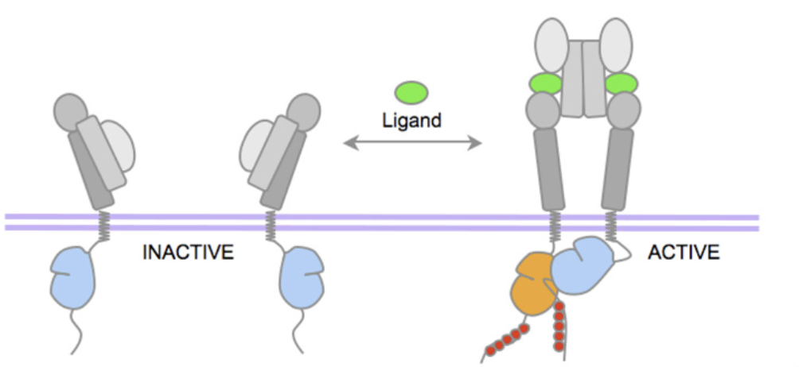
Constitutively active mutant EGFR is generally attributed to mutations in exons 18-21, which code for part of the kinase domain of the receptor. When in the dimerized (active) conformation, the kinase domain binds and hydrolyzes ATP phosphorylating the receptor’s tyrosine residues. Activating mutations alter the kinase domain so it can bind ATP in the absence of an extracellular ligand (Kumar et al, 2008)

Fig 1.
Adapted from Gazdar et al. Shows the inactive and active states of EGFR before and after ligand binding. Tyrosine kinase domain below the purple membrane changes conformation to initiate pathways.
The most common therapies for activating EGFR mutations are small molecule inhibitors that competitively bind to the mutated ATP binding site of the kinase domain. Some common tyrosine kinase inhibitors (TKIs) include drugs Gefitinib and Erlotinib. These drugs, however, have been shown to mainly be effective for exon 19 deletions and exon 21 substitutions. Other mutations, especially those in exon 20, are resistant to TKIs (Sharma et al, 2007) The mechanism of this resistance is not well understood and poses an obstacle for treatment.
Yasuda et al (2013) investigated this resistance. They created seven different cell lines, each expressing a different exon 20 mutation. These cell lines were then exposed to the TKI, Erlotinib. Response of EGFR was measured by Western blotting of EGFR and downstream proteins, AKT and ERK. While six of the seven mutations were resistant to Erlotinib, one displayed sensitivity. After exposure to Erlotinib, no phosphorylated EGFR was detected by Western Blotting.
There is currently no comprehensive study of all resistant or sensitive exon 20 mutations (Russo et al, 2015). The purpose of this study is to determine whether there are other, not previously reported, TKI-sensitive exon 20 mutations.

- The Experiment
This experiment seeks to test clinically prevalent exon 20 mutations for sensitivity to Erlotinib in vitro. Exon 20 mutations are highly variable, with one of the most common mutations only constituting about 22% of all cases (Oxnard et al 2013). Several retrospective studies asses incidence of exon 20 mutations in different populations. Yasuda et al cover almost all of the mutations found in Arcila et al. However, Oxnard et al conduct a similar review of 1086 NSCLC and provide incidence of a few different exon 20 mutations. Ma et al 2015 conduct a review of 942 NSCLC patients. Below are the most common mutations from both studies, not covered by Yasuda et al.
H773_V774insPH
H773_V774insNPH
V774_C775insHV
D770delinsGY
N771_P772insV
P772_H773insPNP
D770_N771insGL
N771delinsGY
H773_V774insAH
A767_TLA_S768
V769_CV_D770
V769_Y_D770
Mutations will then be constructed using cDNA and expressed into plasmids by site-directed mutagenesis. This plasmid will then be transfected into Ba/F3 cells using a retrovirus. Cells stably expressing mutant EGFR will be exposed to Erlotinib for 6 hours at a concentration of 1_{μM} (Yasuda et al 2013). Cells will then be exposed to EGF, lysed and cell extracts will be visualized by Western Blotting. If phosphorylated EGFR is present after exposure to Erlotinib, the mutation is not TKI-sensitizing.

Expression of mutant EGFR
Mutant constructs are created by site-directed mutagenesis (Yasuda et al 2013). First, a plasmid is created containing the wild type EGFR gene. Forward and reverse primers are then created for each desired mutation. These primers anneal to the complementary strands of the parent plasmid and PCR initiates DNA synthesis. Once completed, a new plasmid with a mutated version of the target gene, in this case wild type EGFR, has been created.
These plasmids can then be transfected into cells using a retrovirus. Transfection by definition is the introduction of nucleic acids into a cell, in this case the introduction of a plasmid or a viral vector (Kim et al 2010). This viral vector contains the genetic information for the target protein (mutant EGFR cloned by site-directed mutagenesis) as well as the information for a selective marker. This selective marker will help distinguish which cells have been successfully transfected. The MigR1 retroviral vector expresses a green fluorescent protein when successfully integrated into the host cell’s DNA (Pear et al 1998). The MigR1 viral vector can be transiently transfected into Bosc23, a packing cell line. When Bosc23 cells are transfected with a viral vector, they synthesize all proteins necessary to produce an infectious virus since the viral vector cannot replicate itself (Liebert 1990). This allows for the creation of a large number of retroviruses, ready to transfect cells stably. The retrovirus can then transfect Ba/F3 cells and the viral vector will combine with the cells genome. Ba/F3 cells that have been successfully transfected will express the green fluorescent protein as well as the desired mutant EGFR. Ba/F₃ cell growth is dependent on Interleukin Factor (IL₃). Since constitutively active EGFR causes uncontrolled cell proliferation, successful transfection will also be indicated by cell growth in the absence of IL₃ (.

Western Blotting to determine sensitivity
Once Ba/F3 cell lines are stably expressing the EGFR mutations, they will be exposed to Erlotinib for six hours at a concentration of 1 μM. The cells will then be exposed to the Epidermal Growth Factor (EGF) ligand in order to stimulate EGFR. Ba/F3 cells will then be lysed and analyzed by Western Blotting. Proteins visualized will be EGFR and others that play a role in the signaling pathways controlling growth and proliferation, such as AKT and ERK. Western blotting technique involves separating proteins by size and charge on SDS-polyacrylamide gel. Proteins are then transferred from the gel to a solid polyvinyl fluoride or nitrocellulose membrane. Each protein is tagged by a specific primary and secondary antibody (Mahmood and Yang, 2012). The primary antibody binds directly to the protein at a specific residue. For EGFR, the antibody binds to the phosphor-tyrosine 1068 residue. Akt is identified by the pS473 residue, and ERK ½ by the pT202 and pY204 (Yasuda et al 2013). The secondary antibody binds to the primary antibody and is visualized by film.
- The Discussion
It is possible that this experiment will identify at least one exon 20 mutation that displays in vitro sensitivity to Erlotinib, there by opening conversation for new treatment options regarding that mutation. However, it is also possible that none of the mutations in question will be TKI-sensitizing. Furthermore, sensitivity to Erlotinib in the form of EGFR inhibition does not necessarily indicate the TKI as a viable treatment.
Any mutation found to be sensitive should be subject to a follow up study assessing dose response. It is important that the mutation have a higher affinity for TKI than wild type EGFR in order to create a therapeutic window for treatment (Yasuda et al 2013). It would be useful to determine the Km of an exon 20 mutation that displayed in vitro sensitivity to Erlotinib.
This experiment seeks to investigate clinically prevalent mutations but exon 20 mutations are highly variable. There are still cases in which patients exhibit mutations with no available data. Most data comes from retrospective studies of specific populations (Arcila et al 2013, Oxnard et al 2013). A centralized database that compiles information from both retrospective studies as well as in vitro studies is needed to better characterize and treat mutations.

References:
Molina JR., Yang P., Cassivi S.D., Schild S.E., and Adjei A.E. 2008. Mayo Clin Proc. 83(5) Non–Small Cell Lung Cancer: Epidemiology, Risk Factors, Treatment, and Survivorship.

Yarden Y. 2001. European Journal of Cancer. 37(4). Pg 3-8. The EGFR family and its ligands in human cancer: signalling mechanisms and therapeutic opportunities

Gazdar A.F. 2009. Oncogene. 28(1). Activating and resistance mutations of EGFR in non-small-cell lung cancer: role in clinical response to EGFR tyrosine kinase inhibitors. https://www.ncbi.nlm.nih.gov/pmc/articles/PMC2849651/#R46

Kumar A., Edward TP., Halmos B., Boggon T.J. 2008. 26(10). J. Clin Onco. The Structure and Clinical Relevance of the EGF Receptor in Human Cancer. https://www.ncbi.nlm.nih.gov/pmc/articles/PMC3799959/

Sharma S.V., Bell D.W., Settleman J. and Haber D.A. Nature Reviews Cancer. 2007. 168-191. Epidermal growth factor receptor mutations in lung cancer. https://www.nature.com/nrc/journal/v7/n3/full/nrc2088.html#B18

Arcila M. E. et al. Mol Cancer Ther. Feb 2013. 12(2): 220-229. EGFR Exon 20 Insertion Mutations in Lung Adenocarcinomas: Prevalence, Molecular Heterogeneity, and Clinicopathologic Characteristics https://www.ncbi.nlm.nih.gov/pmc/articles/PMC3714231/

Yasuda H. et al. Sci Transl Med. Dec 18, 2013. 5(216). Structural, biochemical and clinical characterization of epidermal growth factor receptor (EGFR) exon 20 insertion mutations in lung cancer https://www.ncbi.nlm.nih.gov/pmc/articles/PMC3954775/

Pao W. et al. PLoS Med. Mar, 2005. 2(3). Acquired Resistance of Lung Adenocarcinomas to Gefitinib or Erlotinib Is Associated with a Second Mutation in the EGFR Kinase Domain https://www.ncbi.nlm.nih.gov/pmc/articles/PMC549606/
Oxnard G.R., Lo P.C., Nishino M., Dahlberg S. E., Lindeman N. I., Butaney M., Jackman D. M., Johnson B. E., Jänne P. A. Journal of Thoracic Oncology. 2013. 8(2). 179-184. Natural History and Molecular Characteristics of Lung Cancers Harboring EGFR Exon 20 Insertions. http://www.jto.org/article/S1556-0864(15)32739-8/fulltext#tbl1

Pear W. S., Nolan G. P. Scott M. L., and Baltimore D. Production of high-titer helper-free retroviruses by transient transfection. 1993. Proc Natl Acad Sci. Vol 90. http://www.pnas.org/content/90/18/8392.full.pdf

Kim T. K., Eberwine J. H. 2010. Anal Bioanal Chem. 397(8). Mammalian cell transfection: the present and the future. https://www.ncbi.nlm.nih.gov/pmc/articles/PMC2911531/

Mahmood T., Yang P. C. 2012. N Am J Med. 4(9). Western Blot: Technique, Theory, and Trouble Shooting. https://www.ncbi.nlm.nih.gov/pmc/articles/PMC3456489/

Jiang J, Greulich H, Jänne PA, Sellers WR, Meyerson M, Griffin JD. 2005. Cancer Res. 65 (19). Epidermal Growth Factor–Independent Transformation of Ba/F3 Cells with Cancer-Derived Epidermal Growth Factor Receptor Mutants Induces Gefitinib-Sensitive Cell Cycle Progression. https://www-ncbi-nlm-nih-gov.proxy.library.vcu.edu/pubmed/16204070?dopt=Abstract&holding=npg

Russo A. et al. Oncotarget. Sep 29, 2015. 6(29): 26814-26825. A decade of EGFR inhibition in EGFR-mutated non small cell lung cancer (NSCLC): Old successes and future perspectives
Lichun Ma, Wang D. D., Huang Y., Yan H., Wong M. P. and Lee HF. 2015. BMC Bioinformatics. EGFR Mutant Structural Database: computationally predicted 3D structures and the corresponding binding free energies with gefitinib and erlotinib. https://bmcbioinformatics.biomedcentral.com/articles/10.1186/s12859-015-0522-3

