Relating the structure of aggregated alpha synuclein in Parkinsonian neurons to its preferential binding on the outer mitochondrial membrane
- Introduction
Parkinson’s disease is a progressive disorder of the nervous system that affects the human body through the occurrence of motor and non-motor symptoms. Many researchers and scientists concur that the incidence of Parkinson’s disease is on the rise, almost doubling, between 1976 and early 2000s (Medscape). One of the reasons for the rise is because of the inability to effectively recognize and treat the disease. Parkinson’s disease does not have a diagnostic test, therefore, is solely diagnosed on the basis of clinical non-motor, depression, memory problems, and hallucinations, and motor symptoms, trembling, problems with gait, and balance.
These symptoms arise due to the degeneration of dopaminergic neurons, a neuron which releases dopamine (Jankovic). Dopamine is a neurotransmitter that functions in a multi-dimensional manner. Its multifaceted effect can be observed in the variety of symptoms produced, ranging from non-motor to motor complications. Dopamine is transported into the synaptic cleft by a vesicle where alpha-synuclein, a cytoplasmic protein, resides (Burre). Homeostatic alpha synuclein resides in the presynaptic terminal at high frequencies to assist the neurotransmitters’ ability to exocytose the presynaptic neuron. It is a protein that assists the formation of small vesicles around a neurotransmitter to aid in the process of exocytosis. In its “natively unfolded” form alpha-synuclein occurs as a soluble, in cytosol, tetramer, which resists aggregation (Bartels).
In Parkinsonian neurons, alpha synuclein aggregates due to oxidative stress. The aggregation of alpha synuclein (AAS) prevents it from functioning as it does in its native state. AAS significantly impacts the neurotoxicity of dopaminergenic neurons in the substantia nigra because of its ability to aggregate on the lipid membranes of organelles. One of the reasons alpha synuclein is able to preferentially bind to lipid membranes is because of AAS ability to change from a soluble form to an insoluble form. The change in its physical interaction with other molecules enables it to permeate the hydrophobic portion of the outer mitochondrial membrane, resulting in mitochondrial stress (loss of mitochondrial membrane potential).
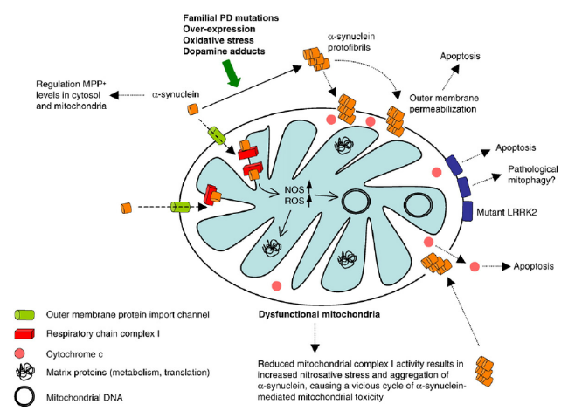

Fig 1. Aggregated alpha synuclein are permeable to the mitochondrial membrane causing mitochondrial dysfunction. AAS associated with PD occurs mainly due to familial PD mutations and oxidative stress on the cell. This causes the overproduction of alpha synuclein which is enhanced to bind to the hydrophobic portions of the mitochondrial membrane. Once AAS binds this causes a dysregulation of mitochondrial activity by increasing the levels of reactive oxygen species (ROS). Homeostatic mechanisms in the cell combat this by apoptosis because the neuron is heavily dependent on mitochondrial activity for energy (Bueler).
Figure 1 is an in-depth depiction of the pathway in which AAS exacerbates mitochondrial stress to trigger apoptotic activities.
The homeostatic mechanisms of the cell override to maintain cellular potential in times of stress; therefore, a cellular response is elicited when AAS binds to mitochondrial membrane, such as apoptosis. The death of dopaminergenic neurons is one of the hallmarks of Parkinson’s disease.
Many researchers undeniably conclude that this form of alpha-synuclein typify many neurodegenerative diseases such as Parkinson’s disease (Lashuel). Although, the observations above lend a hand in determining the function of aggregated alpha synuclein, a more detailed understanding is necessary. The purpose of this proposal is to explore the changes in conformation and modifications of residues from native state alpha synuclein to AAS.
- Experiment
Part A: Extraction of AAS & Immunoblotting
In order to conduct this experiment, small sample of basal ganglia human tissue should be acquired. Bandopadhyay (2016) outline a procedure that allows for the extraction of aggregated alpha synuclein from basal ganglia tissue in the form of a urea-soluble fraction. In this procedure, a tris-buffered Saline (TBS) solution is prepared to provide a buffered solution for the minced basal ganglia. Proteasome, protein that degrades other proteins, inhibitors and phosphatase inhibitors are introduced along with the TBS solution to prevent fragmentation of the alpha synuclein. This solution is homogenized and cooled on ice to prevent the insoluble parts from accumulating and sitting in solution. The TBS and basal ganglia solution is centrifuged to separate the different constituent parts of the basal ganglia. A centrifuge functions to separate fluids components at different densities. The supernatant (lower density) and pellets (higher density) form. The supernatant of the centrifuge is known as the TBS soluble fraction. It is called the TBS soluble fraction because this part of the centrifuged mixture is made up of the components of the basal ganglia that were able to mix with the TBS solution. The pellet, the insoluble portion of the basal ganglia when mixed with TBS solution, must be washed. The pellet must be washed again with TBS solution and then centrifuged again to prevent lingering TBS soluble fraction from being retained in the pellet. After washing the pellet of the second centrifuge, the solution must be allowed to cool to ten degrees Celsius. The increase in temperature prevents precipitation of the buffer. Following this step, 5 volumes of TBS-SDS, sodium dodecyl sulfate, were added to the solution. TBS-SDS is used to prepare brain tissue for microscopy techniques by binding to lipids and proteins from organ tissue. The addition of TBS-SDS acts as a detergent that disrupts noncovalent bonding, which causes the protein to lose its native conformation. After the addition of TBS-SDS, the pellet is re-suspended, completely broken down again, through sonication, a technique that uses sound energy to agitate particles in a sample. After sonication, the particles are ultracentrifuged. The supernatant is known as the SDS soluble fraction. The pellet is centrifuged again and TBS-urea is added. The TBS-urea and pellet solution is solubilized via sonication and is known as the urea-soluble fraction, this is the fraction which contains the AAS. Urea is a protein denaturant that breaks disulfide bonds and increases the solubility of AAS, since it is insoluble (Hummon).
Immunoblotting samples can be run from the three obtained samples: TBS soluble fraction, SDS soluble fraction, and urea-soluble fraction to determine the specific proteins in a sample extract. After the immunoblotting procedure was completed, the three immunoblots, as seen in Figure 2, were observed. The left hand side of the immunoblots represents the quantitative level of alpha synuclein at each type of fraction.
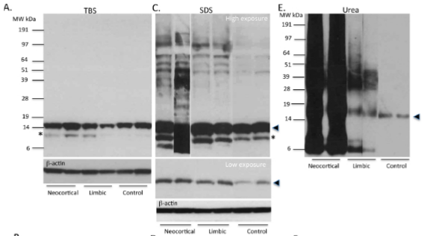
Figure 2: A representation of the immunoblots completed by Bandopadhyay (2012). Immunoblot A, represents the TBS-soluble fraction outlined in Part A. Immunblot C represents the TBS-SDS soluble fraction. Immunoblot E represents the urea soluble fraction. The arrow represents the location on the blot for native state of alpha synuclein. The asterisk represents locations that could exhibit truncated C terminus of alpha synuclein.
The immunoblots provide evidence to believe that the urea soluble fraction has a large amount aggregated alpha synuclein due to the increase in staining along the heavier molecular weight.
Part B: 2D SDS-PAGE
The purpose of the 2D SDS-PAGE (SDS-polyacrylamide gel electrophoresis) is used to analyze amino acid mixtures from extracted cells. This technique uses two dimensions: (1) isoelectric focusing and (2) SDS-polyacrylamide gel electrophoresis. The three fractions attained in the extraction procedure above are used in this procedure. The three fractions are poured into a manufactured isoelectric focusing strip, to be separated by isoelectric point. The isoelectric focusing strip contains a pH gradient range (sometimes from 3-7 pH). The sides of the strip have opposite electrodes, anode or cathode. Positively charged amino acids, amino acids that have an isoelectric point (pI) lower than the pH will move towards the cathode, a negatively charged electrode. Subsequently, an amino acid that has a pI greater than the pH will move towards the anode, a positively charged electrode. But, there is a potential for two different amino acids to have similar isoelectric points, therefore, preventing any separation between them on the isoelectric focusing strip. In the second dimension, the strip is applied on a polyacrylamide gel. The proteins will be separated on the gel are separated via molecular weight (MW). This allows for a distinction between two amino acids which have similar isoelectric points (Vigneswara).
- Discussion
If my experiment goes well, I hope to pinpoint the exact type of post translational modification or change in primary protein structure on the alpha synuclein protein that promotes aggregation. From these results, I am able to make conclusions that could be rash, but attempt to explain the its enhanced ability to bind to lipid membranes. Although this would be the ideal scenario, several problems could occur during the implementation of my experiment(s). My experiment looks at the primary amino acid sequence rather than the secondary or tertiary sequence. Covalent/noncovalent interactions at higher folding interactions could be the cause of the change from a soluble to an insoluble protein. An example of this could be a modified folding pattern that flips the hydrophilic side chains on the outside to the inside of the chain, thereby allowing the hydrophobic regions to interact with other molecules.
One of the reasons I did not take this approach is because alpha synuclein is a 14 kD (140 amino acid protein). In its native state, it exists as a tetramer. There is no evidence to suggest that increased aggregation of alpha synuclein contributes to interactions between separate alpha synuclein’s. Subsequently, that in turn these interactions somehow increase the insolubility of the alpha synuclein protein.
If the experiment was extended the addition of an NMR Spectroscopy could prove beneficial in determining the secondary or tertiary structure of the protein. However, NMR Spectroscopy also has limitations. NMR Spectroscopy is mainly used to study large macromolecular components therefore the addition of protein crystallography might be useful in determining a more atomic resolution of the higher folding structures.

References
- http://www.medscape.com/viewarticle/865262
- Jankovic J (2008). Parkinson’s disease: clinical features and diagnosis. Journal of Neurology, Neurosurgery, & Psychiatry 4: 368-376. (http://jnnp.bmj.com/content/79/4/368.long)
- Burre J, Sharma M, Tsetsenis T, Buchman V, Etherton MR, Sudhof TC (2010). Alpha-synuclein promotes SNARE-complex assembly in vivo and in vitro. Science 5999: 1663-1667. (https://www.ncbi.nlm.nih.gov/pmc/articles/PMC3235365/)
- Lashuel H, Overk C, Oueslati A, Masliah E (2013). The many faces of alpha-synuclein: from structure and toxicity to therapeutic target. Nat Rev Neurosci 14: 38-48(https://www.ncbi.nlm.nih.gov/pmc/articles/PMC3166366/)
- Bartels T, Choi J, Selkoe D (2011) Alpha-synuclein occurs physiologically as a helically folded tetramer that resists aggregation. Nature 477: 107-110. (https://www.ncbi.nlm.nih.gov/pmc/articles/PMC3166366/).
- Venda L, Cragg S, Buchman V, Wade-Martins R (2010). Alpha-synuclein and dopamine at the crossroads of Parkinson’s disease. Trends Neuroscience 33: 559-568.
- Bueler Hansruedi (2009) Impaired mitochondrial dynamics and function in the pathogenesis of Parkinson’s disease. Experimental Neurology. 218: 235-246. https://www.researchgate.net/publication/24216619_Impaired_mitochondrial_dynamics_and_function_in_the_pathogenesis_of_Parkinson%27s_disease
- Vigneswara (2013) Molecular Ageing of Alpha and Beta Synucleins: Protein Damage and Repair Mechanisms. PLos. 8: 4. http://journals.plos.org/plosone/article/file?id=10.1371/journal.pone.0061442&type=printable
- Hummon (2007) Isolation and solubilization of proteins after TRIZOL extraction of RNA and DNA from patient material following prolonged storage. Biotechniques. http://www.biotechniques.com/BiotechniquesJournal/2007/April/Isolation-and-solubilization-of-proteins-after-TRIzol-extraction-of-RNA-and-DNA-from-patient-material-following-prolonged-storage/biotechniques-41641.html?pageNum=3

