Blockage of the S1PR1 receptor using S1P modulator Fingolomid on T cells compared to the silencing of MicroRNA miR-155

Rachel Miller
BNFO 300 Spring 2017
Introduction

Among the United States population, 23.5 million suffer from an autoimmune disease. An autoimmune disease is where the immune system does not do its job in protecting your body from outside pathogens and diseases, but instead attacks the body itself (National Institute of Health, 2012). Autoimmune diseases can attack any part of the body to attack itself including the gastrointestinal (GI) tract; these are called inflammatory bowel diseases or IBDs. IBDs cause unregulated inflammation in the intestinal tract causing severe epithelial damage. IBDs consists of two main diseases, Crohn’s and Ulcerative Colitis. Crohn’s disease and Ulcerative colitis differ in one major way: location. Ulcerative colitis occurs only in the large intestine while Crohn’s can occur throughout the GI tract (Guan & Zhang, 2017).
Not much is known about the cause of these diseases, especially Crohn’s. There have been theories that say the cause is a combination of many factors including the host’s genetic susceptibility, the intestinal microbiome, environmental factors as well as defects in the immune system (Guan & Zhang, 2017). Currently, there are a few treatments for Crohn’s disease and other autoimmune disease such as Humira, however, these drugs have drawbacks. Humira and most other Crohn’s disease treatments are tumor necrosis factor-α (TNF-α) inhibitors. TNF-α is a cell signaling protein or cytokine produced by macrophages and plays a vital role in the inflammatory response. These drugs are highly successful, but have many dangerous side effects. TNF-α also plays a role in protecting the body from outside bacteria or disease such as tuberculosis, without it the body has little protection (Andersen & Jess, 2014).

S1P and S1PR receptors

A possible new treatment for Crohn’s disease is the hindrance of sphingosine-1-phosphate receptors or S1PR receptors in the immune system. Sphingoosine-1-phosphate (S1P) is a sphingolipid that is a vital part of many cell-signaling processes in the body. When phosphorylated by sphingosine kinases (SphKs) they exit cells and regulate many physiological processes including cell trafficking. S1P binds to sphingosine-1-phosphate receptors (S1PR), which consist of 5 different receptors that are involved in many physiological processes (Olivera et al., 2014). Focusing on these receptors and the binding of S1P have been a growing focus in autoimmune and cancer research. S1PR1 is the main receptor that is involved in the migration of dendritic cells, which are messengers in the immune system, and the production of T cells, lymphocytes that participate in the immune response.
Researchers have found correlations with the reduction of S1P or hindrance of the S1P receptors to a possible treatment for autoimmune diseases and stomach cancer due to the decrease in the inflammatory response (Degagné & Saba, 2014). Such a treatment that has been developed is the S1P modulator, FTY720 or Fingolomid. This modulator, when phosphorylated by sphingosine kinase acts as a agonist to the S1PR receptor and then after placement causes the receptor to downregulate, reducing its ability to take in stimuli. This method is the first S1P modulator to be approved by the FDA for multiple sclerosis, another autoimmune disease (Brinkmann et al., 2002). Another important aspect to analyze when treating autoimmune diseases such as Crohn’s, is to see the genetic make-up that is displayed in these inflamed cells such as microRNAs.
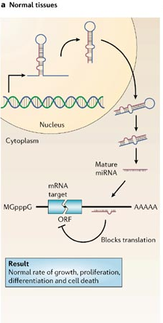
Figure 1: Transcription, processing and binding of microRNA in suppression of target genes in normal cells (Image from Esquela-Kerscher & Slack, 2006).

MicroRNAs and siRNAs

MicroRNAs are single strand, non-coding RNAs that are roughly 22 nucleotides long and are gene regulators in many different types of cells (Figure 1). The microRNA is transcribed by RNA Polymerase II and once outside in the cytoplasm a RNAse II enzyme called Dicer processes the miRNA, splitting the loop shape in to a mature miRNA. This allows the strand to bind to mRNA and inhibit gene expression using imperfect complementary block targeting (Esquela-Kerscher & Slack, 2006). There have been evidence showing that microRNAs have a role in cancer and autoimmune diseases due to their presence in the cell regulation and immune response (Okoye et al., 2014).
In the process called RNA interference or RNAi is the use of short interfering RNAs or siRNAs. siRNAs are used in silencing genes while integrated in biological pathways. This technique has been used as possible treatment in gene-therapy finding new heights in HIV and cancer control (Klemm et al., 2016). Since microRNAs and siRNAs have been seen to have success in control of genes and biological pathways, the question that this proposal hopes to answer is if there is a reduction of MicroRNAs in exosomes and T cells from inflamed tissues caused by Crohn’s, and can it be caused by the blockage of the S1PR1 receptor using the S1P modulator Fingolomid or is simply correlated in a much larger sequence of events?

Experiment

Previous Experiment “conducted”

For this experiment, it is important to note that a previous experiment must be conducted to test the validity of these results. In a mouse model named SAMP1, where there is onset of ileitis, which is similar to Crohn’s, the blockage of the S1PR1 receptor using Fingolomid is done to see its effects on the development of the ileitis in the mice. To analyze the effects, the modulator has on the microRNAs of the intestines, the microRNAs from the exosomes of the inflamed tissue and T cells was analyzed to see the number of microRNAs present and which ones (Mikulski et al., 2015). This previous experiment, for this proposal experiment to have context, had results that showed the decrease in microRNA numbers when the S1p modulator Fingolomid was present. This raises the question previously stated that is he reduction of MicroRNA caused by the blockage of the S1PR1 receptor using the S1P modulator Fingolomid or correlated, which is the question behind this current experiment.

ELISA and qPCR

In this experiment the methods mainly involve the detection in the number of a specific microRNA and cytokines produced by the signaling of S1P. The detection of microRNAs is done using real-time PCR or qPCR. The method is shown in Figure 2 below, and overall the process is the same as regular PCR, where the sample DNA is amplified, but the results are done in real time. Another method of analysis is ELISA which stands for enzyme-linked immunosorbent assay and is the tool that is used to analyze the number of a substance, using antibodies. Indicated in Figure 3, is the method of how ELISA works, where the capture antibody takes hold of the target antigen and a detection antibody attaches allowing the antigen to be detected by a substrate.

Overview

For this experiment a cell line that imitates Crohn’s will hold a T cell, Fingolomid will be added to down regulate the receptor S1PR1. Next, S1P will be added to stimulate the receptor and the number of the microRNA miR-155 will be calculated using qPCR. miR-155 was chosen because it has a role in the inflammatory response and is present in T cells and dendritic cells of the immune system. As well as miR-155, quantitative results will also be taken of the cytokines that are developed due to the stimulation of the S1PR1 receptor, primarily the peptides IL-2, IL-17 and IFN-gamma using ELISA. This process is repeated but where instead of the addition of Fingolomid, the miR-155 microRNA is silenced using siRNA. From there S1P is added to stimulate the S1PR1 receptor and quantitative data of cytokines is taken using ELISA. Examples of results for ELISA and qPCR are seen in Figure 4 and 5 respectively.
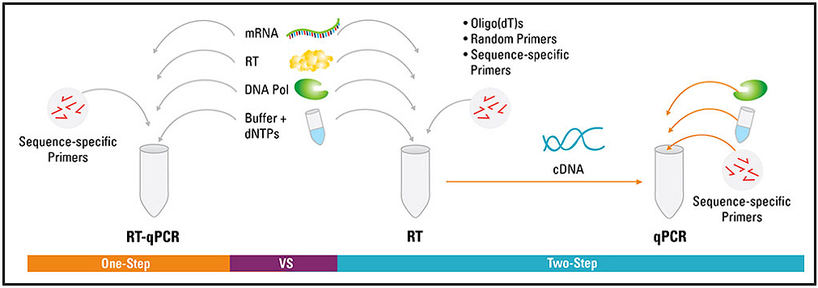
Figure 2: The protocol of real-time PCR or qPCR. Image from https://www.thermofisher.com

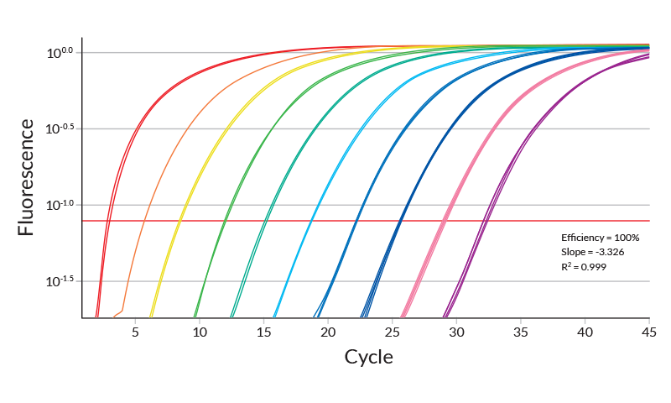
Figure 5: Example of the results from real-time PCR. Image taken from https://www.kapabiosystems.com
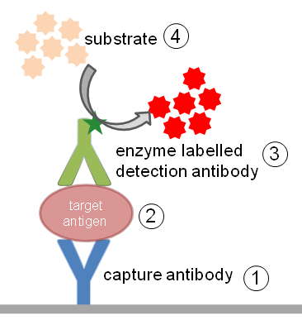
Figure 3: The process of how ELISA detects antigens or any other peptide using antibodies and a substrate. Image taken from https://www.immunology.org
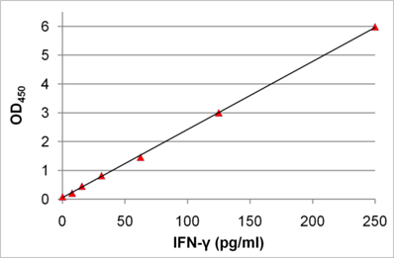
Figure 4: Example of the ELISA analysis of target protein. Image taken from https://www.immunology.org

Discussion

If all is done without error, the best possible results to see that the number of cytokines present while miR-155 is silenced is the same as when the S1P modulator Fingolomid is used on the S1PR1 receptor, then it’s a step in the right direction for autoimmune research and the use of S1P modulators in treating Crohn’s disease. However, if the opposite of this occurs and there is not causation between the two, then further studies need to be done to find the correlation between the blocking of the S1PR1 receptor and microRNAs in the immune system. This experiment can be conducted with different microRNAs to see if the results are the same for all microRNAs present in the immune system and help regulate lymphocytes. If so, this can also be done with different S1P modulators and agonists to see perhaps results may differ.
In either case, the exploration into the therapeutic potential using S1P signaling for autoimmune diseases is definitely a step in the right direction (Aoki et al, 2016). Finding more ways to treat Crohn’s allows there to be more available help and treatments for patients early in life and not be taken to such drastic measures as surgery. With the use of S1P signaling and the analysis of microRNAs, we can see a more expanded treatment in the near future using these methods at a molecular level and have the body overcome its malfunctions and help the body heal itself.

References

Andersen, N. N., & Jess, T. (2014). Risk of infections associated with biological treatment in inflammatory bowel disease. World Journal of Gastroenterology : WJG, 20(43), 16014–16019.

Aoki, M., Aoki, H., Ramanathan, R., Hait, N. C., & Takabe, K. (2016). Sphingosine-1-Phosphate Signaling in Immune Cells and Inflammation: Roles and Therapeutic Potential. Mediators of Inflammation, 2016, 8606878.

Brinkmann, V. et. Al. (2002). The Immune Modulator FTY720 Targets Sphingosine 1-Phosphate Receptors. Journal of Biological Chemistry, 277(24), 21453-21457.

Degagné, E., Saba, J. (2014). S1pping fire: Sphingosine-1-phosphate signaling as an emerging target in inflammatory bowel disease and colitis-associated cancer. Clinical and Expreimental Gastroenterology, 7, 205-214.

Esquela-Kerscher, A., & Slack, F. J. (2006). Oncomirs — microRNAs with a role in cancer. Nature Reviews Cancer,6(4), 259-269.

Guan, Q., & Zhang, J. (2017). Recent Advances: The Imbalance of Cytokines in the Pathogenesis of Inflammatory Bowel Disease. Mediators of Inflammation, 2017, 4810258.

Klemm, V., Mitchell, J., Cortez-Jugo, C., Cavalieri, F., Symonds, G., Caruso, F., … Ahlenstiel, C. (2016). Achieving HIV-1 Control through RNA-Directed Gene Regulation. Genes, 7(12), 119.

Mikulski, Z., Johnson, R., Shaked, I., Kim, G., Nowyhed, H., Goodman, W., Chodaczek G., Pizarro T., Cominelli F., Ley, K. (2015). SAMP1/YitFc Mice Develop Ileitis via Loss of CCL21 and Defects in Dendritic Cell Migration. Gastroenterology, 148, 783-793.

National Institutes of Health. (2012). Autoimmune Diseases [PDF]. Research Triangle Park: National Institutes of Health.

Okoye, I. S., Coomes, S. M., Pelly, V. S., Czieso, S., Papayannopoulos, V., Tolmachova, T., … Wilson, M. S. (2014). MicroRNA-Containing T-Regulatory-Cell-Derived Exosomes Suppress Pathogenic T Helper 1 Cells. Immunity, 41(1), 89–103.

Olivera, A., Allende, M. L., & Proia, R. L. (2013). Shaping the landscape: Metabolic regulation of S1P gradients. Biochimica et Biophysica Acta, 1831(1), 193–202.

