Implementing CRISPR Type III-B in Human cell to Target RNA Encoded Viruses.
I. Introduction
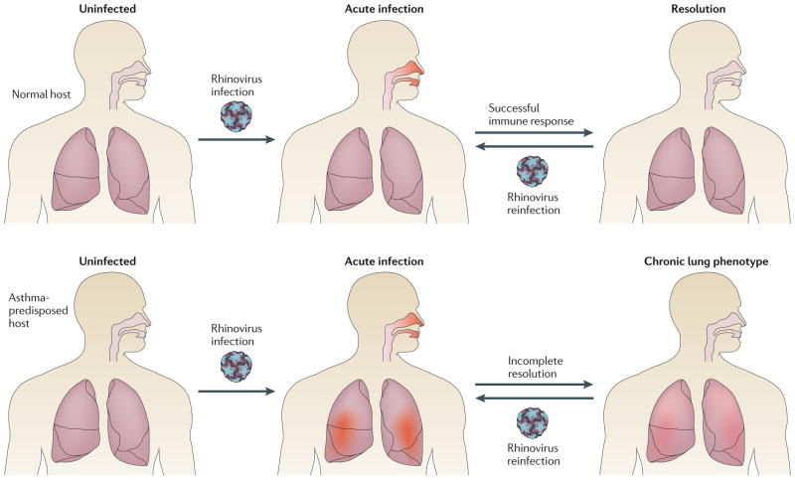
The Rhinovirus, while often synonymous with the “common cold” has also been found to be a contributing factor for the occurrence of acute respiratory conditions such as asthma and inhibit effective infection resolution in at risk individuals (Figure 1). At this current time, an effective means of combating the Rhinovirus has not been established. What treatment options that have been available are limited to addressing the physical symptoms of the virus versus providing treatment to address the virus itself. Yet with the current developments being made regarding the potential of Clustered Regularly Interspaced Short Palindromic Repeats (CRISPR) complexes, the probability for an anti-viral intervention to address the Rhinovirus has become increasingly favorable.
Figure 1. Chart depicting the differences in impact of Rhinovirus between individuals of non- compromised phenotype as compared to individuals who possess a chronic lung phenotype (Adapted from 2).

To understand the potential of CRISPR complexes to address viral infections, it is imperative then to examine what comprises CRISPR and how these structures can be utilized to target specific viral strains. CRISPR is a biological defense mechanism against phages and plasmids that functions by targeting and recognizing a specific site to induce breaks in the targeted ribonucleic acid, (RNA) or deoxyribonucleic acid (DNA)⁵. Currently, there are three distinct types and six unique subtypes of CRISPR systems. The categorization of the main types are based upon the unique series of CRISPR associated proteins (Cas) that are found near the CRISPR loci as well as the CRISPR RNA (crRNA) that is associated with CRISPR interference⁷.
The result of these variations creates functional differences between the subtypes. For example, although both the Type I and Type III systems are known to utilize a sizable multi-Cas protein complex for the purpose of target sequence degradation and crRNA binding⁴, the Type II system in contrast, utilizes a solitary Cas9, a single DNA endonuclease⁶ All three types rely on the process of binding to a target structure and cleaving complimentary target sequences; However, Type I and II systems act upon DNA structures and therefore cannot be utilized to target the Rhinovirus as this it is comprised of RNA. For this reason, CRISPR Type III-B will be used as it is the only system that has been found to directly target and cleave RNA³
CRISPR Type III-B complex possesses 6 Cmr proteins Although the exact functional nature of every Cmr protein is not fully known, for CRISPR Type III-B complexes that have been derived from Pyrococcus furiosus (P. furiosus) Cmr 4 is believed to function as the slicer while the Cmr 1 and Cmr 6 appear to be linked to binding target RNA. All Cmr proteins are essential to achieve binding reactions against the target RNA³.
II. Experiment
The proposed experiment will involve CRISPR Type III-B complex derived from a purified form of P. furiosus. The hypothesis that CRISPR Type III- B complex has the potential to bind and cleave Rhinovirus RNA has yielded positive preliminary results. Through the use of Blastn, it was revealed that the crRNA 8 nucleotides 5’ tag was a 1:1 match to multiple sites on Rhinovirus RNA. Using BioBike, and the coordinates provided by Blastn, the location of the tag and 37 nucleotide sequence was found as seen in Table 1, all associated with the same gene HRV89gp1.
Key materials for this experiment are expected to be crRNA binding assays and Target RNA- binding and cleavage assays. These materials will be required in order to achieve the reactions needed to fully bind and cleave the Rhinovirus RNA. The crRNA- binding assays and Target RNA –binding and cleavage assays will be created through the methods and procedures modeled by Hale et al.
As illustrated in Figure 2, certain requirements must be met to effectively cleave the target RNA and accomplish cRNA binding. Cmr1 and Cmr6 are essential for targeting as well as binding target RNA. The evaluation of the effectiveness of the binding- cleavage reaction will be achieved through analyzing the results of gel electrophoresis. It is expected that the Rhinovirus RNA, as suggested by the preliminary findings of BioBike and Blastn, will be shown to be vulnerable to the binding and cleavage assays and will display evidence of RNA degradation.
Figure 2. Cleavage and Binding Requirements. Illustration of organization of Cmr Complex (Adapted from Hale et al.).
III. Discussion
The demonstrated ability of the CRISPR Type III-B complex to bind and cleave the viral RNA of the Rhinovirus would set a precedent toward expanding this research to target similar RNA based viruses and plasmids. If the required criteria that was addressed in Table 2 is met, the likelihood of achieving favorable results toward additional target RNA is probable.
A limitation of utilizing the CRISPR Type III- B complex is the fact that the functions of the Cmr proteins will vary depending upon what purified form of bacteria is utilized. P. Furiosus, although the first CRISPR Type III-B created, can be derived from a multitude of bacteria and possess similar or dissimilar Cmr proteins as P. Furiosus³. It could be argued however that the variation of Cmr protein functions within the differing bacterial bases would increase the likelihood of effectiveness. For example, if the Cmr proteins of P. furiosus were not able to create a functional tag with a targeted virus, the Cmr proteins of another bacteria may be more effective.
Another possible limitation is in regard to viral mutations. Most of the research that has been made available addresses wild type viruses and has not clearly addressed whether or not viral mutations would limit the effectiveness of the CRISPR Type III- B complex. Further research is needed to explore if the Cmr complexes will still be effective if complementary pairing of the tag is not 1:1. In addition, since CRISPR Type III-B complex is a relatively new finding, the current amount of available research is limited and thus certain functions of Cmr proteins remain ambiguous.
The potential for a means of addressing RNA based viruses can revolutionize what is known regarding molecular biology. It is only through the creation of ideas and proposals that discoveries can be found, and if the results of this experiment are supportive of the efficacy of the CRISPR Type III- B complex, the applications for the CRISPR Type III-B complex may become numerous. Impacting not only the fields of biology, but the fields of medicine and genetic engineering.

Table 1
Sequences | Tag (8nt) + 37 nt sequence | Coordinates
1 | ATTGAAATGTGCCAAGTTGACACACTCATTCCTGTTAACAATACA | 1756 - 1801
2 | ATTGAAACTAGATATGTTATAACTGATCAAACAAGGGATGAAACA | 2491 - 2536
3 | ATTGAAAATTGATTACCTAACCAAATTAAAACAACTTAATCTCTT | 4047 - 4092
4 | ATTGAAATAAACACCCTTCATGATTTATCCTTAAAATTCTTACCA | 4150 - 4195

References

1.Estrella M.A., Kuo F., Bailey S. (2016). RNA-activated DNA cleavage by the Type III-B CRISPR-Cas effector complex. Genes and Development, 30(4): 460-470. DOI: 10.1101/gad.273722.115
2. Foxman, E., Iwasaki, A (2011). Genome-virome interactions: examining the role of common viral infections in complex disease. National Review of Microbiology, 9(4): 254-264. Doi: 10.1038/nrmicro2541
3. Hale C. R., Cocozaki A., Hong L., Terns R.M., & Terns M. P. (2014) Target RNA capture and cleavage by the Cmr type III-B CRISPR-Cas effector complex. Genes and Development (28):2432-2443. DOI: 10.1101/gad.250712.114

4. Tamulaitis G., Venclovas C., Siksnys V. (2017) Type III CRISPR-Cas Immunity: Major differences Brushed Aside. Trends in Microbiology 25(1): 49-61. DOI: 10.1016/j.tim.2016.09.012

5. Taylor D.W., Zhu Y., Staals R.H., Kornfeld J. E., Shinkai A., van der Oost J., Nogales E., Doudna J. (2015) Structures of the CRISPR-Cmr complex reveal mode of RNA target positioning. Science 348(6234): 581-585. DOI: 10.1126/science.aaa4535

6. Wright A.,Nunez J., Doudna (2016).Biology and applications of CRISPR systems: harnessing
nature’s toolbox for genome engineering. Cell 164(1–2):29–44

7. Van der Oost J, Westra ER, Jackson RN, Wiedenheft B. 2014. Unravelling the structural and mechanistic basis of CRISPR–Cas systems. Nat. Rev. Microbiology. 12(7):479–92

