Jared Mann
Downregulation of Sox2 with CBD via AMPK
- Introduction
Medicinal drugs derived from the marijuana plant are becoming valid treatments to aggressive forms of cancer, including Glioblastoma (GBM), a multi-subtype, tumor-developing cancer in the brain. The prognosis of GBM is bleak; largely having to do with GBMs strong resistance to treatment. A primary reason for this resistance lies inside of the cancerous cells with stem-like properties within the tumor. These cancerous “stem cells” (CSCs), have increased levels of many transcriptional regulators that correlate with invasiveness and treatment resistance. Sox2 is a transcription regulator protein that increases proliferation, self-renewal and other stem-like qualities by coupling with two other regulator proteins and orchestrating a path of pluripotency¹.
Cannabidiol (CBD), a molecule found in cannabis that causes no psychoactive effects, has been shown to have antitumor activity on certain mechanisms and pathways in cancerous cells². CBD has, therefore, been the subject of much research as a therapeutic treatment of GBM. CBD has already been found to downregulate the Sox2 gene through a mechanism dependent on the release of reactive oxygen species (ROS) through the mitochondria³. The ability for CBD to increase ROS in cancerous cells makes it a very viable treatment, as many existing and commonly used cancer treatments rely on ROS to induce apoptosis.
After ingestion, metabolism of CBD increases levels of nicotinamide adenine dinucleotide (NADH)⁴ which enters the mitochondria, and undergoes oxidation/reduction reactions at the complex I site of the inner mitochondrial membrane⁵. This is one of the main mechanisms of the electron transport chain, and kicks off the initial flow of electrons through the subsequent complexes. During this flow, free electrons can break loose and get caught by oxygen, forming one of the most common forms of ROS, superoxide (O₂⁻), both inside of the mitochondria, and outside in the cytosol. At a state of high intracellular ROS, AMP-activated protein kinase (AMPK) is activated within the cell. AMPK is a multi-functional enzyme that has three subunits within its complex. Activation of AMPK by AMP occurs within the alpha subunit (AMPKα) at the Thr172 location⁶. AMPK activation has been shown to be a downstream product of two kinases, LKB1 and CaMKK, however, it can be activated through oxidative stress alone^{7,8}.
To gain insight into whether CBD would activate AMPK through ROS, one can observe Physcion, a pigmentation molecule found in lichen plants indigenous to eastern Asia. Physcion is used for medicinal purposes, and has similar effects on cancerous cells as CBD. Physcion has been shown to downregulate Sox2 through an activated AMPK mechanism dependent on ROS in colorectal cancer⁹. It can be implied that CBD should have this same effect, due to its known production of ROS in cancerous cells.
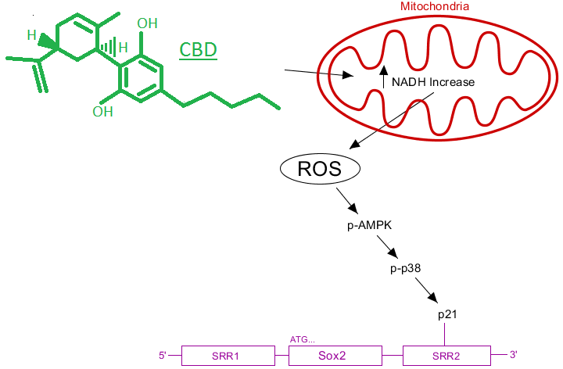
The known mechanisms for CBD’s downregulation of Sox2 include p38 MAP Kinase³. P38 does not interact with Sox2 directly, however a downstream product called p21¹⁰ can bind directly to the transcription factor downstream of Sox2, known as the SRR2 box¹¹. After this bond, Sox2 is effectively downregulated. The only connection left to be made is AMPK’s interaction with p38^{MAPK}. It turns out that AMPK can be involved in the activation of p38^{MAPK (12)}, which provides evidence for the assumption that AMPK is upstream of p38. In the figure to the right, a proposed mechanism for the downregulation of Sox2 through CBD administration is shown. This downregulation of Sox2 could lead to a decrease in GBM cell pluripotency, which could stop resistance to treatment.
Figure 1: Proposed pathway of Sox2 downregulation
CBD is a viable drug for the treatment of cancer, but there are still steps that need to be taken to understand the mechanisms by which CBD works on these tumors.
CBD enters the cell and increases NADH with its metabolism. This causes an activation of the ETC and an increase in ROS, which could activate AMPK. AMPK has downstream products, such as p-38^{MAPK} and p21, that downregulate Sox2 by binding to the SRR2 promotor.
Understanding the antitumor mechanism of CBD within an aggressive tumor would be most beneficial. AMPK has already been researched as a viable target for cancer treatments¹³, so proving CBD targets AMPK would be beneficial to future treatments.
The purpose of this experiment is to show the extent to which CBD, a non-psychoactive cannabinoid, downregulates the expression of the pluripotent Sox2 transcription factor in human multiforme GBM via AMP Kinase.
The Experiment
CBD has already been shown to downregulate Sox2¹⁴. To determine if CBD will activate AMPK while downregulating Sox2 in human GBM, an in vivo experiment aimed at measuring protein content will be performed. GBM cell lines will be grown, maintained, and separated into one of four groups. The first group will contain no drugs meant to alter the protein content within the cell, and will be evaluated as a control. The other groups will be treated with CBD at different levels, and will be evaluated as variables. Western analysis will show the content of AMPK and Sox2, and a densitometry analysis on the western blot will show quantification. With this information, it can be determined if CBD has a downregulation effect on Sox2 through AMPK.
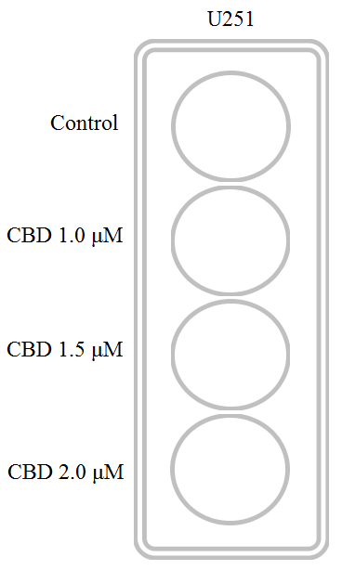
U251 glioma stem-like cells will be obtained and used for this experiment. U251 cell lines have been shown to have high levels of Sox2¹⁵, and will be useful for determining the expression levels in this experiment. Neurosphere culture will be created and used for this experiment. U251 cell lines will be obtained and cultured in neuro basal media mixed with 10% fetal bovine serum (FBS). The cells will be maintained in this media for the preliminary phase of the experiment and will be replaced daily. After two days, or until they reach confluence, the cells will be suspended in trypsin-EDTA and no longer allowed to interact. This suspension will occur in 12-welled plates that contain 100 cells per well. CBD diluted in ethanol will be added in three different concentrations. The first will be a vehicle control. The second will contain 1.0 micro moles (μM), the third will contain 1.5 μM and the fourth will contain 2.0 μM. The purpose on using different levels of CBD diluted within ethanol is to show how much CBD increases phosphorylation of AMPK and how much it downregulates Sox2. Figure 2 to the right shows how the cells will be separated into their respective groups.
Figure 2: Experiment Variables
Vehicle and CBD dilutions will be changed every day for three days. After day three, the protein analysis will be conducted. Cell lysis will take place from centrifugation and use of enzymes. Next, a breaking down of the proteins in the cell by means of SDS/PAGE will be conducted. SDS is a detergent that denatures proteins so they can be separated and observed on a particular membrane surface, and in this case, an Immobilon-P membrane will be used in this experiment. This membrane has been chosen based off of its durability and resilience, as well as its ability to be probed multiple times¹⁶.
This experiment will involve multiple levels of CBD, which will allow for stronger evidence for or against the hypothesis
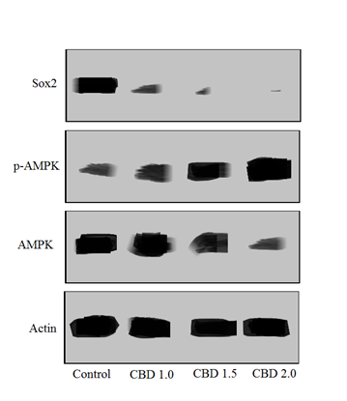
Once the proteins are separated on the membrane, antibodies will be used to probe for the specific protein. Primary antibodies will be used to probe AMPK to detect for presence of phosphorylation, using anti p-AMPKα (Thr172). Rabbit polyclonal antibodies to Sox2 and AMPK will be used, anti Sox2 and anti AMPK. Anti actin will also be used to show CDB’s effect on housekeeping proteins, which should be nonexistent. The use of actin is also for the benefit of the western blot itself. Actin provides a similarity in analysis between the wells which proves the gel worked in the experiment. After probing the protein with the appropriate antibody, blotting will take place.
Figure 3: Faux Western Blot Results
There will be four western blots in this analysis, each pertaining to its respective level of CBD. Figure 3 to the left shows the expected results. Higher levels of CBD should decrease Sox2 while increasing the levels of p-AMPK. It is important to note that the decrease in AMPK with increased levels is due to phosphorylation, which is detected and blotted as p-AMPK. Although a western blot can be visually judged, a quantitative analysis on densitometry will be conducted using imageJ software¹⁷. The point of this analysis is to show how the levels of each protein changed, as well as the amount of phosphorylation. As CBD increases, the density of the bands pertaining to actin should stay the same. To prove the hypothesis, the amounts of AMPK/p-AMPK should have an inverse relationship, so as CBD levels increase the density of the bands pertaining to AMPK should decrease, and the density of the bands pertaining to p-AMPK should increase. Sox2 should have a steady decrease in band density with increased levels of CBD.
If all goes well, CBD should mimic this faux western blot, showing more content of p-AMPK and less content of Sox2 as CBD levels increase.
Discussion
The change in phosphorylation of AMPK could relate to CDB’s known production of ROS in the mitochondria. Due to AMPKs known downstream products, p38^{MAPK} and p21, it is very viable to hypothesize that AMPK activation will downregulate Sox2. The question this experiment posed was the extent to which CBD downregulates Sox2 in U251 cell lines via AMP Kinase.
There are several possible outcomes to the experiment. If the densitometry analysis of the western blot shows that as levels of CBD increased, AMPK phosphorylation increased and Sox2 decreased, this gives evidence to conclude AMPK plays a part in the downregulation of Sox2 through CBD. This also shows that increased amount of CBD are correlated with an increase in AMPK phosphorylation and Sox2 downregulation.
If CBD increased and AMPK activation increased, but Sox2 expression did not decrease, CBD has been shown to activate AMPK, but not downregulate Sox2. This would go against already existing evidence^{3, 14} that CBD decreases Sox2 expression and is highly unlikely. It is more possible, however, that as CBD levels increased, Sox2 will reach a limit of reduction, and will no longer decrease. This would imply there must be some kind of limit to how much Sox2 p-AMPK can deactivate. CBD may benefit from use coupled with a synergistic drug that activates similar pathways to continue Sox2 downregulation
If CBD, at all levels, decreased Sox2, but did not show increased phosphorylation of AMPK, CBD must downregulate Sox2 through other means besides p-AMPK pathways. If the levels of AMPK and p-AMPK both change in tandem, this implies CBD is not only changing phosphorylation of this kinase, but it is changing the levels of AMPK within the cell.
Understanding the pathways by which CBD, a non-psychoactive cannabinoid, downregulates expression of the Sox2 gene, which has been shown to increase stem-ness in GBM and its resistance to treatment, could lead to a better understanding of the drug and more efficient treatment of GBM through CBD.
CBD treatment shows promising news. In a recent clinical analysis, treatments including CBD have been shown to increase one-year survival rate in GBM multiforme by 83%¹⁸. The promising new for CBD being a viable treatment for GBM should prompt more research to be proposed in this field, which could potentially prolong the lives of those afflicted. This proposal has been made for the purpose of continuing that research, delving into the molecular mechanisms of CBD within GBM cells.

Works Cited:
- Fong, Y. W., Inouye, C., Yamaguchi, T., Cattoglio, C., Grubisic, I., & Tjian, R. (2011). A DNA repair complex functions as an Oct4/Sox2 coactivator in embryonic stem cells. Cell, 147(1), 120-131.
http://www.cell.com/abstract/S0092-8674(11)01008-7
- McAllister, S. D., Soroceanu, L., & Desprez, P. Y. (2015). The antitumor activity of plant-derived non-psychoactive cannabinoids. Journal of Neuroimmune Pharmacology, 10(2), 255-267.
https://www.ncbi.nlm.nih.gov/pmc/articles/PMC4470774/
- Singer, E. Judkins, J. Salomonis, N. Matlaf, L. Soteropoulos, P. McAllister, S. Soroceanu, L. (2015). “Reactive oxygen species-mediated therapeutic response and resistance in glioblastoma”. Nature Publishing Group. DOI: 10.1038/cddis.2014.566.
https://www.ncbi.nlm.nih.gov/pmc/articles/PMC4669764/
- Usami, N., Yamamoto, I., & Watanabe, K. (2008). Generation of reactive oxygen species during mouse hepatic microsomal metabolism of cannabidiol and cannabidiol hydroxy-quinone. Life sciences, 83(21), 717-724.
http://www.sciencedirect.com/science/article/pii/S0024320508003809
- Valvassori, S. S., Bavaresco, D. V., Scaini, G., Varela, R. B., Streck, E. L., Chagas, M. H., ... & Quevedo, J. (2013). Acute and chronic administration of cannabidiol increases mitochondrial complex and creatine kinase activity in the rat brain. Revista Brasileira de Psiquiatria, 35(4), 380-386.
http://www.scielo.br/scielo.php?script=sci_arttext&pid=S1516-44462013000400380&lng=en&nrm=iso&tlng=en
- Wang, W., & Guan, K. L. (2009). AMP‐activated protein kinase and cancer. Acta Physiologica, 196(1), 55-63.
http://onlinelibrary.wiley.com/doi/10.1111/j.1748-1716.2009.01980.x/full
- Mackenzie, R. M., Salt, I. P., Miller, W. H., Logan, A., Ibrahim, H. A., Degasperi, A., ... & Dominiczak, A. F. (2013). Mitochondrial reactive oxygen species enhance AMP-activated protein kinase activation in the endothelium of patients with coronary artery disease and diabetes. Clinical science, 124(6), 403-411.
https://www.ncbi.nlm.nih.gov/pmc/articles/PMC3903000/
- Emerling, B. M., Weinberg, F., Snyder, C., Burgess, Z., Mutlu, G. M., Viollet, B., ... & Chandel, N. S. (2009). Hypoxic activation of AMPK is dependent on mitochondrial ROS but independent of an increase in AMP/ATP ratio. Free Radical Biology and Medicine, 46(10), 1386-1391.
https://www.ncbi.nlm.nih.gov/pmc/articles/PMC3326346/
- Han, Y. T., Chen, X. H., Gao, H., Ye, J. L., & Wang, C. B. (2015). Physcion inhibits the metastatic potential of human colorectal cancer SW620 cells in vitro by suppressing the transcription factor SOX2. Acta Pharmacologica Sinica.
https://www.ncbi.nlm.nih.gov/pmc/articles/PMC4753366/

- El Alami, M., Vina-Almunia, J., Gambini, J., Mas-Bargues, C., Siow, R. C., Penarrocha, M., ... & Vina, J. (2014). Activation of p38, p21, and NRF-2 mediates decreased proliferation of human dental pulp stem cells cultured under 21% O 2. Stem cell reports, 3(4), 566-573.
https://www.ncbi.nlm.nih.gov/pmc/articles/PMC4223702/
- Zhao, Z., Yin, J. Q., Wu, M. S., Song, G., Xie, X. B., Zou, C., ... & Wang, J. (2014). Dihydromyricetin activates AMP-activated protein kinase and P38MAPK exerting antitumor potential in osteosarcoma. Cancer Prevention Research, 7(9), 927-938.
http://cancerpreventionresearch.aacrjournals.org/content/7/9/927.long
- Lanna, A., Henson, S. M., Escors, D., & Akbar, A. N. (2014). AMPK-TAB1 activated p38 drives human T cell senescence. Nature immunology, 15(10), 965.
https://www.ncbi.nlm.nih.gov/pmc/articles/PMC4190666/
- Kim, I., & He, Y. Y. (2013). Targeting the AMP-activated protein kinase for cancer prevention and therapy. Frontiers in oncology, 3, 175.
https://www.ncbi.nlm.nih.gov/pmc/articles/PMC3711071/
- Soroceanu, L., Murase, R., Limbad, C., Singer, E., Allison, J., Adrados, I., ... & Khan, S. (2013). Id-1 is a key transcriptional regulator of glioblastoma aggressiveness and a novel therapeutic target. Cancer research, 73(5), 1559-1569.
https://www.ncbi.nlm.nih.gov/pmc/articles/PMC3594064/
- Mo, L. J., Ye, H. X., Mao, Y., Yao, Y., & Zhang, J. M. (2013). B7-H4 expression is elevated in human U251 glioma stem-like cells and is inducible in monocytes cultured with U251 stem-like cell conditioned medium. Chinese journal of cancer, 32(12), 653-660.
https://www.ncbi.nlm.nih.gov/pmc/articles/PMC3870849/
- Immobilon® Membranes, Sandwiches and Blotting Filter Paper. (2005). Immobilon. EMD Millipore, Billerica, Massachusetts.
https://www.emdmillipore.com/US/en/product/Immobilon-Membranes%2C-Sandwiches-and-Blotting-Filter-Paper,MM_NF-C3117#overview
- Schindelin, J., Rueden, C. T., Hiner, M. C., & Eliceiri, K. W. (2015). The ImageJ ecosystem: an open platform for biomedical image analysis. Molecular reproduction and development, 82(7-8), 518-529.
http://onlinelibrary.wiley.com/doi/10.1002/mrd.22489/abstract
- GW Pharmaceuticals. (2017). GW Pharmaceuticals Achieves Positive Results in Phase 2 Proof of Concept Study in Glioma [Press Release].
https://www.gwpharm.com/about-us/news/gw-pharmaceuticals-achieves-positive-results-phase-2-proof-concept-study-glioma

