Amanda Luong May 2017
Identifying the Mechanism of LIN52 Degradation

- Introduction:

In 2016, an estimate of 1,685,210 people will be diagnosed with a form of cancer, and 595, 690 will die from the disease (National Cancer Institute). Cancer is an enigma among the medical field with many researchers racing to solve the puzzle through various approaches. Ultimately, the common goal is to find the best way to defeat it. Cancer develops as a result of the unregulated cellular growth of abnormal cells (National Cancer Institute). The entry of a cell into quiescence(G₀) amid its cell cycle may be crucial in preventing such deleterious proliferation. Failure to do so will lead to progression through mitotic division, ultimately giving arise to cancer.

The MuvB core is a five-member protein complex consisting of LIN9, RBBP4, LIN54, LIN37, and LIN52 (Litovchick et al).). Based on what proteins bind to MuvB, it can form two complexes – DREAM and MMB (DeCaprio).
Figure 1: Visual of Cell Cycle. See G₀/quiescence as exit out of the cycle, which halts any growth

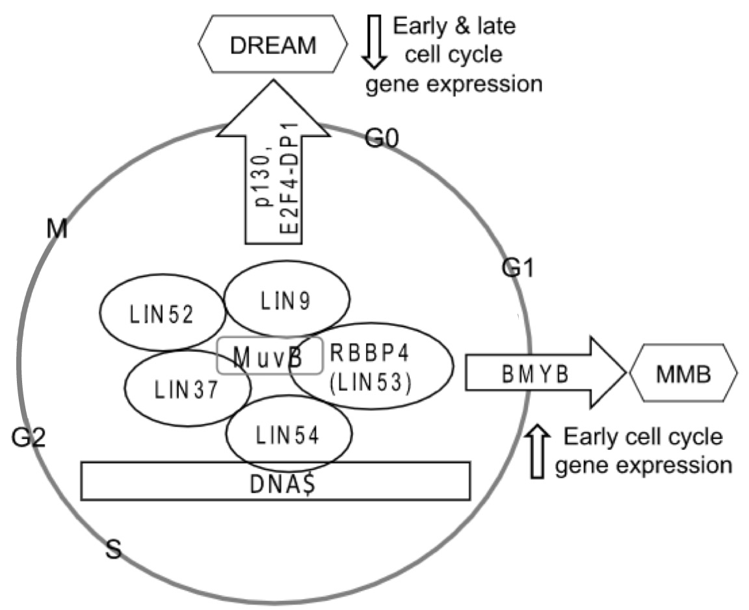
The focus of this experiment is on LIN52. LIN52 is a crucial binding site for proteins p130 and BMYB (Guiley et al). If the LIN52 subunit of MuvB binds p130, the DREAM complex is formed, and this complex functions to promote cellular quiescence(DeCaprio). On the contrary, if LIN52 binds BMYB, the MMB complex is formed, which promotes cellular growth (DeCaprio). Without the formation of DREAM, the cell proliferation continues in a deregulated, harmful manner (Forristal et al).

In a recent experiment, it was determined that a specific protein kinase, DYRK1A, was responsible for phosphorylating LIN52-S28 (Litovchick et al). In order for LIN52 to bind p130 to form DREAM, the phosphorylation by DYRK1A is the catalyzing mechanism (Litovchick et al). Meanwhile, the affinity of binding of BMYB to MuvB to form the MMB complex was not affected by the phosphorylation of LIN52-S28 (Litovchick et al).

Figure 2: Graphic Interpretation of MuvB
core complex and its potential binding proteins that lead to the formation of DREAM or MMB complexes (Adapted from Litovchick unpublished).
Studies have shown that the loss of DYRK1A leads to increased levels of LIN52, which suggests that the degradation of LIN52 occurs within the DREAM complex (Litovchick, unpublished). A potential reason for LIN52 degradation is to prevent the premature formation of MMB that can lead to unregulated cell growth.

One method of protein degradation involves signaling through a ubiquitination cascade in an overall ubiquitin proteasome system (Iconomou). With DREAM having been shown to undergo ubiquitination at LIN52-K106, this suggests that its degradation is involved in a ubiquitin proteasome system (Litovchick, unpublished). Little is known about the exact mechanism of LIN52 degradation, thus the aims of this experiment are to identify the protein(s) involved in the ubiquitination of LIN52 in order to further understand the mechanisms of LIN52 as a component of the MuvB core.
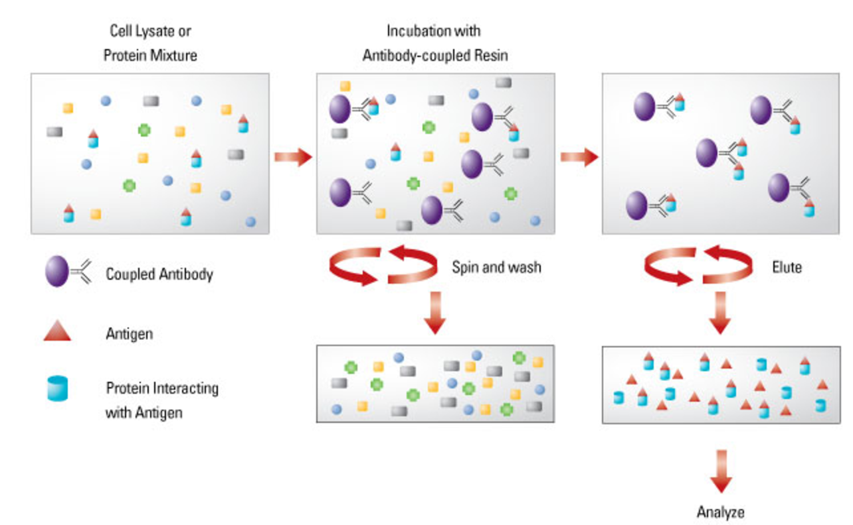
- Experiment:

- Co - Immunoprecipitation:

Immunoprecipitation utilizes antibodies to capture a targeted protein (Mann 2001). The molecules not attached to the antibody will wash away. Initially, LIN52 will undergo co-immunoprecipitation in order to isolate the protein itself and its interacting proteins.

- Mass Spectrometry / Multidimensional Protein Identification Technology (MudPIT):
Figure 3. Graphic representation of co-immunoprecipitation (Adapted from Thermo-Fischer).

A highly specific technique of mass spectrometry, MudPIT, will be utilized to determine the proteins which interact with LIN52. MudPIT utilizes the collaboration between two-dimensional chromatography and tandem mass spectrometry (Washburn 2014). For this experiment, the two dimensions of chromatography will be based on strong cation chromatography and reverse phase chromatography (Washburn 2014). Chromatography allows for the separation of LIN52 and its interacting proteins into fragments which are more easily analyzed via mass spectrometry. The results from the mass spectra will be compared to databases to determine the overall identity of the protein.

Figure 4. Graphic representation of MudPIT (Adapted from Huber 2003).

- siRNA Knockdown:

Despite the highly specific capabilities of MudPIT, it is essential that the results returned are validated through alternative strategies (Washburn 2004). Therefore, upon the identification of various protein interactions, RNA interference (RNAi) will be used to observe the effects of the identified proteins on LIN52. More specifically, small interfering RNA (siRNA) will be used to silence the functions of the identified proteins on an individual basis (Ramaswamy 2002). Observations of the relationship between the siRNA knockdowns can be used to determine which protein is involved with the degradation of LIN52.

- Western Blot:

To confirm the degradation of LIN52 through the interactions involving the previously identified protein, western blot analyses will be utilized (Mahmood 2012). Western blotting can be used to confirm the knockdown of the targeted protein. Then, further blotting LIN52 in regards to the presence of the identified protein can be used to further observe how the protein affects LIN52 degradation.
Figure 5. Illustration of siRNA silencing mechanism

- Discussion

Proteins tagged with ubiquitin are subject to proteasome degradation or other mechanisms of cellular growth regulation (Chen 2010). Recent studies determined that LIN52-K106 is a site of ubiquitination; therefore, it is suggested that the protein involved in the degradation of LIN52 is a protein within a Ubiquitin Proteasome System (Litovchick unpublished). More specifically, it is E3 ligases that catalyze the ubiquitination of its targeted substrates (Chen 2010). When interpreting the results of the mass spectra which may return thousands of proteins, there is a focus on identifying proteins categorized as E3 ligases.
Figure 6. Representation of E3 ligase ubiquitination as catalyzing mechanism involving proteasome degradation (Adapted from Chen 2010).
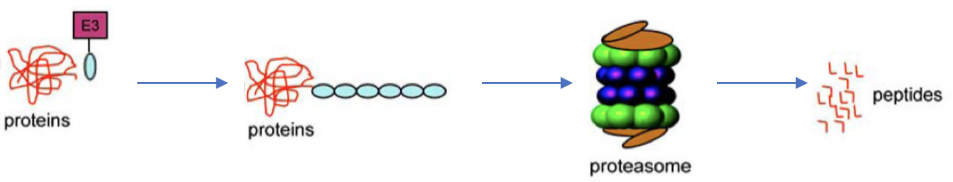

In the event of MudPIT detecting a large range E3 ligases, this experiment will require will a highly-detailed analysis of the enzymatic pathways. RNA interference can be used to further eliminate potential ligases involved, but this can become a strenuous process when dealing with a large network of proteins. This obstacle can be overcome using high-throughput RNAi screening (Iles 2016).
A potential limitation of this experiment is the lack of greater knowledge regarding the MuvB core. It is unknown how this core interacts or even exists outside of cellular regulation mechanisms. With current understandings, MuvB is seen as a unifying intermediate between DREAM and MMB (DeCaprio). Outside of these regulatory protein complexes, little is known about MuvB and its subunits.

References

Chen, D., Dou, P. (2010). The Ubiquitin-Proteasome System as a Prospective Molecular Target for Cancer Treatment and Prevention. Current Protein & Peptide Science, 11(6), 459 – 470.
Forristal, C., Henley, SA., MacDonald, JI., Bush, JR., Ort, C., Passos, DT., Talluri, S., et al. (2014). Loss of Mammalian DREAM Complex Deregulates Chondrocyte Proliferation. Molecular and Cellular Biology, 34(12), 2221 – 2234.
Guiley, KZ., Liban, TJ., Felthousen, JG., Ramanan, P., Litovchick, L., and Rubin, SM. (2015). Structural mechanisms of DREAM complex assembly and regulation. Genes & Dev, 29(9), 961 – 974.
Huber, LA. (2003). Is proteomics heading in the wrong direction?. Nature Reviews Molecular Cell Biology, 4, 74 – 80.
Iconomou, M., Saunders, DN., (2016). Systematic approaches to identify E3 ligase substrates. Biochemical Journal, 473, 4083 – 4101.
Iles, LR., Bartholomeusz, GA. (2016). Three-Dimensional Spheroid Cell Culture Model for Target Identification Utilizing High-Throughput RNAi Screens. Methods in Molecular Biology, 1470, 121- 135.
Link, A., Washburn, MP. (2014). Analysis of Protein Composition Using Multidimensional Chromatography and Mass Spectrometry. Current Protocols in Protein Science, 78(23), 23.1.1 – 23.1.25
Litovchick, L., Florens, LA., Swanson, SK., Washburn, MP., and DeCaprio, JA. (2011). DYRK1A protein kinase promotes quiescence and senescence through DREAM complex assembly. Genes & Development, 25, 801 – 813
Mahmood, T., Yang, PC. (2012) Western Blot: Technique, Theory and Trouble Shooting. North American Journal of Medical Sciences, 4(9), 429 – 434.
Mann, M., Hendrickson, RC., Pandey, A. (2001). Analysis of Proteins and Proteomes By Mass Spectrometry. Annual Review of Biochemistry, 701(1), 437 – 473.
National Cancer Institute. (2017). Cancer Statistics. Retrieved from https://www.cancer.gov/about-cancer/understanding/statistics.
Ramaswamy, G., Slack, FJ. (2002). siRNA: A Guide for RNA Silencing. Chemistry & Biology, 9, 1053 – 1057.
Sadasivam, S., DeCaprio JA. (2013). The DREAM complex: master coordinator of cell cycle-dependent gene expression. Nature Reviews Cancer.
ThermoFisher Scientific. (n.d.). Co-Immunoprecipitation (Co-IP). Retrieved from https://www.thermofisher.com/us/en/home/life-science/protein-biology/protein-biology-learning-center/protein-biology-resource-library/pierce-protein-methods/co-immunoprecipitation-co-ip.html.
Washburn, MP. (2004). Utilisation of proteomics datasets generated via multidimensional protein identification technology (MudPIT). Briefings in Functional Genomics and Proteomics, 3(3), 280 – 286.

