Introduction
The yeast Saccharomyces has been used for millennia for baking and brewing. Their ability to turn sugar into ethanol has been used to make food last longer, make food taste better, and allows for social lubrication at awkward office parties. Early brewers, bakers, and wine makers found that they would get a more reliable and predictable product by using a started from their previous batch. This resulted in lineages of yeast that grew in man-made environments which created the perfect opportunity for domestication. This process caused yeasts to diverge into five clades based on their geography and useage: Asian strains such as saki, wine strains, a mixed clade used in breadmaking, and two clades for beer. The first clade is geographically related to those beers from Germany, Britain, and the US (probably descended from the British lineage during colonization). The other beer clade is much more diverse geographically. Each clade has different phenotypes that have either been selected for or came about due to geographic isolation. One of these differences is how each clade processes sugar in their environment.
Brewer’s wort, the mixture used to make alcohol, contains maltose in 60%, maltotriose (15 - 20%), and glucose (10-15%). Glucose is preferentially used by Saccharomyces and acts as an inhibitor to maltose transporters, . After the glucose is gone, the Saccharomyces will begin to process maltose and some will process the maltotriose if they are able to . This process is not entirely efficient. Some strains are better at utilizing the maltose and/or maltotriose than others. Leftover sugar in the wort is a problem for brewers as that sugar could have been made into alcohol and can affect the final taste of the product. Understanding why some yeasts are more efficient in their maltose utilization and why some do not even use maltotriose is an important economic and culinary question to answer.
Sugar entering the cell is seen as the rate limiting reaction in fermentation. Sugar enters through a proton symporter. Maltose transporter genes are called MALx1 where x stands for the locus of orign (1-4 or 6). All MALx1 transporter genes share a high identity and have been shown to have a high affinity for maltose (being maltose genes, this should not come as a surprise). AGT1 (alpha glucoside transporter) is an allele of MAL11 which can transport a wide range of sugars including maltotriose. MTT1 shares about 90% of identity with MALx1 and transports maltose, maltotriose, trehalose, and turanose and is unusual in that it has a higher affinity for maltotriose than maltose .
Studies have focused on the performance of different transporters and their fermentation efficiency. To measure their alcohol efficiency is easy: measure the amount of alcohol in the wort over a given time. The techniques used to measure the sugar entering the cell are a bit more complicated. In zero-trans uptake assays, makes use of radiolabeled substrate which is uptaken by the cell. Less than 1% of the substrate should enter the cell and the uptake of any impurity can cause overestimation of how well a protein is uptaking sugar . Another technique that does not have this failing is measuring the sugar-induced proton uptake soon after sugar is added to the sample. A pH meter measures the basal limit of proton absorption then after the sugar is added, they subtract that limit from baseline to see how efficient the protein is at absorbing sugar.
In recent study by Magalhaes et al. (2016), studied the relationship between alpha-glucoside transporters and fermentation performance of a set of brewing yeasts. They particularly wanted to know how lager yeast group I utilized maltotriose as little was known about that. During fermentation, they measured the alcohol content of the wort over time, the sugar content of the wort over time, and the efficiency of the alpha-glucoside transporters using zero-trans uptake assays. Even though some yeasts were observed to have high levels of maltose uptake, those yeasts were not the fastest fermenters. This goes against the generally held belief that sugar transport is the rate limiting reaction in fermentation. In this study, they used the zero-trans uptake to measure the sugar. If the test was fault and some contaminant got in, then their results would be wrong.
I purpose to rerun Magalahaes et al. experiment but use the sugar co-transport measurement and the zero-trans measurement to determine uptake efficiency. Should both techniques agree that sugar uptake is not the rate limiting reaction, then we can look for another rate limiting reaction whether is it glycolysis or something else. Should they differ, then their results are no longer valid and would have to be revised.

Experiment
[This experiment will make use of the materials and methods in Magalhães, Vidgren, Ruohonen, & Gibson (2016). Maltose and maltotriose utilisation by group I strains of the hybrid lager yeast Saccharomyces pastorianus. FEMS Yeast Res 16(5). Doi: https://doi.org/10.1093/femsyr/fow053]

In the original experiment, yeast strains were obtained from VTT culture collection consisting of group I strains, group II strains, Ales, and a S. eubayranus strain. The yeasts were grown in a wort at 15° C. Samples were collected and spun down in the centrifuge. The supernatant was used for wort and beer analysis. The pellet was washed and used for yeast analysis. The amount of alcohol (Fig. 1). The concentration of maltose (Fig. 2A) and Maltotriose (Fig. 2B) were measured over time. The sugar uptake activity was also measured for each yeast strain using zero-trans uptake assays (Fig. 2C). Comparing the alcohol production in Fig. 1 and Fig. 2., Magalhaes et al. concluded, “Higher activity did not necessarily ensure faster fermentation. In fact, strains with highest maltose uptake activity (Fig. 2C) were relatively slow fermenters (A11, A12, A53 and C902; Fig. 1).”

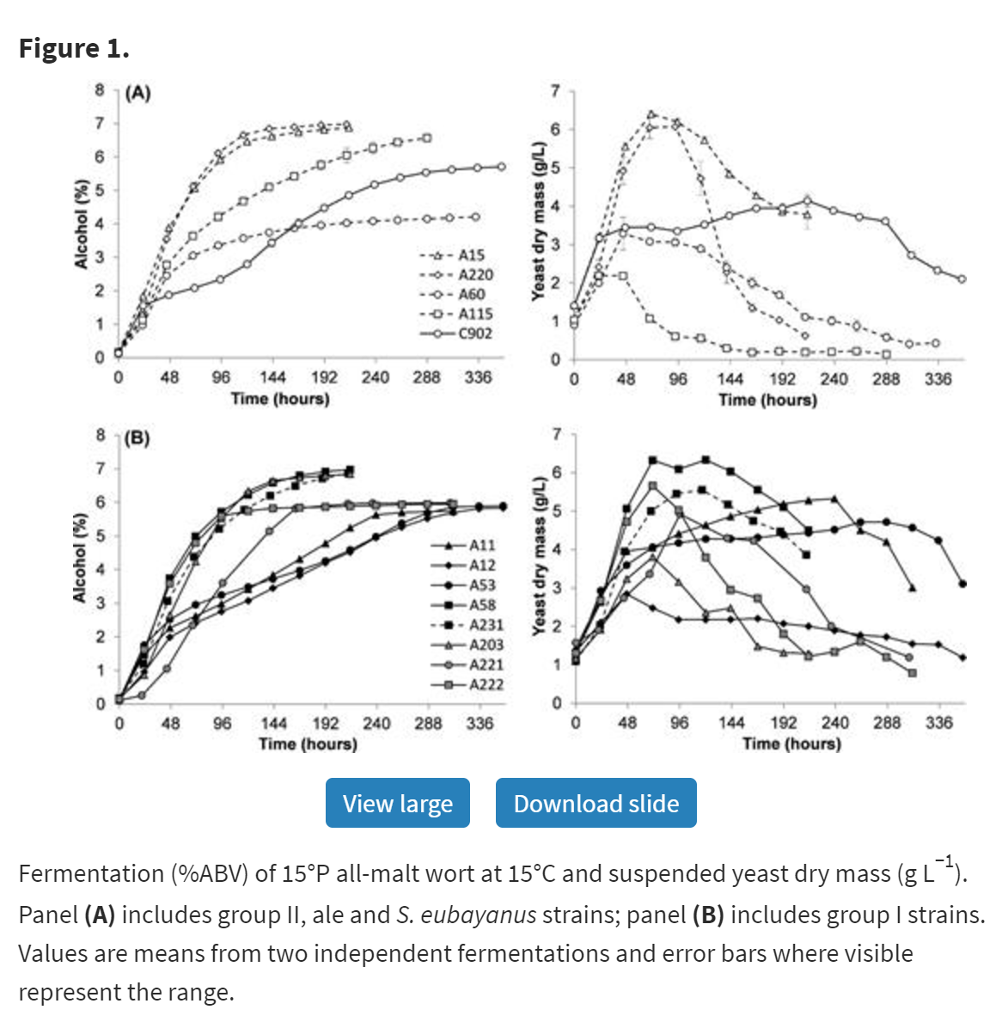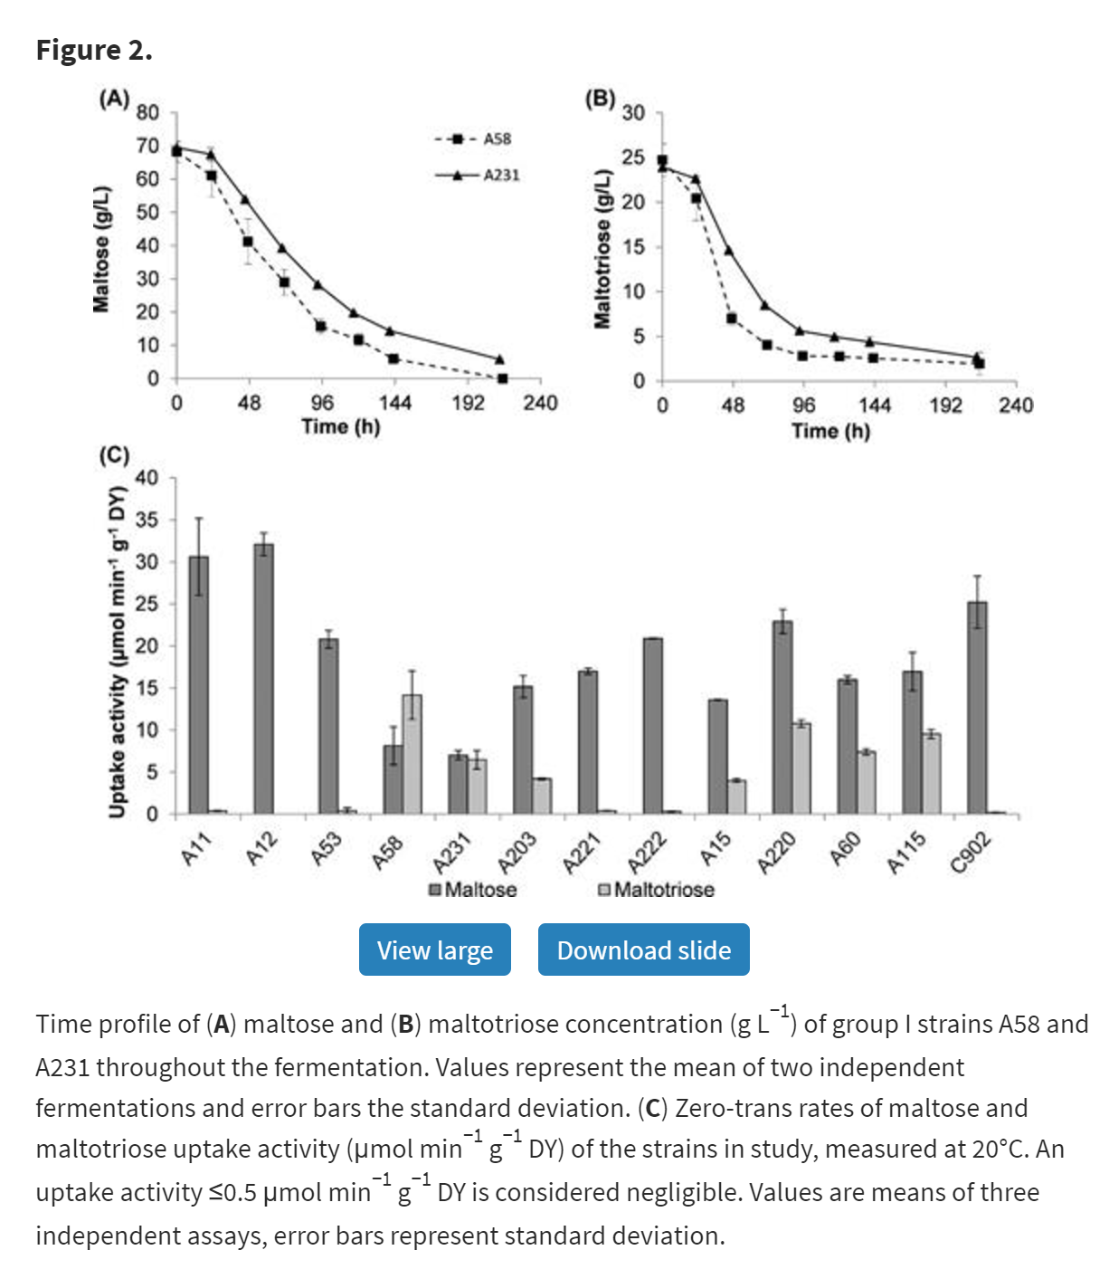

The process for the zero-trans uptake assay is listed below.

“For maltose and maltotriose uptake measurement, the yeast strains were grown at 20°C in liquid YP medium containing maltose (4% w/v) to an OD600 nm between 4 and 8. The cells were harvested by centrifugation (10 min, 5000 rpm, 0°C), washed with ice-cold water and 0.1 M tartrate-Tris (pH 4.2) and resuspended in the same buffer to a concentration of 200 mg fresh yeast mL−1. Zero-trans rates of [U-14C]-maltose and [U-14C]-maltotriose uptake at 20°C, 10°C or 0°C were determined with 5 mM of substrate as described by Lucero et al. (1997). Two incubation times were tested to ensure linearity with respect to time with t2 corresponding to at least 90% of t1 value. Statistical analysis was performed with R (http://www.rproject.org/; v3.3.0) by using one-way ANOVA and Tukey's test.” (direct passage from article)

For my proposal, I want to also measure the uptake using the technique outlined in Alves et al. (2008) which is listed below.

“The -glucosidase activity in cells collected by centrifugation (2,500 g for 3 min) at the exponential phase of growth was determined in situ with permeabilized yeast cells as described previously (31) by using 100 mM MOPS (morpholinepropanesulfonic acid)-NaOH (pH 6.8) buffer and 2 mM p-nitrophenyl-D-glucopyranoside (pNPG) or 100 mM maltose or maltotriose as substrates. The activity of the AGT1 permease was determined with a specific colorimetric assay (17) using 5 mM pNPG in 100 mM succinate-Tris, pH 5.0. All assays were done in triplicate, and controls with previously boiled yeast cells were used. The rates and kinetics of active H-trehalose, H-maltose, or H-maltotriose symport were determined as previously described (32) using a PHM84 research pH meter attached to a TT1 Servograph (Radiometer, Copenhagen). Initial rates of sugar-induced proton uptake were calculated from the slope of the initial (10-s) part of the curve obtained in the recorder by subtracting the basal rate of proton uptake observed before the addition of 0.1 to 100 mM sugar. All determinations were done at least in duplicate, and assays were monitored so that no more than 5% of the substrate was depleted. All activities were expressed as nanomoles of the substrate transported (or hydrolyzed) per milligram (dry weight) of cells per minute.” (direct quote from article)

Using these two measurements for sugar utilization and uptake, I would verify the previous results and see if their claim that “Higher activity did not necessarily ensure faster fermentation.” The final results would be presented much like the ones shown above. Maltose and maltotriose levels in the residual wort would be measured and the alcohol level in the wort. The two measurements of the sugar upkeep would also be measured and the two techniques would be compared to see if they returned similar results.

Discussion
Yeast has been used for its culinary and euphoric effects. Understanding how to make yeasts efficient in how they uptake sugars will help create better yeasts for industry and in the kitchen.

References
[1] Gallone B Steensels J Prahl T Soriaga L Saels V et. al. Cell 2016 vol: 166 (6) pp:
1397-1410.e16

[2] Alves S L Herberts R A Hollatz D T Miletti L C de Araujo P S Stambuk B U App
and Env MIcrobio vol: 74 (5) pp: 1494-1501

[3] Lucero, P., M. Herweijer, and R. Lagunas. 1993. Catabolite inactivation of the
yeast maltose transporter is due to proteolysis. FEBS Lett. 333: 165–168.

[4] Riballo, E., M. Herweijer, D. H. Wolf, and R. Lagunas. 1995. Catabolite
inactivation of the yeast maltose transporter occurs in the vacuole after
internalization by endocytosis. J. Bacteriol. 177:5622–5627.d

[5] Meneses, F. J., and V. Jiranek. 2002. Expression patterns of genes and enzymes
involved in sugar catabolism in industrial Saccharomyces cerevisiae strains
displaying novel fermentation characteristics. J. Inst. Brew. 108:322–335.

[6] Stewart, G. G., J. Erratt, I. Garrison, T. Goring, and I. Hancock. 1979. Studies on
the utilization of wort carbohydrates by brewer’s yeast strains. Tech. Q. Master
Brew. Assoc. Am. 16:1–7.

[7] Zheng, X., T. D’Amore, I. Russell, and G. G. Stewart. 1994. Factors influencing
maltotriose utilization during brewery wort fermentations. J. Am. Soc. Brew.
Chem. 52:41–47.

[8] Zastrow C.R., Hollatz C., De Araujo P.S., Stambuk B.U. (2001). Maltotriose
fermentation by Saccharomyces cerevisiae. J. Ind. Microbiol. Biotechnol., 27:
34-38.

[9] Smit A Otero R R C Pretorius. 2007. Differences among AGT1-encoded
α-glucoside transporters and their ability to transport maltotriose in
Saccharomyces yeasts. Ann. of Microbio. 57 (1):77-84

[10] Han E Cotty F Sottas C Jiang H Michels C A. 1995. Characterization of AGT1
encoding a general α-glucoside transporter from Saccharomyces. Mol. Microbio.
17 (6):1093-1107

[11] Dietvorst J Londesborough J Steensma HY Maltotriose utilization by lager yeast
strains: MTT1 encodes a maltotriose transporter Yeast 2005 22 775 88

[12] Salema-Oom M Pinto VV Gonçalves P et al Maltotriose utilization by industrial
Saccharomyces strains: characterization of a new member of the α-glucoside
transporter family Appl Environ Microbiol 2005 71 5044 9

[13] Dietvorst, J., J. Londesborough, and H. Y. Steensma. 2005. Maltotriose utilization
in lager yeast strains: MTT1 encodes a maltotriose transporter. Yeast
22:775–788.

[14] Characterization and Functional Analysis of the MAL and MPH Loci for Maltose
Utilization in Some Ale and Lager Yeast Strains

[15] Molecular Analysis of Maltotriose Active Transport and Fermentation by
Saccharomyces cerevisiae Reveals a Determinant Role for the AGT1 Permease

[16] Frederico Magalhães, Virve Vidgren, Laura Ruohonen, Brian Gibson; Maltose
and maltotriose utilisation by group I strains of the hybrid lager yeast
Saccharomyces pastorianus. FEMS Yeast Res 2016; 16 (5): fow053. doi:
10.1093/femsyr/fow053

Gallone B Steensels J Prahl T Soriaga L Saels V et. al. Cell 2016 vol: 166 (6) pp: 1397-1410.e16
Alves S L Herberts R A Hollatz D T Miletti L C de Araujo P S Stambuk B U App and Env MIcrobio vol: 74 (5) pp: 1494-1501
Meneses, F. J., and V. Jiranek. 2002. Expression patterns of genes and enzymes involved in sugar catabolism in industrial Saccharomyces cerevisiae strains displaying novel fermentation characteristics. J. Inst. Brew. 108:322–335.
Stewart, G. G., J. Erratt, I. Garrison, T. Goring, and I. Hancock. 1979. Studies on the utilization of wort carbohydrates by brewer’s yeast strains. Tech. Q. Master Brew. Assoc. Am. 16:1–7.
Zheng, X., T. D’Amore, I. Russell, and G. G. Stewart. 1994. Factors influencing maltotriose utilization during brewery wort fermentations. J. Am. Soc. Brew. Chem. 52:41–47.
Lucero, P., M. Herweijer, and R. Lagunas. 1993. Catabolite inactivation of the yeast maltose transporter is due to proteolysis. FEBS Lett. 333: 165–168.
Riballo, E., M. Herweijer, D. H. Wolf, and R. Lagunas. 1995. Catabolite inactivation of the yeast maltose transporter occurs in the vacuole after internalization by endocytosis. J. Bacteriol. 177:5622–5627.d
Smit A Otero R R C Pretorius. 2007. Differences among AGT1-encoded α-glucoside transporters and their ability to transport maltotriose in Saccharomyces yeasts. Ann. of Microbio. 57 (1):77-84
Zastrow C.R., Hollatz C., De Araujo P.S., Stambuk B.U. (2001). Maltotriose fermentation by Saccharomyces cerevisiae. J. Ind. Microbiol. Biotechnol., 27: 34-38.
Han E Cotty F Sottas C Jiang H Michels C A. 1995. Characterization of AGT1 encoding a general α-glucoside transporter from Saccharomyces. Mol. Microbio. 17 (6):1093-1107
Dietvorst, J., J. Londesborough, and H. Y. Steensma. 2005. Maltotriose utilization in lager yeast strains: MTT1 encodes a maltotriose transporter. Yeast 22:775–788.
Characterization and Functional Analysis of the MAL and MPH Loci for Maltose Utilization in Some Ale and Lager Yeast Strains
Dietvorst J Londesborough J Steensma HY Maltotriose utilization by lager yeast strains: MTT1 encodes a maltotriose transporter Yeast 2005 22 775 88
Salema-Oom M Pinto VV Gonçalves P et al Maltotriose utilization by industrial Saccharomyces strains: characterization of a new member of the α-glucoside transporter family Appl Environ Microbiol 2005 71 5044 9
Molecular Analysis of Maltotriose Active Transport and Fermentation by Saccharomyces cerevisiae Reveals a Determinant Role for the AGT1 Permease
Frederico Magalhães, Virve Vidgren, Laura Ruohonen, Brian Gibson; Maltose and maltotriose utilisation by group I strains of the hybrid lager yeast Saccharomyces pastorianus. FEMS Yeast Res 2016; 16 (5): fow053. doi: 10.1093/femsyr/fow053

