Mutations in MCL-1 PEST Region of Breast Cancer on Binding Affinity to Bak/Bax
Deeksha Jain
BNFO 300
04/30/2017

- Introduction

Cancer is the second leading cause of death in the United States with breast cancer being the most common type of cancer in females (Center for Disease Control). Cancer is a disease of dysregulation, resulting in the unregulated growth and division of cells with an increased propensity to form malignant tumors. A hallmark of cancer is to surpass apoptosis, the process for mediated cell death of unregulated or harmful cells. Apoptosis is vital for the removal of cancerous, damaged, and unnecessary cells within the body. The presence of cancer in the body imposes a stress onto the cells which result in apoptotic signaling. Cancer mechanisms block this signaling to allow for increased proliferation and eventually metastasis.

Myeloid Cell Luekemia-1 (MCL-1) is a protein from the BCL-2 family which are key regulators of the apoptotic process through the induction or inhibition of apoptosis. Past research has reported amplifications of MCL-1 with increased frequency in human cancers (Wei et al., 2012). Subsequent experimentation has proved the integral functioning of MCL-1 in anti-apoptotic activity with complete knockout procedures (Vick, et al., 2008). Furthermore, partial knockout of MCL-1 research has implicated the need for both functioning alleles of MCL-1 for proper anti-apoptotic functioning (Grabow et al., 2016).

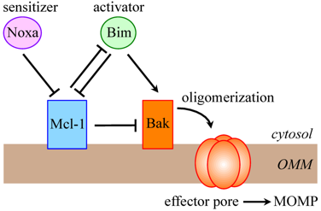
MCL-1 is an anti-apoptotic gene which functions by sequestering pro-apoptotic proteins Bak and Bax via hydrophobic grooves (Thomas, Lam, & Edwards, 2010). Heterodimerization of Bak or Bax by MCL-1 prevents them from oligomerizing via a conformational change. Oligomerization of Bak/Bax allows for the aggregated body to translocate to the outer mitochondrial membrane (OMM). From there, Bak/Bax work to pierce and form pores within the mitochondrial membrane to stimulate the release of cytochrome C into the cytoplasm, resulting in the initiation of apoptosis (Thomas, et al., 2010). This process is called the mitochondrial outer membrane permeabilization (MOMP). Once inside the cytoplasm, cytochrome C induces the activation of caspases in what is called the caspase cascade (Thomas, et al., 2010). Caspases are responsible for the macromolecular degradation of lethal cells via proteolytic activity. Additionally, MCL-1 can bind to a direct activator of Bak/Bax called Bim to prevent it apoptosis (Mojsa, Lassot, & Desagher, 2014). Binding of Bak/Bax by MCL-1 prevents that process and thus the initiation of apoptosis. Noxa can bind to MCL-1 to relieve Bak/Bax and allow for apoptotic activity (Mojsa et al., 2014). Pathway elucidated in Figure 1.
Release of cytochrome c
Figure 1: Protein interaction pathway of MCL-1 with Bak/Bax in apoptosis. Adapted from Figure 1 of Mojsa et al.
Bax

The MCL-1 gene contains, unlike other BCL-2 genes, a PEST region towards the N-terminus which is rich in proline (P), glutamic acid (E), serine (S), and threonine (T). The PEST region is responsible for the short half life of MCL-1 through enhancement of MCL-1’s degradation (Germain & Duronio, 2007). More importantly, the PEST region is the primary site of post-translational modifications, significantly including phosphorylation, caspase cleavage, and ubiquination (Fig. 2).
Figure 2: PEST sequence and sites of post-translational modifications within MCL-1 gene in comparison to BCL-2. Adapted from Figure 2 of Thomas et al.
Phosphorylation is integral to the functioning of MCL-1 and its anti-apoptotic activity (Thomas, et al., 2010). Phosphorylation at specific sites within these phosphoresidues has been shows to stability of MCL-1 and its interactions with other proteins/pathways, notably ERK and BIM resulting in varying degrees of apoptotic activity (Thomas, et al., 2010). Deletion of this domain has shown to impair both mitochondrial localization and anti-apoptotic activity, signifying its vital role in proper functioning of MCL-1 (Germain & Duronio, 2007). Induced mutations within this domain and the phosphoresidues have shown to affect the anti-apoptotic activity of MCL-1 (Thomas, et al., 2010).

The question posed now is how are mutations within this PEST region affecting the anti-apoptotic activity of MCL-1? It is known from Thomas et al. that phosphorylation of and mutations at these residues affect the functioning of BIM, but it is unclear whether mutations within this region affect the binding affinity of MCL-1. The aim of this investigation is to determine whether mutations within the PEST region of MCL-1 affect its ability to bind Bak/Bax for anti-apoptotic measures.

- Experiment

In order to assess whether mutations within the PEST region of MCL-1 affects its ability to bind Bak/Bax, there will need to be be multiple preceding steps which will have to take place. The basic set up to test for binding affinities will include the use of previously established MCL-1 KO breast cancer cell lines and breast cancer cell lines with fully functional MCL-1 obtained externally. These cell lines will comprise the experimental trials. One cell line will remain as a complete KO cell line, whereas another will have a mutated version of MCL-1 introduced within. The last cell line for comparison will have the fully functional MCL-1 as stated above. Then will be an incubatory period followed by a biochemical assay test to determine binding affinities.

Mutation Creation via CRISPR/Cas9 Technology and Insertion into Cell Lines

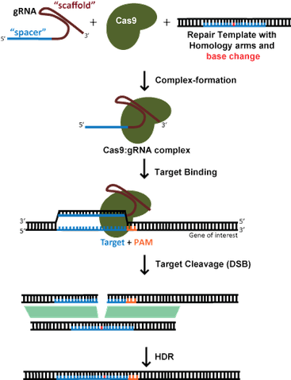
Random mutations will be created within the PEST region of MCL-1 using the CRISPR/Cas9 genome editing technology. CRISPR/Cas9 is a site directed mutagenesis tool used to make changes to the DNA sequence of a gene within a certain location. To introduce a mutation within a gene, in this case MCL-1, via CRISPR/Cas9 technology, a guide RNA (gRNA) sequence must be established (Addgene). To establish this gRNA, first the genome sequence of MCL-1 needs to be assessed to identify a unique gene sequence for modification, in this case the PEST region. This can be done via the assistance of NCBI BLAST for both identification and primer design. Once identified, a gRNA strand is designed complementary to the target sequence which will form an endonuclease by associating with Cas9. It is vital to choose a Cas9 variant that has a relatable PAM sequence within the target sequence to allow for binding of the nuclease (Addgene). Following creation of a gRNA, a repair template has to be assembled containing the desired sequence with the mutation to be introduced without a PAM sequence region. PAM regions can be verified using online gRNA design programs.
Figure 3: Cas9 endonuclease formation and functionality. Adapted from Figure 4 of Addgene.

Once designed, the gRNA oligos will be developed
and cloned into a plasmid using standard restriction-ligation cloning (Addgene). The gRNA/Cas9 complex and repair template will be delivered via lentiviral transfection similar to as described in Aubrey et al. The gRNA/Cas9 complex will then move forward to seek out the DNA sequences that are complementary to the gRNA to facilitate in a double strand break. Following the cleavage of the target sequence, the repair template will be included into the gene via a homology directed repair or HDR (Addgene). Process is outlined in Figure 3.

Once the the aforementioned templates have been delivered, it is necessary to validate that the genome editing worked. Validation of mutation creation will occur via PCR amplification of the plasmid followed by gel electrophoresis for confirmation of necessary amplicon (Addgene). For more accurate results, Sanger or next generation sequencing (NGS) can be used, which would give additional insight into off target results of the procedure (Addgene).

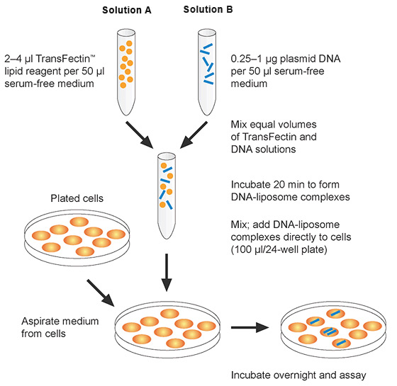
Following validation of successful genome edits, this new entry vector containing the DNA of interest needs to be transferred over to a destination vector, i.e. the established cell lines. This plasmid transfection was done via lipofection as described in Demelesh et al. Lipofetion is a technique used to inject genetic material into a cell by the means of liposomes, or vesicles which merge with the cell membrane easily as they both contain a phospholipid bilayer. The Lipofectamine 2000 (Life Technologies) kit will be used as described by the manufacturer to open pores within the cell membranes. Cell lines in poly-L-lysine coated glass coverslips would be transfected with the mutated MCL-1 containing plasmid. The medium would be changed in 24 hour and cells would be incubated for 48 hours prior to verifying transgene expression. Stable transfectants would be selected with geneticin. Basic process as outlined in Figure 4. To verify transgene
Figure 4: Basic Lipofection process. Adapted from Figure 1 of BioRad.
expression, PCR would be conducted to amplify significant portions of the target sequence which can be analyzed via Western Blot following lysis of samples within cell line. Additionally, Sanger sequencing or NGS could be run again for more accurate results.

Binding Affinity via Biochemical Assay

Following confirmation of mutant MCL-1 gene within breast cancer cell lines and a short incubatory period, the experiment can move forward with testing the binding affinity of MCL-1 with Bak/Bax. MCL-1 firstly has to be isolated and lysed (2% CHAPS buffer) from the cell lines using poly-histidine tags and the QIAGEN Ni-NTA fast start protein purification kit as described by the manufacturer. Once purified, MCL-Bak/Bax binding affinity will be test via a co-immunoprecipitation assay as described in Vartak et al. and Sharma et al. Antibodies needed will be purchased externally. MCL-1 lysates would be precleared via Protein G agarose beads. Primary polyclonal antibody would be incubated with MCL-1 lysate. The beads will be washed and heated in an buffer. The protein will be resolved on SDS-PAGE. Following electrophoresis, proteins will be transferred to a PVDF membrane and probed with the appropriate primary antibodies for MCL-1, and secondary antibodies as needed. Tubulin will be used as an internal loading control. Immunoblotting will evaluate the extent of coimmunoprecipitation and scanned by a gel documentation system for analysis. A Multi Guage (V3.0) software will be used for quantification of bands and binding affinities. Generalized protocol for coimmunoprecipitation clarified in Figure 5.
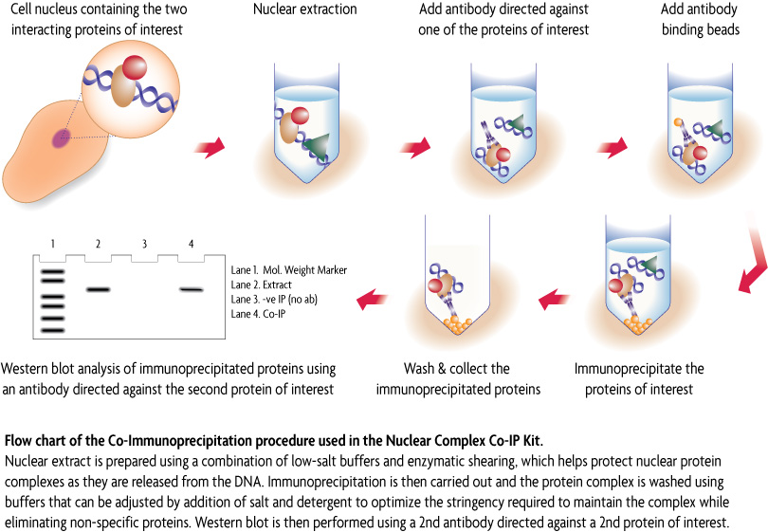
Figure 5: Basic coimmunoprecipitation methodology. Adapted from Active Motif.

- Discussion

The importance of PEST regions with MCL-1 and its functioning were stressed earlier. If all goes as directed, at the end, binding affinities of mutated MCL-1 for Bak/Bax will be indicated to have a decreased affinity for binding to Bak/Bax given mutations within the PEST sequences. PEST sequences are responsible for assisting MCL-1 with it’s localization and anti-apoptotic action. Given mutations in such an integral part of the gene, it can affect how the protein binds, disable to proteins actions, or even further decrease the genes half life, resulting in decreased binding of MCL-1 to Bak/Bax. It is a possibility that the binding affinity of both protein are not affected, or even that the affinity is increased for increased anti-apoptotic activity on MCL-1’s part.

A potential concern that this experiment does not address completely is the formation of insertion/deletion mutations (InDels) in off-target locations within the gene which may indirectly affecting binding abilities. While HDR is precise in its process of involving a repair template into the target region, a portion of the DNA damage, the DSB, can be repaired with non-homologous end joining, or NHEJ (Addgene ). This can occur further away from the site of mutagenesis. NHEJ has been indicated to cause increased InDels within target sequence. While a small InDel could be harmless, it could just as much be harmful to the functionality of the gene itself.

Despite the potential setbacks, decreased binding affinity for Bak/Bax translates to a major step as it reduces the anti-apoptotic activity of the gene, allowing for apoptosis to occur, and for cancer to be combatted. This can assist with mediated drug transfers and treatments within patients, or even as a preventative measure for those in remission.

References

Active Motif. Nuclear Complex Co-IP Kit. (n.d.). Retrieved April 2017, from
https://www.activemotif.com/catalog/25/nuclear-complex-co-ip-kit

Addgene. CRISPR/Cas9 Guide. Retrieved April 2017, from
https://www.addgene.org/crispr/guide/

Aubrey, B., Kelly, G., Kueh, A., Brennan, M., O’Connor, L., Milla, L., . . . Herold, M. (2015).
An Inducible Lentiviral Guide RNA Platform Enables the Identification of Tumor-Essential Genes and Tumor-Promoting Mutations In Vivo. Cell Reports,10(8), 1422-1432. doi:10.1016/j.celrep.2015.02.002

BioRad. Chemical- and Viral-Based Transfection Methods. (n.d.). Retrieved April 2017, from
http://www.bio-rad.com/en-us/applications-technologies/chemical-viral-based-transfection-methods

Center for Disease Control. Statistics for Different Kinds of Cancer. (2016, August 16).
Retrieved April 2017, from https://www.cdc.gov/cancer/dcpc/data/types.htm

Demelash, A., Pfannenstiel, L. W., Tannenbaum, C. S., Li, X., Kalady, M. F., Devecchio, J., &
Gastman, B. R. (2015). Structure-Function Analysis of the Mcl-1 Protein Identifies a Novel Senescence-regulating Domain. Journal of Biological Chemistry,290(36), 21962-21975. doi:10.1074/jbc.m115.663898

Grabow, S., Delbridge, A., Aubrey, B., Vandenberg, C., & Strasser, A. (2016). Loss of a Single
Mcl-1 Allele Inhibits MYC-Driven Lymphomagenesis by Sensitizing Pro-B Cells to Apoptosis. Cell Reports,14(10), 2337-2347. doi:10.1016/j.celrep.2016.02.039

Germain, M., & Duronio, V. (2007). The N Terminus of the Anti-apoptotic BCL-2 Homologue
MCL-1 Regulates Its Localization and Function. Journal of Biological Chemistry,282(44), 32233-32242. doi:10.1074/jbc.m706408200

Mojsa, B., Lassot, I., & Desagher, S. (2014). Mcl-1 Ubiquitination: Unique Regulation of an
Essential Survival Protein. Cells,3(2), 418-437. doi:10.3390/cells3020418

Sharma, S., Javadekar, S. M., Pandey, M., Srivastava, M., Kumari, R., & Raghavan, S. C.
(2015). Homology and enzymatic requirements of microhomology-dependent alternative end joining. Cell Death and Disease,6(3). doi:10.1038/cddis.2015.58

Thomas, L. W., Lam, C., & Edwards, S. W. (2010). Mcl-1; the molecular regulation of protein
function. FEBS Letters,584(14), 2981-2989. doi:10.1016/j.febslet.2010.05.061

Vartak, S. V., Iyer, D., Santhoshkumar, T., Sharma, S., Mishra, A., Goldsmith, G., . . .
Raghavan, S. C. (2017). Novel BCL2 inhibitor, Disarib induces apoptosis by disruption of BCL2-BAK interaction. Biochemical Pharmacology,131, 16-28. doi:10.1016/j.bcp.2017.02.015

Vick, B., Weber, A., Urbanik, T., Maass, T., Teufel, A., Krammer, P. H., . . . Schulze-
Bergkamen, H. (2008). Knockout of myeloid cell leukemia-1 induces liver damage and increases apoptosis susceptibility of murine hepatocytes. Hepatology,49(2), 627-636. doi:10.1002/hep.22664

Wei, G., Margolin, A., Haery, L., Brown, E., Cucolo, L., Julian, B., . . . Golub, T. (2012).
Chemical Genomics Identifies Small-Molecule MCL1 Repressors and BCL-xL as a Predictor of MCL1 Dependency. Cancer Cell,21(4), 547-562. doi:10.1016/j.ccr.2012.02.028

