Leukocyte Migration through the Blood Brain Barrier

INTRODUCTION

There is a constant war raging in our bodies between invaders and our own cells.
White blood cells (or leukocytes) are the unsung superheroes in this battle- targeting pathogens, fighting infection, and aiding in immune response.
However, this isn’t a story about their accomplishments- it’s clear enough how important their function is to us after we emerge from a bad cold or witness the clotting of blood after an injury.
This is a tale of a superhero gone rogue.
The trouble begins when leukocytes accumulate in the brain. Unfortunately, too much of a good thing can be harmful to your health. Multiple studies show that inhibited leukocyte migration to the brain is commonly seen in patients with neurological problems like multiple sclerosis, cerebral infection, stroke, and trauma.
But before we get too ahead of ourselves, we need to figure out exactly how leukocytes are travelling to the brain in the first place.

Blood Brain Barrier
Reaching the brain isn’t easy. As the seat of the central nervous system, the brain plays a crucial role in the rest of the body’s functioning. Here is where decisions are made (either consciously or subconsciously), nervous signals are sent out, and neurotransmitters are directed.
The brain can’t be affected by the countless hormones and harmful pathogens zooming around through the rest of the body- it would be disastrous for the organism.
This is where the blood brain barrier (BBB) comes in. As the name suggests, it’s a barricade between nasty things in the blood and the brain. A web of blood vessels (capillaries, the smallest blood vessels) sheath the brain. These capillaries are lined with a special type of cell that lines the inside of all blood vessels- endothelial cells. The slight gaps between the endothelial cells are traversed by thin fibers of protein (the claudins, claudin-3 and claudin-5) called tight junctions, which keep unwanted molecules from slipping past the cells.
In the brain, the gaps in between the endothelial cells are smaller than in other parts of the body. The end result is a brain that’s protected from most molecules except very small ones and ones easily dissolved in fat (the cells that line the BBB, like most cells, have membranes made of lipids- a type of fat. Molecules that can easily slip in between lipids will have an easier time getting through them).

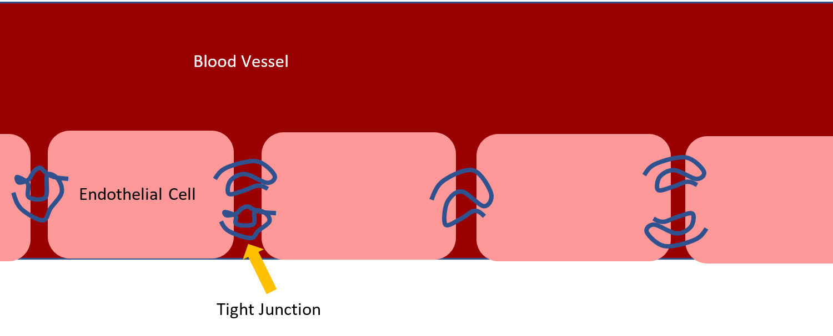
Endothelial cells lining blood vessels
Leukocyte Migration Pathway
How leukocytes cross the blood brain barrier has long been a mystery. It’s accepted that they take the path of least resistance (19), which should be right between the gaps of the endothelial cells (and, somehow, bypassing the tight junctions). This method of travel is known as paracellular migration, para meaning parallel to the borders of the cells. Bizarrely, they’ve also been witnessed barreling straight through the middle of the endothelial cells themselves (20-22) through transcellular migration (trans meaning through).
So what is it? Do leukocytes slip in between EC cells and into the brain, or do they stroll right through? Winger and Koblinski hypothesized that leukocyte travel to the brain, or transendothelial migration (TEM), depends on how tightly packed together the endothelial cells in question are. The smaller the gaps, the more likely leukocytes would find it easier to travel through the cells rather than in between them. In the tightly packed cells of the blood brain barrier, this would mean a high percentage of TEM would be paracellular- right through the cells. This hypothesis also solved the problem of what happens to tight junctions as leukocytes travel through the cells, as they would be undisturbed by paracellular migration.
Go to “making the model” to begin reading how their hypothesis was tested.
Knowing how exactly leukocytes travel to the brain can be the first step towards preventing their accumulation in the brain and learning more about the blood brain barrier.

THE MODEL

It’d be pretty difficult to test the in a living human being or other organism (in vivo). Researchers instead constructed a model to mimic the environment of the blood brain barrier that could be manipulated and observed.

Making the Model
Human umbilical vein endothelial cells (HUVECs) were used to simulate endothelial cells in the brain. Taken from umbilical cells shortly after birth, HUVECs are a cheap and readily accessible source of endothelial cells. However, there is one problem with using them, and it lies in the name.
HUVECs by definition are cells that come from veins. As previously mentioned, the endothelial cells in the blood brain barrier are found in capillaries, which are significantly smaller blood vessels- and therefore significantly more selective when it comes to letting molecules in. Leukocyte interaction with the HUVECs wouldn’t be an accurate representation of how they interact with actual cells in the BBB.
Because the vein endothelial cells weren’t selective enough, their resistance to outside molecules had to be artificially raised by adding in molecules that play a role in the blood brain barrier.
These include astrocytes, which support the function of BBB endothelial cells, and CPT-cAMP. cAMP, or cyclic adenosine monophosphate, as been shown to enhance tight-junction function, making them tighter and less impermeable.
HUVECs were grown in Invitrogen, a solution which helps mammalian cells grow and flourish. Astrocyte medium was separately prepared; once finished, HUVEC cells were grown in the astrocyte cultured media (ACM). The end goal was to fully incorporate astrocyte cells into the HUVEC model.
CPT-cAMP was then added to the ACM/HUVEC mixture to further increase resistivity and the entire mixture was let undisturbed for 24 h to ensure that all components were adequately mixed in. Finally, the cells were placed in plates coated with collagen gel and fibronectin, both common components of cell cultures.
At this point, the model resembled a single layer of cells and should have acted more and more like the actual blood brain barrier in terms of impermeability.
ACM/HUVEC Cells (single layer)
Collagen Fibronectin Layer

However, it’s not enough to assume that the model acts like the blood brain barrier- it should be rigorously tested as well.

Testing the model
Two assessments were performed to test how impermeable this model was. The more impermeable it was, the more it resembled the actual blood brain barrier, and the more accurate any conclusions made from the experiment would be. The assessments of the ACM/HUVEC model were compared to a control culture of just HUVEC cells, which would not contain any molecules that increased resistance.
Trans endothelial electrical resistance (TEER) was the first. A current was passed through the cell model to determine whether the cells could prevent ions from breaching them; quantitatively, this could be measured by the electrical resistance the cells exhibited. A higher resistance meant ions had a harder time getting through the cells.
- 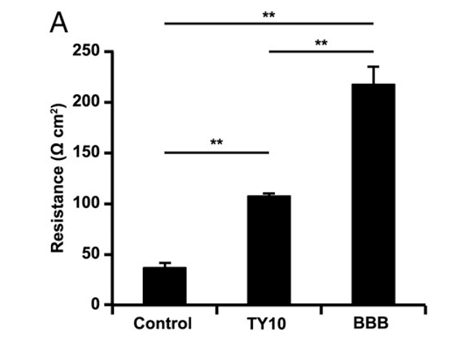
The constructed cell model had a resistance of 250 ohms, far greater than the resistance of the control or even cells from the actual blood brain barrier (shown in the chart). It wouldn’t be easy for leukocytes or other molecules to bypass the model.
The second assessment to measure permeability involved larger molecules: polysaccharides, or complex sugars. Fluorescein Isothiocyanate Dextran, a fluorescent polysaccharide, was added to the cell model and left undisturbed for one hour. At the end of the hour, the amount of fluorescence that had permeated the layer of endothelial cells and reached the bottom was measured. Lower levels of fluorescence would indicate
The constructed model had nearly 10 times less fluorescence at the end of the hour than the control of untouched HUVEC cells, indicating that little had been able to breach the endothelial cells.
In the end, both assessments indicated that the model was extremely impermeable to ions and other molecules, making it the perfect (or, at least, a good enough) vehicle to test the hypothesis that more impervious endothelial cells in the blood brain barrier would force leukocytes to cross them in different ways.

TESTING THE HYPOTHESIS

A number of different experiments were performed to determine how most leukocytes travelled across the blood brain barrier and what molecules were involved.
Experiment 1: How TEM is affected by PECAM-1 or CD99
PECAM-1 and CD99 are both signaling molecules that have been shown to be involved in encouraging leukocytes to traverse across the endothelium cells of the blood brain barrier. Pinpointing their affects in this model helps solve a piece of the puzzle that is leukocyte migration.
Peripheral blood mononuclear cells (PBMCs), a type of leukocyte, were used for this experiment as they migrate faster than any other leukocyte- and are thus easily observable. Blood was drawn from human volunteers and PBMCs within were isolated by centrifugation, a technique that uses high speeds and gravity to separate substances by their densities.
The blood cells were separated into two groups. One group was given anti-PECAM-1 or anti-CD99, which would block their respective signaling molecules. The other group was given a non-blocking control.
The altered PBMCs were then placed onto the endothelial cell model and stored for 1 hour at 37 degrees Celsius in a CO2 incubator so that migration could occur.
Why CO2? Carbon dioxide plays a major role in homeostasis and pH regulation within our bodies- it keeps everything balanced (along with water). Without a CO2 incubator, your cells may be drastically altered in terms of pH, rendering them unusable.
Both groups were then washed, stained, and viewed under a microscope to assess how many leukocytes (in this case, PBMCs) had migrated.

Experiment 2: How tight junctions behave during TEM
Leukocyte migration with PBMCs was performed as described in the above experiment for 10 minutes. This time, however, they were immediately placed in paraformaldehyde on ice and triton X-100 to be frozen in place for visualization, as tight junctions could soon return to their normal states otherwise. Fluorescent dye with a claudin-5 label was added to the cell model; as mentioned before, claudin-5 is one of the proteins that make up tight junctions- labelling it would allow for easy observation under the microscope of the junctions and how they behave.

Experiment 3: How leukocytes move across the endothelial cells: paracellularly or transcellularly
Leukocyte migration with PBMCs was performed similarly to both of the experiments above. This time, however, the endothelial cell models were divided into groups, with some receiving TNF (which increases TEM in endothelial cells, allowing for migration of leukocytes to occur when necessary) and some receiving CCL2 (another molecule which increases leukocyte migration). Previous studies have shown that leukocytes which received TNF or CCL2 were more likely to travel straight through the cell.
As in experiment 2, the cell models were washed and fixed in cold paraformaldehyde so that leukocytes would stay fixed where they were in the moment at migration. After staining the cells to visualize the gaps (junctions) in between, migration was quantified as being paracellular or transcellular. That is, the cells were viewed and it was noted whether the leukocytes moved through the gaps of the endothelial cells or straight through the cells themselves.

Results and Implications
In the end, did the leukocytes primarily migrate paracellularly or transcellularly through the blood brain barrier? And how else is TEM controlled?

Experiment 1: Effect of PECAM-1 and CD99 (signaling molecules)
When PECAM-1 and CD99 weren’t blocked, leukocytes migrated through the endothelial cells at 90%, a normal rate for TEM. When they were blocked, however, leukocyte migration decreased to 15%-20%. These results were replicated in another cell line, TY10, that is found in the blood brain barrier.
PECAM-1 and CD99 clearly play an important role in leukocyte migration through the blood brain barrier. The implications of this could potentially lead to a treatment for neurological disorders that are linked to an abundance of leukocyte migration; halting TEM could lead to better outcomes in these diseases.

Experiment 2: How tight junctions behave during TEM
VE-Cadherin, another type of gatekeeping protein found at junctions between endothelial cells, is known to allow molecules through by dispersing and then remodeling immediately after entry of molecule; the results of this experiment would indicate whether tight junctions do the same.
Labelling and viewing of claudin-5, which makes up tight junctions, showed that it disappeared as leukocytes travelled between endothelial cells just as cadherin does, implying that it too alters itself to allow entry to molecules.

Experiment 3: Method of leukocyte migration (para vs. transcellular)
In order to view their method of transport, TEM had be halted prematurely- half of leukocytes hadn’t finished migration yet. However, it was clear which was the primary method of travel.
Over 98% of leukocytes migrated paracellularly across the endothelium. When CCL2 (a leukocyte activator that encourages migration) was added, transcellular migration straight through the cell was up to 15% higher; however, under normal conditions with tightly packed endothelial cell as found in the blood brain barrier, transcellular migration rarely occurred.
Piecing together the results of these separate experiments points to one conclusion: the small gaps between endothelial cells in the brain do not cause leukocytes to migrate straight through the cell body. Rather, leukocytes migrate in between the cells, and tight junctions reform themselves to allow this passage. PECAM-1 and CD99 were also found to be integral to leukocyte migration. These conclusions could potentially lead to a method of controlling leukocyte migration to the brain and, eventually, treating the multiple neurological disorders it causes.

