Neel Gohil

The role of Phospholipase C-β1 in intracellular calcium diffusion

Introduction:
Calcium ions (Ca2+) play a vital role in the physiology and biochemistry of organisms and the cell. Ca2+ in excitable cells is the primary signal to activate skeletal muscle contraction, cardiac muscle contraction, beta cell insulation secretion, and neuron excitability. In non-excitable cells, calcium is needed for fertilization, proliferation, metabolism, secretion and smooth muscle contraction. In resting cells, Ca2+ concentration in the cytosol ([Ca2+]C) is maintained at very low levels (55–100 nM). Stimulation of cells with an agonist, such as acetylcholine, results in an increase in [Ca2+]C, which regulates cellular function (7).
This figure refers to the voltage gated calcium channel
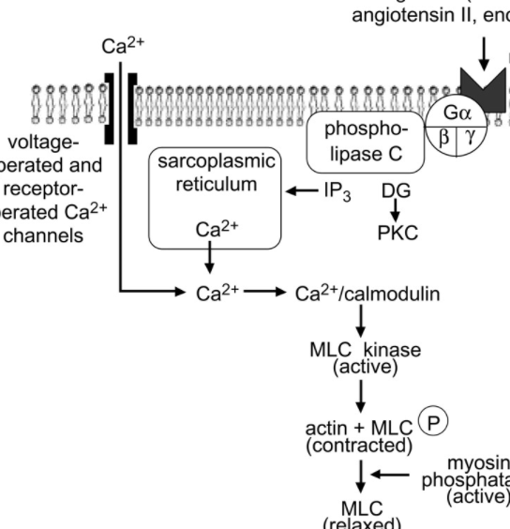
Calcium plays an important role in smooth muscle contraction. There are two systems that play a role in the increase of [Ca2+] in the cytosol. The first system is a voltage gated channel. When a smooth muscle cell is depolarized, it causes opening of the voltage-gated (L-type) calcium channels (3). Depolarization may be brought about by stretching of the cell, agonist-binding its G protein-coupled receptor (GPCR), or autonomic nervous system stimulation. Opening of the L-type calcium channel causes influx of extracellular Ca2+, which then binds calmodulin (4). The activated calmodulin molecule activates myosin light-chain kinase (MLCK), which phosphorylates the myosin in thick filaments. Phosphorylated myosin is able to form cross bridges with actin thin filaments, and the smooth muscle cell contracts via the sliding filament mechanism (3).
Membrane bound receptor recognizes external signal, that signal is converted into molecular information through a pathway that produces a secondary messenger that triggers Ca2+ release. Ca2+ release from the SR to the cytoplasm is tightly regulated through feedback with the Ca2+ pump (11), where flow is terminated when Ca2+ levels reach a feedback threshold (10). Lowering Ca2+ in the lumen of the SR would decrease channel activity, thereby providing a potential negative control mechanism to counter the positive feedback. The Sarco/Endoplasmic Reticulum Calcium ATPase (SERCA) pump is a method in which the calcium ions get shuttled back in to the sarcoplasmic reticulum (10). It is one of these pumps that is activated once the concentration of extracellular [Ca2+] levels reach its peak, so that the cell doesn’t reach apoptosis. The SERCA pump returns two Ca2+ ions into the SR lumen in exchange for three protons into the cytoplasm of the cell (5). In order to drive this movement, the SERCA pump hydrolyzes ATP to ADP and Pi. Once calcium is bound to the calcium inhibitory site on the IP₃ receptor, the calcium flow terminates within the sarcoplasmic reticulum (8).
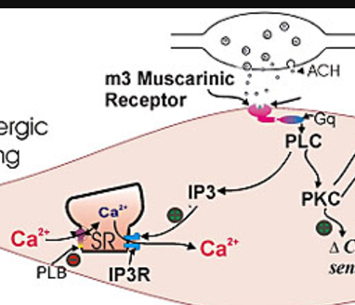
In non-excitable cells, Ca2+ signaling is initiated upon the activation of phospholipase C (PLC) signaling pathways (7).Binding of an agonist (like the neurotransmitter acetylcholine) to the cell surface receptor activates a PLC type (PLCγ or PLCβ) (6). PLSCs in turn serve as a signaling intermediary to then catalyze a secondary messenger through the hydrolysis of phosphotidyl-inositolbisphosphate (PIP2) into inositol 1,4,5-trisphosphate (IP3) and diacylglycerol (DAG) (9). Most importantly, IP3 triggers the release of Ca2+ from the IP3-sensitive Ca2+ stores, causing a transient increase in [Ca2+]C (2). This is followed by a relatively sustained phase of increase in [Ca2+]C, due to the calcium influx from the outside. The aim of this experiment is to observe the role of PLC-B1 in the release of intracellular calcium through the IP3 pathway.
Figure depicts acetylcholine induced signaling pathway that releases calcium from sarcoplasmic reticulum

Methods:
Animals:

PLC-β1 KO mice9 were bred from mice heterozygous for the null mutation on an SV129/C57Bl6 background strain (13). A preliminary behavioral screen established basic visual, oral and sensory abilities of the KO mice. Testing was performed blind to the genotype. All procedures had the approval of the Institute’s Animal Ethics Committee.
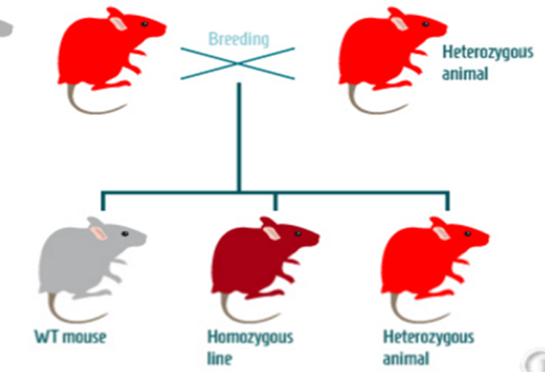

Colonic myocyte isolation
Mice heterozygous with the PLC-β1 knock out can be breed to produce homozygous with the knock out, these mice do not produce the PLC-β1 gene.
(from http://paperv.com/story/2415/gene-targeted-mouse-model-tool-creator-creative-animodel/
All animal care and experimental procedures complied with the Animal (Scientific Procedures) Act UK 1986. The mice were humanely killed by cervical dislocation. The colon was immediately removed and transferred to an oxygenated physiological saline solution. From this tissue single smooth muscle cells were enzymically isolated (1), stored at 4°C and used the same day. All experiments were conducted at room temperature (20–22°C).

Fluo-4 dye
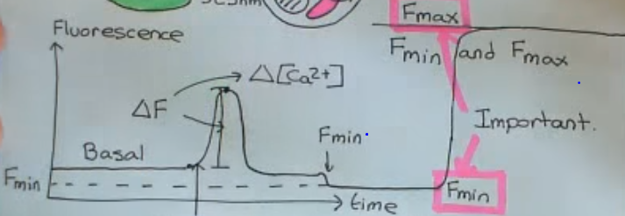
Cytoplasmic Ca²⁺ concentration will be measured as fluorescence using fluo-4 Acetoxymethyl ester (fluo-4AM) dye. Fluo-4AM dye will be purchased online to perform this assay. Fluo-4 dye cannot naturally permeate the cell membrane due to its four negative charges, that is why the fluo-4AM dye will be used due to no ionization (12). The Fluo-4 AM dye will be mixed with a buffer solution and will be placed aside for 5 minutes so that the dye to properly mix. The colonic myocytes will be placed in 96 well plate and the fluo-AM dye mixture will be poured on top of the myocytes. Once the dye is placed, the cells will be incubated for an hour in the dark because the dye is light sensitive. During the incubation process, the dye will slowly permeate through the cell membrane and into the cytoplasm of the myocytes (12). Cells contain non-specific esterase’s that are in the cytoplasm and will cut the acetoxymethyl ester links in the fluo-4AM dye. Thus, the dye will return to its original fluo-4 conformation. Because the dye is back to its original conformation, it will be ionized and therefore, cannot exit the cell membrane. This procedure will be done on the wildtype cell line and the gene KO cell line.
Minimum and Maximum fluorescence (F_{min} / F_{max})
The myocytes will be taken out of incubation after an hour and will be ready to interact with an agonist. Before the interaction with the agonist, the cells will be washed with a buffer solution so that fluo-4 dye that has not entered the cell membrane will be washed away and not give false reports during image analysis. The myocytes will then be placed back into the well. In this experiment, the agonist will be acetylcholine (ACh). ACh will be added first to the well and will be placed on an equipment called a microfluorometer (2). This will be used to shoot photons at the well at an excitation frequency of 485nm. This will then record the emission frequency which should be higher than the excitation which indicates a longer wavelength. A detergent called Triton X-100 (14) will be added shortly after to mix the water and fat molecules and lyse the myocytes. This will destroy the cell structure and turn it into free solution. Once the free solution is formed, a calcium binding agent called BAPTA will be introduced to the free solution and will bind to all of the calcium ions so that there is no calcium in the free solution (12). This will result in a decrease in the florescence signal because all of the fluo-4 molecules will no longer have calcium bounded to them. The microfluorometer will then record its frequency output. This is the F_{min} of the experiment because this will be the lowest concentration of calcium recorded. In order to find the F_{max}, a high concentration of calcium, usually in the form of calcium chloride (CaCl₂), will be added to the free solution so that the BAPTA molecule will be saturated and therefore, the fluo-4 dye will once again be bound to calcium. This will increase the fluorescence signal to its peak and stay there. Once again, the microfluorometer will be used to measure its maximum fluorescence.
This figure first depicts the initial calcium concentration at its basal rate. Once the well has been exposed to ACh, fluorescence increases and drops back down to its basal state. Once Triton X-100 and BAPTA have been added, calcium concentration is dropped because of the absence of calcium being bounded to fluo-4 dye (F_{min}). Once a high concentration of CaCl₂ has been added, graph spikes up due to calcium being bound to the dye.
Confocal microscopy and image analysis
The fluorescence will be imaged using inverted microscope with LCD instead of oculars. A 488nm excitation laser will be pointed at the myocytes at linescan mode. Linescans are going to be taken from the middle of the cell to avoid measurement of the cell’s circumference. Fluorescence intensity will be analyzed using ImageJ software and cells will be disposed once multiple images are taken.
Discussion
By analyzing images taken, calcium concentration should be decreased in the PLC-β1 knockout cell line compared to the wildtype cell line. Because PLC-β1 is the most dominant phospholipase enzyme in smooth muscle, there should be a decrease in IP₃ production which overall would lead to lesser calcium release from the SR. There are few points of possible errors that needs to be discussed. One important error could be no IP₃ production in wildtype mice. It is very possible that there may be a mutated wildtype cell line possibly due to its environment which may skew the data. One way around it is using caged IP₃ to bypass the GPCR signaling pathway and directly activating IP₃ through flash lamp. This would show that the problem is the PLC-β1 enzyme itself and not the receptor or the other way around. Another problem may be the SR of a cell may not contain calcium to begin with. A way around that is injecting ionomycin to see if calcium is being released or not. If it is, then the problem is the IP₃ receptor; if not, then there may be no calcium stored in the SR.
This experiment will hopefully further our understanding of the role of PLC-β1 in smooth muscle contraction. There are many PLC-β enzymes in smooth muscles cells, as well as PLC enzymes in general. Understanding the role of these enzymes will help us understand the regulation of smooth muscle contraction and how to address problems related to lack of or unregulated contraction of the smooth muscle.
Bibliography
- Horowitz LF, Hirdes W, Suh BC, Hilgemann DW, Mackie K, Hille B. Phospholipase C in living cells: activation, inhibition, Ca2+ requirement, and regulation of M current. J Gen Physiol. 2005;126(3):243-62.
- Macmillan D, Mccarron JG. The phospholipase C inhibitor U-73122 inhibits Ca(2+) release from the intracellular sarcoplasmic reticulum Ca(2+) store by inhibiting Ca(2+) pumps in smooth muscle. Br J Pharmacol. 2010;160(6):1295-301.
- Murthy, K.S. Signaling for contraction and relaxation in signaling of the gut. Annu. Rev. Physiol. 2006. 68: 345-374
- Mogami H, Lloyd mills C, Gallacher DV. Phospholipase C inhibitor, U73122, releases intracellular Ca2+, potentiates Ins(1,4,5)P3-mediated Ca2+ release and directly activates ion channels in mouse pancreatic acinar cells. Biochem J. 1997;324 ( Pt 2):645-51.
https://www.ncbi.nlm.nih.gov/pmc/articles/PMC1218477/
- Bers DM, Shannon TR. Calcium movements inside the sarcoplasmic reticulum of cardiac myocytes. J Mol Cell Cardiol. 2013;58:59-66.
https://www.ncbi.nlm.nih.gov/pmc/articles/PMC3628081/
- An JY, Yun HS, Lee YP, et al. The intracellular pathway of the acetylcholine-induced contraction in cat detrusor muscle cells. Br J Pharmacol. 2002;137(7):1001-10.
https://www.ncbi.nlm.nih.gov/pmc/articles/PMC1573577/
- Bootman MD, Berridge MJ, Roderick HL. Activating calcium release through inositol 1,4,5-trisphosphate receptors without inositol 1,4,5-trisphosphate. Proc Natl Acad Sci USA. 2002;99(11):7320-2.
- Haddock RE, Hill CE. Differential activation of ion channels by inositol 1,4,5-trisphosphate (IP3)- and ryanodine-sensitive calcium stores in rat basilar artery vasomotion. J Physiol (Lond). 2002;545(Pt 2):615-27.
- Lyon AM, Tesmer JJ. Structural insights into phospholipase C-β function. Mol Pharmacol. 2013;84(4):488-500.
- Gómez-viquez L, Guerrero-serna G, García U, Guerrero-hernández A. SERCA pump optimizes Ca2+ release by a mechanism independent of store filling in smooth muscle cells. Biophys J. 2003;85(1):370-80.
- Vandecaetsbeek I, Vangheluwe P, Raeymaekers L, Wuytack F, Vanoevelen J. The Ca2+ pumps of the endoplasmic reticulum and Golgi apparatus. Cold Spring Harb Perspect Biol. 2011;3(5)
- Paredes RM, Etzler JC, Watts LT, Zheng W, Lechleiter JD. Chemical calcium indicators. Methods. 2008;46(3):143-51.
- McOmish, C. E., E. Burrows, M. Howard, E. Scarr, D. Kim, H-S Shin, B. Dean, M. Van Den Buuse, and A. J. Hannan. "Phospholipase C-|[beta]|1 Knockout Mice Exhibit Endophenotypes Modeling Schizophrenia Which Are Rescued by Environmental Enrichment and Clozapine Administration." Nature News. Nature Publishing Group, 31 July 2007. Web. 30 Apr. 2017.
- Raychaudhuri D, Chatterjee AN. Use of resistant mutants to study the interaction of triton X-100 with Staphylococcus aureus. J Bacteriol. 1985;164(3):1337-49.

