Ruairidh Barlow
Does a knockout of NDUFA2 Lead to Parkinson’s disease? (Draft)
Introduction
Parkinson’s disease (PD) affects 0.3% of the human population and 1% of people over the age of 60 ^{1, 2}. PD is classified as an age related neurodegenerative disease, a type of disease characterized by a deterioration of the structure and function of neurons that can lead to neuron cell death. Symptoms include tremors, stiffness, and slow movement³. Studies of PD note that the death of dopaminergic neurons in the substantia nigra pars compacta is a key feature in the pathology of the disease. The substantia nigra pars is a group of subcortical nuclei that is located in the midbrain. Formed by dopaminergic neurons (neurons that contain the neurotransmitter dopamine), the substantia nigra pars plays a key role in motor control. However, despite this information, the complete pathology of PD is still unknown.
In 1979, it was discovered that the toxin, 1-methy-4-phenyl-1,2,3,6-tetrahydropyridine (MPTP) induced PD like symptoms. MPTP is a toxin that inhibits the activity of complex I (a protein complex) in the electron transport chain found in mitochondria⁴. This observation has alluded to a possible cause of death for neurons in the substantia nigra pars, as well as shifted the scope of PD related research to focus more on complex I dysfunction, and by extension, mitochondrial dysfunction. However, the hypothesis that mitochondrial dysfunction (more specifically a dysfunction in complex I) may play a role in the pathology of PD has yet to be confirmed as the root cause of PD.
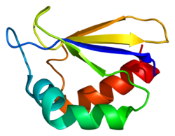
Complex I (NADH:ubiquinone oxidoreductase) is the first enzyme in the electron transport chain. Specifically located in the inner membrane of mitochondria, its overall function is to catalyze the transfer of electrons from NADH to coenzyme Q10⁵. This process moves four protons across the inner membrane which causes a membrane potential to build, a vital first step in ATP production. Complex I is made up of 44 protein subunits, 7 of which are synthesized by the mitochondrial genome⁵. An important subunit is NDUFA2 (Figure 1).
Figure 1: Structure of NDUFA2 Protein
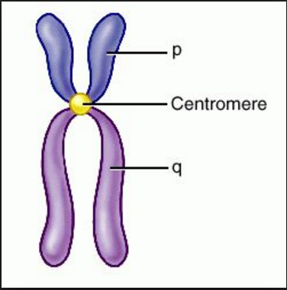
The protein NADH dehydrogenase [ubiquinone] 1 alpha sub complex subunit 2 (NDUFA2) is encoded by nDNA and is located on the long q arm (Figure 2) of chromosome 5 at position 31.2 and it span 2,422 base pairs⁶. It has been observed that NDUFA2 interacts with other subunits of complex I as well as plays a role in the assembly of complex I⁶. Heo et al (2012) experiment on another protein that affected complex I assembly. DJ-1 was the protein in question, DJ-1 is a PD related gene, which produces a protein that is known to maintain mitochondrial function⁷. However, it is not known in what way it affects the assembly of complex I.
Figure 2: Diagram of a chromosome, note location of q arm¹
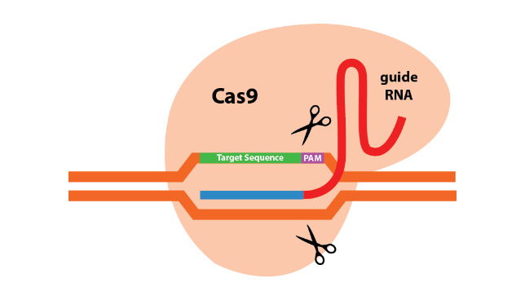
For this experiment, DJ-1 null mice were provided for this experiment. Heo et al did not actually perform the knock. The first part of the experiment was accessing the formation of complex I in a DJ-1 null cell. Effects of a DJ-1 deficiency on the translation subunits of complex I was observed by comparing the expression levels between a wild type (SN4741) and the DJ-1 null cell. This was done by using a Bradford assay. Next Heo et al tested if complex I was assembled correctly. This was done using a blue native-polyacrylamide gel electrophoresis (BN-PAGE). BN-PAGE is used for the isolation of protein complexes in cell membranes. The second part of the experiment focused on the affects that an incorrectly formed complex I would have on the rest of the mitochondria. This was done by measuring the production levels of ATP, oxygen consumption, and membrane potential. Levels of oxygen consumption was measured using a Seahorse Bioscience XF24 analyzer, mitochondrial membrane potential was measured with a rhodamine 123 dye (molecule with a positive charge, sensitive to proton gradients), and ATP production was measured by comparing the basal levels with a luminometer. This experiment will use CRISPR/Cas9 (Clustered regularly-interspaced short palindromic repeats) a genome editing tool (Figure 3) to perform a knockout of NDUFA2 in a SH-SY5Y cell and then observe the effects of the knockout using methods similar to ones used in Heo et al. Does a knockout of NDUFA2 lead to Parkinson’s disease?
Figure 3: Cas9 protein about to excise target sequence. Note how target sequence is adjacent to PAM sequence.

Experiment

The objective of this experiment is to determine how a knockout of NDUFA2 will affect the formation of complex I, mitochondrial oxygen consumption levels, mitochondrial membrane potential, and ATP synthesis in a SH-SY5Y cell. The affects will be compared to both a control and PD diseased dopaminergic cell. I hypothesize that a NDUFA2 null cell will exhibit similar levels of oxygen consumption, membrane potential, and ATP synthesis found in a PD cell.

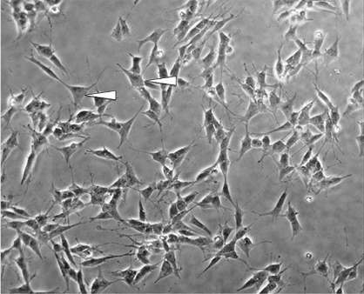
Core Materials Needed
Figure 4: SH-SY5Y cells. “Neurites extend, reminiscent of dendrites and/or axons.” Kovalevich et al (2013)
The SH-SY5Y cell line (Figure 4) for humans will be purchased from SIGMA- ALDRICH.com. NDUFA2 - human gene knockout kit via CRISPR will be purchased from OriGene.com. Both a control and a PD patient dopaminergic neuron will be used for this experiment. However, to be used for this experiment they would have to be live, and not from a post mortem specimen. Stem cell lines for both PD patients and disease-free patients are available at the Coriel biorepository. The actual dopaminergic neurons would have to be grown from these stem cell lines, however this process is beyond the scope of this proposal.

gRNA Design
An important first step to using CRISPR/Cas9 is the creation of a guiding RNA (gRNA). gRNA functions as a way to help target the specific gene that is to be mutated. For this experiment NDUFA2 is the gene that will be targeted. Using the ATUM gRNA Design Tool web tool⁸, optimum target sites for CRISPR/Cas9 were selected. The resulting sequence for targeting NDUFA2 is “CCAGAGCTTGGGCTGCACAT”, located on Chromosome 5 at position 140,026,868 with a score of 100 (a higher score indicates that the gRNAs are less likely to exhibit off target activity)⁹. The generated sequence follows the convention oligos, short sequences of DNA, are about 19 – 25 nucleotides long⁹. A key element to have in mind when creating gRNA, is that the target sequence is close to a 5’-NGG-3’ proto-spacer motif (PAM) sequence (Figure 3). PAM helps Cas9 proteins recognize the desired area in the genome. Without it Cas9 proteins cannot edit the genome⁹. Furthermore, it is essential that designed gRNA does not have homology to other genes. These two factors, help prevent off targeting effects, basically the mutating an undesired gene⁹. After the completion of oligo design, oligos will be lysed into a CRISPR/Cas9 vector.

Insertion of Oligo (gRNA) into a CRISPR/Cas9 Vector
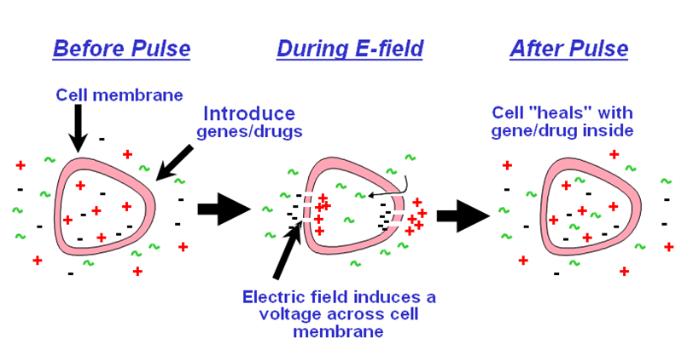
The cloning of gRNA into the CRISPR/Cas9 vector is done using plasmids. Plasmid are small DNA molecules within a cell that are separated from a chromosomal DNA and can replicate independently. Pertaining to CRISPR/Cas9, E.coli plasmids are cleaved with restriction enzymes and the prepared oligos are then combined together. The combing process is done by heating the DNA strands and then cooling them, this results in the accurate joining of two oligos. The now double stranded DNA oligo are then ligated, the covalent linking of two ends of DNA, into the E. coli plasmids using T4 DNA ligase⁹. This part of the procedure produces recombinant DNA that is then transferred into E. coli via electroporation (Figure 5). This technique uses electric fields which results in the increased permeability of cell membranes. In this case, small holes will be created in the cell wall of E. coli which will allow the plasmids to enter the cell.
Figure 5: Overview of electroporation

Infection of SH-SY5Y Cell Line
SH-SY5Y cell lines will be cultured in a (DMEM/F-12 50/50) growth medium¹⁰. To deplete NDUDA2 expression with CRISPR/Cas9 successful recombinants (the Cas9 gRNA vectors) will be packaged into an adeno-associated virus⁹. This virus will then infect the host’s (SH-SY5Y) genome, where the DNA will be incorporated into the genome via homologous recombination⁹. Once the cell lines have matured, the success of the knockout will be determined during the 2D BN/SDS-PAGE part of the experiment.

The rest of the procedure will be performed for each cell type (control, PD, and experimental).

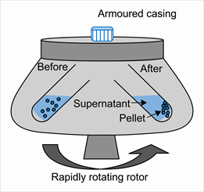
Isolation of mitochondria
Cells will be centrifuged (Figure 6) in buffer 1. Pellets formed from this process will then were then homogenized, the process of making a mixture out of two non-soluble substances the same throughout, in the same buffer. Resulting homogenate will then centrifuged, the resulting supernatant will then be centrifuged again, resulting in a crude mitochondrial pellet. This pellet will then then be suspended in buffer 2, and centrifuged one final time⁷. This pellet will be used in the analysis of complex I assembly.
Figure 6: Overview of centrifugation

Complx I Assembly and Protein Subunit Detection
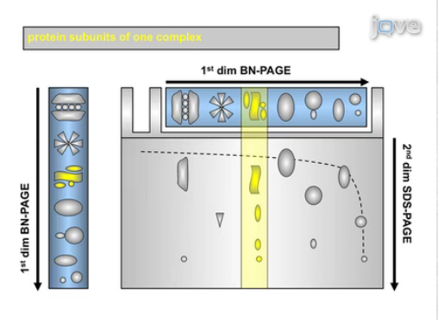
This section of the procedure will focus on first observing if complex I was able to properly for and what subunits are present, testing if the knockout was successful or not. Both a one dimensional, isolation of the mitochondrial superstructures, and two dimensional BN- PAGE, observing if the knockout was a success (Figure 7). The mitochondria pellet will be made soluble by using sodium dodecyl maltoside. For the detection of mitochondrial supercomplexes, such as complex I, digitonin, has been observed maintain the individual stability of the complex’s subunits¹¹, will be used in the lysis buffer (used to break open cells)⁷. The samples will then be centrifuged and the resulting supernatants will then be separated under native conditions in a first-dimension BN-PAGE. Coomassie blue dye (negatively charged, binds nonspecifically to all the proteins and most importantly does not act like a detergent. This maintains the individual complex structures during electrophoresis) is used in BN-PAGE. Therefore, the electrophoretic mobility and separation of the samples is determined by the negative charge of the bound Coomassie blue and the size and shape of each complex¹².
Figure 7: How to read a Blue Native Polyacrylamide Gel Electrophoresis (BN-PAGE)
For 2D BN/SDS-PAGE, the protein complexes of interest are cut out form the BN-PAGE gel. The gel is then placed in sodium dodecyl sulfate (SDS) buffer, which denatures the proteins, and then will be in incubated on a shaker. The gel will then be loaded into a well where the separation of the protein subunits will be facilitated by an extend duration of electrical flow (Figure 7). SDS makes the protein subunits negatively charged, the distance each subunit travels is determined by its size¹³.
The separated subunits will be desalted, to improve ionization efficiency, and moved onto MALDI target plates. Mass spectra will be acquired using a 4700 proteomic analyzer (Applied Biosystems, Framingham, MA, USA). Protein will then be identified using Mascot version 2.2 software (Matrix Science Inc., Boston, MA) ⁷.

Mitochondrial Oxygen Consumption
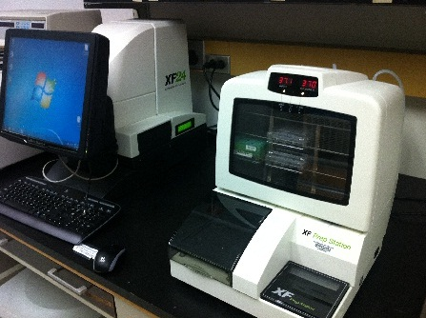
Mitochondrial oxygen consumption levels will be measured using a Seahorse XF24 Extracellular Flux Analyzer (Seahorse Bioscience Inc., USA) in 24-well plates at 37°C. All cell types were seeded in wells 18 hours prior to examination. Before each measurement, the cells were washed and 590 µl of non-buffered medium was added to each well⁷. The XF24 analyzer (Figure 8) is able to make measurements in a way that does not require any dyes or labels¹⁴.
Figure 8: XF24 Extracellular Flux Analyzer

Mitochondrial Membrane Potential
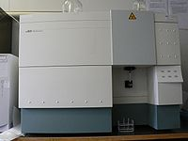
Cells will be grown in 6 well plates for 24 hours and washed with phosphate buffer saline (PBS) 3 times. Cells will then be stained with rhodamine 123 dye in an incubator for 15 minutes at 37°. Cells will then be dissociated using trypsining, centrifuged at 800× g at room temperature (RT), and resuspended in PBS. Samples will then be analyzed on a FACScan (Figure 9), used to measure dye accumulation on membrane¹⁵ (BD Biosciences, Bedford, MA, USA) and data analysis will be performed with BD FACSDiva software (BD Biosciences, Bedford, MA, USA)⁷.
Figure 9: FACScan

Mitochondrial Rate of ATP synthesis
In order to measure ATP synthesis in each cell type, cells will have to be collected using trypsinization, and then centrifuged. The resulting pellet will then be washed with glucose and a serum free medium¹⁵. In order to permeablizie the membrane cells will then be incubated in a buffer for a minute at room temperature. The cell pellet will then be resuspended in buffer A. Next, diadenosine pentaphosphate, malate, pyruvate, and succinate will be added to the cell solution⁷. ADP and another buffer will then be added to the cell solution⁷. Immediately after this addition, ATP luminesce levels will be measured by a luminometer.

Discussion
The hypothesis, a NDUFA2 knock out in a cell will cause the see to exhibit similar levels of oxygen consumption, membrane potential, and ATP synthesis found in a PD cell, will be tested by knocking out NDUFA2 with CRISPR/Cas9. To ensure the knock out is successful, a 2D BN-PAGE analysis will be performed to analyze the individual proteins expressed in the SH-SY5Y cell line. The second portion of the experiment is done is understand the results of this knock out. (1) Complex I formation; (2) Mitochondrial O₂ consumption; (3) Mitochondrial membrane potential; (4) Mitochondrial ATP synthesis levels. This part of the procedure will be performed on the experimental SH-SY5Y cell line, the control patient dopaminergic neurons, and PD patient dopaminergic neurons. Results will be compared. Expected results would be 1) Decreased formation of complex I; (2) Lowered levels of mitochondrial O₂ consumption; (3) Lowered levels of mitochondrial membrane potential; (4) Lowered levels of mitochondrial ATP synthesis levels.
The first potential problem of this experiment is the cost of all the components, which are rather expensive. Actual problems that this experiment might face would be killing the cell with a knockout of NDUFA2. NDUFA2 could prove to be such a vital subunit of complex I that not only a dysfunction might occur, complex I might not even work at all! Steps have been taken to create two “back up experiments” should this occur (knockout NDUFS6 or NDUFA8). Another possible experimental pitfall would lie I the western blot. Both a one and two dimensional BN-Page are long and tedious methods so should both be done carefully and with care to ensure expected results. A possible unexpected result would be the knockout of NDUFA2 having no impact on both complex I and experimental levels (1 – 4).
Despite the potential pitfalls of this experiment the relation between complex I and Parkinson’s disease need to be studied further. Further experimentation needs to be performed in order to determine whether Parkinsonism is just the expression of complex I dysfunction in dopaminergic neurons.

References

- de Lau LM, Breteler MM. Epidemiology of Parkinson’s disease. Lancet Neurol 2006;5:525-535.
- Tanner, C. M., & Aston, D. A. (2000). Epidemiology of Parkinsonʼs disease and akinetic syndromes. Current Opinion in Neurology, 13(4), 427-430. doi:10.1097/00019052-200008000-00010
- Postuma RB, Berg D, Stern M, et al. MDS clinical diagnostic criteria for Parkinson’s disease. Mov Disord 2015;30:1591-1601.
- Nicklas, W., Vyas, I., & Heikkila, R. E. (1985). Inhibition of NADH-linked oxidation in brain mitochondria by 1-methyl-4-phenyl-pyridine, a metabolite of the neurotoxin, 1-methyl-4-phenyl-1,2,5,6-tetrahydropyridine. Life Sciences, 36(26), 2503-2508. doi:10.1016/0024-3205(85)90146-8
- Wirth, C., Brandt, U., Hunte, C., & Zickermann, V. (2016). Structure and function of mitochondrial complex I. Biochimica et Biophysica Acta (BBA) - Bioenergetics, 1857(7), 902-914. doi:10.1016/j.bbabio.2016.02.013
- NDUFA2 NADH:ubiquinone oxidoreductase subunit A2 [Homo sapiens (human)] - Gene - NCBI. (n.d.). Retrieved April 15, 2017, from https://www.ncbi.nlm.nih.gov/gene?Db=gene&Cmd=ShowDetailView&TermToSearch=4695
- Heo, J. Y., Park, J. H., Kim, S. J., Seo, K. S., Han, J. S., Lee, S. H., . . . Kweon, G. R. (2012). DJ-1 Null Dopaminergic Neuronal Cells Exhibit Defects in Mitochondrial Function and Structure: Involvement of Mitochondrial Complex I Assembly. PLoS ONE, 7(3). doi:10.1371/journal.pone.0032629
- (n.d.). Retrieved April 15, 2017, from https://www.atum.bio/eCommerce/cas9/input
- NDUFA2 - human gene knockout kit via CRISPR. (n.d.). Retrieved April 29, 2017, from http://www.origene.com/CRISPR-CAS9/KN202715/NDUFA2.knockout
- Bao, L., Chen, S., Conrad, K., Keefer, K., Abraham, T., Lee, J. P., . . . Miller, B. A. (2016). Depletion of the Human Ion Channel TRPM2 in Neuroblastoma Demonstrates Its Key Role in Cell Survival through
- Schagger, H. (2000). Supercomplexes in the respiratory chains of yeast and mammalian mitochondria. The EMBO Journal, 19(8), 1777-1783. doi:10.1093/emboj/19.8.1777
- Proteomics, C. (n.d.). 2D Blue Native. Retrieved April 29, 2017, from http://www.creative-proteomics.com/services/2d-blue-native-sds-page-for-complex-analysis.htm
- Fiala, G. J., Schamel, W. W., Blumenthal, B. Blue Native Polyacrylamide Gel Electrophoresis (BN-PAGE) for Analysis of Multiprotein Complexes from Cellular Lysates. J. Vis. Exp. (48), e2164, doi:10.3791/2164 (2011).
- University of Virginia School of Medicine. (n.d.). Retrieved April 29, 2017, from https://pharm.virginia.edu/facilities/seahorse-xf24-extracellular-flux-analyzer/
- Vives‐Bauza, C., Yang, L., & Manfredi, G. (2007). Assay of Mitochondrial ATP Synthesis in Animal Cells and Tissues. Mitochondria, 2nd Edition Methods in Cell Biology, 155-171. doi:10.1016/s0091-679x(06)80007-5
- Hodge, G. K., & Butcher, L. L. (1980). Pars compacta of the substantia nigra modulates motor activity but is not involved importantly in regulating food and water intake. Naunyn-Schmiedeberg's Archives of Pharmacology, 313(1), 51-67. doi:10.1007/bf005058
- Figure 1: https://upload.wikimedia.org/wikipedia/commons/thumb/a/a5/Protein_NDUFA2_PDB_1s3a.png/375px-Protein_NDUFA2_PDB_1s3a.png
- Figure 2: http://img.tfd.com/dorland/arm_chromosome.jpg
- Figure 3: https://www.abmgood.com/premadeICRISPR-new/images/CRISPR-Sorting-Feature-Knowledge-Base-Intro-CRISPR.png
- Figure 4: https://www.ncbi.nlm.nih.gov/pmc/articles/PMC5127451/
- Figure 5: http://www.btxonline.com/media/wysiwyg/faq_page/electroporation-cartoon.png
- Figure 6: https://adarshsomani02.files.wordpress.com/2015/02/centrifugation4.png
- Figure 7: https://www.jove.com/video/2164/blue-native-polyacrylamide-gel-electrophoresis-bn-page-for-analysis
- Figure 8: https://pharm.virginia.edu/files/2014/01/Seahorse.jpg
- Figure 9: https://upload.wikimedia.org/wikipedia/commons/thumb/1/13/FACS-toestel.JPG/300px-FACS-toestel.JPG05

