Lysis of shiga toxin-producing Escherichia coli by delivery of Crispr/Cas9 cascade coding cosmid targeting Stx 1 and Stx 2 genes via lambda
Amanda Rutledge
Introduction
Consumption of food or water contaminated with specific strains of Escherichia coli can cause dire illness and lead to development of more serious diseases such as hemolytic-uremic syndrome (HUS). E. coli strains that can express the shiga toxin gene (Stx 1 or Stx 2) are responsible for causing this foodborne illness, serotype O157:H7 being one of the most common. Of those who become infected with shiga toxin-producing E. coli (STEC), 5%-10% are expected to develop HUS, especially children and elderly persons [1].

E. coli become capable of producing shiga toxins when a bacteriophage that contains the gene for Stx integrates its own DNA into the genome of the E. coli, a process known as lysogenesis [2]. Stx genes are part of the late gene regions of the prophage – phage genome integrated into the host’s – which are genes expressed only after the induction of the lytic cycle [3]. After induction of the lytic cycle, early phage genes are transcribed which code for proteins that allow RNA polymerase to bypass transcription terminators of later genes, allowing them to be expressed. Once the shiga toxin is secreted out of the E. coli, it may invade surrounding tissues by passing through or in-between cells, or translocation through intact epithelial cells [4]. The toxin can travel to the kidneys, where they are taken up by cells with globotriaosylceramide (Gb3) receptors, and once in the cell, the toxin inhibits the host’s protein synthesis [5]. This proapoptotic stimulus is thought to cause HUS.

There are no current methods of treatment when sick with STEC, so it’s important for precautions to be taken at the source. There are several methods of prevention that include exposure reduction, exclusion reduction and direct anti-pathogen strategies. Exposure reduction strategies include providing cattle with clean water, feed, and a spacious environment to limit interaction between cattle. An example of exclusion reduction is use of chlorine treatment in water to lower transmission of pathogens. Water and feed additives are utilized for prevention as well. Adding antibiotics and probiotics to feed has been shown to decrease E. coli O157:H7 shedding. [6]

Taking antibiotics while sick with STEC is advised against. Antibiotic attacks on the cell and its DNA lead to an SOS response when transcription is increased. This SOS response can lead to an excess of shiga toxin production, which can increase the permit damage of having this pathogen. For many years, it was debated whether or not antibiotics caused this response due to mixed results from many experiments. It was found that various antibiotics have differing effects, depending on the strain of E. coli causing the infection [7]. This, coupled with depletion of the host’s microbiome, is why it is best for antibiotics to be avoided.

Here, a method of possible treatment of shiga toxin-producing E. coli-related illness is designed, one that could attack STEC cells without triggering stx gene transcription. Utilization of a Crispr/Cas9 system will allow for recognition and cutting of a specific DNA sequence, in this case, the shiga toxin gene. Delivery of a cosmid coding for a Crispr cascade via a lambda phage delivery system allows for selective infection of bacteria of the host’s microbiome, only targeting E. coli. While this would allow infection of harmless e coli cells as well, since they do not contain the Stx gene, their DNA will not be cut, avoiding cell lysis when the Crispr cascade has been translated.

Experiment

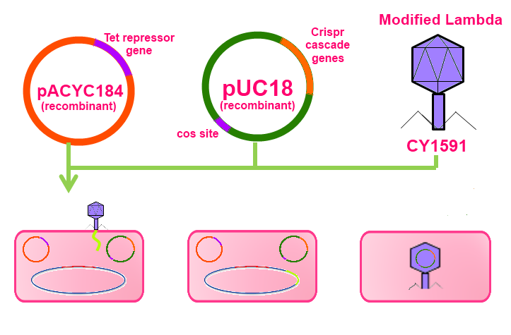
The focus of the described experiment is to develop a potential method for the treatment of E. coli poisoning caused by shiga toxin-producing E. coli strains. This proposed method utilizes a lambda phage delivery system which carries a cosmid containing genes encoding for a Crispr/Cas system with a guide RNA that specifically recognizes either the stx 1 or stx 2 genes that code for shiga toxin and cuts the DNA at that site. Figure 1 illustrates an overview of the construction of the delivery phage.
Figure 1. Construction of lambda phage delivery system. The construction of this phage requires two plasmids. Plasmid pUC18 was selected to be altered to contain the crispr/cas gene cascade with Tet promoters. Plasmid pACYC184 was selected to contain the Tet repressor gene which codes for the protein responsible for restricting the transcription of genes with the Tet promoter (i.e. the Crispr cascade genes on plasmid pUC18). The other key feature of the altered pUC18 is the cos site, making it a cosmid. The modified lambda CY1591 does not contain this cos site, which is essential for phage packaging of DNA. Since the modified lambda can’t package its own DNA during lysis, but modified pUC18 contains the cos site, the cosmid will be packaged into the new phage. The pink boxes are the competent cells being transformed by the plasmids and infected by the phage.
In order to create these Crispr/Cas encoding phage, a modified lambda, altered to be incapable of packaging its own DNA, needs to undergo lysogenesis with a cell containing a plasmid with the cos site for phage DNA packaging. The lambda phage selected for this is CY1591, constructed by Cronan [8]. Two plasmids will need to be present in the bacteria cell that this phage infects, modified pUC18 and modified pACYC184. The pUC18 plasmid will be modified to contain a functional phage packaging cos site and the Crispr/Cas gene cascade coding for the nuclease designed to contain guide RNA that specifically recognizes either of the shiga toxin genes and cuts the DNA. The Crispr cascade will be designed by Gibson assembly to have Tet promoters. The plasmid pACYC184 was selected to be modified to contain the gene encoding the Tet repressor protein to block transcription of the Crispr genes.
Construction of pACYC184 plasmid

In order to control transcription of the Crispr/Cas9 genes in our cosmid during construction of these phage delivery systems, there needs to be a repressor present. The plasmid pACYC184 can be edited to replace the region between HindIII and AvaI with a Tet repressor gene. The main cosmid will contain Tet promoters, which the product of the Tet repressor gene will block the binding of DNA polymerase to. This plasmid would be used so transcription of the pACYC184 cosmid genes would be blocked while packaging the cosmid. To verify proper recombination of the gene, a PCR can be performed to amplify this specific gene, and those fragments can be sequenced. If the gene was verified through sequencing, the plasmid contains the gene.

Construction of pUC18 plasmid
The Crispr/Cas cosmid will be constructed out of the plasmid pUC18. A functioning cos site, which is the site of DNA packaging in phage, will be introduced to the plasmid, making it a “cosmid”. Using Gibson assembly, the Crispr cascade can be constructed with the Tet promoter. These fragments will be integrated into the plasmid into the lacZ gene. Transcription of genes with Tet promoters is blocked by the Tet repressor protein encoded on the pACYC184 plasmid. To verify proper recombination of the gene, a PCR can be performed to amplify this specific gene, and those fragments can be sequenced. If the gene was verified through sequencing, the plasmid contains the gene.

Modified Lambda

The modified Lambda phage, pCY1591, constructed by Cronan [8] will be utilized because it’s cos site is interrupted by a kanamycin resistance gene, disabling the phage’s ability to package its own DNA during cell lysis. Instead, when the lytic cycle is thermally induced, the cos site on the cosmid will be recognized, leading to the packaging of the Crispr cascade genes. The new cosmid-containing phage can then be collected and tested for proper packaging. A blue-white screening test can be performed to test if proper packaging of the cosmid occurred. The phage will infect bacterial cells, and these cells will be plated and grown in the presence of X-gal. Cells that were infected and received a cosmid will grow into colonies on the plate. Blue colonies received a non-recombinant plasmid, not containing the desired modifications, due to the intact lacZ gene encoding β-galactosidase which reacts with the X-gal, creating the blue color. White colonies received the cosmids with the desired Crispr cascade. If white colonies form, amplification of the Crispr genes can be performed by PCR and the fragments can then be sequenced. The purpose of sequencing yet again is to ensure the proper genes are present in this final step.

What the expected results mean

If white colonies for on the plate during blue-white screening, and those colonies are confirmed to contain the desired genes, these phage can be used as treatment for E. coli poisoning. Since the delivery phage is lambda, only lambda’s hosts (E. coli) will be infected in a sick person’s gut, and because of the Crispr/Cas system, only E. coli containing the shiga toxin gene will lysed.

*tables with finalized sequences coming soon*

References
1. Thorpe CM. Shiga toxin-producing Escherichia coli infection. Clin Infect Dis 2004; 38: 1298–303.
2. Bloch S, Nejman-Faleńczyk B, Dydecka A, et al. Different Expression Patterns of Genes from the Exo-Xis Region of Bacteriophage λ and Shiga Toxin-Converting Bacteriophage Ф24_{B} following Infection or Prophage Induction in Escherichia coli. Dąbrowska K, ed. PLoS ONE. 2014;9(10):e108233. doi:10.1371/journal.pone.0108233.
3. Mauro SA, Koudelka GB. Shiga Toxin: Expression, Distribution, and Its Role in the Environment. Toxins. 2011;3(6):608-625. doi:10.3390/toxins3060608.
4. Acheson DW, Moore R, De Breucker S, et al. Translocation of Shiga toxin across polarized intestinal cells in tissue culture. Infection and Immunity. 1996;64(8):3294-3300.
5. Thorpe, C. (2004). Shiga Toxin--Producing Escherichia coli Infection. Clinical Infectious Diseases, 38(9), 1298-1303. http://dx.doi.org/10.1086/383473
6. Pre-harvest Management Controls and Intervention Options for Reducing Shiga Toxin-Producing Escherichia coli Shedding in Cattle: An Overview of Current Research,. (2016).
7. Grif K., M. P. Dierich, H. Karch, F. Allerberger. Strain-Specific Differences in the Amount of Shiga Toxin Released from Enterohemorrhagic Escherichia coli O157 following Exposure to Subinhibitory Concentrations of Antimicrobial Agents. European Journal of Clinical Microbiology and Infectious Diseases. December 1998, Volume 17, Issue 11, pp 761-766
8. Cronan JE. Cosmid-Based System for Transient Expression and Absolute Off-to-On Transcriptional Control of Escherichia coli Genes. Journal of Bacteriology. 2003;185(22):6522-6529. doi:10.1128/JB.185.22.6522-6529.2003.

