Measuring the Effect of Silencing the APP gene and Stimulating the CaMKII Pathway on Synaptic Plasticity in Alzheimer’s Disease

I. Introduction

Alzheimer’s Disease (AD) is a progressive neurodegenerative disorder that affects the memory and brain function of middle to old aged individuals¹. Currently, there are more than five million Americans living with AD². The disorder kills more individuals than breast cancer and prostate cancer combined². The increasing prevalence of AD has caused major concern due to the fact that AD is a complex disorder that is difficult to diagnose¹. Currently, the only accurate method to diagnose an individual with AD is through post mortem exams in which pathological markers can be identified¹. Through these post-mortem studies, it has been shown that there are specific regions of the brain that are targeted by AD¹. One such brain region that is affected is the hippocampus, which controls memory formation in the brain¹.

Regardless, the disorder cannot be understood in a holistic manner. Thus, no cures have been developed to effectively treat AD. As a result, research has focused on the two hallmark characteristics of disease: neurofibrillary tangles (NFT) and senile plaques (SP) ³. NFTs are tangles that are composed of hyper-phosphorylated tau proteins³. The tau protein is mainly present in neurons and helps to stabilize microtubules in the neurons⁴. SPs are plaques that contain aggregate forms of the β-amyloid peptide³. The β-amyloid peptide affects the brain’s synaptic plasticity or the ability of the neurons in the brain to communicate with each other³. This is one function that is deteriorated in AD patients.

Both NFTs and SPs are observed in individuals diagnosed with AD in postmortem studies and are responsible for the deterioration in brain function seen in individuals with AD¹. Previous research suggests that these two proteins interact with each other³. An increase in the β-amyloid peptide has been show to increase the aggregation of the tau proteins³. This aggregation of the tau protein causes a build up of NFTs to form in the neurons³.

Research has focused on the origin of the β-amyloid peptide in order to decrease β-amyloid peptide levels and hinder the formation of NFTs in the brain. A gene located on chromosome 21, the APP, encodes for the amyloid precursor protein⁵. This precursor protein is cut into many smaller fragments by enzymes known as secretases⁵. As can be seen by Figure 1, one of the fragments that result from this process is the β-amyloid peptide^{5, 5}.

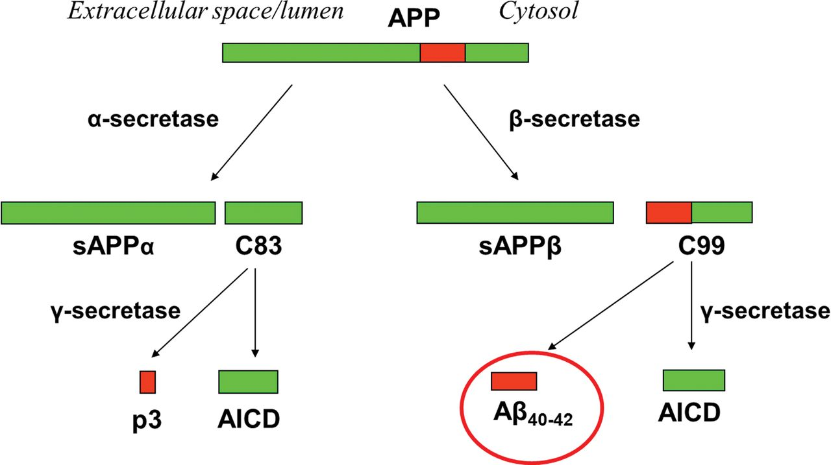
Figure 1: The APP gene produces the amyloid precursor protein. This precursor protein is cut into fragments by secretase enzymes. Cleaving the precursor protein with the β-secretase and then the y-secretase results in the formation of the β-amyloid peptide.

Due to the fact that the β-amyloid peptide is synthesized from the APP gene, silencing this gene will prevent the synthesis of the β-amyloid peptide. Without the β-amyloid peptide present, there will not be an increase in the aggregation of the tau protein thereby delaying the progression of AD³. However, previous research has shown that silencing or knocking out the APP gene decreases the synaptic plasticity of neurons⁷. The absence of the APP gene prevents presynaptic neurons from sending neurotransmitters to the postsynaptic neuron, which has receptors that receive these neurotransmitters⁷. As can be seen from Figure 2, neurotransmitters are released by the presynaptic neuron through fluid-filled sacs known as synaptic vesicles⁶. However, when the APP gene is not present, the ability of the presynaptic neuron to secrete synaptic vesicles diminishes⁷.

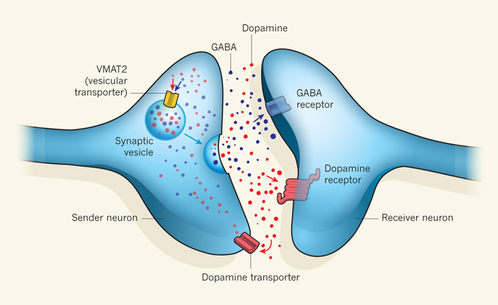
Figure 2: The presynaptic neuron (the neuron on the left) is in charge of releasing neurotransmitters, which are signaling molecules, to the postsynaptic neuron (the neuron on the right), which has receptors to receive the neurotransmitters. The presynaptic neuron releases the neurotransmitters in a fluid-filled sac known as a synaptic vesicle. The neurotransmitters travel through the gap between the two neurons, known as the synapse, and bind to the receptors on the postsynaptic neuron. When the APP gene is not present, the ability of the presynaptic neuron to secrete synaptic vesicles diminishes.

There are two methods to counteract the inhibition of the presynaptic neuron to release synaptic vesicles. Both of these methods involve calcium (Ca²⁺) because Ca²⁺ has been shown to increase synaptic vesicle release by the presynaptic neuron⁸. One method is to increase intracellular Ca²⁺ levels to a point where very little extra Ca²⁺ is needed to stimulate the presynaptic neuron to release the synaptic vesicle⁸. Another method is to lower the threshold of Ca²⁺ required for the presynaptic neuron to release the synaptic vesicle⁸. For the purpose of this proposal, the first method will be elected due to the fact that this method is simpler to implement.
Calcium readily enters the neurons through ion channels because there is more Ca²⁺ present outside the cell compared to inside the cell⁸. One such ion channel that increases intracellular Ca²⁺ is the NMDA ion channel¹². NMDA receptors are also known to play a role in long-term potentiation, one of the brain functions impaired in AD patients¹². NMDA receptors can be activated by the neurotransmitter glutamate as well as the amino acid derivative, N-Methyl-D-aspartate (NMDA)¹³. NMDA acts similar to glutamate, except that NMDA only activates the NMDA receptors while glutamate activates four classes of receptor¹³. Thus, NMDA, which mimics glutamate in Figure 3 below, will be used in this proposal. Incubating neurons with NMDA will open NMDA channels causing Ca²⁺ to flood into the cells. This increase in Ca²⁺ levels activates the CaMKII kinase⁹. The CaMKII Kinase also increases long-term potentiation and enhances the efficacy of synaptic transmission similar to the NMDA receptors⁹. As a result, this proposal aims to design an experiment that attempts to counteract the effect that silencing the APP gene has on synaptic plasticity by increasing intracellular Ca²⁺ levels using NMDA to activate NMDA channels.

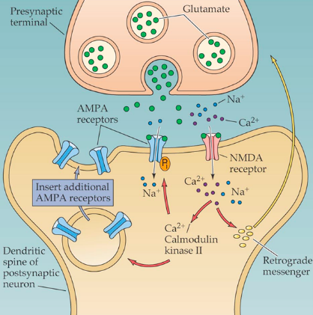
Figure 3: The amino acid derivative, NMDA, is very similar to the neurotransmitter glutamate and mimics its actions seen in this figure. Glutamate is released and binds to the NMDA receptors. This causes Ca²⁺ to enter the cell, thereby activating the CaMKII pathway. Both the NMDA receptors and the CaMKII pathway are known to play a role in long-term potentiation.

II. Experiment

The purpose of this experiment is to determine a method in which neurotransmitter secretion by the presynaptic neuron is not compromised when the APP gene is silenced or knocked out. In order to conduct this experiment, hippocampal slices from normal mice should be isolated. AD is artificially induced in mice and thus has activated β-amyloid peptide present. Thus, normal mice are being used for this experiment. Seibenhener et al. (2012) outline a procedure in which this can be done using a technique known as Trituration. In this technique, proteases (enzymes) are used to isolate cells from the brain and break up their connections so that individual neurons are obtained¹⁰. Once these neurons are obtained, they are grown in a medium and can be used for up to four days after dissection¹⁰. The trituration technique was chosen because of the ability of the selected neurons to be used days after they are isolated from the body.

After the normal hippocampal cells are isolated, the β-amyloid peptide can be inserted into these cells through a process known as electroporation. Morgan et al. (1995) demonstrate how this technique can be used to effectively introduce proteins into cells without damaging the cells. Figure 4 below outlines the process of electroporation.

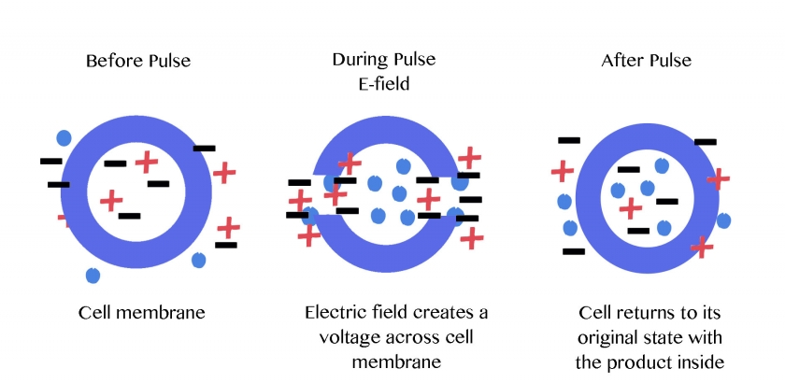
Figure 4: Electroporation employs an electric field that can be used to break up the cell membrane and introduce small molecules such as proteins. Since the electric field is only turned on for a small amount of time, there isn’t much damage to the cell membrane and the cell membrane can reform after the electric field is turned off. The small molecules move into the cell membrane during the pulse when the electric field is turned on. Thus, when the cell membrane reforms after the pulse, the molecules are present inside the cell.

After a few hours, the presence of NFTs can be checked for using an electron microscope to ensure that the β-amyloid peptide was successfully introduced into these cells. Electron microscopy allows researchers to observe small biological specimens¹⁵. Once these neurons are ready, they will be separated into three different groups. One group will serve as the control group in which the APP gene in the neurons is not silenced. The second group of cells will have the APP gene silenced but no mechanism to increase presynaptic plasticity. This group will serve as the positive control. The third group of cells will have the APP gene silenced and be provided with N-Methyl-D-aspartate (NMDA), an amino acid derivative, since NMDA activates NMDA receptors⁹. This group will service as the negative control. The third group is grown in a medium containing NMDA the other two groups will be grown in a regular cell culture media.

Once these cells are isolated and sorted into their respective groups, silencing RNA (siRNA) molecules can be used to target the APP gene and silence the gene. To check if the APP gene was successfully silenced, the cells can be checked for the presence of NFTs after a few hours. If there are fewer NFTs present in the cell compared to the control group, the APP gene was successfully silenced.

In order to determine if the presence of NMDA affected the synaptic plasticity of the hippocampal cells, a technique known as the patch-clamp technique can be employed. The patch-clamp technique allows researchers to investigate single ion channels¹¹. In this experiment, NMDA channels will be studied since NMDA binds to the NMDA receptors. Thin pipettes are used to seal onto the membrane and isolate that membrane patch electrically¹¹¹. The currents that flow through this patch then flow through the pipette and can be measured using electrodes⁹. The electrodes that are attached to the pipette are very sensitive and can pick up on membrane voltage changes when an ion channel is open¹¹. Figure 5 illustrates this process below. The activity of the NMDA channel should be measured for all three groups using this patch-clamp technique in order to compare the levels of the synaptic activity between the three groups.

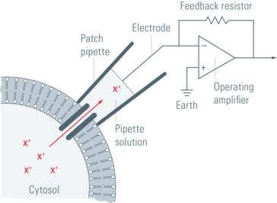
Figure 5: The patch pipette is a very thin pipette that can be used to target a specific ion channel on a cell membrane. The pipette uses suction to bind to the membrane. This allows the pipette to receive any current that flows through the ion channel when the ion channel is open. The electrode that is connected to the pipette is highly sensitive and can measure this change in voltage in the membrane.

III. Discussion

The ideal results from this experiment are two fold, to successfully silence the APP gene from the isolated hippocampal cells and to counteract the decreased synaptic plasticity present from the absence of the APP gene. If the APP gene is silenced successfully, then no new β-amyloid peptide can be synthesized. The control group had an active APP gene while the positive and negative control groups had a silenced APP gene. Thus, the control group’s β-amyloid peptide levels should be much higher than either of the positive and negative control groups. The decreased presence of the β-amyloid peptide will not cause an increase in the aggregation of the tau protein and will lead to a lack or lower presence of NFTs in these neurons.

Incubating the negative control group with NMDA, thereby increasing intracellular calcium levels, attempted to counteract the decreased synaptic activity caused by the absence of the APP gene. NMDA activated the NMDA receptors, which caused an influx of calcium. This increase in Ca²⁺ activated the CaMKII pathway, which plays a role in long-term potentiation (one of the functions inhibited in AD patients). By measuring how much the NMDA receptors were activated with the incubated NMDA through the patch-clamp technique, a measure for synaptic activity was obtained.

While these are the ideal results that can be expected from this experiment, there can be errors or problems associated with the experiment as well. For example, research has shown that increased calcium levels can leave the neurons in a hyper excitability state that can make an individual more susceptible to seizures and epilepsy.

Additionally, there is a possibility that the synaptic ability of the hippocampal cells may be compromised even with the increase in calcium level. The increase in calcium levels may not be enough to counteract the effect that the silencing of the APP gene has on synaptic activity. If so, then the presynaptic neurons in the hippocampus will not be able to secrete the synaptic vesicles. This will lead to decreased synaptic activity and eventually lead to cell death.

In the case that synaptic activity is compromised even with increased calcium levels, then other methods to increase synaptic activity can be used or combined with the increase in calcium levels. Additionally, focusing specifically on certain areas that are known to be impaired in AD might be beneficial. Silencing the APP gene in only those specific regions of the brain may lower the amount of NFTs that are present in the brain without fully compromising the neuronal organ’s synaptic activity.

Regardless, mechanisms that will prevent the formation of NFTs and SPs show the most promise for future research into AD. Special focus should be placed on the APP gene and its related proteins as this gene is the source for the formation of NFTs and SPs. Extensive research into the various mechanisms involved in AD will hopefully lead to a treatment for individuals suffering from this neurodegenerative disease.

References

- Liang et al. (2010). Neuronal gene expression in non-demented individuals with intermediate Alzheimer’s Disease neuropathology. Neurobiological Aging:549-566. (http://www.ncbi.nlm.nih.gov/pubmed/18572275)
- Latest Alzheimer's Facts and Figures. (2016). Retrieved May 07, 2016, from http://www.alz.org/facts/
- Perez M, Cuadros R, Benitez M, Jimenez J (2004). Interaction of Alzheimer’s disease amyloid β peptide fragment 25–35 with tau protein, and with a tau peptide containing the microtubule binding domain. Journal of Alzheimer’s Disease 6:461-467. (http://content.iospress.com/download/journal-of-alzheimers-disease/jad00350?id=journal-of-alzheimers-disease%2Fjad00350)
- Mandal, A. (2014, October 20). What are Tau Proteins? Retrieved May 07, 2016, from http://www.news-medical.net/life-sciences/What-are-Tau-Proteins.aspx
- APP. (2016, April 26). Retrieved April 30, 2016, from https://ghr.nlm.nih.gov/gene/APP
- Williams, J. T. (2012, October 11). Neuroscience: Promiscuous vesicles. Retrieved May 07, 2016, from http://www.nature.com/nature/journal/v490/n7419/fig_tab/490178a_F1.html
- Laßek et al. (2014). Amyloid precursor protein knockout diminishes synaptic vesicle proteins at the presynaptic active zone in mouse brain. Current Alzheimer Research 10:971-980. (http://www.ncbi.nlm.nih.gov/pubmed/25387333)
- Simons, T. J. (1988). Calcium and neuronal function. Neurosurgical Review, 11(3):119-129. (http://link.springer.com/article/10.1007/BF01794675)
- Strack S, Choi S, Lovinger D, Colbran R (1997). Translocation of Autophosphorylated Calcium/Calmodulin-dependent Protein Kinase II to the Postsynaptic Density. The Journal of Biological Chemistry 272(21):13467-13470. (http://www.jbc.org/content/272/21/13467.full.pdf+html)
- Seibenhener, M. L., & Wooten, M. W. (2012). Isolation and Culture of Hippocampal Neurons from Prenatal Mice. Journal of Visualized Experiments : JoVE 65:3634. (http://www.ncbi.nlm.nih.gov/pmc/articles/PMC3476399/)
- Veitinger, S. (2011, November 09). The Patch-Clamp Technique. Retrieved May 07, 2016, from http://www.leica-microsystems.com/science-lab/the-patch-clamp-technique/
- Zito K and Scheuss V (2009). NMDA Receptor Function and Physiological Modulation. Encyclopedia of Neuroscience:1157-1164. (http://brain.phgy.queensu.ca/pare/assets/Neurobiology2.pdf)
- Purves, D., & Williams, S. M. (2001). Neuroscience. 2nd edition. Sinauer Associates. Retrieved April 30, 2016, from http://www.ncbi.nlm.nih.gov/books/NBK10802/
- Morgan, W. F., & Day, J. P. (1995). The Introduction of Proteins into Mammalian Cells by Electroporation. Methods of Molecular Biology, 48:63-71 (http://link.springer.com/protocol/10.1385/0-89603-304-X:63)
- Light Microscope vs Electron Microscope. (n.d.). Retrieved May 01, 2016, from http://www.ivyroses.com/Biology/Techniques/light-microscope-vs-electron-microscope.php

