Importance of SPH2 in RAS/MAPK signalling pathway in NF1 nondystrophic scoliosis
Miral Mahmood
Background:
Neurofibromatosis is one the most common autosomal genetic disorder that is characterized by the growth of non cancerous tumors called neurofibromas. NF1 which is usually diagnosed during childhood and affects more than 100,000 people in the United States and every 1 in 4000 people. NF1 gene which is located on chromosome 17 codes for the neurofibromin protein. The neurofibromin protein regulates the activity of another protein called the RAS, however the mutation leads to a disruption in this train of regulation. The mutation on the NF1 gene results in a shortened version of neurofibromin being produced that cannot bind to RAS or regulate its activity, resulting in a more active RAS. Cells are provided with the instructions to begin dividing but never told when to stop, leading to abnormal cell division and the formation of tumors.
Secondary Symptoms
NF1 is characterized with several secondary symptoms that can affect the brain, spinal cord, nerves and skin. Secondary symptoms range from distinctive café au lait spots to bone defects, scoliosis (curvature of the spine) to learning disabilities. A great deal of of research has been conducted on the pathogenesis of the peripheral and central nervous system tumors that affect NF1 patients. However, there isn’t much focus or research on understanding the molecular mechanisms of several secondary non-malignant symptoms, specifically the skeletal manifestations that affect upto 50 % of NF1 patients. The orthopedic bone manifestation fall into three main categories: scoliosis, pseudarthrosis, and disorders of bone growth. The most prevalent skeletal manifestation amongst NF1 patients is scoliosis, which affects up to 35% of NF1 patients. Scoliosis is a term that refers to the pathological curvature of the spine, it is mostly diagnosed in young school age children, is extremely deforming, and requires multiple surgeries to prevent further secondary morbidities such as lung disease and disfigurement. Scoliosis associated with NF1 can take two forms: dystrophic and nondystrophic scoliosis based on radiographic evaluation. The dystrophic form has distinguishable features that include a curve that is thoracic kyphoscoliosis and a sharp angular curve with distorted ribs and vertebrae. Nondystrophic scoliosis is classified by being compared to idiopathic scoliosis. It has similar presentations, curvatures, physical resemblance as well as diagnosis to idiopathic scoliosis (Halmai et al). Based on the many structural similarities and diagnosis between the two, we will be using similar techniques to proceed with our experiment.
Introduction:
Key components:
SHP2 in chondrocytes from Osteochondroprogenitor cells:
Some of the key components that are required for this experiment to proceed are SHP2, chondrocytes, and osteochondroprogenitor and how they are linked to one another.
Osteochondroprogenitor cells:
Osteochondroprogenitor cells are derived from mesenchymal stem cell (MSCs) in the bone marrow. Osteochondroprogenitor have the ability to differentiate into osteoblasts and chondrocytes, depending on which signalling molecules they are exposed to, giving rise to either bone or cartilage. The image below shows how chondrocytes are formed through osteochondral differentiation which is differentiated from mesenchymal bone stem cells.
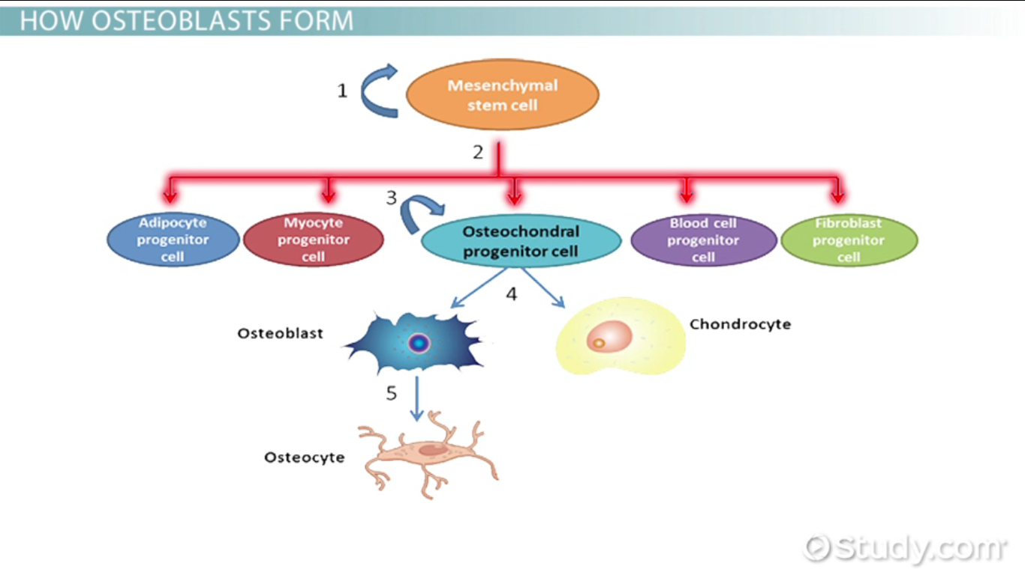
Chondrocytes and SHP2:
Cartilage plays an important role in supporting skeletal growth, reducing frictions at joints, and normal functions of certain organs. There are three types of cartilage but for the purpose of this experiment only fibrocartilage is important as it is found in tendon insertions and intervertebral discs (the site causing scoliosis). Chondrocytes are the solely cellular component in cartilage; their development involves finely regulated processes. Shp2, encoded by the Ptpn11 gene, is one of two Src homology 2 domain- containing protein-tyrosine phosphatases, and is required for most, if not all, receptor tyrosine kinases (RTKs), cytokine, and cell proliferation, differentiation, and are controlled by the cellular signal transduction processes in which protein phosphorylation and dephosphorylation take place (Hunter et al) We chose to work specifically with and disrupt SHP2 in chondrocytes since it has been demonstrated that SHP2 regulates chondrocyte terminal differentiation, growth plate architecture, and skeletal fates (Bowen et al). Shp2 regulates chondrogenesis by influencing multiple RTK and cytokine receptor signaling pathways and the expression of Sox9 and Runx2 (Raghavendra et al). Sox9 and Runx2 are two transcriptional regulators essential for articular cartilage formation and hypertrophic maturation, respectively (Lefebvre et al 2005; Wuelling et al 2011)
RAS/MAPK Signaling
  - RAS/RAF/MEK/ERK pathway:

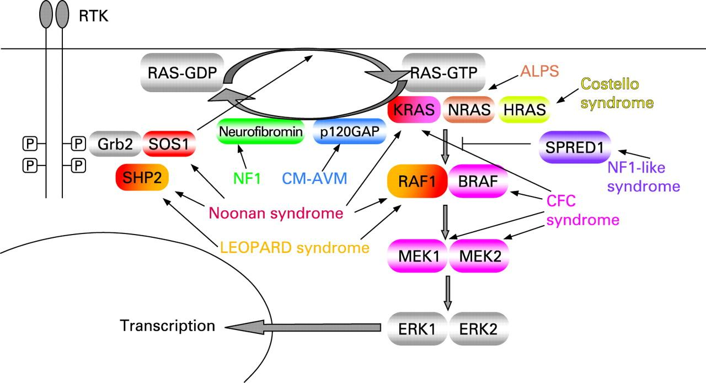
The Ras/MAPK pathways converts (as energy or a message) extracellular input in the form of growth factors and small molecules to the intracellular environment. Ras genes exist as a multigene family that includes HRAS, NRAS and KRAS. They are activated through growth factors binding to receptor tyrosine kinases (RTK). Activation through RTK occurs with the binding of a growth factor causing RTK autophosphorylation and interaction with the adaptor protein GRB2. GRB2 is bound to SOS which is then recruited to the plasma membrane. SOS proteins are guanosine nucleotide exchange factors (GEF) that increase the Ras nucleotide exchange rate of GDP for GTP, resulting in an increase Ras in the active GTP-bound form.
Where does SHP2 come into play?
SHP2 is a positive regulator of RAS-MAPK signaling, which is essential for normal skeletal growth. Human mutations involving the RAS-MAPK signaling pathway have been described with skeletal abnormalities, including scoliosis and kyphosis. RAS pathway is important in the regulation of the following all of which are critical to normal development; cell cycle, differentiation, growth and cell senescence. Protein-tyrosine phosphatases nonreceptor type 11 encodes SHP2 (Src homology-2)-containing protein tyrosine phosphate. Protein-tyrosine phosphatases nonreceptor type 1, plays a central role in RAS/MAPK signaling downstream of several receptor tyrosine kinases including epidermal growth factor receptor and fibroblast growth factor receptor.. The figure above demonstrated the RASopathies diseases and their connection with the RAS pathway. The image below shows the RAS pathway mechanism and differentiation. We will be using the RAF/MEK/ERK pathway on to survival.
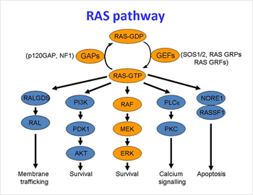
What we do know
As described in Chen et al (2008) NF1 cells have the ability to be expressed in osteoblasts as well as chondrocytes make them a good candidate for targeted deficiency of SPH2. So thus we will proceed with the experiment speculating similar results as Kim et al (2013) based on the similar RAS/MAPK pathways expressed in both NF1 and idiopathic scoliosis and the ability of NF1 cells to differentiate into chondrocytes. The article that is central to our research here was conducted by Kim et al (2013), who speculated that a deficiency in SHP2 in chondrocytes leads to severe scoliosis in mice, and an activation of Shp2 leads to a positive effect on the RAS/MAPK signal transduction, specifically in idiopathic scoliosis.
Another key factor to be considered when applying Kim et al application and procedure to this experiment is this was only effective in mice of from juvenile to adolescent stages. Kim et al carried out the same experiment on adult mice and observed no change in the scoliosis or development of scoliosis at all. Non dystrophic scoliosis is also usually detected and diagnosed in school age children and on to adolescence, this is another factor which makes the application of this experiment more beneficial on the study of non dystrophic scoliosis.
What we don’t know
We still don’t understand what cells come into play or the pathway, however we do know that NF1 MSC cells can be differentiated into chondrocytes as previous studies have demonstrated (Wu et al). So now we can hypothesize and continue or experiment by applying et al since we have all the key components available: SHP2 in chondrocytes and a RAS/MAPK signaling pathway.
II. The Experiment:
In question are the specific effects of SHP2 deficiency in chondrocytes studied in the experimental procedure (Kim et al); they aimed to specifically target SHP2 by using genetically modified mice with a deletion of SHP2 gene in chondrocytes to control what cell type and time length of the SHP2 deficiency, this was achieved via tamoxifen administration. This study aims to delete SHP2 only in specific cells-chondrocytes- in order to observe the effects and how and what osseous manifestations generate. This experimental procedure will follow the same guidelines as those presented in Kim et al as well as Chen et al. To investigate the SHP2 deletion affects, genetically modified mice as described in Chen et al were used, this is the only known mouse model generated specifically for scoliosis. To investigate the effects of SHP2 deletion in chondrocytes the transgenic mice line expressing Cre recombinase under the control of the Type II collagen promoter (Col2a1CreERt2 mice) as presented by Chen et al, this is possible through tamoxifen administration. Type II collagen is a chondrocyte-specific protein and its expression is detected in growth plate and chondrocytes in long bones as well as other cartilage tissues in the body. Type II collagen promoter (col2a1) has been used in a several of animal models previously to achieve tissue-specific gene expression in chondrocytes (Schipani et al 1997; Stricker et al 2002; Takeda et al 2001; Ueta et all 2001; Weir et al 1996). Col2a1-CreERt2 mice were bred and floxed with SHP2 ( SHP2fx/fx mice) and mice in the experimental group (Col2a1CreERt2+:SHP2fx/fx mice) and the control group (Col2a1CreERt2−:SHP2fx/fx mice) were procured as well as defined by genotyping. To induce SHP2 gene disruption in vivo, tamoxifen was injected into the mice using an intraperitoneal injection at a concentration of 1 mg per mouse per injection, the dosage and concentration was following as previous report by Hayashi et al. As Cre recombinase induces SHP2 gene deletion is controlled by Type II collagen promoter after tamoxifen administration. Only the cells expressing Type II collagen (chondrocytes) will develop SHP2 disruption. The specific aim of this experiment is to show the importance of SPH2 in RAS/MAPK signalling pathway in NF1 and the effects of SPH2 deficiency on nondystrophic scoliosis using genetically engineered mice.
Materials and Methods
During the juvenile to adolescent stages and 4 weeks after birth both the control and experimental mice were administered tamoxifen twice for 5 weeks (4 weeks of age in mice is considered juvenile stage). The experimental group will be referred to as “SHP2 deficient” and the control mice will be called “Control”; 60 mice were used in each category. SHP2 genetic expression was detected and measured by collecting rib cartilage and using quantitative RT-PCR (Chen et al). SHp2 disruption was done at 4 weeks old and the spinal deformity was observed at 12 weeks of age. The spinal deformities were analyzed using gross morphology, radiography, and a micro-CT scan of the spine. Photographs were taken right after the euthanization of the mice for the gross morphology. Faxitron x-ray system was used to obtain the radiographic images. Micro CT scan was accomplished by usage of SkyScan 1172 Micro-CT (Kim et al). A visible spinal deformity was observed within 2-3 weeks after tamoxifen administration (figure 1). The scoliosis worsened over the time period of 12 weeks and the severity varied.
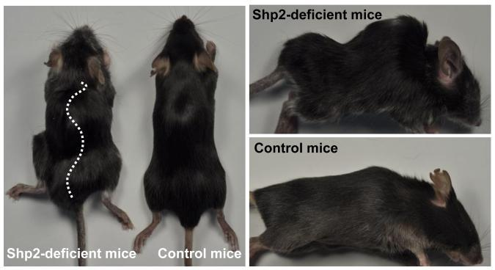
Figure 1. Gross morphology of spinal deformity in SHP2-deficient mice
Discussion:
Scoliosis can be classified into the categories idiopathic, congenital, or neuromuscular. The spinal deformity identified in the SHP2-deficient mice is relevant for idiopathic scoliosis or in our case non dystrophic scoliosis, but not for congenital or neuromuscular scoliosis. In congenital scoliosis, congenital vertebral abnormalities cause curvature during the embryonic stage leading and neuromuscular scoliosis is secondary to neurological disorders. In this study the SHP2 gene is expected to be inactive only in cartilage. It was found the a single SHP2 gene disruption led severe spinal deformity. It has been determined from the experiment above that SHP2 is a positive regulator of RAS-MAPK signaling. Earlier in the introduction it was discussed how the normal RAS pathway works. Here we will discuss the molecular pathway and what the interference of SHP2 in the RAS/MAPK pathway does. Agazie et al have demonstrated in a previous experiment the interference of SHP2 in RAS pathway. It has been shown that SHP2 acts upstream of Ras and functions by increasing the half-life of activated Ras (GTP-Ras) in the cell by interfering with the process of Ras inactivation catalyzed by Ras GTPase-activating protein (RasGAP) ( Agazie et al). It does this by inhibition of tyrosine phosphorylation-dependent translocation of RasGAP to the plasma membrane, to its substrate (GTP-Ras) microdomain. Inhibition is achieved through the dephosphorylation of RasGAP binding sites at the level of the plasma membrane. In conclusion it has been hypothesized and proposed that SHP2 deficiency in chondrocytes leads to scoliosis and SHP2 is a positive regulator of the RAS-MAPK signaling pathway.
Some setbacks of this experiment and its application are that despite the similarities between mice and humans there are differences that could affect the way the experiment would affects humans. Mice are tetrapods and humans are bipeds, as well mice have a more kyphotic spine. Clinical applications of this experiment should be proceeded with caution. Similarities include the spinal overview is the same; mice have distinct cervical, thoracic, and lumbar spine segments just like humans. Studying the molecular pathways in mice have provided useful insight into our understanding of human growth plate regulation. It is also useful model to gain insight and observe how gene manipulation and disruption affects the spine. In the long term we hope to be able identify some molecular pathway or relation between NF1 and the osseous manifestations like kyphoscoliosis that occur from it.
IV. References:

Halmai V1, Domán I, de Jonge T, Illés T. Surgical treatment of spinal deformities associated with neurofibromatosis type 1. Report of 12 cases. Journal of neurosurgery. , 2002, Vol.97(3 Suppl), p.310-316.

Wang W, Nyman JS, Ono K, Stevenson DA, Yang X, Elefteriou F. Mice lacking Nf1in osteochondroprogenitor cells display skeletal dysplasia similar to patients with neurofibromatosis type I. Human Molecular Genetics. 2011;20(20):3910-3924. doi:10.1093/hmg/ddr310.
Agazie YM, Hayman MJ. Molecular Mechanism for a Role of SHP2 in Epidermal Growth Factor Receptor Signaling. Molecular and Cellular Biology. 2003;23(21):7875-7886. doi:10.1128/MCB.23.21.7875-7886.2003
Giampietro PF. SNPping away at the genetic basis of adolescent idiopathic scoliosis. Annals of Translational Medicine. 2015;3(Suppl 1):S26. doi:10.3978/j.issn.2305-5839.2015.02.34.
Nemethova M, Bolcekova A, Ilencikova D, et al. Thirty-Nine Novel Neurofibromatosis 1 (NF1) Gene Mutations Identified in Slovak Patients. Ann Hum Genet. 2013 Jun 12.
Kim HKW, Aruwajoye O, Sucato D, et al. Induction of SHP2-deficiency in chondrocytes causes severe scoliosis and kyphosis in mice. Spine. 2013;38(21):10.1097/BRS.0b013e3182a3d370. doi:10.1097/BRS.0b013e3182a3d370.
Kim HKW, Aruwajoye O, Sucato D, et al. Induction of SHP2-deficiency in chondrocytes causes severe scoliosis and kyphosis in mice. Spine. 2013;38(21):10.1097/BRS.0b013e3182a3d370. doi:10.1097/BRS.0b013e3182a3d370.
Chen M, Lichtler AC, Sheu T-J, et al. Generation of a Transgenic Mouse Model With Chondrocyte-Specific and Tamoxifen-Inducible Expression of Cre Recombinase. Genesis (New York, NY : 2000). 2007;45(1):44-50. doi:10.1002/dvg.20261.
Seto H, Kamekura S, Miura T, et al. Distinct roles of Smad pathways and p38 pathways in cartilage-specific gene expression in synovial fibroblasts. Journal of Clinical Investigation. 2004;113(5):718-726. doi:10.1172/JCI200419899.
Wu X1, Estwick SA, Chen S, Yu M, Ming W, Nebesio TD, Li Y, Yuan J, Kapur R, Ingram D, Yoder MC, Yang FC. Neurofibromin plays a critical role in modulating osteoblast differentiation of mesenchymal stem/progenitorcells. Human Molecular Genetics. 2006; Vol. 15, No. 19 2837–2845 doi:10.1093/hmg/ddl208.

Stevenson DA, Schwarz EL, Carey JC, et al. Bone Resorption in Syndromes of the Ras/MAPK Pathway. Clinical genetics. 2011;80(6):566-573. doi:10.1111/j.1399-0004.2010.01619.x.

Chen H1, Qiu Y, Chen L, Li L, Chen J, Zhang C, Wang B, Yu Y, Zhu Z, Zhu F, Qian B, Ma W. The expression of neurofibromin in human osteoblasts and chondrocytes. Annals of Clinical & Laboratory Science. 2008; vol. 38, no. 1.
Agazie YM, Hayman MJ. Molecular Mechanism for a Role of SHP2 in Epidermal Growth Factor Receptor Signaling. Molecular and Cellular Biology. 2003;23(21):7875-7886. doi:10.1128/MCB.23.21.7875-7886.2003.
Bhattacharyy S, Kumar A, Khanduja K. The voyage of stem cell toward terminal differentiation: a brief overview. Oxford Journals. 2011; Volume 44, Issue 6, Pp. 463-475
Upadhyaya M, Cooper DN, eds. Neurofibromatosis Type 1. Berlin: Springer-Verlag; 2012.

