Bryce Kirby
BNFO 300
May 8, 2016
Inhibition of the p53 tumor suppressor by MDM2 and the role miRNA plays in p53 gene expression and regulation
Introduction
The p53 tumor suppressor
p53 is a highly specialized protein designated with preventing cancerous tumor growth in cells. The P53 protein is classified as a tumor suppressor and is tasked with keeping the genomic stability of cells by inducing apoptosis and cell cycle arrest in cancerous cells (Frum, 2014). A key characteristic of p53 is its susceptibility to genetic mutation, these mutations can either be germline (passed genetically) or acquired through genetic damage, like exposure to UV radiation or old age (Freed-Pastor, 2012). P53 mutations are “acquired” and the most common “gene-specific” alterations in found in human cancers. P53 can typically attain “gain-of-function” and “loss-of-function” characteristics when mutated, usual outcomes include tumor progression and an increased resistance to anti-cancer drugs (Oren and Rotter, 2010).
MDM2 regulation
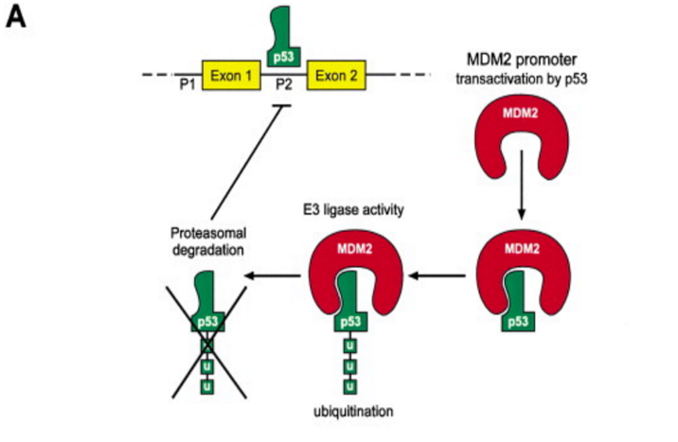
The functional and transcriptional activity of p53 is commonly inhibited by an oncoprotein known as MDM2. MDM2 is known as a negative regulator of p53 and responsible for cancer progression by deactivating p53. p53 essentially activates the transcription of MDM2 by upregulation (Ren, 2014). Furthermore, MDM2 operates as an E3 ubiquitin-protein ligase, this means it binds to its target (p53 protein) through an E3 enzyme complex due to transcriptional recognition on the N-terminal domain on the polypeptide chain. In essence, the ubiquitin proteins are loaded into the E3 complex to signal protein degradtion in order to deactivate the transcription of p53 proteins by the cell (Bartel, 2002).
Figure 1: MDMDMDMDMDMDMDMDMDMDMD This model shows how MDM2 and p53 interact. p53 activates transcription of MDM2. MDM2 then binds to p53 and acts as an E3 ubiquitin ligase. The ligase then targets p53 for degradation thus inhibiting its own transcription (Bartel, 2002).
The miRNA molecule
MicroRNAs exist as small non-coding RNAs involved in regulatory processes in cancer initiation and development. In order to combat the detrimental effects of MDM2 on the transcriptional activity of p53, the use of miRNAs has been observed to deactivate MDM2 entirely. Relative to p53 mutation, degradation and cancer growth in cells, miRNAs are typically used for post transcriptional regulation of p53’s gene expression (Fortunato, 2014). For all intents and purposes this means they are able to alter deactivated or mutated p53 and restore their tumor suppressor functionality in cells. MicroRNAs in relation to p53 regulation operate by binding to the 3’ untranslated region on the MDM2 messenger RNA, at this location they have the functionality to suppress protein synthesis or initiate the messenger RNA to degrade (Jansson, 2015).
Key question in consideration:
Does miRNA-1827 down regulate the transcription of MDM2 in p53 lung cancer cells as affectively as it does with the colorectal cancer cells in the experiment performed by Zheng, 2016?

Experiment
In question are the specific effects of miRNA-1827 studied in the experiment proposed by (Zheng, 2016); they aimed to specifically target MDM2 directly by binding miRNA-1827 to the untranslated region on the 3’ end of the MDM2 E3 ubiquitin protein ligase. Their procedure aimed to down regulate MDM2 activity by the use of miRNA-1827 in colorectal cancer cells. This rendition of the experiment will follow similar guidelines as those presented in (Zheng, 2016) as well as excerpts from (Fortunato, 2014).
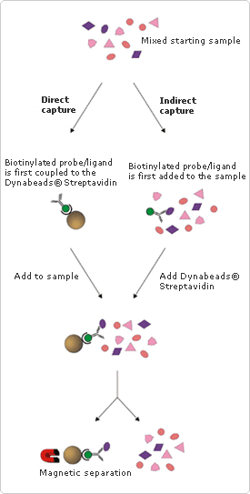
To investigate the ability of miRNA-1827 to bind to MDM2, two human cell lines will be used, in this case wild type human lung cancer cells A549 p53 +/+ and LT73 p53 +/+ are chosen (Fortunato, 2014); also, mutant p53 -/- along with an miRNA control group containing wild type p53 are also included. In order to obtain direct evidence of miRNA-1827 interaction with MDM2 in these cell lines, a Biotin-streptavidin systematic procedure will be performed. Streptavidin, a purified protein from the bacteria Streptomyces avidinii has a high affinity for biotin, a small water-soluble B vitamin molecule present in small amounts in living cells. Biotin’s biological makeup makes it an excellent molecule for this experiment due to its ability to conjugate to numerous existing proteins and molecules by essentially acting as a tag, which in turn alters their biological activity. Biotin’s features make it an exemplary molecule to display the binding interactions of miRNA-1827 and MDM2.
Methods
Figure 2.
Figure provided by thermofisher.com
A depiction of the mirRNA-MDM2 complex bound to the biotinylated Streptavidin and its interaction with the introduced Dynobead.
This experiment will make use of a probe consisting of biotin conjugated to Streptavidin antibodies by transfecting the designated lung cell samples A549 and LT73 with biotinylated miRNA-1827s. The transfected cell samples will then be lysed in a strong ionic buffer of NaCl and incubated with magnetic streptavidin Dyno Beads® for approximately 5 hours. The process of incubation with the Dyno Beads allows the biotinylated MDM2-miRNA-1827 molecule to bind to the beads. After the binding has taken place the molecule-bead complex will be separated with a Dynal ® magnet, represented in the latter half of figure 2. The use of the magnetic separation technique allows for efficient purification of the miRNA-MDM2 precipitate as well as a mechanism to wash away the unwanted unbound proteins. Once the precipitate is magnetically removed from the beads the next step will involve analyzing the product using a western blot assay (Zheng, 2016 and Fortunato, 2014).
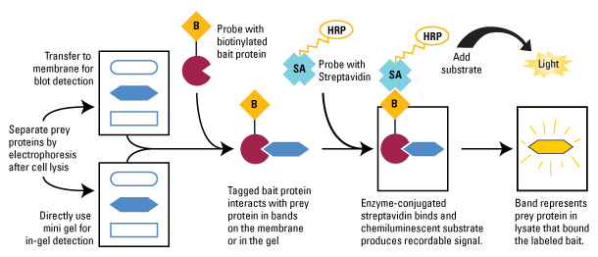
Fig. 3
The Western blot Assay process
In essence, the Western blot assay in this case will be used to demonstrate the relative abundance and absence of p53 levels in the wild/mutant type lung cancer cells along with MDM2 mRNA levels. The richness of p53 and MDM2 will be represented by either dark or light bands, like those represented in Fig. 4 from Zheng, 2016. The dark and robust bands (stained with the streptavidin antibodies) will identify with a more dense weight, measured in kilo Daltons and contain a higher presence of the labelled protein/molecule (p53 and MDM2) and vice-versa for the lighter bands.

Related Results
The levels of MDM2 mRNAs that bind to the biotinylated wild-type, mutant and control miRNA-1827s from (Zheng, 2016) are displayed in Figure 4. This figure serves to reiterate the fact that MDM2 mRNAs were significantly enriched in their miRNA-1827 Western blot assay for both the HCT116 +/+ and RKO +/+ p53 cells.

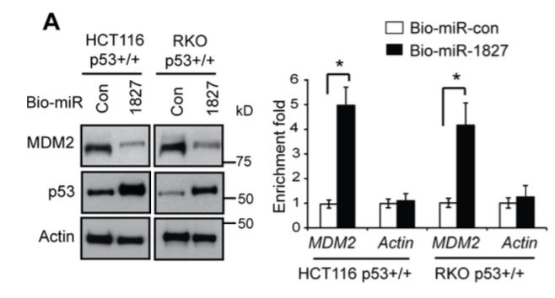
Figure 4: miR-1827 regulates MDM2 through binding to the 3ʹ-UTR of MDM2

This figure depicts the results obtained by a Western Blot Assay by (Zheng, 2016) in the down regulation of MDM2 levels by miRNA-1827 in colorectal cancer cells containing wild and mutant type p53.

We hope to produce a similar outcome using the same miRNA-1827 in the down regulation of MDM2 levels in wild and mutant type p53 human lung cells, A549 and LT73.

(A) miR-1827 bound to MDM2 mRNA in cells detected by miRNA pull-down assays. HCT116 p53+/+ and RKO p53+/+ cells were transfected with biotinylated miR-1827 (bio-miR-1827) or biotinylated miR-control (bio-miR-con), and collected at 24 h after transfection for miRNA pull-down assays. The levels of MDM2 and Actin mRNAs bound to bio-miR-1827 or bio-miR-con were analyzed by Taqman real-time PCR assays. The mRNA levels were normalized to input (cellular RNA without incubation with beads) and then to GAPDH. Left panels: The down-regulation of MDM2 and up-regulation of p53 by bio-miR-1827 in cells detected by western-blot assays. Right panel: the enrichment fold with bio-miR-1827 relative to bio-miR-con for MDM2 and Actin mRNA.
(Zheng, 2016).

Discussion
Regarding the above proposed experiment, it is expected that the use of lung cancer cells A549/LT73 both containing wild and mutant type p53 will produce a similar outcome to the experiment performed by Zheng, 2016. It is hypothesized that the p53 protein levels will be increased in the experimental lung cancer cells due to the down regulation of MDM2 transcription by the binding of the novel miRNA-1827 molecule.

P53 has the ability to monitor the expression of various target genes greatly involved in activities like DNA repair, apoptosis and cell cycle arrest. In addition to protein-coding genes, p53 is also involved in the expression of miRNAs like miR-34 to combat protein complexes like MDM2 (Zhou, 2014). In recent studies difficulties involving miRNAs have been observed, it was shown that the expression of 19 different miRNAs in HeLa cells performed through experimentation by (Ren, 2014) have been variously regulated, 10 having been successfully up regulated and 9 down regulated. Further results based on this outcome presented in (Ren, 2014) have surmised that certain miRNAs may possibly be involved in cancer cell development.
The explanation that miRNAs may also be involved in cancer development creates a massive impression on which types of miRNAs are best for down regulating MDM2 in wild and mutant type p53. In the experimental procedure from (Zheng, 2016) certain limitations involving other miRNAs may be encountered and hindrances effecting MDM2 expression might occur in future endeavors.

References
Bartel, Frank, Helge Taubert, and Linda C. Harris. "Alternative and Aberrant Splicing of MDM2 MRNA in Human Cancer." Cancer Cell 2.1 (2002): 9-15. Web.

Brighenti M. MicroRNA and MET in lung cancer. Ann Transl Med 2015; 3(5):68. doi: 10.3978

Fortunato, O., M. Boeri, M. Moro, C. Verri, M. Mensah, D. Conte, L. Caleca, L. Roz, U. Pastorino, and G. Sozzi. "Mir-660 Is Downregulated in Lung Cancer Patients and Its Replacement Inhibits Lung Tumorigenesis by Targeting MDM2-p53 Interaction." Cell Death Dis Cell Death and Disease 5.12 (2014): 1-9. Web.
Frum, R., Grossman, S., 2014. Mechanisms of mutant p53 stabilization in cancer. Subcell Biochem. (85): 187-97. http://www.ncbi.nlm.nih.gov/pubmed/25201195
Freed-Pastor, W. A., and C. Prives. "Mutant P53: One Name, Many Proteins."Genes & Development 26.12 (2012): 1268-286. Web.

Grossman, S., Vaughan, C., et al. 2012. Gain-of-Function Activity of Mutant p53 in Lung Cancer through Up-Regulation of Receptor Protein Tyrosine Kinase Axl. Genes Cancer 3(7-8): 491–502. http://gan.sagepub.com/content/3/7-8/491.short
Jansson, M. D., N. D. Damas, M. Lees, A. Jacobsen, and A. H. Lund. "MiR-339-5p Regulates the P53 Tumor-suppressor Pathway by Targeting MDM2." Oncogene 34.15 (2014): 1908-918. Web.
Li, D., N. D. Marchenko, R. Schulz, V. Fischer, T. Velasco-Hernandez, F. Talos, and U. M. Moll. "Functional Inactivation of Endogenous MDM2 and CHIP by HSP90 Causes Aberrant Stabilization of Mutant P53 in Human Cancer Cells." Molecular Cancer Research 9.5 (2011): 577-88. Web.

Li, Liang, and Binquan Wang. "Overexpression of MicroRNA-30b Improves Adenovirus-Mediated P53 Cancer Gene Therapy for Laryngeal Carcinoma." IJMS International Journal of Molecular Sciences 15.11 (2014): 19729-9740. Web.

Oren, M., and V. Rotter. "Mutant P53 Gain-of-Function in Cancer." Cold Spring Harbor Perspectives in Biology 2.2 (2009). Web.

Ren, Z-J, X-Y Nong, Y-R Lv, H-H Sun, P-P An, F. Wang, X. Li, M. Liu, and H. Tang. "Mir-509-5p Joins the Mdm2/p53 Feedback Loop and Regulates Cancer Cell Growth." Cell Death Dis Cell Death and Disease 5.8 (2014). Web.

Zheng, Cen, et. al. "MicroRNA-1827 Represses MDM2 to Positively Regulate Tumor Suppressor P53 and Suppress Tumorigenesis." Oncotarget 7.8 (2016): 1-14. Web.
Zhou, Chun-Hong, Xiao-Peng Zhang, Feng Liu, and Wei Wang. "Involvement of MiR-605 and MiR-34a in the DNA Damage Response Promotes Apoptosis Induction." Biophysical Journal 106.8 (2014): 1792-800. Web.

