How does the membrane environment of Neurofascin 155 impact the inflammatory response of Microglial Cells?
Kelly Flounlacker
I. Introduction
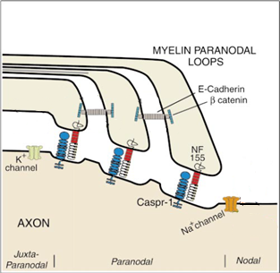
Multiple sclerosis (MS) is an inflammatory, neurodegenerative disease characterized by the loss of myelin on the axons of neurons in the central nervous system (CNS). Myelin is an insulating ensheathment of the axon which allows for rapid propagation of action potentials, a process called salutatory conduction (Maier et al, 2005). In the CNS, myelin is produced by oligodendrocyte cells and consists of segmental units called internodes, separated by exposed regions of the axon, called nodes of Ranvier. (Shafer et al, 2004). Collectively, the internodes are referred to as the myelin sheath.
Action potentials are propagated along axons in order to signal to other neurons. The action potential is caused by the rapid depolarization of the axonal membrane, resulting from the influx of sodium ions through voltage-gated channels (Squire et al, 2012). These sodium channels are clustered at the nodes of Ranvier.
At the end of each internode is the paranode (fig. 1), where the internode contacts the axon membrane. The paranodes are incredibly important for the adhesion of myelin to the axons, as well as the clustering of ion channels at the nodes of Ranvier; both of which are important for efficient action potential propagation (Schafer et al, 2005). These paranodes are preferential sites of initial myelin breakdown (Thummala, 2015).
Figure 1 graphical representation of the Paranodal junction of the axon and the proteins and ion channels associated with it. Cadherin’s and catenin’s are used to hold the layers of the myelin membrane together (adapted from Trapp B, Kidd G, 2000)
The main cell type involved with the myelin attack is microglial cells, which are the resident inflammatory cells in the CNS. Microglial cells exist in resting and active states (Lull, Block, 2010). When microglia cells are resting, or ramified, they exhibit a star-shaped morphology and extend numerous processes to surveil the CNS environment. When in the ramified state, microglia have minimal levels of inflammatory cytokine expression. If these cells are activated, they change their morphology into an amoeboid shape, proliferate, and release pro- or anti-inflammatory cytokines at much higher levels (Lull, Block, 2010). These cytokines recruit more microglial cells to the site (Lull, Block, 2010). The activation of the microglial cells and the release of pro-inflammatory cytokines produce the hallmark demyelination and inflammation seen in MS. What remains unclear, is initiating the signal for activation.
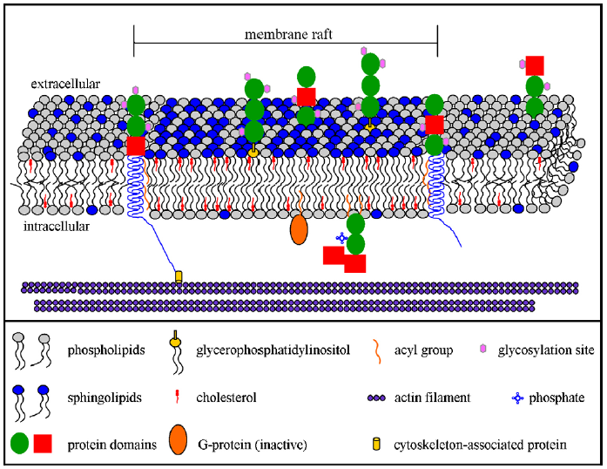
One hypothesis for the activation signal is changes in the membrane organization of the paranode; as mentioned, the paranode is the attachment site for the internode. One of the key proteins for this adhesion is Neurofascin 155 (NF155), which binds to Caspr, a contactin associated protein that binds with NF155, on the axonal membrane (Shafer et al, 2005). NF155 normally localized in the membrane to the sites of lipid rafts (fig. 2), which are unique domains that are rich in cholesterol and sphingolipids used for lateral membrane organization and partitioning of proteins (Pomicter et al, 2013; Dupree et al, 2010). The additional cholesterol in rafts stiffens the membrane, which decreases the ability of proteins to laterally diffuse in and out of the raft. This raft composition produces a more ordered and rigid environment, which affects the configuration and proper functioning of the proteins in the raft. In this case, NF155 helps to anchor the myelin to the axonal membrane by associating with Caspr at the paranode, which anchors the protein and thusly the raft to the cytoskeleton of the axon.
Figure 2 a graphical representation of a membrane raft (adapted from: Dupree et al, 2010)
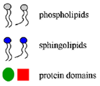
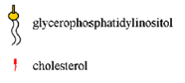
Interestingly, in myelin isolated from MS patients, the association of NF155 with lipid rafts is has been shown to be dramatically reduced (Maier et al, 2007). This mis-localization, causes NF155 to no longer cluster at the paranodal junction, which decreases the ability of the myelin to adhere to the axon (Dupree et al, 2010, Pomicter et al, 2013). An additional consequence of the displacement of NF155, could be an altered exposure of the protein to the local microglia surveilling the environment. Detection of this exposure by the microglial cells could lead to their activation, and produce a neuro-inflammatory response leading to demyelination.
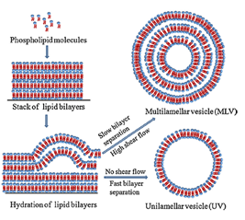
The focus of this proposal, is to investigate how the membrane environment of NF155 (i.e. its raft association) impacts the inflammatory response of the microglial cells.
II. Experiment
The purpose of this experiment is to investigate whether raft association of NF155 effects the inflammatory response of microglial cells. If the loss of raft association increases the inflammatory response of microglial cells then there will be an increase in pro-inflammatory cytokine release, cell proliferation, and morphological change to the ameboid shape. The three aforementioned responses will be quantified using: an ELISA kit, a cell proliferation assay, and immunocytochemistry respectively. This will be accomplished with an in vitro model system using cultured microglial cells and synthetic liposomes to simulate the membrane envornment of NF155.
Figure 3 Basic methodology for the synthesis of multilamellar vesicles, lipids to compose the liposome are stacked in a dry environment, then hydrated with water to spontaneously form into vesicles due to their amphipathic nature. To synthesize unilamellar vesicles the hydration is done quickly forming a single membrane layer (Patil & Jadhav, 2013)
II A – Myelin Isolation and Fractioning
Myelin will be isolated from the white matter of mice by published methods. White matter of the brain is homegenized in a sucrose EGTA solution. The sucrose causes the myelin to peel off the axons and form into vesicles, and the EGTA is used to bind to the calcium present in the axons (Kim et al, 1995, Norton, W. 1974). Following this treatment, the homogenates undergo density gradient ultracentifgation with sucrose, the pellet from this is then re-homogenized with sucrose and EGTA. Thie homogenate is then density gradient centriguged a second time, the pellet is then composed only of myelin and sucrose, the sucrose is washed out, and myelin is isolated (Kim et al, 1995). To isolate the raft fractions of the myelin, pure myelin is homogenized in a non-ionic detergent, since lipid rafts are not soluble in these. The lysate then undergoes lysate flotation using a sucrose density gradient, since the raft and non-raft fractions vary in density (Kim et al, 1995, Dupree et al, 2010). Lipid composition is analyzed using thin layer chromatography, which uses silica gel on glass to separate lipids by polarity (Fuchs et al, 2011). Rafts can be disrupted by solublization in an ionic detergent (Dupree et al 2010).
Liposome Treatment
Control protein, non-raft liposomes
NF155, non-raft liposomes
Control protein, raft liposomes
NF155, raft liposomes
Table 1 Liposome treatments for the experiment
II B – Liposome Synthesis
The amount of myelin present at the paranode is far too small for collection of human samples from deceased patients, for this reason, unilamellar liposomes (also called unilamellar vesicles) will be synthesized in lab to simulate the membrane environment (fig 3). The composition of these liposomes will be simulating either the normal membrane composition of myelin, or the composition of the lipid rafts that contain NF155. Due to the lack of lab protocol for synthesis of lipid rafts, the raft environment will be simulated by composing liposomes that mimic the raft environment. Lipid rafts contain much higher quantities of sphingolipids and cholesterol; therefore, the raft liposomes will have the same components as the non-raft liposomes but with altered quantities of the lipids (Dupree et al, 2010). Lipid composition of the liposomes will be confirmed by thin-layer chromatography, which is chromatography that is conducted on glass plate with a thin layer of silica gel on it (Fuchs et al, 2011).
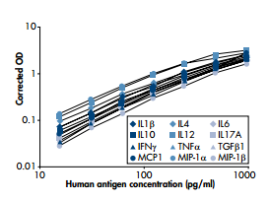
II C – Microglia Cell Culturing
Microglial cultures from 2 day postnatal mice will be prepared according to published methods (Deierborg, T. 2013). Briefly, the cortex will be isolated from the brains of 3 mice, which will then be chopped and incubated with trypsin and DNase for 15-20 min. The trypsin functions to prevent cells sticking to the sides of the culture dish, the DNase prevents the cells from clumping. Tissue is then aspirated until a cell suspension is obtained, the suspension is then centrifuged at 400 xg to obtain a pellet of cells. Cells are cultured for an additional 2-3 weeks, after which they will be used in these studies (Deierborg, T. 2013).
II D – Liposome Treatments
To compare and contrast the inflammatory response of the microglial cells, I will be using 4 different liposome treatments (table 1): (1) control protein in non-raft liposome; (2) NF155 in non-raft liposomes; (3) control protein in raft liposomes; and (4) NF155 in raft liposomes. The control protein used will be Amyloid Precursor Protein (APP), which is a ubiquitously expressed, cell-surface, transmembrane protein (O’brien Wong, 2011).
Figure 4 Standard curve for the ELISA human inflammatory cytokines kit, cytokines are shown in the key (QIAGEN)

Figure 4 standard curve for the ELISA human inflammatory cytokines (QIAGEN)
II E – ELISA
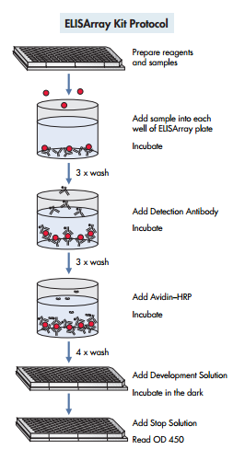
To measure the amount of pro-inflammatory cytokine release from the microglial cells, culture supernatants will be analyzed using an ELISArray kit, which will be purchased from QIAGEN. The ELISA kit uses cytokine-specific antibodies absorbed onto the surface of 96-well ELISA plates for antigen capture. Sample supernatants are added to the wells and cytokine binding is then detected using a panel of biotinylated detection antibodies. Wells are incubated with horseradish peroxidase (HRP)-avidin, the detection antibodies are biotinylated for use with the HRP-avidin since avidin has a strong affinity for biotin. This is then visualized using the HRP substrate tetramethylbenzidine (TMB) and hydrogen peroxide (QIAGEN). This resultant blue color, the intensity of which is proportional to the amount of cytokine bound, is quantified at 450 nm with an optical ELISA plate reader. Individual cytokine levels are determined by comparison with standard curves (fig 4).
Figure 5 Protocol for the ELISArray (QIAGEN)

Figure 4 protocol for the ELISArray (QIAGEN)
II F – Cell Proliferation Assay
Microglial cell proliferation will be determined by bromodeoxyuridine incorporation. Bromodeoxyuridine (BrdU) is an analog of thymidine (fig. 6), which has a bromo- group where the methyl group would be on a thymidine (Crane, Bhattacharya). The BrdU is incorporated into cellular DNA during the S phase of the cell cycle, in which DNA is replicated (Crane, Bhattacharya). In order to determine the presence of BrdU, cultures are incubated with a BrdU antibody under DNA denaturing conditions, to allow the antibody access to the DNA (Crane, Bhattacharya). Following the initial antibody association, the samples are exposed to a peroxidase-labeled secondary antibodies using diaminobenzidene as the chromogen. A chromogen is a molecule that can readily change color, in this case the molecule changes color when it acts as a substrate for the peroxidase enzyme producing a colored product. The percentage of labeled cells under each condition will be counted by bright field microscopy (Crane, & Bhattacharya, 2013).
II G – Immunocytochemistry with IBA1 antibody
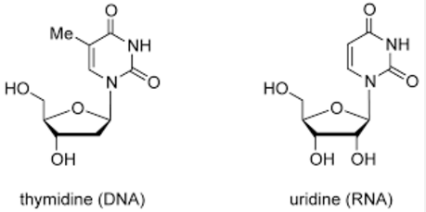
To assess the morphological changes in microglia in response to liposome treatment, cells will be immunostained with and IBA1 antibody. IBA1 is a surface protein in microglial cells that increases in expression when the microglial cells are activated (Biocare Medical). The percentage of cells in the ramified aster morphology will be compared to the percentage in the activated state, or amoeboid morphology.
Thymidine Bromodeoxyuridine
Br

Br
Figure 6 Side by side comparison of thymidine, a deoxynucleoside, and Bromodeoxyuridine with the bromo- group in blue (adapted from atdbio)

Figure 6 side by side comparison of thymidine, a deoxynucleoside, and uridine with the bromo- group added in blue (adapted from atdbio)
III. Discussion
The hypothesis being tested in these experiments is: does the raft environment of NF155 impact its neuroinflammatory potential. Using a microglial cell culture model and liposome delivery system for NF155, inflammation will be assessed by (1) cytokine production; (2) proliferation; and (3) morphological changes. The most relevant control condition in these experiments is APP in raft liposomes. Therefore, all values for NF155 raft liposomes will be compared with this control. A positive correlation between the raft-lipid environment and inflammation will be indicated by: (1) an increase in pro-inflammatory cytokines; (2) increased cell proliferation; and (3) a greater percentage of microglia with amoeboid morphologies.

While this experiment could provide very informative observations that would clarify the direction of further study, there are many potential issues. First, the liposome synthesis could fail due to limitations of associating the proteins with the lipids, or alternatively the synthesis not going as planned and proteins becoming enclosed by the liposome as opposed to integrated in the membrane. Additionally, the control protein could cause an innate inflammatory response that would provide results that would be inconclusive due to inability to clearly observe NF155 as an impetus for neuroinflammation. Moreover, the experiment is limited by the cost of purchasing numerous proteins and lipids, as well as the materials and mice needed. The experiment is also limited in its results by the fact that this would be a fully in vitro environment, which would in no way be able to encompass the vast and intricate myelin membrane, or the other factors that could be influencing this inflammatory response.
Despite the potential limitations and pitfalls, the results of this experiment would provide direction for further work into investigating the paranodal environment and how it influences the inflammatory response of microglial cells. This research could provide answers into the cause of a convoluted disease, and further research could lead to an eventual cure or treatment for MS.

References
Aggarwal, Shweta, Yurlova, Larisa, & Simons, Mikael. (2011). Central nervous system myelin: Structure,
synthesis and assembly. Trends in Cell Biology, 21(10), 585-593. [LINK]
Atdbio. (n.d.). Nucleic acid structure. Retrieved April 30, 2016, from
http://www.atdbio.com/content/5/Nucleic-acid-structure
Arvanitis, D., Min, W., Gong, Y., Heng, Y., & Boggs, J. (2005). Two types of detergent‐insoluble,
glycosphingolipid/cholesterol‐rich membrane domains from isolated myelin. Journal of Neurochemistry, 94(6), 1696-1710.
Biocare Medical. (n.d.). Microglia (Iba1) Concentrated Polyclonal Antibody. California, Concord.
Block, M. (2014). Neuroinflammation: Modulating mighty microglia. Nature Chemical Biology, 10(12), 988-9.
[LINK]
Bosio, A., Büssow, H., Adam, J., & Stoffel, W. (1998). Galactosphingolipids and axono-glial interaction in
myelin of the central nervous system. Cell and Tissue Research, 292(2), 199-210 [LINK]
Brady, S., Siegel, George J, Albers, R. Wayne, & Price, D. L. (2012). Basic neurochemistry : Principles of molecular,
cellular, and medical neurobiology (8th ed.). Amsterdam ; Boston: Elsevier Academic Press.
Coggan, J., Bittner, S., Stiefel, K., Meuth, S., & Prescott, S. (2015). Physiological Dynamics in Demyelinating
Diseases: Unraveling Complex Relationships through Computer Modeling. International Journal of Molecular Sciences, 16(9), 21215-36.
Crane AM1, Bhattacharya SK., The use of bromodeoxyuridine incorporation assays to assess corneal stem
cell proliferation. Methods Mol Biol. 2013;1014:65-70
Deierborg, T. (2013). Preparation of Primary Microglia Cultures from Postnatal Mouse and Rat Brains. In
Microglia: Methods and Protocols (Vol. 1041, Methods in Molecular Biology, pp. 25-31). New York, NY: Springer Science Business Media. [LINK]
Dupree, Jeffrey L., & Pomicter, Anthony D. (2010). Myelin, DIGs, and membrane rafts in
the central nervous system. Prostaglandins and Other Lipid Mediators, 91(3), 118-129. [LINK]
Fuchs, Süß, Teuber, Eibisch, & Schiller. (2011). Lipid analysis by thin-layer chromatography—A review of the
current state. Journal of Chromatography A,1218(19), 2754-2774.
Giulian, D., & Baker, T. (1986). Characterization of ameboid microglia isolated from developing mammalian
brain. The Journal of Neuroscience : The Official Journal of the Society for Neuroscience, 6(8), 2163-78. [LINK]
Grassi, S., Prioni, S., Cabitta, L., Aureli, M., Sonnino, S., & Prinetti, A. (2016). The Role of 3- O –
Sulfogalactosylceramide, Sulfatide, in the Lateral Organization of Myelin Membrane. Neurochemical Research,41(1), 130-143. [LINK]
Howell, Palser, Polito, Melrose, Zonta, Scheiermann, . . . Reynolds. (2006). Disruption of neurofascin
localization reveals early changes preceding demyelination and remyelination in multiple sclerosis. Brain, 129(12), 3173-3185. [LINK]
Kim, T., Fiedler, K., Madison, D., Krueger, W., & Pfeiffer, S. (1995). Cloning and characterization of MVP17:
A developmentally regulated myelin protein in oligodendrocytes. Journal of Neuroscience Research, 42(3), 413-422.
Lull, M., & Block, E. (2010). Microglial activation and chronic neurodegeneration. Neurotherapeutics, 7(4), 354-
365. [LINK]
Maier, O., Van Der Heide, T., Van Dam, A., Baron, W., De Vries, H., & Hoekstra, D. (2005). Alteration of
the extracellular matrix interferes with raft association of neurofascin in oligodendrocytes. Potential significance for multiple sclerosis? Molecular and Cellular Neurosciences, 28(2), 390-401. [LINK]
Maier, O., Baron, W., & Hoekstra, D. (2007). Reduced raft-association of NF155 in active MS-lesions is
accompanied by the disruption of the paranodal junction. Glia, 55(8), 885-95. [LINK]
Norton, W. (1974). Isolation of myelin from nerve tissue. Methods in Enzymology, 31, 435-44.
O'Brien, R., & Wong, P. (2011). Amyloid precursor protein processing and Alzheimer's disease. Annual Review
of Neuroscience, 34, 185-204.
Ozgen, H., Schrimpf, W., Hendrix, J., Jonge, J., Lamb, D., Hoekstra, D., . . . Baron, W. (2014). The Lateral
Membrane Organization and Dynamics of Myelin Proteins PLP and MBP Are Dictated by Distinct Galactolipids and the Extracellular Matrix. PLoS One,9(7), PLoS One, Jul 2014, Vol.9(7). [LINK]
Patil, Yogita P., & Jadhav, Sameer. (2013). Novel methods for liposome preparation.Chemistry and Physics of
Lipids, 177, 8-18.
Pomicter, A., DeLoyht, D., Hackett, J., Purdie, M., Sato-Bigbee, R., Henderson, N., & Dupree, C. (2013).
Nfasc155H and MAG are Specifically Susceptible to Detergent Extraction in the Absence of the Myelin Sphingolipid Sulfatide. Neurochemical Research, 38(12), 2490-2502. [LINK]
Pomicter, A., Shroff, S., Fuss, B., Sato-Bigbee, C., Brophy, P., Rasband, M., . . . Dupree, J.
(2010). Novel forms of neurofascin 155 in the central nervous system: Alterations in paranodal disruption models and multiple sclerosis. Brain, 133(2), 389-405. [LINK]
Qiagen. (n.d.). Human Inflammatory Cytokines Multi-Analyte ELISArray Kit: MEH-004A. Retrieved April
30, 2016, from http://www.sabiosciences.com/ELISA_product/HTML/MEH-004A.html
Schafer, D., Bansal, R., Hedstrom, K., Pfeiffer, S., & Rasband, M. (2004). Does paranode formation and
maintenance require partitioning of neurofascin 155 into lipid rafts? The Journal of Neuroscience : The Official Journal of the Society for Neuroscience, 24(13), 3176-85. [LINK]
Sherman, Diane L., Tait, Steven, Melrose, Shona, Johnson, Richard, Zonta, Barbara, Court, Felipe A., . . .
Brophy, Peter J. (2005). Neurofascins Are Required to Establish Axonal Domains for Saltatory Conduction. Neuron, 48(5), 737-742. [LINK]
Squire, Larry, Berg, Darwin, Bloom, Floyd E., Du Lac, Sascha, Ghosh, Anirvan, & Spitzer, Nicholas C.
(2012). Fundamental Neuroscience (4th ed.). Elsevier Science.
Stansley Branden, Post Jan, & Hensley Kenneth. (2012). A comparative review of cell culture systems for the
study of microglial biology in Alzheimer’s disease. Journal of Neuroinflammation, 9(1), 115.
Thummala, S. (2015). Axon initial segment stability in multiple sclerosis. [LINK]
Trapp, B., & Kidd, G. (2000). Axo-glial septate junctions. The maestro of nodal formation and
myelination? The Journal of Cell Biology, 150(3), F97-F100.

