Part I: Introduction

Many of the cellular responses to a hypoxic environment are orchestrated by a group of these transcription factors, which induce the expression of genes that mediate a metabolic rewiring of the hypoxic cell, induce formation of new blood vessels around the hypoxic tissue. The cellular adaptation to hypoxia, as a result of HIFs sustains the growth of rapidly proliferating tissues such as those of developing embryos and solid tumors. HIFs are essential for embryonic development, but are also exploited by cancer cells during the progression of many solid tumors. The implications being that the HIFs have their own respective medicinal and research applications, and understanding how various HIFs affect one another adds a crucial layer to future research.

A transcription factor is a protein that binds to specific DNA sequences, thereby controlling the rate of transcription of genetic information from DNA to messenger RNA. DNA binding proteins known as HIFs, short for Hypoxia Inducible Factors, are transcription factors that creates a response to hypoxia.

Fig 1. The oxygen dependence of HIF destruction. (When there is sufficient oxygen present, HIFs are degraded)

In vitro, the oxygen-regulated subunits HIF-1 and 2 are expressed in inverse relationship to oxygen tensions in every cell line investigated to date. HIFs are regulated at the protein level by oxygen-dependent enzymes and, hence, allow for tissue hypoxia detection.

Figure 2. HIF1a pathway
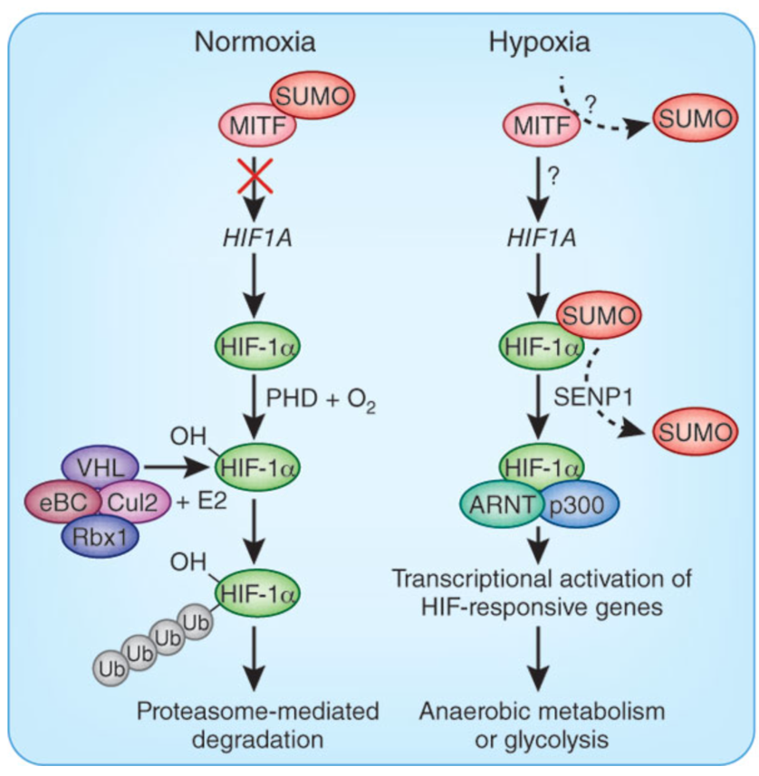
A visual of the molecular pathway of HIFs allows a better understanding of their regulation of the transcriptional apparatus that enables the response to hypoxia. Under conditions of normal oxygen conditions, the alpha subunits of the HIF’s are hydroxylated at key proline and asparagine residues, in turn inhibiting their function. Upon hypoxia, the HIF alpha subunits are stabilized and accumulate in the nucleus, where they dimerize with the HIF1 beta subunits (HIF1B). HIF1B is stably expressed and is also an obligate partner for the HIF alpha subunit. The dimerization of HIF alpha subunits and the HIF1B allows them to bind to DNA and stimulate the transcription of their target genes. This allows the coordinate activation of genes essential in the adaptive response to hypoxia including pathways that decrease the cellular demand for O₂ and increase O₂ delivery and tissue re-oxygenation.

The interplay between these two HIF alpha sub units is an interesting dynamic, as it could be possible that they do not interfere with each other at all, or may they are more dependent than anticipated. Even though it is known that they are two separation entities, it is still possible that they may pose some sort of an effect on the other as HIF2A shares high sequence homology with HIF1A and functions in a similar manner. HIF2A also dimerizes with HIF1B upon hypoxic induction. Different from HIF1A, HIF2A stimulates the expression of its own distinct set of target genes, leaving us to wonder what relationship these two transcription factors share. To begin to investigate the possible entanglement between the two, I will investigate the consequential effects that the knockout of HIF1a will pose to HIF2a?

Part II. The Experiment

The template for the experiment will follow Rosenber et al, (2002). The following is a condensed form the aforementioned template. Renal tissue of rats will be used as medium to conduct this experiment. The rats were kept in chambers flushed with a gas mixture to mimic a hypoxic environment.

Half of the rat kidneys will be used as a control and the other half will be subject to the protein hypoxia-associated factor (HAF), via the inject of a plasmid. HAF also regulates the stability of alpha subunits via ubiquitination and proteasomal degradation; however, unlike other regulators such as phosphokinases, they do so independently of oxygen tension. HAF ubiquitinates HIF1A, but not HIF2A, targeting it for destruction. Thus, HAF is an ideal protein to use for the removal of HIF1a, leaving only the HIF2a. This will effectively eliminate the the HIF1a, leaving only the HIF2a, which can then be measured to see what has occurred.

High amplification immunohistochemical analyses (IHC) will be used to measure the concentration of the two HIFs. IHC can be used to identify discrete tissue components, in this case the two distinct HIFs, by the interaction of target antigens with specific antibodies tagged with a visible label. This is the ideal method to use to measure HIFs because previous studies in rats revealed the need for standardized fixation, special target retrieval, and high-amplification technique to obtain reliable results. For detection of HIF isoforms, monoclonal mouse anti-human HIF-1 antibody and polyclonal rabbit anti-mouse HIF-2 antibodies were used. Specific staining of each HIF isoform was confirmed in immunoblots by using in vitro transcribed and translated mouse HIF-1 and HIF-2.

The kidneys will be measured daily for a period of 3 days to ensure consistent results. The resting kidneys will stay in hypoxic chambers at all times, except for when they will be measured.

Part III. Discussion

There is already a sufficient amount of evidence to support the view that the HIFs’ are up-regulated upon hypoxia, and short-lived when sufficient oxygen is reestablished. That being said, however, there is not much evidence as to how the absence of one HIF alpha sub unit affects the other. This is a result of previous studies focusing on measuring only one type of HIF at a time.

In addition to HIF2A having more restricted expression across tissues, there is evidence supporting the notion that there is a time delay in play that affects when HIF1a and HIF2a respond. Under conditions of acute hypoxia, i.e. Less than 24 hours of stimulation, transactivation of target genes occurs primarily by virtue of HIF1a, whereas following longer periods of time, HIF2a begins to exert more of an influence. Thus, a potential result of suppression HIF1a could be that there is no temporal delay for the incidence of HIF2a, meaning that the target cells could adapt to the influence of HIF2a, as opposed to the original HIF1a.

More specifically, HIF1A regulates the activation of glycolytic genes, thereby allowing cells to survive under conditions of decreased oxygen by switching the metabolic scheme from one of oxidative phosphorylation to anaerobic glycolysis. Several studies demonstrate that HIF2A plays no role in glycolytic gene regulation. If this is the case, then it can be possible that the cell takes additional adaptions from HIF2a, to survive without the presence of the HIF1a.

A potential pitfall this experiment could face is if the renal cells die too quickly in a hypoxic environment, as a result of the lack of the cellular adaptions mediated by HIF1a. This is only an issue if HIF2a doesn’t react to the lack of HIF1a. A potential remedy to this pitfall would be to use tissue that can survive longer in hypoxic environments. The limitations of this experiment are that it does not encompass the affects of the suppression of HIF2a on HIF1a, and also this experiment has no mention of the third HIF factor found in mammalian cells, HIF3a. If this were a larger experiment, then all permutations of suppression and resulting effect could have been tested from the three distinct HIF factors.

Part IV.
References

- Dengler, Veronica L., Matthew Galbraith, and Joaquín M. Espinosa. “Transcriptional Regulation by Hypoxia Inducible Factors.” Critical reviews in biochemistry and molecular biology 49.1 (2014): 1–15. PMC. Web. 1 May 2016
- Hu CH, Wang L-Y, Chodosh LA, et al. Differential Roles of Hypoxia-Inducible Factor 1 (HIF-1 ) and HIF-2 in Hypoxic Gene Regulation. Mol Cell Biol. 2003;23:9361–9374.
- Koh MY, Darnay BG, Powis G. Hypoxia-associated factor, a novel E3-ubiquitin ligase, binds and ubiquitinates hypoxia-inducible factor 1α, leading to its oxygen-independent degradation. Mol Cell Biol. 2008a;28:7081–7095.
- Koh MY, Spivak-Kroizman TR, Powis G. HIF-1 regulation: not so easy come, easy go. Trends Biochem Sci. 2008b;33:526–534.
- Ohh, Michael. "Tumor Strengths And Frailties: Cancer Summons Otto's Metabolism." Nature Medicine 18.1 (2012): 30-31. Academic Search Complete. Web. 7 May 2016
- Rosenberger C, Mandriota S, Jurgensen JS, Wiesener MS, Horstrup JH, Frei U, Ratcliffe PJ, Maxwell PH, Bachmann S, Eckardt KU: Expression of hypoxia-inducible factor-1alpha and -2alpha in hypoxic and ischemic rat kidneys. J Am Soc Nephrol 13 : 1721 –1732, 2002
- Takeda N, Maemura K, Imai Y, et al. Endothelial PAS domain protein 1 gene promotes angiogenesis through the transactivation of both vascular endothelial growth factor and its receptor, Flt-1. Circ. Res. 2004;95:146–153
- Warnecke C, Griethe W, Weidemann A, Jurgensen JS, Willam C, Bachmann S, Ivashenko Y, Wagner I, Frei U, Wiesener MS, Eckardt KU: Activation of the hypoxia-inducible factor-pathway and stimulation of angiogenesis by application of prolyl hydroxylase inhibitors. FASEB J 17 : 1186 –1188, 2003
- Wiesener MS, Seyfarth M, Warnecke C, Jürgensen JS, Rosenberger C, Morgan NV, Maher ER, Frei U, Eckardt KU: Paraneoplastic erythrocytosis associated with an inactivating point mutation of the von Hippel-Lindau gene in a renal cell carcinoma. Blood 99 : 3562 –3565, 2002

Reference 5
Reference 5
Reference 2
Reference 6
Reference 3
Reference 3
Reference 8
Reference 6
References 3, 4, and 7

