CRISPR/Cas9 as a tool for creation of
p53 knock-outs in human glioma cells
I. Introduction
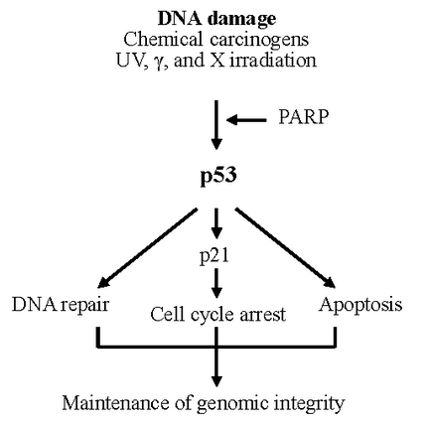
As the second deadliest disease in the United States, cancer is as varied as it is difficult to treat. In the US, over 500,000 people are claimed by the various forms of cancer annually.¹ However, even amongst cancers, certain types are infamous for their aggressive nature and poor prognosis – one such cancer is Glioblastoma Multiforme. This cancer is known as the most malignant and lethal form of brain cancer.²
Although mutations creating oncogenes that lead to cellular deregulation are random, certain genes are of great importance for controlled cell proliferation; among these is the p53 gene. The product of this gene is the first protein in a pathway that regulates a cell division-stimulating protein (cdk2). If the final protein in this pathway, p21, is not available, then the cell will begin to proliferate uncontrollably (Fig. 1)³. Cells that divide in this way become tumors.⁴ Research has also shown that mutated p53 genes tend to have additional oncogenic properties that are separate from the normal duties of normal p53. Mutant p53 may increase a tumor’s ability to migrate and promote angiogenesis, as well as boost a tumor’s resistance to chemotherapy.⁵
Figure 1: Basic protein pathway of normally functioning p53. Adapted from Figure 2 of Ref 3.
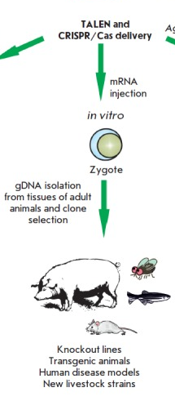
Mutations in the p53 gene are one of the most significant aspects of the origin of cancers. In order to reduce the potential dangers of mutated p53, artificial stimulation of the cell’s normal DNA repair mechanisms have been considered. Biddlestone-Thorpe et al. (2013) demonstrated that stimulation of one of the genes that plays a role in repairing DNA damage to p53 helped to reduce the overall level of growth and invasion of glioblastoma multiforme tumor cells in mice. This was accomplished through application of a kinase inhibitor on the targeted gene, ataxia-telangiectasia mutated (ATM).⁶ The present investigation aims to determine whether there are other means to control the function of p53.
One of the methods we might use to facilitate the inactivation of p53 is the Clustered Regulatory Interspaced Short Palindromic Repeats/Cas9 system, or simply CRISPR/Cas9. CRISPR consists of a non-coding guide RNA coupled with a Cas protein. In this system, the RNA associates with a complementary strand of target DNA. Additionally, the coupling of RNA and Cas protein imparts nuclease activity upon the complex. This complex was identified to be a defense mechanism in microorganisms – this system has protected prokaryotic genomes from viral DNA by limiting horizontal gene transfer. However, CRISPR/Cas9 also has potential as a genomic engineering tool. By designing a CRISPR/Cas9 nuclease construct that has high specificity for a particular gene target, and delivering the complex to a cell’s nucleus, it is possible to alter the genome at selected sites.⁷
Figure 2: General strategy for application of the CRISPR/Cas9 system. Adapted from Figure 3 of Ref 7.

A sequence specific nuclease like the CRISPR/Cas9 complex cannot simply glue itself to the target gene after excising the unwanted sequence, however. Doench et al. (2014) have used single guide RNA (sgRNA) mediated CRISPR to create ‘knock-out’ organisms.⁸ Knock-out organisms are created by removing a small section of the genome of a plant or animal zygote at the germ-line (Fig 2). As long as the target gene is not necessary for survival, the organism will grow up without it – similarly, all of its offspring will lack the target gene. This technique is extremely useful for studying the functions of one gene in isolation.⁹
CRISPR/Cas9 is not a perfect tool, however. While the results of a CRISPR mediated system are often reproducible, they do not work most of the time.¹⁰ Furthermore, experimental evidence has demonstrated that this system may generate off target effects – unintentional changes made in areas other than the target gene.⁷ Since exacting specificity of CRISPR/Cas9 has not yet been achieved, it is clear that this tool is still in its infancy in terms of a practical and clinical approach.
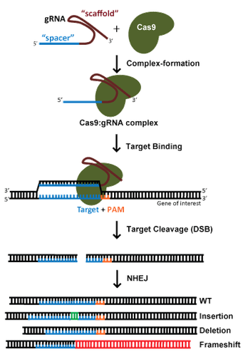
It is conceivable that CRISPR/Cas9 might be used to knock-out the p53 gene in human glioma cells in order to set up an experiment with three varieties of cells: wild type p53 cells, heterozygous p53 cells, and full knockout p53 cells. The aim of this investigation will be to determine whether CRISPR/Cas9 is a suitable method for creating knockout cells with high specificity for a target gene. This would require that glioma p53 knock-outs that are isogenic, or otherwise genetically identical, in locations other than p53.
II. The Experiment
There are two central goals for this experiment. The primary objective is to successfully create multiple variations of human glioma cell knockdowns for p53. The secondary objective is to determine any off-target effects for glioma cells heterozygous for p53, as well as total p53 knockouts.
II.A. CRISPR/Cas9 Design & Expression

In order to accomplish the primary objective, guide RNA (gRNA) sequences must be designed for the CRISPR system. This system is outlined in Figure 3: after unique gene sequences on the target gene are identified, a gRNA strand complementary to a target sequence forms an endonuclease by associating with Cas9. This complex seeks out the DNA sequences complementary to the guide strand and facilitates a double stranded DNA break. In most instances, after the target strand is removed, DNA is repaired via non-homologous end joining (NHEJ), which is efficient, but frequently introduces insertions or deletions (InDels).¹¹For this experiment, the practical aim will be to remove a portion of the p53 gene with this method as to render the gene inactive. The gRNA design process will be carried out via BLAST search of the human genome; by using BLAST to identify potential binding points, as many unique sets of oligonucleotides as are available on p53 will be identified and synthesized in vitro. This technique was used by Zhen et.al (2004)¹² in order to design oligonucleotide gRNA primers targeting genes associated with human papillomavirus.
Figure 3: Basic outline of Cas9 endonuclease formation and functionality. Adapted from Figure 1 of Ref 11.

Unfortunately, it is not possible to predict which gRNA/Cas9 complex will be most effective at knocking out p53 with the fewest isogenic effects, as potential InDels resulting from NHEJ cannot be controlled.¹¹To circumvent this problem, each nuclease will have three trials. All trials will rely on microinjection of gRNA and Cas9 expression vector into p53 wild-type glioma cell lines. Three trials are necessary in order to see varying levels of p53 knockdown. The first cell line will not be transfected (control group). The second cell line will be transfected with 1µg of Cas9 expression vector (retrovirus vector) and 1µg of the gRNA expression vector (oligonucleotide). The third trial will include 3µg of the Cas9 and gRNA expression vectors. It is predicted that increased levels of expression vector will result in a more complete knockdown of p53. The purpose of this triple-trial method is to attain differing levels of p53 knockdown, with the ultimate goal of determining whether a more aggressive knockdown/knockout will result in more severe off-target effects.
II.B. Determining Knockdown & Off-Target Effects:
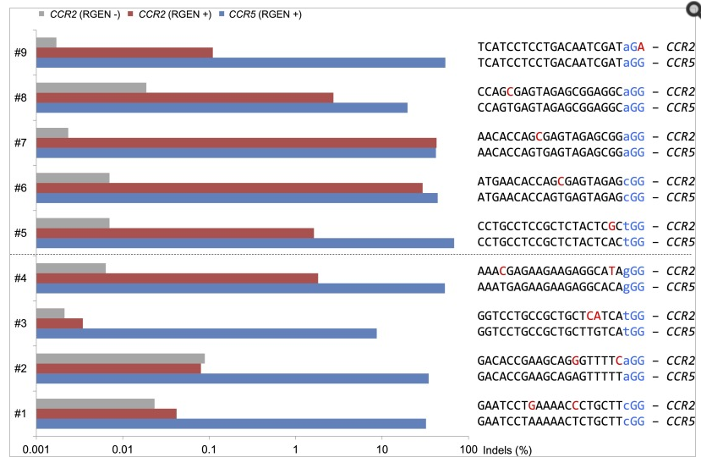
After all transfection trials are completed, each glioma cell line will be incubated until a full colony can form. In this way, I will have many clones from each gRNA/Cas9 transfection cell line – each with their own level of p53 knockdown and off-target effects. In order to characterize off-target effects in each cell line, high-throughput DNA sequencing will be employed to locate all sites of mutagenesis within and around the target sequence.
Figure 4: High-throughput analysis of off-target and on-target mutations of CCR2 & CCR5 by Cho et al. (2014); demonstrated that gRNA/Cas9 nucleases caused off-target mutations in CCR2 in < 1% of trials, but caused on-target mutations in both CCR2 & CCR5 in > 10% of trials. Adapted from Figure 2 of Ref 13.

This method has been used by Cho et al. (2014), where it was determined that unintended mutagenesis is most common at points differing by just one nucleotide away from the target site.¹³ Although genotypic differences can be determined with DNA sequencing, phenotypic and protein differences will also be determined via Western Blot analysis.
III. Discussion
If all goes well, I will end up with at least one cell line that features a full knockout of p53 with few off-target protein effects – ideally there will be no observable phenotypic effects in the colony compared with the original p53 wild-type glioma cells. From this position I would hope to conclude that I had successfully optimized a CRISPR mediated p53 knockout procedure, and that such a feat had laid the groundwork for knocking-in an immaculate p53 gene, devoid of InDels that might cause dysregulation of the cell. This translates to a major step in curing cancers in which p53 is defective. However, this experiment does little to investigate whether a p53 knock-in procedure would create any InDels and/or off-target effects that I am hoping to avoid! Additionally, a p53 knockout procedure has never before been attempted, so while previous studies have observed few off-target InDels (Figure 4), knockdown of the p53 gene may not necessarily follow this same trend.
An additional concern are any potential InDels that the NHEJ process may induce within the target sequence itself. In general, gRNA oligonucleotides are around 20 bases in length, but this length is significantly smaller than most genes.¹¹ Therefore, although a deletion of 20 or so nucleotides in p53 may succeed in knocking-down or deactivating it completely, the unpredictable nature of mutation may induce changes in functionality of genes that lay elsewhere on chromosome 17 entirely, via frameshift⁴. Depending on where the mutation occurs, the change may be phenotypically invisible if any related proteins are not immediately affected.
Despite these potential setbacks, successfully creating an optimized p53 knockdown is the first step in utilizing CRISPR/Cas9 to treat dangerous cancers. With this brute-force approach to gRNA/Cas9 endonuclease design, this investigation will determine the best way to create a minimal-impact knockdown, thereby taking one step closer towards the elimination of human cancers.

References:
- Statistics for Different Kinds of Cancer – Centers for Disease Control and Prevention. (http://www.cdc.gov/cancer/dcpc/data/types.htm; Accessed April 2016)
- Glioblastoma Multiforme – Medscape (http://emedicine.medscape.com/article/283252-overview; Accessed April 2016).
- Mechanism of benzo(a)pyrene-induced accumulation of p53 in tumour suppressor protein in mouse. Oulun Yliopisto. (http://users.ipfw.edu/blumenth/CancBiol/p53.html; Accessed April 2016)
- Genes and Disease: The p53 tumor suppressor protein. NCBI. (http://www.ncbi.nlm.nih.gov/books/NBK22268/; Accessed April 2016)
- P.A.J. Muller and K.H. Vousden. p53 mutations in cancer. 2013. Nature Cell Biology. 15: 2-8.
- L. Biddlestone-Thorpe, M. Sajjad, E. Rosenberg, J.M. Beckta, N.C.K. Valerie, M. Tokarz, B.R. Adams, A.F. Wagner, A. Khalil, D. Gilfor, S.E. Golding, S. Deb, D.G. Temesi, A. Lau, M.J. O’Connor, K.S. Choe, L.F. Parada, S.K. Lim, N.D. Mukhopadhyay, and K. Valerie. ATM Kinase Inhibition Preferentially Sensitizes p53-Mutant Glioma to Ionizing Radiation. 2013. Clinical Cancer Research. 19(12): 3189-3200.
- Nemudryi, A.A., Valetdinova, K.R., Medvedev, S.P., and Zakain S.M. 2014. TALEN and CRISPR/Cas Genome Editiing Systems: Tools of Discovery. Acta Naturae. 6(3): 19-40. http://www.ncbi.nlm.nih.gov/pmc/articles/PMC4207558/
- Doench, J.G., Hartentian, E., Graham, D.B., Tothova, Z., Hegde, M., Smith, I., Sullender, M., Ebert, B.L., Xavier, R.J., and Root, D.E. 2014. Rational Design of Highly Active gRNAs for CRISPR-Cas9-Mediated Gene Inactivation. 2014. Nature Biotechnology. 32(12): 1262-1267. http://www.nature.com/nbt/journal/v32/n12/full/nbt.3026.html
- A.F. Gilles and M. Averof. Functional genetics for all: engineered nucleases, CRISPR and the gene editing revolution. 2014. EvoDevo. 5(43). http://www.ncbi.nlm.nih.gov/pmc/articles/PMC4332929/
- Remy, S., Tesson, L., Menoret, S., Usal, C., De-Cian, A., Thepenier, V., Thinard, R., Daron, D., Charpentier, M., Renaud, J.B., Buelow, R., Cost, G.J., Giovannangeli, C., Fraichard, A., Concordet, J.P., and Anegon, I. 2014. Efficient Gene Targeting by Homology-Direct Repair in Rat Zygotes Using TALE Nucleases. Genome Research 24(8): 1371-1383. http://www.ncbi.nlm.nih.gov/pmc/articles/PMC4120090/
- CRISPR/Cas9 Guide: addgene – the nonprofit plasmid repository. (https://www.addgene.org/crispr/guide/; Accessed April 2016).
- Zhen, S., Ling, H., Takahasi, Y., Narita, S., Yun-Hui, L., and Yan, L. 2014. In Vitro and in Vivo Growth Suppression of Human Papillomavirus 16-Positive Cervical Cancer Cells by CRISPR/Cas9. Biochemical and Biophysical Research Communications. 450(4): 1422-1426. https://vcu.userservices.exlibrisgroup.com/view/action/uresolver.do?operation=resolveService&package_service_id=21670491840001101&institutionId=1101&customerId=1090
- Cho, S.W., K. Sojumg, K. Yongsub, K. Jiyeon, K. Heon, B. Sangsu, and K. Jin-Soo. 2014. Analysis of off-target effects of CRISPR/Cas-derived RNA-guided endonucleases and nickases. Genome Research. 24(1): 132-141. http://www.ncbi.nlm.nih.gov/pmc/articles/PMC3875854/

