Nate Stearrett
Measurement of the expression of the ALOX15 gene
in wounds undergoing negative pressure wound therapy
I. Introduction
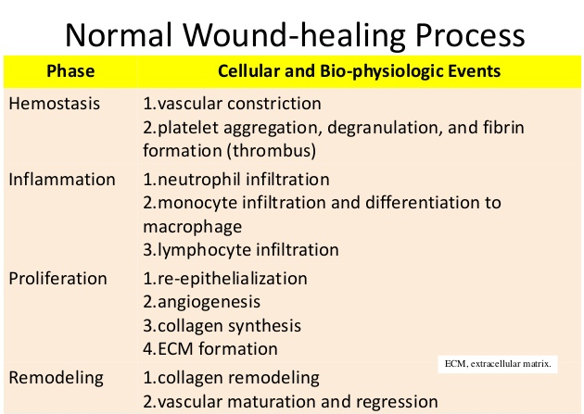
Chronic non-healing wounds affect 6 million people in the United States. ^{[1]} The normal stages of wound healing are hemostasis, inflammation, proliferation, and remodeling (Table 1).^{[2]} The transition to each stage of wound healing is directed by molecular signaling molecules and biosynthesis of certain signals. A chronic wound is characterized as being stuck in the inflammation phase of wound healing. ^{[3]} When the inflammatory phase continues without resolution, neutrophils build up at the site and cause cellular damage via release of toxic chemicals and inflammatory cytokines. ^{[3]} This results in prolonged inflammation which can cause chronic non-healing wounds.
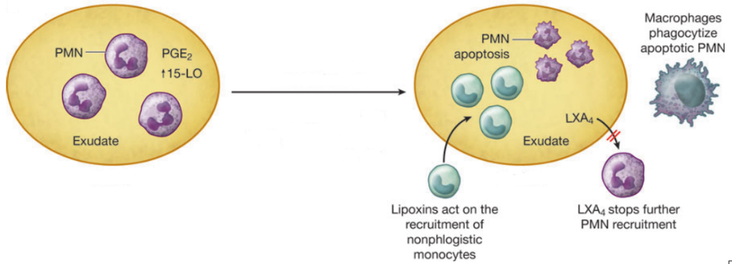
Lipoxins, derived from arachidonic acid, aid in ending the inflammatory phase of wound healing. ^{[4]} Lipoxins are synthesized from the metabolite of 15-lipoxygenase (15-LO), an enzyme produced by macrophages and dendritic cells. ^{[5]} They inhibit neutrophil infiltration into the wound site by reducing vascular permeability. ^{[4][6]} Lipoxins also stimulate the non-inflammatory recruitment of macrophages to phagocytose the apoptotic neutrophils built up at the site of the wound (Figure 1). ^{[7][8]} This aids in returning the wound site to homeostasis and stimulating the end of the inflammatory phase of wound healing. It has been demonstrated that lipoxin biosynthesis is concurrent with wound resolution. ^{[9]} Since 15-lipoxygenase is crucial to the biosynthesis of lipoxins, its expression plays a key role in the resolution process.
Figure 1: PMNs at the site of the wound switch to lipoxin production instead of leukotrienes. This is due to an upregulation of 15-lipoxygenase. The lipoxins stimulate macrophages to migrate to the wound site and phagocytose the apoptotic PMNs at the site. Lipoxins also suppress PMN infiltration from the blood vessels by modifying the permeability of the vessel walls. This aids in wound resolution and a return to homeostasis at the site of the wound. ^{[10]}
Table 1: The stages of wound healing and the cellular events associated with each stage. ^{[2]}
Negative pressure wound therapy (NPWT), also known as vacuum assisted closure, reduces ambient pressure at the site of the wound. NPWT increases the incidence and rate of wound closure in patients with problematic wounds. ^{[10]} Previously it was thought that NPWT accomplished this simply by reducing the bacterial load at the wound site and sucking away excess wound exudate, which can cause issues with proper wound healing due to its matrix metalloprotease rich environment degrading the collagen of the extracellular matrix (ECM). ^{[10]} Recently, the molecular mechanism of NPWT has been investigated and it has been discovered that it affects the expression levels of a variety of genes involved in wound healing. NPWT causes an upregulation of a variety of genes including Cdc42 and VEGF, proteins that are key to cellular migration and angiogenesis. ^{[10][11]} NPWT also downregulates the expression of matrix metalloprotease genes, ensuring that the ECM is not degraded as it forms. ^{[10]}
Given the knowledge that NPWT affects gene expression at the site of the wound, further investigation is needed in regards to expression of the enzymes involved in the biosynthesis of the mediators that control the resolution of the inflammatory phase of wound healing. The purpose of this experiment is to discover whether NPWT effects the gene expression of ALOX15, whose protein product controls biosynthesis of the lipoxins directly involved in wound resolution.
II. Experiment
The aim of this experiment is to find out if negative pressure therapy effects the expression of the ALOX15 gene, which codes for the 15-lipoxygenase protein needed to create lipoxins. To quantify gene expression, it is necessary to isolate the cellular RNA as a measure of the expression level. In addition to RNA quantification, it is helpful to identify target protein levels as they are the end result of the increased gene expression. The RNA transcript and protein amounts under NPWT will be compared to the amounts under ambient pressure.
IIA. Sampling
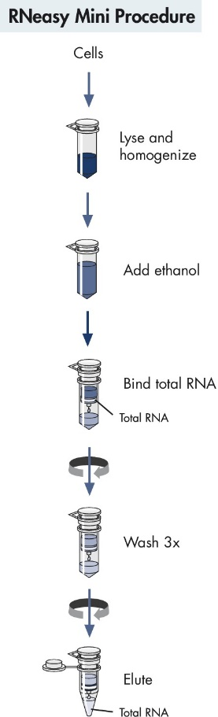
Acute compartment syndrome is a buildup of pressure in one of the nerve and muscle containing compartments in the body. It most commonly occurs in legs after a tibia fracture, which causes bleeding into the adjacent muscles resulting in pressure buildup. ^{[12]} The only treatment is to cut open the muscular compartment to relieve the pressure. ^{[13]} After the wound is cut open, negative pressure can be applied to the wound in order to aid healing and protect from infection. ^{[13]} Tissue biopsies will be taken every day for 30 days from post-operative patients being treated for lower-leg compartment syndrome with NPWT at a constant pressure of 125 mmHg. If the patient is older than 50 years old, has diabetes, or is prescribed anti-inflammatory drugs, they will be excluded from the study to reduce comorbidity and disruption of the natural inflammatory process. Samples intended for qPCR analysis will be stabilized using the RNAlater solution made by Qiagen, which will stop RNase activity and preserve the RNA for later testing so that it can be completed at one time. ^{[14]} Samples intended for ELISA analyzation will be suspended in saline solution containing a non-ionic detergent to solubilize membrane proteins and homogenized with a Polytron.
IIB. RNA Extraction and Quantification
Tissue samples will be immersed in guanadinium thiocyanate, which will lyse the cells and denature RNase as well as DNase. It accomplishes this by disrupting the hydration shells of the nonpolar amino acids, which weakens the effect of the hydrophobic forces that contribute to the tertiary structure of enzymes.^{[15]} This will preserve the RNA for analysis when it would otherwise be hydrolyzed by the RNase. The sample will then be centrifuged in a RNeasy tube produced by the company Qiagen. The RNeasy silica filter lets everything except the RNA pass through, while the RNA adheres to the filter (Figure 2).^{[16]}
Once the cellular RNA has been isolated, relative RNA levels will be measured using quantitative real-time PCR (qPCR). qPCR begins by a reverse transcriptase using the mRNA transcripts as templates for complimentary DNA (cDNA) synthesis. DNA primers specific for 15-LO and Cyclophilin E are then added to their respective tubes and the polymerase chain reaction is used to amplify the resulting cDNA exponentially. SYBR Green is present in the assay and fluoresces when bound to DNA.^{[17]} The more DNA is generated by the PCR reaction, based on the amount of starting mRNA, the more fluorescence will occur. Gene expression levels are then determined by the fluorescence of target ALOX15 cDNA relative to the Cyclophilin E, which will serve as a stable expression reference in the assay.^{[18]} In addition to the reference gene, two wells for each sample will have negative controls to control for contamination. The first negative control will contain the sample but will not undergo reverse transcription prior to PCR amplification and the second control will contain water rather than RNA. The two positive controls will be known DNA and RNA samples.
Figure 2: The RNeasy kit allows for simple isolation of the cellular RNA via silica filter. ^{[16]}
IIC. Protein Quantification
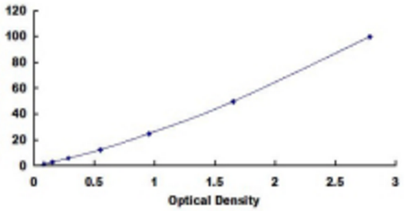
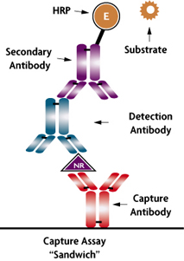
An ELISA assay will be used for cellular LO-15 protein measurement using the ALOX15 kit produced by Wuhan USCN Business Co. ^{[19]} Confirmation that the target protein is present happens when the assay changes color due to the secondary antibody associated enzyme catalyzing conversion of the substrate into a colored product (Figure 3). ^{[20]} The ELISA assay is very specific to the target protein, so it is unlikely for a non-target protein to bind. This is because the non-target protein would have to have the epitope for both the capture and detection antibodies (Figure 3). Optical density, which is a logarithmic measure of the amount of light lost due to absorption when light passes through a medium, will then be quantified for the sample. The results will be compared against the standard optical density curve provided by the kit manufacturer to determine the concentration of the protein (Figure 4).
Concentration (ng/mL)
Figure 4: The standard curve provided by the manufacturer is used to determine protein concentration based on optical density. Optical density is a logarithmic measure, so an OD of 3 means that the light was attenuated by a factor of 10³. ^{[19]}
Figure 3: The ELISA assay uses an immobilized capture antibody to initially bind the target protein. A detection antibody then binds to the protein, effectively “sandwiching” it between the first two antibodies. A secondary antibody with an enzyme bound to it then binds to the detection antibody. Upon addition of the substrate that the secondary antibody’s enzyme acts upon, the enzyme catalyzes conversion of the substrate into a colored product and produces a distinct color. ^{[20][21]}

III. Discussion
Ideally, there will be a significant increase in ALOX15 fluorescence in the qPCR for wounds undergoing negative pressure therapy when compared with wounds at ambient pressure. The Cyclophilin E expression should remain stable and the ALOX15 expression should increase under NPWT if the negative pressure has an effect on the ALOX15 gene expression. The two negative controls for the qPCR assay should result in no fluorescence and the two positive controls should result in measureable fluorescence. Furthermore, the ELISA assay should show a color change for the ALOX15 and the concentration of 15-lipoxygenase as determined by optical density should increase under NPWT when compared with the concentration at ambient pressure.
If any of the experimental controls prove to be unreliable, it will be very hard to interpret the results. If the negative controls in the qPCR show increases in fluorescence, it is likely that there is DNA contamination in the sample or reagents. If the positive control containing known RNA does not fluoresce, the reverse transcription step of the qPCR could not be working. If the known DNA positive control is negative, there is likely an issue with the polymerase chain reaction step. As the reference gene, the Cyclophilin E must remain relatively constant or the results cannot be interpreted accurately. Moreover, wound environments vary widely from patient to patient and the results can be hard to compare directly. ^{[22]}
Despite these difficulties, it is important to understand the effect of negative pressure therapy on 15-lipoxygenase expression so that the molecular mechanism of NPWT can be further elucidated. The more we understand about the treatment, the more useful and refined its applications become. This research stands to benefit our understanding of the treatment of chronic wounds, which continue to be a common malady burdening our healthcare system. If NPWT does indeed effect the expression of 15-lipoxygenase, further research can be conducted to investigate the mechanism by which it accomplishes the shift.

References
1. Branski, Ludwik K., Gauglitz, Gerd G., Herndon, David N., & Jeschke, Marc G. (2009). A review of gene and stem cell therapy in cutaneous wound healing. Burns, 35(2), 171-180. http://www.sciencedirect.com.proxy.library.vcu.edu/science/article/pii/S0305417908000946
2. Wound healing 2014. (n.d.). Retrieved April 30, 2016, from http://www.slideshare.net/ChuchaiSornchumni/wound-healing-2014
3. Schreml, Stephan, Szeimies, Rolf-Markus, Prantl, Lukas, Landthaler, Michael, & Babilas, Philipp. (2010). Wound healing in the 21st century. Journal of the American Academy of Dermatology, 63(5), 866-881. http://www.sciencedirect.com.proxy.library.vcu.edu/science/article/pii/S0190962209014996
4. Serhan, C. (2007). Resolution phase of inflammation: Novel endogenous anti-inflammatory and proresolving lipid mediators and pathways. Annual Review of Immunology, 25, 101-37. http://www.annualreviews.org.proxy.library.vcu.edu/doi/abs/10.1146/annurev.immunol.25.022106.141647
5. Chiang, N., Arita, M., & Serhan, C. (2005). Anti-inflammatory circuitry: Lipoxin, aspirin-triggered lipoxins and their receptor ALX. Prostaglandins, Leukotrienes, and Essential Fatty Acids, 73(3-4), 163-77. http://www.sciencedirect.com.proxy.library.vcu.edu/science/article/pii/S0952327805000815
6. Serhan, C., Hamberg, M., & Samuelsson, B. (1984). Lipoxins: Novel Series of Biologically Active Compounds Formed from Arachidonic Acid in Human Leukocytes. Proceedings of the National Academy of Sciences of the United States of America,81(17), 5335-5339. http://www-ncbi-nlm-nih-gov.proxy.library.vcu.edu/pmc/articles/PMC391698/
7. Godson, C., Mitchell, S., Harvey, K., Petasis, N., Hogg, N., & Brady, H. (2000). Cutting edge: Lipoxins rapidly stimulate nonphlogistic phagocytosis of apoptotic neutrophils by monocyte-derived macrophages. Journal of Immunology (Baltimore, Md. : 1950), 164(4), 1663-7. http://www.jimmunol.org/content/164/4/1663.full.pdf+html
8. Gilroy, D., Lawrence, T., Perretti, M., & Rossi, A. (2004). Inflammatory Resolution: New Opportunities for Drug Discovery.Nature Reviews: Drug Discovery, 3(5), 401-416. http://www.nature.com.proxy.library.vcu.edu/nrd/journal/v3/n5/full/nrd1383.html
9. Bruce D. Levy, Clary B. Clish, Birgitta Schmidt, Karsten Gronert, & Charles N. Serhan. (2001). Lipid mediator class switching during acute inflammation: Signals in resolution. Nature Immunology, 2(7), 612. http://www.nature.com/ni/journal/v2/n7/full/ni0701_612.html
10. Glass, G., Murphy, G., Esmaeili, A., Lai, L., & Nanchahal, J. (2014). Systematic review of molecular mechanism of action of negative‐pressure wound therapy. British Journal of Surgery, 101(13), 1627-1636. http://onlinelibrary.wiley.com.proxy.library.vcu.edu/doi/10.1002/bjs.9636/abstract
11. Hsu, C., Chow, S., Chen, C., Tsai, W., Wang, J., Yu, S., & Lee, S. (2013). Negative pressure accelerated monolayer keratinocyte healing involves Cdc42 mediated cell podia formation. Journal of Dermatological Science, 70(3), 196-203. http://www.sciencedirect.com.proxy.library.vcu.edu/science/article/pii/S0923181113000972
12. Power, R., & Greengross, P. (1991). Acute lower leg compartment syndrome. British Journal of Sports Medicine, 25(4), 218. http://bjsm.bmj.com/content/25/4/218
13. Zenke, Yukichi, Inokuchi, Koichi, Okada, Hiroyuki, Ooae, Kazunori, Matsui, Kentaro, & Sakai, Akinori. (2014). Useful technique using negative pressure wound therapy on postoperative lower leg open wounds with compartment syndrome.Injury Extra, 45(9), 83-87. http://www.sciencedirect.com/science/article/pii/S1572346114000208
14. RNAlater® Solutions for RNA Stabilization and Storage. (n.d.). Retrieved April 28, 2016, from https://www.thermofisher.com/us/en/home/brands/product-brand/rnalater.html
15. Mason, P., Neilson, G., Dempsey, C., Barnes, A., & Cruickshank, J. (2003). The Hydration Structure of Guanidinium and Thiocyanate Ions: Implications for Protein Stability in Aqueous Solution. Proceedings of the National Academy of Sciences of the United States of America, 100(8), 4557-4561. http://www.ncbi.nlm.nih.gov/pmc/articles/PMC404697/
16. RNeasy Mini Kit. (n.d.). Retrieved April 28, 2016, from https://www.qiagen.com/us/shop/sample-technologies/rna/rna-preparation/rneasy-mini-kit#orderinginformation
17. QuantiNova SYBR Green PCR Kit. (n.d.). Retrieved April 29, 2016, from https://www.qiagen.com/us/shop/pcr/real-time-pcr-enzymes-and-kits/two-step-qrt-pcr/quantinova-sybr-green-pcr-kit/?cmpid=QVen8GASybrGreen
18. Joon-Il Jun, Ki-Hyun Kim, & Lester F. Lau. (2015). The matricellular protein CCN1 mediates neutrophil efferocytosis in cutaneous wound healing. Nature Communications, 6, Nature Communications, 2015, Vol.6. http://www.nature.com/ncomms/2015/150616/ncomms8386/full/ncomms8386.html
19. SEA891Hu | ELISA Kit for Arachidonate-15-Lipoxygenase (ALOX15) | Homo sapiens (Human) USCN(Wuhan USCN Business Co., Ltd. ). (n.d.). Retrieved April 28, 2016, from http://www.uscnk.com/uscn/ELISA-Kit-for-Human-Lipoxygenase-15-LOX15-523.htm
20. Chiang, N., Arita, M., & Serhan, C. (2005). Anti-inflammatory circuitry: Lipoxin, aspirin-triggered lipoxins and their receptor ALX. Prostaglandins, Leukotrienes, and Essential Fatty Acids, 73(3-4), 163-77. http://www.sciencedirect.com/science/article/pii/S0952327805000815
21. NR Sandwich AR ELISA. (n.d.). Retrieved April 28, 2016, from www.activemotif.com/catalog/249/nr-sandwich-ar-elisa
22. Schreier, T., Degen, E., & Baschong, W. (1993). Fibroblast migration and proliferation during in vitro wound healing. A quantitative comparison between various growth factors and a low molecular weight blood dialysate used in the clinic to normalize impaired wound healing. Research in Experimental Medicine. Zeitschrift Für Die Gesamte Experimentelle Medizin Einschliesslich Experimenteller Chirurgie, 193(4), 195-205. http://link.springer.com/article/10.1007/BF02576227
23. Funk, Colin D., Funk, Lena B., Fitzgerald, Garret A., & Samuelsson, Bengt. (1992). Characterization of Human 12-Lipoxygenase Genes. Proceedings of the National Academy of Sciences of the United States of America, 89(9), 3962-3966. http://www.ncbi.nlm.nih.gov/pmc/articles/PMC525611/

