Measuring effects of Deep Venous Thrombosis in pregnant mice on pups by fibrinogen/ hepatocytes/ platelet levels in pups

Introduction
Deep Vein Thrombosis or DVT is a condition which causes blood clots or a thrombus to form in multiple places deep within veins. According to the Centers for Disease Control and Prevention, venous thromboembolism occur in around 2 in every thousand people in the United states each year. They also say 60,000-100,000 Americans die due to this very preventable condition. This sometimes sever condition can cause leg pain, swelling, and even cardiovascular issues. Why it can be fatal is if certain clots break off and travel all the way to the lungs, or any part of the system where it can form blocks. The blocking of blood flow is what causes pulmonary embolism and leads to heart attacks.
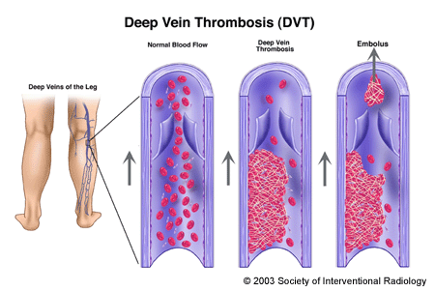
This diagram shows how the forming clot looks like, and how a piece broken off does as well. Here, they refer to it as an embolus.
How this condition occurs is generally through a lack of activity. Lack of movement allows for easier clotting, and the coagulation cascade to initiate. In pregnant women, this can be more common. This is due to the sudden inactivity, as well as the body’s way of protecting the mother from too much blood loss during labor. Since venous blood flows towards the heart, the rate of flow is much slower. This is caused by hormones secreted during pregnancy. Another reason why pregnant women are more prone to DVT is due to the pressure of the baby on the pelvis. The pressure on veins will cause for a greater chance in clotting. 1 in 1000 women experience this.
What happens on a more microscopic level is that platelets flowing through blood are signaled by vessel wall tears that house collagen and Von Wellebrand factor. VWF in association with factor 8 creates the signal for clotting. Without VWF, hemophilia or the lack of clotting can occur. The VWF protein however is a unique and formed through the endothelial cells, versus the hepatocytes which create most plasma proteins. The VWF flows through the blood looking for any vessel damage or the building of new vessel wall. Because the structure of VWF is very long and “sticky”, one multimer can attract multiple platelets. This attraction and bond is very strong, allowing for proper coagulation and repair. Platelets have a membrane glycoprotein receptor that can sense vessel damage in the extra cellular matrix. GP6 along with a few other receptors are important in allowing for the sensing of the contents of a damaged vessel wall, such as collagen and VWF. When VWF binds, it will bind to the GPIb-5-9 receptor glycoprotein complex, which creates a conformational change thus activating. This activation allows for fibrinogen or a glycoprotein called Factor I, made in the liver by hepatocytes, to bind to the platelet receptor GPII. Even without fibrinogen, platelets and VWF are joined because of the glycoprotein activation.
Glycoprotein 6 a 60kD platelet membrane GP induces collagen activation. Because collagen is one of the more thrombogenic fibers, platelet interaction is greater. Thrombogenicity relates to the ability of a substance in the blood stream to produce clots/ thrombus. Any damage to the vessel wall is an immediate contributor for a thrombus formation. Also GP Ia/IIa integrin complex is a receptor for the collagen. The structure is similar to VWF. There are cysteine-rich regions that interact with collagen and aggregate platelets. GPIIb/IIa interacts with fibrinogen and plays a more direct role with the aggregation of platelets on the damaged vessel wall. This GP complex has disulfide bridges as well as calcium dependent complexes and is sensed by fibrinogen receptors.
Fibrinogen’s structure is very large as well as soluble. It has three subunits on a thin fiber that stretch to 15A; 2 large ends and 1 smaller middle. With the help of the protease thrombin, fibrinogen is turned to fibrin, a fibrous protein. These fibrins polymerize to form clots with platelets. Zymogen prothrombin is first activated in the coagulation cascade by turning into thrombin. Platelets have thrombin receptors or PAR1/PAR3/PAR4(protease-activated receptor part of g-protein coupled receptor group). Thrombin is a serine protease which means the enzymes cleave peptide bonds where serine is the nucleophile at an enzyme’s active site. This will inherently deactivate them. The thrombin cleaves the N-terminus of the PAR receptors. The new N-terminus associated with a tethered ligand binds to another PAR receptor, which activates it. Fibrinogen that’s soluble converts to insoluble fibrin and attaches to platelets occurs through this receptor process. Factor 10 links fibrin together even more, to ensure decent repair. To measure Fibrinogen levels, venous or deoxygenated blood is studied. Citrated plasma samples are studied. The average level is around 1.5g/L. Higher levels include at least 3.43g/L. These may be the values in individuals facing DVT.
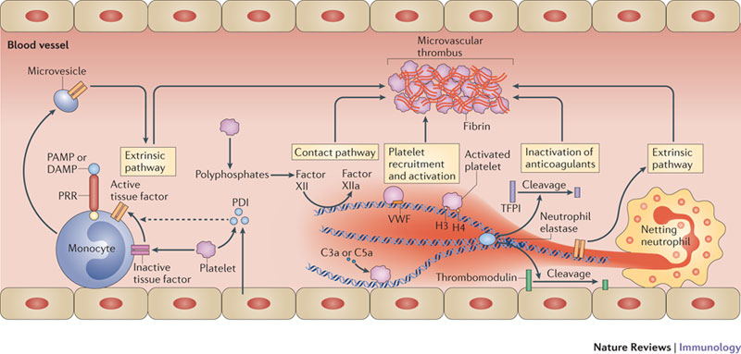
In the diagram, it shows when there is damage multiple units work together to create a thrombus. Monocytes will sense damage and initiate the cascade.
Thromboregulation is one way of regulating these clots. Mechanisms such as competitive inhibition/ negative feedback can slow clotting or completely stop it. Problems with regulation can cause either extreme; thrombosis or hemorrhaging.

Experiment

To test if pregnant mice with DVT can have a direct impact on the pups, the experiment would follow as so. To induce DVT, mothers would be fed a high fat diet around 60% of cholesterol in their food. Usually overweight individuals develop DVT easier than those of normal weight, so a high fat diet will be used. A low fat and no fat diet will also be used, to compare. Before that, the mice will be bred and separated by sex. As soon as they’re old enough to eat around 6 weeks, they’ll be fed the fat diet (only females). Then at around 12 weeks, breeding with a normal male occurs. Pups are extracted after a few weeks (12th day). The females should be measured for cholesterol levels, platelet levels, fibrinogen/hepatocyte levels before during and after pregnancy.
To measure fat levels and platelet levels, fibrinogen levels a blood test will be done. To measure if the mouse even has DVT, the inferior vena cava will be studied. The pups will have the same measurements taken.

Discussion
Why the mouse model is used, is due to its similarities to humans physiologically, and the rapid life cycle. The standard mouse model C57BL/6 (black mouse) is used. Thrombosis is then induced, to study the effects of the DVT. The big question was, do mothers have a direct effect on their offspring if they have clotting throughout their veins. Earlier, it was mentioned that because these are veins and not arteries, they have a more direct impact on the heart and cardiovascular system. This could create damage to the heart as well as other crucial organs. This in turn could create other damage to the offspring such as a lessened supply of nutrients or oxygen. But the direct effect that is hypothesized to happen is that they inherently have overactive hepatocytes and therefor and increased amount of fibrinogen flowing through their system. This is automatically an increase in risk for embolization.
Other methods that may work are perhaps studying certain glycoprotein levels such as GP6. Or measuring phospholipase C.
Problems that may occur from the methods above are especially with the vena cava. This is a fairly new technique and may give inaccurate results. In pups especially it is hard to measure.

In conclusion, there will most likely be some effect on the offspring. If it will be as direct as the increased levels in the units that cause coagulation is left up to the experiment to decide.

http://www.ncbi.nlm.nih.gov/pmc/articles/PMC150939/
http://www.bloodjournal.org/content/112/5/1549?sso-checked=true

