Michael Livingston

BPTF role in PI3K-AKT pathway in breast cancer
Intro

It is estimated that one in eight women will be diagnosed with breast cancer during their lifetime. Advances in therapies in the past few decades have led to improved survival rates, however, still more than 40,000 patients die from breast cancer annually in the USA. Cancer is a group of diseases characterized by normal cells acquiring tumor promoting traits, such as uncontrolled cell growth, avoiding detection by the immune system, and overriding DNA damage checkpoints. Avoiding antitumor immunity response requires cancerous cells to deregulate gene expression in part through epigenetic mechanisms such as chromatin remodelling. Chromatin remodeling is correlated with the control of gene expression by condensing DNA through changes in the position and occupancy of nucleosomes to regulate DNA access to transcriptional machinery proteins. There are specific protein complexes whose role it is to regulate chromatin structure, called nucleosome remodeling complexes.

These nucleosome remodeling complexes are diverse class of enzymes grouped into four families, SWI/SNF, ISWI, CHD, and INO80 sub-families, based on sequence homology of ATPase. Nucleosome remodeling complexes are largely controlled through interaction with specific ATPase subunits, which make the majority of the nucleosome remodeling complexes ATP-dependent. These nucleosome remodeling complexes are triggered by very specific ATPase subunits makes these enzymes potential novel therapeutic targets. One particular nucleosome remodeling complex, Nucleosome Remodeling Factor (NURF), part of the ISWI family has been well documented as a key ATP-dependent regulator for the development of many model organisms. The NURF complex consists of three subunits BPTF, SNFL, and RBAP46/48. In this research approach the focus will be on the the largest main subunit Bromodomain PHD finger transcription factor (BPTF), which is located on chromosome 17 and is 158,855 bases long. (SITE)

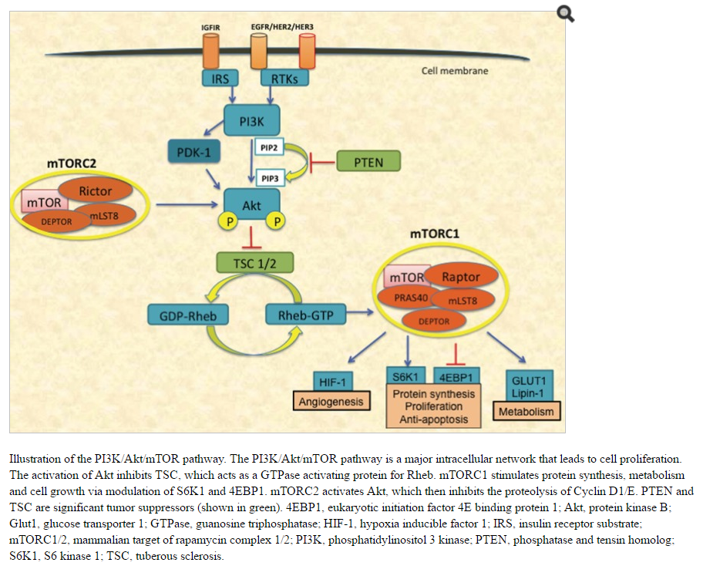
This subunit plays an important role in chromatin remodeling, but its functional role in tumor progression is incompletely understood. Dai et al (2015) examined the effects of BPTF on lung cancer proliferation and reported that BPTF regulates PI3K-AKT signaling pathway along with other cancerous pathways in lung cancer. (FIG) Phosphoinositide 3-kinase (PI3K) is a major signaling component downstream of growth factor receptor tyrosine kinases (RTKs) PI3K catalyzes the production of the lipid second messenger phosphatidylinositol-3,4,5-triphosphate (PIP3) at the cell membrane. PIP3 activates a wide range of downstream targets, including the serine-threonine protein kinase Akt .(FIG) The PI3K-Akt signaling pathway regulates many normal cellular processes including cell proliferation, survival, growth, motility, and metabolism —processes that are critical for tumorigenesis. (SITE) Dai et al (2015) tested the effects of BPTF on cancer proliferation by knocking down the gene, inserting the knockdown gene in lung cancer cell lines, and observed the expression of proteins related PI3K-AKT pathway.

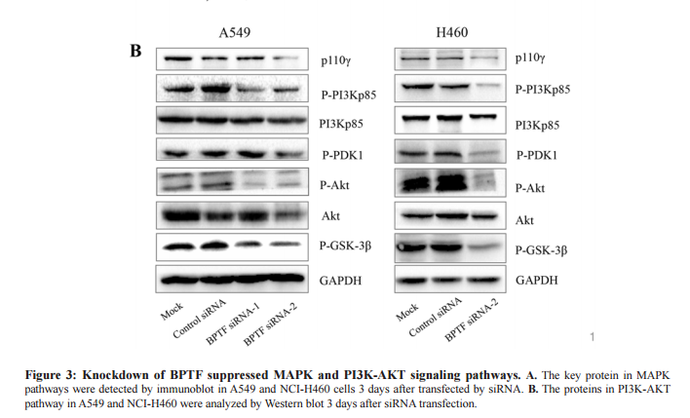
The gene’s were knocked down using short hairpin RNA (shRNA) which is an artificial RNA molecule with a tight hairpin turn that can be used to silence target gene expression via RNA interference (RNAi). The RNAi sequences used were: BPTF-siRNA-1 (BPTF-homo-1550): 5′-GGUCCAACUUGCAGAAUUATT-3′ and 5′-UAAUUC UGCAAGUUGGAC CTT-3′; BPTF-siRNA-2 (BPTF-homo-6959): 5′-GACCCA AACAACUGUUUCATT-3′ and 5′-UGAAACAGUUGUUUGGGUCTT-3′. These sequences were transiently transfected into tissue culture plates using Lipofectamine® RNAiMAX Transfection Reagent, which contain lipid subunits that can form liposomes in an aqueous environment. These liposomes enclose the siRNA and are able to cross a cell membrane due to the neutral co-lipid mediating fusion of the liposome with the cell membrane. The western blot shows a decreased expression in phospho-p85, p110γ, phospho-PDK1, phospho-Akt and phospho-GSK-3β proteins when the BPTF gene is knocked out (FIG). In this research approach a slightly different method to knockdown the BPTF will be explored.
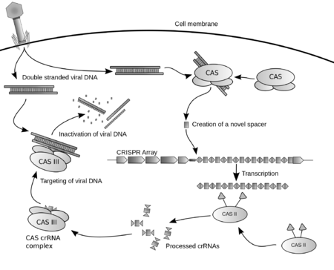
The CRISPR/Cas9 (Clustered regularly-interspaced short palindromic repeats) system is a state of the art genome editing tool that can efficiently knockout a specific gene, BPTF. The CRISPR/Cas9 system is a naturally occurring adaptive immune system in prokaryotic cells against invading bacteriophage DNA and other exogenous DNA. The CRISPR name refers to short palindromic repeats of DNA that are separated by the foreign DNA called “spacers”.This system works by recording foreign DNA sequences, targeting the sequence, and degrading the invading sequence so that the gene cannot be expressed (SITE). With just a guide RNA and a protein called Cas9, researches have shown that the CRISPR/Cas9 system can home in on and cleave a specific strand of DNA. This system has created a platform for researchers to edit genomic data and create novel molecular therapies for families in need. How will the knockout and overexpression of the BPTF gene affect expression of proteins related to the PI3K-AKT signaling pathway in normal and breast cancer cell lines?

Experiment

The aim of this experiment is determine if BPTF knockout and overexpression affects cancerous molecular pathway PI3K-AKT in breast cancer cell lines. I hypothesize that the knockout of BPTF will decrease the expression of proteins related to the PI3K-AKT pathway in breast cancer cell lines and the overexpression will result in an increase in proteins expressed related to PI3K-AKT pathway.

To use the CRISPR/Cas9 system a design strategy for a guide RNA (gRNA) must be created to target the BPTF gene. When choosing a target sequence for the leading DNA oligo the range of length should be from 19 to 20 nucleotides in length. It is vital that this oligo is adjacent to an AGG proto-spacer adjacent motif (PAM) sequence on the 3’ end of the target sequence, PAM is essential for target gene recognition. The gRNA should not contain significant homology to other genes, as this can increase off-target effects to unintended genes. A five base, GTTTT overhang sequence must be added to the 3’ ends of each top and bottom DNA oligos, needed for cloning. CHOPCHOP web tool was used to select the optimum target sites for CRISPR/Cas9 mutagenesis. The resulting sequence for targeting BPTF is AGAGGAGGACATGGTCTCCGAGG, located on chr17:65822200-65822222, and no predicted off targets for this guide sequence are reported (SITE). Once design of the target DNA oligos are finished they must be annealed and ligated into a CRISPR/Cas9 cloning vector.
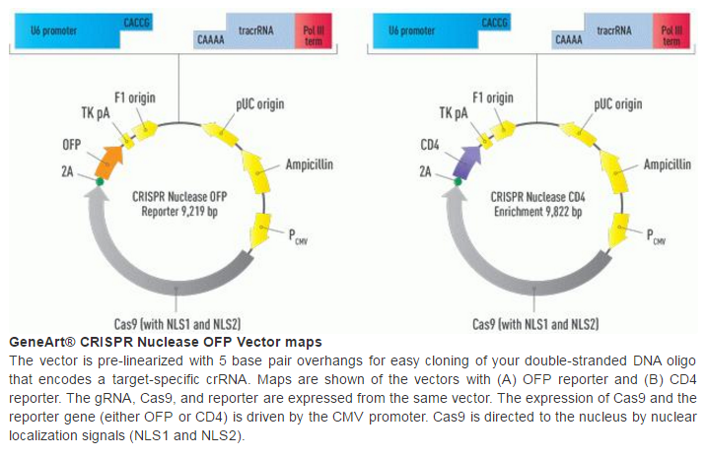
Plasmids are used to facilitate the cloning of the
guide sequence in the CRISPR/Cas9 cloning vector. E. coli plasmids are cleaved with restriction enzymes and the target DNA oligos are annealed together by first denaturing them by heating the strands and then slowly cool them. This process of nucleic acid thermodynamics joins the two DNA oligos together with high accuracy. The resulting double stranded DNA oligo are then ligated into the E. coli plasmids using T4 DNA ligase which produces recombinant DNA (Fig.1). The recombinant plasmids are then transferred into E. coli using electroporation. Electroporation uses mild pulses of electricity to disrupt the cell wall of E. coli and create small pores, the plasmids are small enough to pass through.

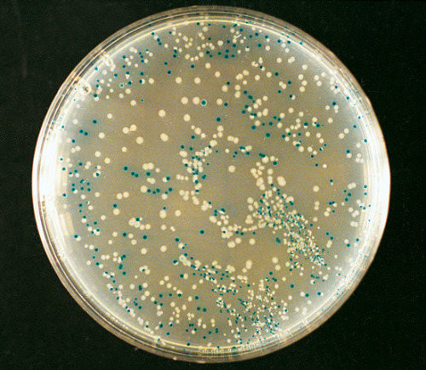
The colonies are then screened using amp^{R} (ampicillin resistance) gene in order to differentiate between colonies that have successfully taken in the recombinant plasmid (Fig.1). The recombinant E.coli are grown in neutral media petri dish then transferred to ampicillin media, only the cells with the amp^{R} gene will survive. Furthermore, the transformed cells containing the plasmid with the gene of interest can be distinguished from cells with the plasmid but without the gene of interest,
just by looking at the color of the colony they make on agar media supplemented with IPTG and X-gal. Recombinants are white, whereas non-recombinants are blue (Fig.3). After the recombinants are located a restriction digest process is used to cleave DNA sequence out to further screen using.

Amplified fragment length polymorphism (AFLP) can be used to make sure that the correct DNA sequence is chosen to knockout target BPTF gene in cell lines. This process is a PCR based tool and its measurements are highly sensitive. The measurements are not based upon length but rather by presence-absence of form (SITE). This will allow for visualization of any varying DNA which can be sequenced to make sure the correct DNA sequence is chosen to knockout BPTF. AFLP starts by selective amplification of targeted DNA fragments with two PCR primers that have corresponding adaptor and restriction site specific sequences. Followed by electrophoretic separation on a gel matrix, results can be visualisation of the band pattern or by graphically. After the correct sequence is chosen the Cas9/gRNA plasmid vector are packaged into adenovirus and are introduced to cell lines to infect the host cell line’s genome, the DNA is integrated into the the host genome by homologous recombination. This packaged viral transfection method is used to observe knockout and overexpression in cell lines. In order to observe overexpression of BPTF, promoter cytomegalovirus (CMV) is used to drive gene expression. After normal, knockout, and overexpression cell lines mature we can analyze the proteins that were expressed using Western blot (Immunoblotting).
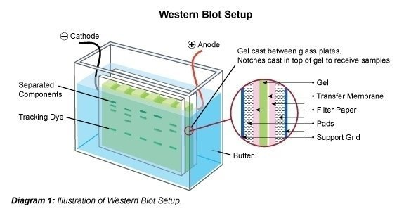
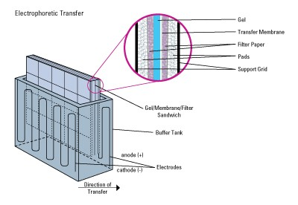
Immunoblotting procedure will analyze individual proteins expressed by the cell lines. The protein mixture obtained from cell lines are separated using sodium dodecyl sulfate polyacrylamide gel electrophoresis (SDS-PAGE) sorting proteins primarily by size. The proteins are loaded into the polyacrylamide gel and exposed to an extended period of electrical flow (Fig). The movement of proteins are facilitated by SDS buffer which denatures and binds to proteins to make them evenly negatively charged, proteins then move through the gel toward the positively charged cathode. Smaller proteins travel more quickly through the gel than larger proteins because of the pore size of the gel, which can be manipulated. Following electrophoresis, the protein are electrophoretically transferred again but this time from the gel to a nitrocellulose membrane, a matrix used in protein blotting because of its high protein-binding affinity.

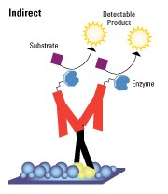
When an electric field is applied, the proteins move out of the polyacrylamide gel and onto the surface of the nitrocellulose membrane, where the proteins become tightly attached. After the proteins have been transferred to a secondary matrix antibodies that target specific proteins can be introduced to analyze the degree of expression of proteins by the various cell lines. BPTF Antibody-2F10 (Thermofisher, USA) and Phospho-AKT pathway antibodies can be purchased to detect there specific proteins, a key characteristic for antibodies. Most primary antibodies are unreadable, therefore indirect detection can be implemented where tagged secondary antibodies are introduced and bind with the primary antibodies to help visualize the expression of proteins (Fig.3). Visualization occurs through chemiluminescence detection, this is when a chemical substrate is catalyzed by an enzyme, HRP, and produces light as a by-product (FIG). The light signal can be captured on X-ray film. Proteins phospho-p85, p110γ, phospho-PDK1, phospho-Akt and phospho-GSK-3β will be targeted due to their strong connection with the PI3K-AKT pathway.

Discussion

As the largest unit of NURF, BPTF plays a role in chromatin remodelling which is a key factor in gene expression. In many cases normal cells transition into cancerous cells in part due to abnormal gene expression. Over the past decades chromatin remodeling complexes have been shown to establish and maintain abnormal gene expression in cancerous cells (SITE). In addition, with so many cancerous genomes being sequenced it has been found that subunits of chromatin remodeling complexes are frequently mutated in in cancer, suggesting that these mutations can drive cancerous phenotypes. In this research proposal the BPTF subunit is investigated and its relationship with known cancerous pathway PI3K-AKT.

Dai et al (2015) found that BPTF significantly promoted cell cell proliferation by regulating the PI3K-AKT pathway in lung cancer. I proposed to do a similar experiment, but, in breast cancer.
- Limitations

- The experiment is possible based off of previous results and methods
- Cell line and Western blot methods are tedious processes so screening as outlined should be done to ensure good results.
- Because only a subset of the cellular processes regulated by the PI3K-Akt pathway are involved in tumorigenesis, the choice of drug targets must take into account the adverse effects resulting from the inhibition of other PI3K-Akt-dependent cellular processes. For example, insulin's effects on metabolism are mediated through the PI3K-Akt pathway(Saltiel and Kahn, 2001): inhibitors of PI3K or Akt are therefore likely to perturb glucose homeostasis. It would be desirable, therefore, to target components of branches further downstream in the PI3K-Akt pathway, such as mTOR, Bad

Chromatin remodeling complexes have great potential to become novel targets for cancer targeted therapies. We must fully understand the mechanisms that are affected by targeting these complexes such as PI3K-Akt pathway in order to benefit humans.

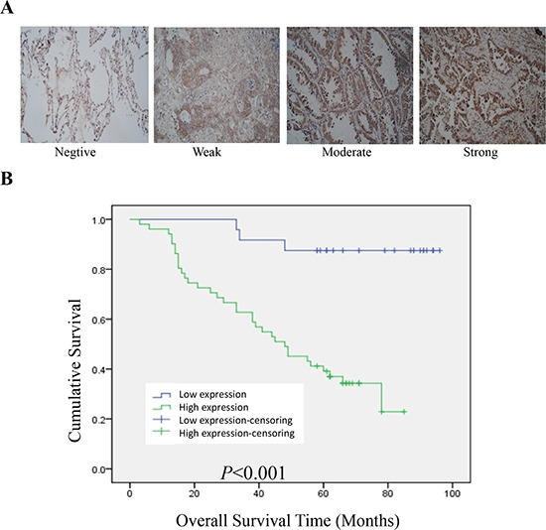
6A. Examples for negative, weak, moderate and strong BPTF expression in lung adenocarcinoma tissues.
- 6B. Results show that high expression of BPTF is negatively associated with the overall a survival, indicating that BPTF predicts a poor prognosis in lung adenocarcinomas.
- I like this figure, would is be appropriate to use in discussion?

References

Tessa G. Montague; Jose M. Cruz; James A. Gagnon; George M. Church; Eivind Valen. (2014). CHOPCHOP: a CRISPR/Cas9 and TALEN web tool for genome editing. Nucleic Acids Res. 42. W401-W407

- "GeneArt CRISPR Products and Services." Thermo Fisher Scientific. N.p., n.d. Web. 30 Apr. 2016.

- Luo, Ji, Brendan D. Manning, and Lewis C. Cantley. "Targeting the PI3K-Akt pathway in human cancer: rationale and promise." Cancer cell 4.4 (2003): 257-262.

- Vos, Pieter, et al. "AFLP: a new technique for DNA fingerprinting." Nucleic acids research 23.21 (1995): 4407-4414.

- Liu, B., Yip, R. K., & Zhou, Z. (2012). Chromatin Remodeling, DNA Damage Repair and Aging. Current Genomics, 13(7), 533–547. http://doi.org/10.2174/138920212803251373

- Raab, J. R., Resnick, S., & Magnuson, T. (2015). Genome-Wide Transcriptional Regulation Mediated by Biochemically Distinct SWI/SNF Complexes. PLoS Genet, 11(12), e1005748.

- -Kim, K. H., Kim, W., Howard, T. P., Vazquez, F., Tsherniak, A., Wu, J. N., ... & Orkin, S. H. (2015). SWI/SNF-mutant cancers depend on catalytic and non-catalytic activity of EZH2. Nature medicine, 21(12), 1491-1496.

- ATP-dependent chromatin remodeling complexes as novel targets for cancer therapy Mayes, Kimberly ; Qiu, Zhijun ; Alhazmi, Aiman ; Landry, Joseph W Advances in cancer research, 2014, Vol.121, pp.183-233

- The Nucleosome Remodeling Factor. Alkhatib, Suehyb G. ; Landry, Joseph W.
FEBS Letters, 2011, Vol.585(20), pp.3197-3207

- Examination of Epigenetic and other Molecular Factors Associated with mda-9/Syntenin Dysregulation in Cancer Through Integrated Analyses of Public Genomic Datasets Bacolod, Manny D ; Das, Swadesh K ; Sokhi, Upneet K ; Bradley, Steven ; Fenstermacher, David A ; Pellecchia, Maurizio ; Emdad, Luni ; Sarkar, Devanand ; Fisher, Paul B. Advances in cancer research, 2015, Vol.127, pp.49-121

- Landry, J. W., Banerjee, S., Taylor, B., Aplan, P. D., Singer, A., & Wu, C. (2011). Chromatin remodeling complex NURF regulates thymocyte maturation. Genes & development, 25(3), 275-286.

- Wang, G. G., Allis, C. D., & Chi, P. (2007). Chromatin remodeling and cancer, Part I: Covalent histone modifications. Trends in molecular medicine, 13(9), 363-372

- Carré, Clément, et al. "The Drosophila NURF remodelling and the ATAC histone acetylase complexes functionally interact and are required for global chromosome organization." EMBO reports 9.2 (2008): 187-192.

- Li, Haitao, et al. "Molecular basis for site-specific read-out of histone H3K4me3 by the BPTF PHD finger of NURF." Nature 442.7098 (2006): 91-95.

