Bryce Kirby
BNFO 300
May 1, 2016
Inhibition of the p53 tumor suppressor by MDM2 and the role miRNA plays in p53 gene expression and regulation
Introduction
The p53 tumor suppressor
The p53 gene is a highly specialized protein designated with preventing cancerous tumor growth in cells. The P53 protein is classified as a tumor suppressor and is tasked with keeping the genomic stability of cells by inducing apoptosis and cell cycle arrest in cancerous cells (Frum, 2014). A key characteristic of the p53 gene is its susceptibility to genetic mutation, these mutations can either be germline (passed genetically) or acquired through genetic damage, like exposure to UV radiation or old age (Freed-Pastor, 2012). P53 mutations are “acquired” and the most common “gene-specific” alterations in found in human cancers. P53 can typically attain “gain-of-function” “loss-of-function” characteristics when mutated, usual outcomes include tumor progression and an increased resistance to anti-cancer drugs (Oren and Rotter, 2010).
MDM2 regulation
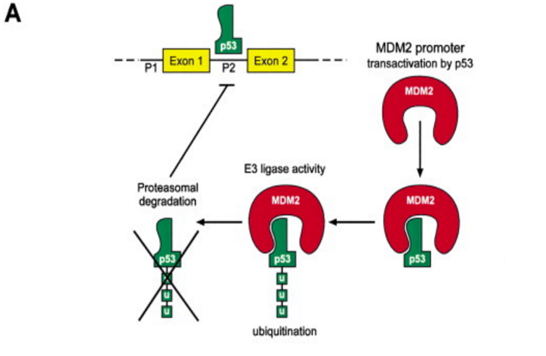
The functional and transcriptional activity of p53 is commonly inhibited by an oncoprotein known as MDM2. MDM2 is known as a negative regulator of p53 and responsible for cancer progression by deactivating p53. p53 essentially activates the transcription of MDM2 by upregulation (Ren, 2014). Furthermore, MDM2 operates as an E3 ubiquitin-protein ligase, this means it binds to its target (p53 protein) through an E3 enzyme complex due to transcriptional recognition on the N-terminal domain on the polypeptide chain. In essence, the ubiquitin proteins are loaded into the E3 complex to signal protein degradtion in order to deactivate the transcription p53 proteins by the cell (Bartel, 2002).
Figure 1: MDMDMDMDMDMDMDMDMDMDMD This model shows how MDM2 and p53 interact. p53 activates transcription of MDM2. MDM2 then binds to p53 and acts as an E3 ubiquitin ligase. The ligase then targets p53 for degradation thus inhibiting its own transcription (Bartel, 2002).
The miRNA molecule
MicroRNAs exist as small non-coding RNAs involved in regulatory processes in cancer initiation and development. In order to combat the detrimental effects of MDM2 on the transcriptional activity of p53 the use of miRNAs has been observed to deactivate MDM2 entirely. Relative to p53 mutation, degradation and cancer growth in cells, miRNAs are typically used for post transcriptional regulation of p53’s gene expression (Fortunato, 2014). For all intents and purposes this means they are able to alter deactivated or mutated p53 and restore their tumor suppressor functionality in cells. MicroRNAs in relation to p53 regulation operate by binding to the 3’ untranslated region on the MDM2 messenger RNA, at this location they have the functionality to suppress protein synthesis or initiate the messenger RNA to degrade (Jansson, 2015).
Key questions in consideration:
Does p53 loss of function by MDM2 degradation cause a certain type of cancer over another relative to the effectiveness of certain types of miRNA?
Is lung cancer more prominent over colorectal cancer in the case of miRNA regulation of MDM2?

Experiment
In question are the specific effects of miRNA-1827 studied in the experimental proposed by (Zheng, 2016); they aimed to specifically target MDM2 directly by binding miRNA-1827 to the untranslated region of the 3’ end of the MDM2 E3 ubiquitin protein ligase. The procedure aims to down regulate MDM2 activity by the use of miRNA-1827 in colorectal cancer cells. This experimental procedure will follow the same guidelines as those presented in (Zheng, 2016) as well as excerpts from (Brighenti, 2015). To investigate the ability of miRNA-1827 to bind to
MDM2, two human cell lines are used, wild type human colorectal HCT116 p53 +/+ and RKO p53 +/+ also in accordance, mutant p53 -/- along with a miRNA control group containing wild type p53 are also included. In order to obtain direct evidence of miRNA-1827 interaction with MDM2, pull down assays tagged with biotinylated miRNA-1827(biotin: water soluble B vitamin attached to miRNA) were performed. The levels of MDM2 mRNAs that bind to the biotinylated wild-type, mutant and control miRNA-1827s are displayed in Figure 2. This figure serves to reiterate the fact that MDM2 mRNAs were significantly enriched in the miRNA-1827 pull down assay for both the HCT116 +/+ and RKO +/+ p53 cells.

Materials and Methods
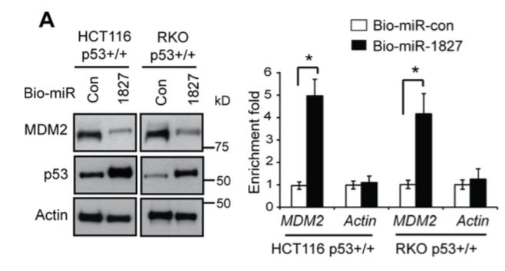
The HCT116 p53 +/+, -/- , RKO p53 +/+, -/- and control cells will be obtained from the American Type Culture Collection. These cells will be transfected with the previously described biotinylated miRNA-1827/miRNA-1827 control by the use of Lipofectamine 2000, a transfection agent. Transfection will take place for approximately 24 hours where the cells will be harvested in a lysis buffer containing 20mM Tris, 100 mM KCl, and 5mM MgCl2 solutions, along with a 0.3% detergent concentration of NP-40. The lysates produced from this process will then be added to Invitrogen branded Streptavidin Dynobeads (bacterial derived biotin binding proteins) and incubated at 4 °C for about 4 hours. The procedure will cause RNAs from the solution to bind to the Streptavidin beads, at this point the RNAs produced will be extracted using the RNA extraction chemical Trizol. Conclusively, the MDM2 mRNA levels will be analyzed by Taqman real-time PCR assays (Zheng, 2016).
Figure 2: miR-1827 regulates MDM2 through binding to the 3ʹ-UTR of MDM2
(A) miR-1827 bound to MDM2 mRNA in cells detected by miRNA pull-down assays. HCT116 p53+/+ and RKO p53+/+ cells were transfected with biotinylated miR-1827 (bio-miR-1827) or biotinylated miR-control (bio-miR-con), and collected at 24 h after transfection for miRNA pull-down assays. The levels of MDM2 and Actin mRNAs bound to bio-miR-1827 or bio-miR-con were analyzed by Taqman real-time PCR assays. The mRNA levels were normalized to input (cellular RNA without incubation with beads) and then to GAPDH. Left panels: The down-regulation of MDM2 and up-regulation of p53 by bio-miR-1827 in cells detected by western-blot assays. Right panel: the enrichment fold with bio-miR-1827 relative to bio-miR-con for MDM2 and Actin mRNA.
(Zheng, 2016).

Discussion
P53 has the ability to monitor the expression of various target genes greatly involved in activities like DNA repair, apoptosis and cell cycle arrest. In addition to protein-coding genes, p53 is also involved in the expression of miRNAs like miR-34 to combat protein complexes like MDM2 (Zhou, 2014). In recent studies difficulties involving miRNAs have been observed, it was shown that the expression of 19 different miRNAs in HeLa cells performed through experimentation by (Ren, 2014) have been variously regulated, 10 having been successfully up regulated and 9 down regulated. Further results based on this outcome presented in (Ren, 2014) have surmised that certain miRNAs may possibly be involved in cancer cell development.

The explanation that miRNAs may be involved in cancer development creates a massive impression on which types of miRNAs are best for down regulating MDM2 in wild and mutant type p53. In the experimental procedure from (Zheng, 2016) certain limitations involving other miRNAs may be encountered and hindrances effecting MDM2 expression might occur in future endeavors.
References
Bartel, Frank, Helge Taubert, and Linda C. Harris. "Alternative and Aberrant Splicing of MDM2 MRNA in Human Cancer." Cancer Cell 2.1 (2002): 9-15. Web.

Brighenti M. MicroRNA and MET in lung cancer. Ann Transl Med 2015; 3(5):68. doi: 10.3978

Dar, Altaf A., Shahana Majid, David De Semir, Vladimir Bezrookove, Mehdi Nosrati, and Mohammed Kashani-Sabet. "Abstract 3065: The Role of MiR-18b in MDM2-p53 Pathway Signaling and Melanoma Progression." Cancer Research Cancer Res 73.8 Supplement (2013): 3065. Web.
Fornari, F., M. Milazzo, M. Galassi, E. Callegari, A. Veronese, H. Miyaaki, S. Sabbioni, V. Mantovani, E. Marasco, P. Chieco, M. Negrini, L. Bolondi, and L. Gramantieri. "P53/mdm2 Feedback Loop Sustains MiR-221 Expression and Dictates the Response to Anticancer Treatments in Hepatocellular Carcinoma." Molecular Cancer Research 12.2 (2013): 203-16. Web.
Fortunato, O., M. Boeri, M. Moro, C. Verri, M. Mensah, D. Conte, L. Caleca, L. Roz, U. Pastorino, and G. Sozzi. "Mir-660 Is Downregulated in Lung Cancer Patients and Its Replacement Inhibits Lung Tumorigenesis by Targeting MDM2-p53 Interaction." Cell Death Dis Cell Death and Disease 5.12 (2014): 1-9. Web.
Frum, R., Grossman, S., 2014. Mechanisms of mutant p53 stabilization in cancer. Subcell Biochem. (85): 187-97. http://www.ncbi.nlm.nih.gov/pubmed/25201195
Freed-Pastor, W. A., and C. Prives. "Mutant P53: One Name, Many Proteins."Genes & Development 26.12 (2012): 1268-286. Web.
Grossman, S., Vaughan, C., et al. 2012. Gain-of-Function Activity of Mutant p53 in Lung Cancer through Up-Regulation of Receptor Protein Tyrosine Kinase Axl. Genes Cancer 3(7-8): 491–502. http://gan.sagepub.com/content/3/7-8/491.short
Huang, Kai, Yuxin Tang, Leye He, and Yingbo Dai. "MicroRNA-340 Inhibits Prostate Cancer Cell Proliferation and Metastasis by Targeting the MDM2-p53 Pathway." Oncology Reports Oncol Rep 35.2 (2015): 887-95. Web.
Jansson, M. D., N. D. Damas, M. Lees, A. Jacobsen, and A. H. Lund. "MiR-339-5p Regulates the P53 Tumor-suppressor Pathway by Targeting MDM2." Oncogene 34.15 (2014): 1908-918. Web.
Li, Liang, and Binquan Wang. "Overexpression of MicroRNA-30b Improves Adenovirus-Mediated P53 Cancer Gene Therapy for Laryngeal Carcinoma." IJMS International Journal of Molecular Sciences 15.11 (2014): 19729-9740. Web.
Mei, Qian, Xiang Li, Mingzhou Guo, Xiaobing Fu, and Weidong Han. "The MiRNA Network: Micro-regulator of Cell Signaling in Cancer." Expert Review of Anticancer Therapy 14.12 (2014): 1515-527. Web.

Oren, M., and V. Rotter. "Mutant P53 Gain-of-Function in Cancer." Cold Spring Harbor Perspectives in Biology 2.2 (2009). Web.
Ren, Z-J, X-Y Nong, Y-R Lv, H-H Sun, P-P An, F. Wang, X. Li, M. Liu, and H. Tang. "Mir-509-5p Joins the Mdm2/p53 Feedback Loop and Regulates Cancer Cell Growth." Cell Death Dis Cell Death and Disease 5.8 (2014). Web.
Wang, Y., J.-W. Huang, M. Castella, D. G. Huntsman, and T. Taniguchi. "P53 Is Positively Regulated by MiR-542-3p." Cancer Research 74.12 (2014): 3218-227. Web.
Zhang, Cen, Juan Liu, Xiaolong Wang, Rui Wu, Meihua Lin, Saurabh V. Laddha, Qifeng Yang, Chang S. Chan, and Zhaohui Feng. "MicroRNA-339-5p Inhibits Colorectal Tumorigenesis through Regulation of the MDM2/p53 Signaling." Oncotarget 5.19 (2014): 9106-117. Web.
Zheng, Cen, et. al. "MicroRNA-1827 Represses MDM2 to Positively Regulate Tumor Suppressor P53 and Suppress Tumorigenesis." Oncotarget 7.8 (2016): 1-14. Web.
Zhou, Chun-Hong, Xiao-Peng Zhang, Feng Liu, and Wei Wang. "Involvement of MiR-605 and MiR-34a in the DNA Damage Response Promotes Apoptosis Induction." Biophysical Journal 106.8 (2014): 1792-800. Web.
Li, D., N. D. Marchenko, R. Schulz, V. Fischer, T. Velasco-Hernandez, F. Talos, and U. M. Moll. "Functional Inactivation of Endogenous MDM2 and CHIP by HSP90 Causes Aberrant Stabilization of Mutant P53 in Human Cancer Cells." Molecular Cancer Research 9.5 (2011): 577-88. Web.

