Can Apis Mellifera develop resistance to sub-lethal doses of cyano-substitued Neonicotinoids?
- Neonicotinoid’s and their role in Colony Collapse Disorder
Neonicotinoid pesticides are an agonist for the Nicotinic Acetylcholine receptors (nAChRs) in insects. Their use has been very effective at combatting common agricultural pests, however they have had the unintended effect of harming populations of Apis Mellifera (honey bee) through mortality in large doses, and impaired motor function and memory in smaller doses (Gauthier, 2010). This is because nAChR’s are receptors involved in the chemical juncture between nerve cells. They are a form of ion channel that facilitates movement of Ca2+, K+, and Na+ across the cellular membrane, and then through the synaptic cleft to continue transmission of the action potential (Thany et al, 2007). Currently, through industrial scale agriculture many bees are exposed to sub-lethal amounts of these pesticides that are inadvertently spread to nearby food sources. As workers are exposed, they begin to experience impaired motor function and memory. They bring contaminated food to the hive, and it is spread throughout (Suchail et al, 2001). As explained by Dr. Dyer and Dr. Could in their paper, “Honey Bee Navigation”, workers often rely on remembered landmarks when returning to the hive from a food source, especially when the sun is unavailable for geolocation (1983). When enough workers are too badly impaired to return, the colony collapses; neonicotinoid pesticides are one of the leading causes of colony collapse disorder (CCD). Although these chemicals are always going to affect insects that they come in contact with, they can be optimized to minimize unintended effects to bystander populations.
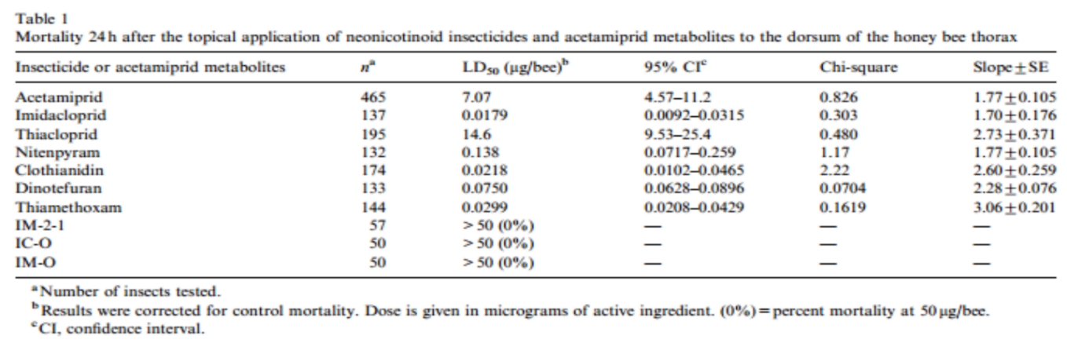
- Cyano vs. Nitro-substituted Neonicotinoid’s effect on Apis Mellifera
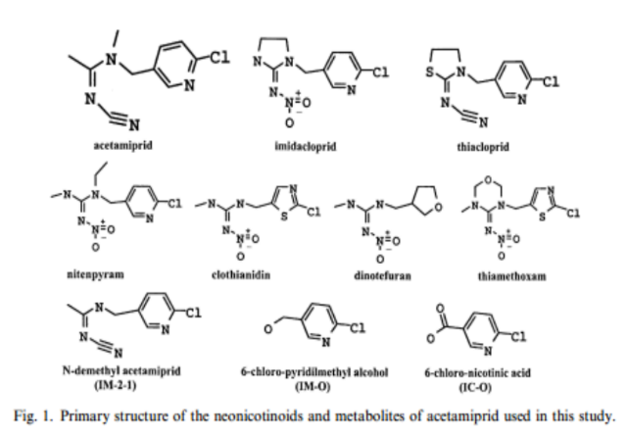
As shown in Table 1 above (Iwasa et al, 2004), Acetamiprid and Thiacloprid were only lethal when administered at a much higher dose than the rest of the compounds. The main difference shown between these two compounds and the other 5 insecticides pictured in the Figure 1 (Iwasa et al, 2004) is the change on the N-terminus end from a nitro-substituted group to a cyano-substituted. In another study, Yamada et al found that the nAChR’s of honey bee and house fly receptors have similar structural affinity to Acetamiprid, which makes it unlikely that the decreased toxicity shown only in honey bees is caused by the structure of the binding site (1999). Rather, it is most likely produced by the three metabolites shown in Figure 1, which all greatly increased the dose needed to make the pesticide lethal.
- nAChR affinity and developed resistance to Imidacloprid by Drosophilia
In their experiment, "Exploring the Pharmacological Properties of Insect Nicotinic Acetylcholine Receptors.", Thany et al isolated nAChR alpha subunits from 6 species of insects and then paired with well understood vertebrate Beta subunits and vice-versa (2007). However, when vertebrate alpha subunits were used no affinity was found, regardless of the beta subunit paired. As vertebrates are known to have no affinity to neonicotinoids, this result isolates determination of affinity to the alpha subunit. Insect-alpha hybrid receptors were then exposed to various receptor agonists and antagonists to see which parts of the alpha subunit’s protein determines the molecular attraction.
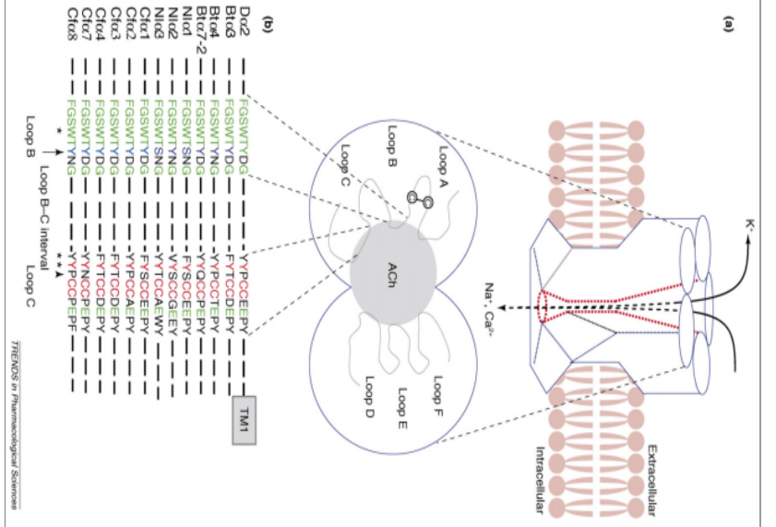
Imidacloprid is not only the most common nitro-substituted neonicotinoid, but also the most common pesticide used globally. It binds to insect nACh receptors by an Imidazoline ring (Suchail et al, 2001). When preforming their experiment mentioned earlier, Shimomura et al tested the response to Imidacloprid from Drosophila-Chicken hybrid Da1-B2 and Da2-B2 receptors, Da2-B2 was activated and Da1-B2 was not. This revealed that resistance and also increased affinity to Imidacloprid can be developed by changes to the alpha subunit (leftmost expanded section in Figure 2). As shown in the diagram, the main binding sites on the alpha subunit are two sequences of nucleotides on the edge of loops B and C. After further investigation through imposed mutations oDrosophila, Thany et al concluded that the base change of proline at position 242 (Arrowhead on Loop C sequence, Figure 2) to glutamic acid (P242E) on the Da2 subunit caused a increase in affinity of the receptor, subunits Bta4, Cfa2, and Cfa8 also contain proline at position 242. By comparing a subunits cloned from resistant subunits, Thany et al were able to conclude that a unique mutation of conserved tyrosine to serine in loop B from Nla1 and Nla3 subunits confers resistance to Imidacloprid, this is marked by the arrow on the loop B binding site.
Figure. 2

- Experimental Outline and Proposal
Although cyano-substituted pesticides are much less harmful to bee populations than their nitro-substituted counterparts because of the metabolic effect mentioned earlier, they still impair memory and motor skills in sub-lethal quantities (Gauthier, 2010). I have found that there is also much less research on these compounds as compared to the nitro-substituted class. One possible cause is that Acetamiprid was first registered with the EPA in 2002, much later than Imidacloprid which was originally patented in 1988. As shown in Figure 1 above, the cyano-substituted Neonicotinoids do not contain the imidazoline ring which is the main agonist of the honey bee’s nAChR, however it still harms the bee in a similar manner. I want to explore whether Acetamiprid resistance and affinity are developed by the same mutations that result in Imidacloprid’s effects. Similar to Thany et al, I plan to use Drosophila receptor proteins for my experiment. As stated earlier, Drosophila have similar nAChR affinity to Acetamiprid as Apis Mellifera (Yamada et al, 1999). Protein alpha subunits will be combined with vertebrate beta subunits as done by Shimomura et al, I will test Acetamiprid affinity to all insect subunits through voltage clamp electrophysiology and the methods laid out by Ihara et al. I hypothesize mutant proteins that contain resistance towards Imidacloprid will not effect the affinity of the receptor to Acetamiprid. If this hypothesis holds true, I can propose that Acetamiprid affinity is determined differently than that of Imidacloprid due to the lack of the imidazoline ring which is the primary binding site for Imidacloprid. Once results are received, I can compare the different structures on the binding sites of loops B and C to look for patterns that could result in Acetamiprid affinity and/or resistance.
  - Overview of experiment
    - Test affinity of Imidacloprid and Acetamiprid on multiple mutated forms of Drosophilia Nicotinic receptors.
    - Acetamiprid affinity will not be effected by mutations that cause Imidacloprid resistance as it does not contain the Imidazoline binding site.
  - Preparation of Mutant a7 subunits (Shimomura et al, 2002)
    - Drosophila nicotinic a7 subunits prepared in plasmid will be used as a template.
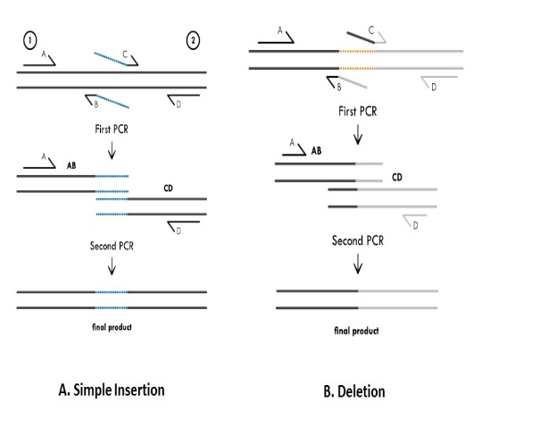
    - Mutations will be introduced using PCR based mutagenesis.
      - 4 primers are necessary –
          - A and D primers: complementary to the ends of the target sequence.
          - B and C: contain desired mutation – replace original binding sites.
      - The mutation occurs in 2 steps. First, after the introduction of all 4 primers the AB and CD strands are created. These product strands are mixed with primers A and D for a second round of PCR to finish hybridization. The final product contains the mutated binding site that was introduced by the complementary AB primers.
    - I will create replicas of the subunits Bta4, Cfa2, Cfa8, Nla1 and Nla3, among others, to study the effects of 2 specific mutations in the alpha subunit.
      - I specifically want to assess the effects of the Proline to Glutamic Acid mutation in loop C and Tyrosine to Serine mutation in loop B on Acetamiprid resistance.
  - Nuclear Injection of Oocytes (Shimomura et al, 2002) (Ihara et al, 2002) (Rudy and Iverson, 1992)
    - Mature Xenopus Laevis Females will be anaesthetized by immersion in 1.5g I⁻¹ tricaine for 30 minutes. Afterwards they will be cut open and larger Oocytes (stage IV and V) will be removed.
    - Follicle cell layer of each Oocyte must be removed manually by fine forceps
    - The nucleus of each Oocyte will be injected with 20 nL of a single form of mutant DNA submersed in distilled water, which will then be incubated at 16°C in saline solution.
  - Voltage Clamp Electrophysiology (Ihara et al, 2002) (Rudy and Iverson, 1992)
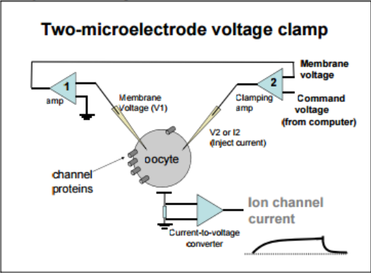
    - Electrophysiology will be performed after 3-6 days of incubation.
    - 2 clamps will be attached to form a series current. A constant voltage will be maintained throughout the Oocyte cell by injecting current through one clamp.
    - Solutions of Nicotine (control), Imidacloprid, and Acetamiprid will be prepared for testing.
    - When one of these solutions is introduced, it should initiate opening of the nAChR which will change the current running through the cell. This change can be recorded and accurately monitored by a receiver. The one mentioned in the procedure of Rudy and Iverson is a Geneclamp 500.

Bibliography:
Dyer, Fred C., and James L. Could. “Honey Bee Navigation: The Honey Bee's Ability to Find Its Way Depends on a Hierarchy of Sophisticated Orientation Mechanisms”. American Scientist 71.6 (1983): 587–597. Web. http://www.jstor.org/stable/27852344?seq=1#page_scan_tab_contents.
Gauthier, Monique. "State of the Art on Insect Nicotinic Acetylcholine Receptor Function in Learning and Memory." Advances in Experimental Medicine and Biology Insect Nicotinic Acetylcholine Receptors (2010): 97-115. Springer. Web. https://www.researchgate.net/profile/Monique_Gauthier/publication/45950074_State_of_the_art_on_insect_nicotinic_acetylcholine_receptor_function_in_learning_and_memory/links/0c96053a5918baeabf000000.pdf.
Ihara, Makoto, Masaru Shimomura, Morihiko Kuwamura, Miki Akamatsu, David B. Sattelle, Kazuhiko Matsuda, Maiko Otake, and Valerie Raymond. "A Single Amino Acid Polymorphism in the Drosophila Melanogaster Dα1 (ALS) Subunit Enhances Neonicotinoid Efficacy at Dα1-chicken β2 Hybrid Nicotinic Acetylcholine Receptor Expressed in Xenopus Laevis Oocytes." Neuropharmachology 45.1 (2003): 133-44. Web. http://www.sciencedirect.com/science/article/pii/S0028390803001345.
Iwasa, Takao, Naoki Motoyama, John T. Ambrose, and R.michael Roe. "Mechanism for the Differential Toxicity of Neonicotinoid Insecticides in the Honey Bee, Apis Mellifera." Crop Protection 23.5 (2004): 371-78.Elsevier. Web. http://www.farmlandbirds.net/sites/default/files/Iwasa2004.pdf.
Methods in Enzymology. Volume 207 ION CHANNELS. Bernardo Rudy and Linda Iverson, eds. Academic Press, 1992. (Section IIA. Expression of ion channels in Xenopus oocytes). pp 225-390. http://www.sci.utah.edu/~macleod/bioen/be6003/labnotes/W05-voltage-clamp-lab
Shimomura, Masaru, Hiroshi Okuda, Kazuhiko Matsuda, Koichiro Komai, Miki Akamatsu, and David B. Sattelle. "Effects of Mutations of a Glutamine Residue in Loop D of the α7 Nicotinic Acetylcholine Receptor on Agonist Profiles for Neonicotinoid Insecticides and Related Ligands."British Journal of Pharmacology 137.2 (2002): 162-69. Web. http://onlinelibrary.wiley.com/doi/10.1038/sj.bjp.0704848/full.P
Suchail, Severine, David Guez, and Luc P. Belzunces. "Discrepancy between Acute and Chronic Toxicity Induced by Imidacloprid and Its Metabolites in Apis Mellifera." Environmental Toxicology and Chemistry20.11 (2001): 2482-486. Wiley Online Library. Web. http://onlinelibrary.wiley.com/doi/10.1002/etc.5620201113/abstract.
Thany, Steeve H., Guy Lenaers, Valérie Raymond-Delpech, David B. Sattelle, and Bruno Lapied. "Exploring the Pharmacological Properties of Insect Nicotinic Acetylcholine Receptors." Trends in Pharmacological Sciences 28.1 (2007): 14-22. Clinical Key. Web. https://www.clinicalkey.com/#!/content/playTesContent/1-s2.0-S0165614706002719?returnurl=null&referrer=null.
Yamada,T.,Takahashi,H.,Hatano,R.,1999. A novel insecticide, acetamiprid. In: Yamamoto,I.,Casida,J.E. (Eds.),Nicotinoid Insecticides and the Nicotinic Acetylcholine Receptor. Springer, Tokyo,pp. 149–176.

