Epigenetic Effects of the Krüppel-Like Transcription Factor 1 on DNA Methylation
Introduction
Red blood cells are the most common cell type in the human body, and play a crucial role in embryonic development. So the proper development of these cells is of interest in scientific research. Krüppel-like Transcription Factor 1 (KLF1) is a Zinc fingered transcription factor necessary for the maturation of erythroid cells (red blood cells) (fig. 1). KLF1’s role in erythroid maturation makes the protein important for proper embryonic development. This proposal will investigate how different ratios of KLF1 is able to change the epigenome in embryonic development by changing the levels of the KLF1 protein during embryonic development, using gene knock out, and examining the changes epigenetic changes in DNA methylation.
Other studies previously conducted have been able to show the interactions between epigenetics and some DNA binding proteins, using techniques like: Chromatin Immunoprecipitation (ChIP), MeChIP, and DNA microarrays (Reviewed in Han).
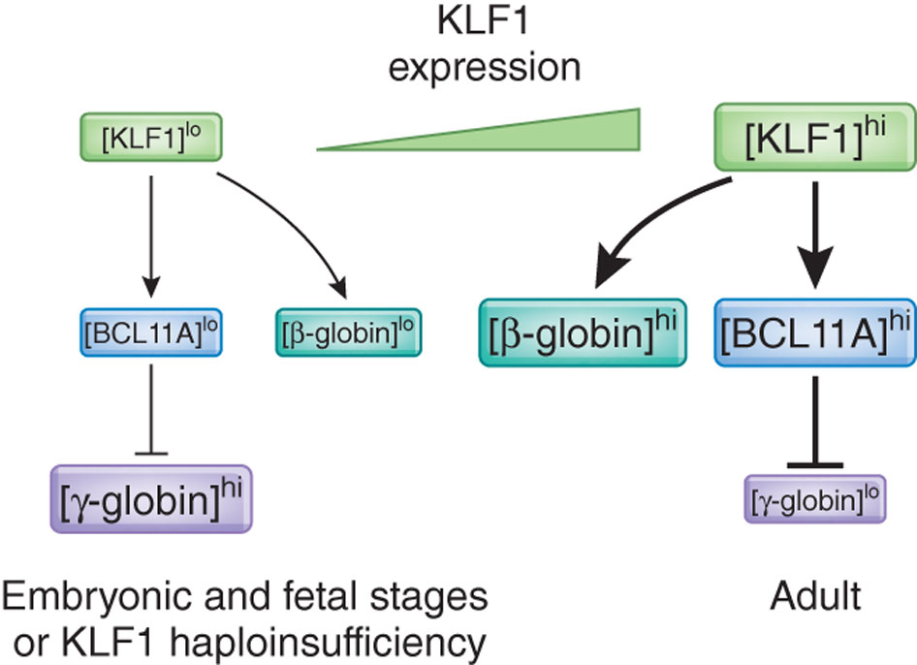
There are two sides to epigenetics, histone modification, and DNA methylation. Recently an article has published showing the importance of KLF1 in histone modification (Alhashem). They proved that when KLF1 is knocked out, the Histones are less accelerated. This research proposal will study KLF1’s role in the second half of epigenetics, DNA methylation. The understanding of KLF1’s full role in epigenetics is valuable information due to the importance of KLF1 in embryonic development. While one half of KLF1’s epigenetic role is known, the other half still needs to be studied. This research proposal will attempt to find direct epigenetic modifications of the genome caused by KLF1 through the use of embryonic mice. The goal is to find direct epigenetic modifications in the DNA caused by KLF1.

Experiment
This experiment will be performed on embryonic mice. There will be two groups of mice, one with the KLF1 gene functioning normally, and another with the KLF1 gene knocked out (KO). The mice liver cells will be extracted at the 15th day mark of development (in pervious experiments where the KLF1 gene has been shut off the mice end up dying due to severe β-thalassemia (Perkins), at day 15 they should still be alive (Tallack)). The liver cells are chosen because due to their association with blood development, they are also associated with KLF1. The genome of the lever cells will be examined for DNA methylation, specifically genes associated with the b-goblin genes, y-globin genes or red blood cell membranes (BCL11A) will be examined. The difference in the DNA methylation between the KLF1 normal control mice and KLF1 KO mice will hopefully help us gain insight into the epigenetic effects of KLF1. Knowledge of the epigenetics effects of KLF1 will improve our understanding of the maturation of erythroid cells, which will be useful in understanding the embryonic development of RBC’s.
Fig.1 KLF1 is a transcription factor necessary for RBC development. Here are the genes transcribed by KLF1.
Gene Knock Out
The first step of this procedure is to obtain mice with knock out the KLF1 gene. This can be done using a reporter gene. Previous studies have knocked out genes in the KLF1 already, one used a lacZ reporter gene to knock out the genes that code KLF1 (Nuez). Since the procedure has already been performed, there is no need to create our own KO mice, heterozygotes mice for the KO gene already exist. These mice will be used in the experiment. The mice can be purchased from Jackson research labs.
The heterozygotes mice then need to be breed to obtain the homozygous mice. These mice will be grown until day 15, where their liver cells will be extracted and then the cells will be used on to the next stage of the experiment, anti-body tagging by ChIP.

ChIP
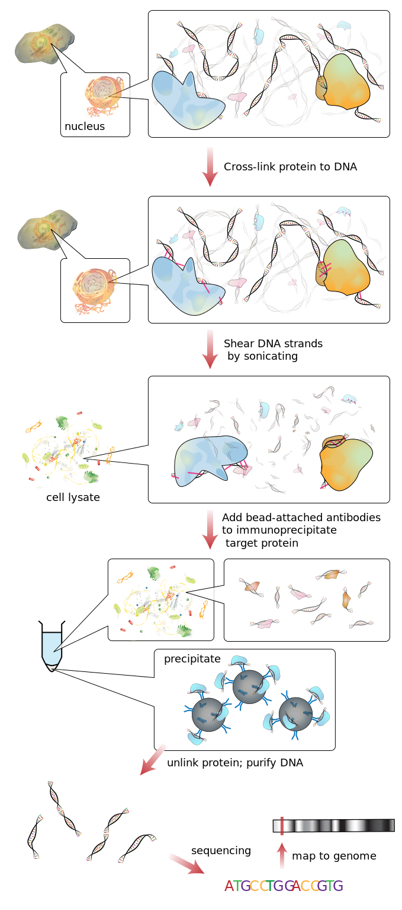
In order to examine the genes from the 15-day mice cells, ChIP techniques will be deployed (fig. 2). There are different versions of the ChIP techniques, this experiment will take deploy the MeDIP-chip version. Due to its specialization in DNA methylation. ChIP works by first cross-linking the DNA in the nucleus with by exposing the target cells (liver cells in this experiment) to a reagent such as formaldehyde (Han). The propose of crosslinking the DNA is to bind the target antigen to its chromatin binding site. Next the crossed linked DNA is sheared by sonication (soundwaves). Then anti-bodies that specified for the directed against 5-methylcy-tidine of the KLF1 associated DNA, are added to the lysed cell (Weng). Once the anti-bodies are added the cell material is precipitated, the target proteins are heavier due to the antibodies, allowing them to be isolated and collected. It is isolated though centrifugation, the supernatant is discarded and then the sample is washed by ethanol. The protein/DNA precipitate is then reversed crosslinked by digestion with proteinase K (Weinmann). In order to create a control group to performed the DNA microarray a second MeDIP-ChIP experiment will be performed with the primary anti-body absent, this is the input DNA (the control). Input DNA and methylated DNA will then be paired with complementary DNA (cDNA) The cDNA will be labeled with Cy5 (red) and Cy3 (green) cyanine fluorescent dyes and then will chemically linked as a dual-color experiment on DNA microarrays. Cy5 and Cy3 are chemically linked to the DNA by their nitrogen side chains. The dyes link to any DNA indiscriminately, since the methylated and non-methylated DNA is already separated each sample gets its own dye. These procedures will be performed twice, once on the control mice and once on KLF KO mice.
Fig. 2. Diagram of the ChIP technique.

DNA Microarray
DNA microarrays will then be used to examine the DNA (fig. 3). Specifically, a Probe CpG microarray (fig. 4). The CpG (Shorthand for 5'—C—phosphate—G—3') is the site where DNA methylation typically occurs. This technique is performed by taking a pair of DNA samples from immunoprecipitation samples which uses the red Cy5, and input DNA with the green Cy3. The microarray itself is a small silicon slide containing thousands of spots, called wells, that house the DNA samples (Lee). Then the two Cy-labeled DNA samples will be mixed and hybridized to a single microarray. Hybridization works by heating up the DNA causing it to denature (separate into single strands), the wells in the slide contains complementary DNA strands to the gene being studied, after the DNA is denature, it will be cooled down allowing it to bind to its complementary strand within the well. The slide will then will be scanned by the microarray scanner which will visualize the fluorescence of the Cy-labeled samples. This is preformed after samples have been subjected to laser excitation. The methylated DNA will glow red, and the non-methylated DNA will glow green, because the red Cy5 was added to the non-methylated DNA and green Cy3 was added to the methylated DNA. The ratio of each sample can then be measured by ratio-based analysis to find the difference in the DNA methylation (Weinmann).

Overall Procedure
These two techniques, MeDIP-ChIP and CpG Island Microarray combined should provide sufficient data to measure the difference in methylation between control mice and KLF1 knock out mice’s DNA (fig. 5).
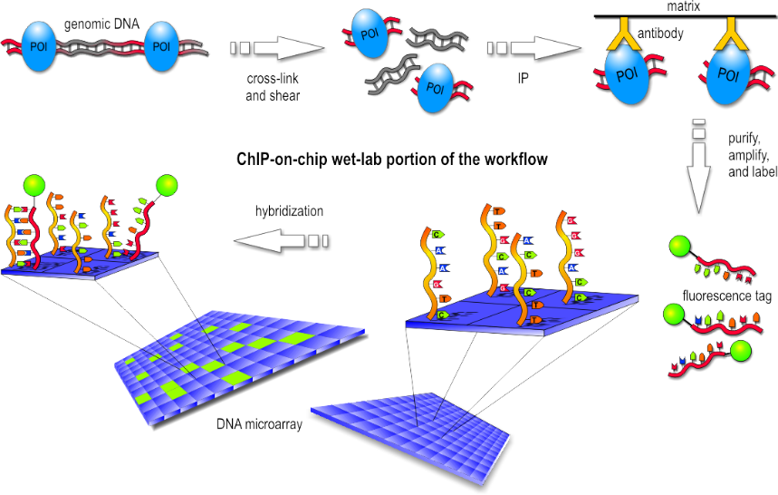
Figure 3. An example of the DNA Microarray procedure. Fluorescently labeled tags added to the target and control DNA which is then mixed. The mix is then hybridized onto microarray’s, scanned and analyzed.

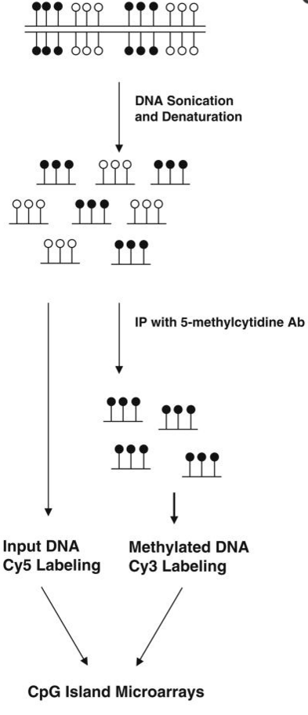
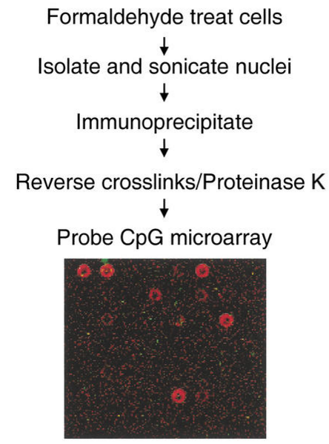
Fig. 5 An example of CpG island microarray

Discussion
DNA methylation is the process of the addition of methyl groups to 5 carbon group of the cytosine in a CpG region of DNA. These methyl groups can affect the transcription of genes. KLF1, as a transcription factor also affects the transcription of genes. Therefore, I hypotheses that in the absence of KLF1, the DNA should be less methylated. The question is by how much and what genes are affected. This experiment hopefully will answer’s these questions and further our understanding of KLF1’s role in epigenetics.
Fiq. 4 ChIP paired with CpG Island Microarrays.
The information gained from this experiment can help expand our understanding of the development of red blood cells in the embryo. The impact that KLF1 has on the methylation of DNA could prove further demonstrate the importance of this transcription factor and the need to ensure its healthy development.

Bibliography

Han, Y., & Garcia, B. A. (2013). Combining genomic and proteomic approaches for epigenetics research. Epigenomics, 5(4), 439–452. http://doi.org/10.2217/epi.13.37https://www.ncbi.nlm.nih.gov/pmc/articles/PMC4055025/
Tallack, M. R., Magor, G. W., Dartigues, B., Sun, L., Huang, S., Fittock, J. M., … Perkins, A. C. (2012). Novel roles for KLF1 in erythropoiesis revealed by mRNA-seq. Genome Research, 22(12), 2385–2398. http://doi.org/10.1101/gr.135707.111
Nuez, Beatriz, Dave Michalovich, Anne Bygrave, Rob Ploemacher, and Frank Grosveld. "Defective Haematopoiesis in Fetal Liver Resulting from Inactivation of the EKLF Gene." Nature 375.6529 (1995): 316-18. http://www.ncbi.nlm.nih.gov/pubmed/7753194/
Alhashem, Y. N., D. S. Vinjamur, M. Basu, U. Klingmuller, K. M. L. Gaensler, and J. A. Lloyd. "Transcription Factors KLF1 and KLF2 Positively Regulate Embryonic and Fetal -Globin Genes through Direct Promoter Binding." Journal of Biological Chemistry 286.28 (2011): 24819-4827. http://www.jbc.org/content/286/28/24819.long
Weng, Y.-I., Huang, T. H.-M., & Yan, P. S. (2009). Methylated DNA Immunoprecipitation and Microarray-Based Analysis: Detection of DNA Methylation in Breast Cancer Cell Lines. Methods in Molecular Biology (Clifton, N.J.), 590, 165–176. http://doi.org/10.1007/978-1-60327-378-7_10
Weinmann, A. S. "Isolating Human Transcription Factor Targets by Coupling Chromatin Immunoprecipitation and CpG Island Microarray Analysis." Genes & Development 16.2 (2002): 235-44. Web. http://www.ncbi.nlm.nih.gov/pubmed/11799066?dopt=Abstract
Andrew Perkins, Xiangmin Xu, Douglas R. Higgs, George P.Patrinos, Lionel Arnaud, James J. Bieker, Sjaak Philipsen. "Krüppeling" erythropoiesis: an unexpected broad spectrum of human red blood cell disorders due to KLF1 variants unveiled by genomic sequencing. Blood Jan 2016, DOI: 10.1182/blood-2016-01-694331 http://www.bloodjournal.org/content/early/2016/02/22/blood-2016-01-694331.long?sso-checked=true
Lee, T. I., Johnstone, S. E., & Young, R. A. (2006). Chromatin immunoprecipitation and microarray-based analysis of protein location. Nature Protocols, 1(2), 729–748. http://doi.org/10.1038/nprot.2006.98

