I. Introduction
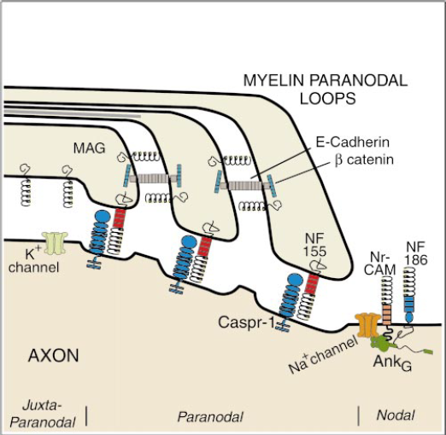
Multiple sclerosis (MS) is an inflammatory, neurodegenerative disease characterized by the loss of myelin on the axons of neurons in the central nervous system (CNS). Myelin is an insulating ensheathment of the axon which allows for rapid conduction propagation of action potentials, a process called salutatory conduction (Maier et al, 2005). In the CNS, myelin is produced by oligodendrocyte cells and consists of segmental units called internodes, separated by exposed regions of the axon, called nodes of Ranvier. (Shafer et al, 2004). Collectively, the internodes are referred to as the myelin sheath.
Figure 1 graphical representation of the Paranodal junction of the axon and the proteins and ion channels associated with it (Trapp B, Kidd G, 2000)
Action potentials are propagated along axons in order to signal to other neurons. The action potential is caused by the rapid depolarization of the axonal membrane, resulting from the influx of sodium ions through voltage-gated channels (Squire et al, 2012). These sodium channels are clustered at the nodes of Ranvier.
At the ends of each internode is the paranode (fig. 1), where the internode contacts the axon membrane. The paranodes are incredibly important for the adhesion of myelin to the axons, as well as the clustering of ion channels at the node of Ranvier; both of which are important for efficient action potential propagation (Schafer et al, 2005). These paranodes are preferential sites of initial myelin breakdown (Thummala, S).
The main cell type involved with this attack is microglial cells, which are the resident inflammatory cells in the CNS. Microglial cells exist in resting and active states (Lull, Block, 2010). When microglia cells are resting, or ramified, they exhibit a star-shaped morphology and extend numerous processes to surveil the CNS environment. When in the ramified state, microglia have minimal levels of inflammatory cytokine expression. If these cells are activated, they change their morphology into an amoeboid shape, proliferate, and release pro- or anti-inflammatory cytokines at much higher levels (Lull, Block, 2010). These cytokines recruit more microglial cells to the site (Lull, Block, 2010). The activation of the microglial cells and the release of pro-inflammatory cytokines produce the hallmark demyelination and inflammation seen in MS. What remains unclear, is initiating the signal for activation.
One hypothesis for the activation signal is changes in the membrane organization of the paranode; as mentioned, the paranode is the attachment site for the internode. One of the key proteins for this adhesion is Neurofascin 155 (NF155), which binds to caspr on the axonal membrane (Shafer et al, 2005). NF155 normally localized in the membrane to the sites of lipid rafts (fig. 2), which are unique domains that are rich in cholesterol and sphingolipids used for lateral membrane organization and partitioning of proteins (Pomicter et al, 2013; Dupree et al, 2010). This raft composition produces a more ordered and rigid environment, which affects the configuration and proper functioning of the proteins in the raft.
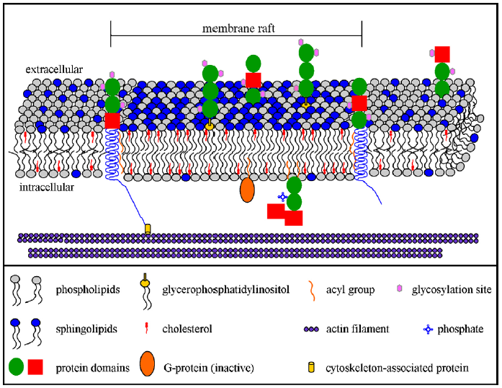
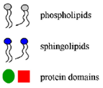
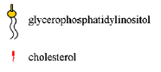
Interestingly, in myelin isolated from MS patients, the association of NF155 with lipid rafts is h9as been shown to be dramatically decreased (Maier et al, 2007). This mis-localization, causes NF155 to no longer cluster at the paranodal junction, which decreases the ability of the myelin to adhere to the axon (Dupree et al, 2010, Pomicter et al, 2013). An additional consequence of the displacement of NF155, could be an altered exposure of the protein to the local microglia surveilling the environment. Detection of this exposure by the microglial cells could lead to their activation, and produce a neuro-inflammatory response leading to demyelination.
Figure 2 a graphical representation of a membrane raft (adapted from: Dupree et al, 2010)
The focus of this proposal, is to investigate how the membrane environment of NF155 (i.e. its raft association) impacts the inflammatory response of the microglial cells.
II. Experiment
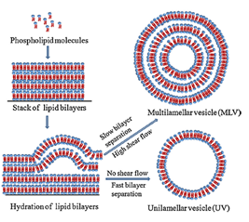
The purpose of this experiment is to investigate whether raft association of NF155 effects the inflammatory response of microlial cells. If the loss of raft association increases the inflammatory response of microglial cells then there will be an increase in pro-inflammatory cytokine release, cell proliferation, and morphological change to the ameboid shape. The three aforementioned responses will be quantified using: an ELISA kit, a cell proliferation assay, and immunocytochemistry respectively. This will be accomplished with an in vitro model system using synthetic liposomes to simulate the membrane envornment of NF155, in which microglial cells will be suspended in for 2-24 hours.
Figure 3 basic methodology for the synthesis of multilamellar vesicles, lipids to compose the liposome are stacked in a dry environment, then hydrated with water to spontaneously form into vesicles due to their amphipathic nature. To synthesize multilamellar vesicles the hydration is done at a slower pace to allow multiple membrane layers to envelope each other (Patil & Jadhav, 2013)
II A – Liposome Synthesis
The amount of myelin present at the paranode is far too small for collection of human samples from deceased patients, for this reason, multilamellar liposomes will be synthesized in lab to simulate the membrane environment (fig 3). The composition of these liposomes will be simulating either the normal membrane composition of myelin (table 1), or the composition of the lipid rafts that contain NF155. Due to the lack of protocol in place for lab synthesis of lipid rafts, the raft environment will be simulated by, composing the liposomes that simulate the raft environment of the lipids and other constituents consistent with these rafts. Lipid rafts contain much higher quantities of sphingolipids and cholesterol; therefore, the raft liposomes will have the same composition as the non-raft liposomes but with altered quantities of the lipids (Dupree et al, 2010). Table 1 shows
Constituent | Percent total lipid weight | Raft Percent total lipid weight
Cholesterol | 27.7 | 41.6
Galactocerebroside | 22.7 | 22.7
Sulfatide | 3.8 | 11.4
Ethanolamine phosphatides | 15.6 | 5.4
Phosphatidyl choline | 11.2 | 5.6
Sphingomyelin | 7.9 | 15.8
Phosphatidylserine | 4.8 | 0
Phosphatidylinositol | 0.6 | 0
Plasmaogens | 12.3 | 4.1
total phospholipid | 43.1 | 15.1
total galactolipid | 27.5 | 49.9
the approximate amount of lipids that will be used to synthesize the liposomes, exact fractions will be altered by trial and error in lab. Lipids will be purchased from Avanti Polar Lipids inc.

Table 1 the composition of the myelin membrane in humans, which will be used to synthesize non-raft liposomes, and approximate altered composition for the proportions of lipids to simulate the raft environment (Brady et al, 2012, Dupree et al 2010)
II B – Liposome Treatments

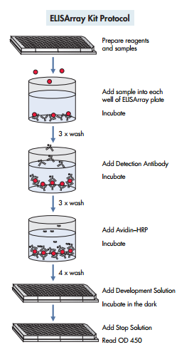
To compare and contrast the inflammatory response of the microglial cells, I will be using 4 different liposome treatments. The negative control will be a protein free, non-raft liposome composed only of lipids, my positive controls will be: NF155 and control protein non-raft liposome, NF155 raft liposome, and NF155 and control protein raft liposome. NF155 will be integrated into the liposomes by lipid linkage since NF155 is a peripheral membrane protein. The lipid linked NF155 will be purchased from a biotech company with the appropriate linkage to a membrane lipid. The control protein used will be human Semicarbazide-Sensitive Amine Oxidase, which is a vascular adhesion protein which associates with the membrane peripherally (Nilsson et al, 2005).
Figure 4 protocol for the ELISArray (QIAGEN)
II C – ELISA kit
To measure the pro-inflammatory cytokine release from the microglial cells, an ELISArray kit will be purchased. An ELISA kit uses wells with antigen specific antibodies and buffer, these antibodies bind to specific antigens of interest. Once the antigens have bound to the antibodies, a detection antibody is added to bind to the antigen, this antibody is recognized by a secondary antibody, which has a Horseradish Peroxidase (HRP) enzyme attached to it (fig. 4). The HRP enzyme changes color when exposed to the development solution, this color change from blue to yellow can be used to identify the amount of antigen present by referring to the standard curve, this standard curve associated the optical density of the HRP color (fig. 5), to a concentration of antigen. Optical density is the amount of light that is lost passing through a medium, in this case, the amount of light lost when passing through the HRP enzyme.

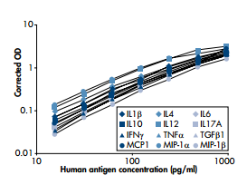
II D – Cell Proliferation Assay
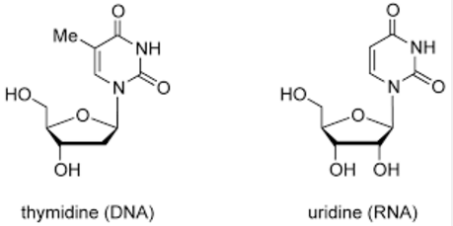
In order to quantify the cell proliferation of the microglia, Bromodeoxyuridine will be used in a cell proliferation assay. Bromodeoxyuridine (BrdU) is an analog of thymidine (fig. 6), which has a bromo- group where the methyl group would be on a thymidine (Crane, Bhattacharya). The BrdU is incorporated into cellular DNA during the S phase of the cell cycle, in which DNA is replicated (Crane, Bhattacharya). In order to determine the presence of BrdU in samples, they are incubated with a BrdU antibody under DNA denaturing conditions, to allow the antibody access to the DNA (Crane, Bhattacharya). Following the initial antibody association, the samples are exposed to enzyme-linked secondary antibodies that undergo color change when exposed to their substrate, this response is then analyzed using bright field microscopy (Crane, Bhattacharya).
Figure 5 standard curve for the ELISA human inflammatory cytokines (QIAGEN)
Br
Figure 6 side by side comparison of thymidine, a deoxynucleoside, and uridine with the bromo- group added in blue (adapted from atdbio)
II E – Immunocytochemistry with IBA1 antibody
The morphological change from the ramified aster morphology, to the amoeboid morphology in activated microglia, will be observed using Immunocytochemistry with the IBA1 antibody. IBA1 is a protein in microglial cells that increases in expression when the microglial cells are activated (Biocare Medical). The IBA1 antibody binds to the protein, which is then marked with a secondary antibody that is enzyme linked to HRP to exhibit a color change that can be observed using microscopy.
II F – Microglia Cell Culturing
Microglial cells will be isolated from 2 day postnatal mice; this will be done using primary cell culturing. The cortex will be isolated from the brains of 3 mice, which will then be chopped and incubated with trypsin and DNase for 15-20 min. Tissue is then aspirated until a cell suspension is obtained, the suspension is then centrifuged at 400 xg to obtain a pellet of cells. Following 2-3 weeks of culturing, microglial cells can be isolated by agitation and used in lab (Deierborg, T. 2013).
III. Discussion
The results that I expect to see from this experiment if it goes according to plan, is a clear increase or stagnation in the inflammatory response of the microglial cells. If the lack of raft association of NF155 influences the inflammatory response, I expect to see an increase in the pro-inflammatory cytokine release, cell proliferation, and morphological shift to the amoeboid shape in the non-raft liposomes with NF155 and control protein. The response I expect to see in the other liposomes would be much lower levels of pro-inflammatory cytokine release, and cell proliferation. I would expect to see morphological change in all cases due to the phagocytic nature of microglial cells, and the function of the amoeboid shape in phagocytosis. While the increase in inflammatory response would indicate that loss of raft association of NF155 is a cause of neuroinflammation, this would not indicate that it is the cause of the overall demyelination associated with MS.
While this experiment could provide very informative observations that would clarify the direction of further study, there are many potential issues. Firstly, the liposome synthesis could fail due to limitations of associating the proteins with the lipids, or alternatively the synthesis not going as planned and proteins becoming enclosed by the liposome as opposed to integrated in the membrane. Additionally, the control protein could cause an innate inflammatory response that would provide results that would be inconclusive due to inability to clearly observe NF155 as an impetus for neuroinflammation. Moreover, the experiment is limited by the cost of purchasing numerous proteins and lipids, as well as the materials and mice needed (also the emotional weight of killing little baby mice). The experiment is also limited in its results by the fact that this would be a fully synthetic environment, which would in no way be able to encompass the vast and intricate myelin membrane, or the other factors that could be influencing this inflammatory response.
Despite the potential limitations and pitfalls, the results of this experiment would provide direction for further work into investigating the paranodal environment and how it influences the inflammatory response of microglial cells. This research could provide answers into the cause of a convoluted disease, and further research could lead to an eventual cure or treatment for MS.

References
Aggarwal, Shweta, Yurlova, Larisa, & Simons, Mikael. (2011). Central nervous system myelin: Structure,
synthesis and assembly. Trends in Cell Biology, 21(10), 585-593. [LINK]
Atdbio. (n.d.). Nucleic acid structure. Retrieved April 30, 2016, from
http://www.atdbio.com/content/5/Nucleic-acid-structure
Biocare Medical. (n.d.). Microglia (Iba1) Concentrated Polyclonal Antibody. California, Concord.
Block, M. (2014). Neuroinflammation: Modulating mighty microglia. Nature Chemical Biology, 10(12), 988-9.
[LINK]
Bosio, A., Büssow, H., Adam, J., & Stoffel, W. (1998). Galactosphingolipids and axono-glial interaction in
myelin of the central nervous system. Cell and Tissue Research, 292(2), 199-210 [LINK]
Brady, S., Siegel, George J, Albers, R. Wayne, & Price, D. L. (2012). Basic neurochemistry : Principles of molecular,
cellular, and medical neurobiology (8th ed.). Amsterdam ; Boston: Elsevier Academic Press.
Coggan, J., Bittner, S., Stiefel, K., Meuth, S., & Prescott, S. (2015). Physiological Dynamics in Demyelinating
Diseases: Unraveling Complex Relationships through Computer Modeling. International Journal of Molecular Sciences, 16(9), 21215-36.
Crane AM1, Bhattacharya SK., The use of bromodeoxyuridine incorporation assays to assess corneal stem
cell proliferation. Methods Mol Biol. 2013;1014:65-70
Deierborg, T. (2013). Preparation of Primary Microglia Cultures from Postnatal Mouse and Rat Brains. In
Microglia: Methods and Protocols (Vol. 1041, Methods in Molecular Biology, pp. 25-31). New York, NY: Springer Science Business Media. [LINK]
Dupree, Jeffrey L., & Pomicter, Anthony D. (2010). Myelin, DIGs, and membrane rafts in
the central nervous system. Prostaglandins and Other Lipid Mediators, 91(3), 118-129. [LINK]
Giulian, D., & Baker, T. (1986). Characterization of ameboid microglia isolated from developing mammalian
brain. The Journal of Neuroscience : The Official Journal of the Society for Neuroscience, 6(8), 2163-78. [LINK]
Grassi, S., Prioni, S., Cabitta, L., Aureli, M., Sonnino, S., & Prinetti, A. (2016). The Role of 3- O –
Sulfogalactosylceramide, Sulfatide, in the Lateral Organization of Myelin Membrane. Neurochemical Research,41(1), 130-143. [LINK]
Howell, Palser, Polito, Melrose, Zonta, Scheiermann, . . . Reynolds. (2006). Disruption of neurofascin
localization reveals early changes preceding demyelination and remyelination in multiple sclerosis. Brain, 129(12), 3173-3185. [LINK]
Lull, M., & Block, E. (2010). Microglial activation and chronic neurodegeneration. Neurotherapeutics, 7(4), 354-
365. [LINK]
Maier, O., Van Der Heide, T., Van Dam, A., Baron, W., De Vries, H., & Hoekstra, D. (2005). Alteration of
the extracellular matrix interferes with raft association of neurofascin in oligodendrocytes. Potential significance for multiple sclerosis? Molecular and Cellular Neurosciences, 28(2), 390-401. [LINK]
Maier, O., Baron, W., & Hoekstra, D. (2007). Reduced raft-association of NF155 in active MS-lesions is
accompanied by the disruption of the paranodal junction. Glia, 55(8), 885-95. [LINK]
Nilsson, J., Ogg, D., Jakobsson, E., & Kleywegt, G. (2005). Structure of human semicarbazide‐sensitive
amine oxidase/vascular adhesion protein‐1. Acta Crystallographica Section D, 61(11), 1550-1562.
Ozgen, H., Schrimpf, W., Hendrix, J., Jonge, J., Lamb, D., Hoekstra, D., . . . Baron, W. (2014). The Lateral
Membrane Organization and Dynamics of Myelin Proteins PLP and MBP Are Dictated by Distinct Galactolipids and the Extracellular Matrix. PLoS One,9(7), PLoS One, Jul 2014, Vol.9(7). [LINK]
Patil, Yogita P., & Jadhav, Sameer. (2013). Novel methods for liposome preparation.Chemistry and Physics of
Lipids, 177, 8-18.
Pomicter, A., DeLoyht, D., Hackett, J., Purdie, M., Sato-Bigbee, R., Henderson, N., & Dupree, C. (2013).
Nfasc155H and MAG are Specifically Susceptible to Detergent Extraction in the Absence of the Myelin Sphingolipid Sulfatide. Neurochemical Research, 38(12), 2490-2502. [LINK]
Pomicter, A., Shroff, S., Fuss, B., Sato-Bigbee, C., Brophy, P., Rasband, M., . . . Dupree, J.
(2010). Novel forms of neurofascin 155 in the central nervous system: Alterations in paranodal disruption models and multiple sclerosis. Brain, 133(2), 389-405. [LINK]
Qiagen. (n.d.). Human Inflammatory Cytokines Multi-Analyte ELISArray Kit: MEH-004A. Retrieved April
30, 2016, from http://www.sabiosciences.com/ELISA_product/HTML/MEH-004A.html
Schafer, D., Bansal, R., Hedstrom, K., Pfeiffer, S., & Rasband, M. (2004). Does paranode formation and
maintenance require partitioning of neurofascin 155 into lipid rafts? The Journal of Neuroscience : The Official Journal of the Society for Neuroscience, 24(13), 3176-85. [LINK]
Sherman, Diane L., Tait, Steven, Melrose, Shona, Johnson, Richard, Zonta, Barbara, Court, Felipe A., . . .
Brophy, Peter J. (2005). Neurofascins Are Required to Establish Axonal Domains for Saltatory Conduction. Neuron, 48(5), 737-742. [LINK]
Squire, Larry, Berg, Darwin, Bloom, Floyd E., Du Lac, Sascha, Ghosh, Anirvan, & Spitzer, Nicholas C.
(2012). Fundamental Neuroscience (4th ed.). Elsevier Science.
Stansley Branden, Post Jan, & Hensley Kenneth. (2012). A comparative review of cell culture systems for the
study of microglial biology in Alzheimer’s disease. Journal of Neuroinflammation, 9(1), 115.
Thummala, S. (2015). Axon initial segment stability in multiple sclerosis. [LINK]
Trapp, B., & Kidd, G. (2000). Axo-glial septate junctions. The maestro of nodal formation and
myelination? The Journal of Cell Biology, 150(3), F97-F100.

