Jordan Davis
BNFO 300
Proposal Final

Relations between chromosome protecting protein woc and terminin complex protein Verrocchio

I. Introduction
Chromosome fusion can occur through plenty of different reasons. The fusion of chromosomes can lead to premature cell death in organisms. Research has been done on fruit fly chromosomes, to analyze and discover multiple proteins that regulate chromosome protection and maintenance (Raffa et al. 2013). These chromosome protecting proteins are extremely significant for an organism to function properly (Raffa et al. 2010). Interestingly enough, chromosome defense and maintenance proteins that are found in fruit flies can also be found in humans and display similar roles in protecting chromosomes (Raffa et al. 2010).
Terminin is a protein complex in fruit flies that is comprised of various proteins that perform chromosome maintenance. The main role of terminin is to ‘cap’ and protect the end of each chromatid from chromosome fusion (Raffa et al. 2005). Raffa et al. 2013 and Gao et al. 2010 suggests that the terminin complex is also conserved in humans. The name we give the complex in humans is shelterin, and it behaves in the same way as terminin does in fruit flies (Raffa et al. 2010). There are differing proteins between the fruit fly’s terminin and the human’s shelterin, but they perform the same tasks of chromosome protection and maintenance proteins (Raffa et al. 2013).
When there are mutations to any component of the terminin complex chromosome fusions ensue in fruit flies (Raffa et al. 2010, 2011, 2013). Studies suggest that mutations in the shelterin complex have the same unfortunate effect in humans (Gao et al. 2010, Raffa et al. 2010, 2011, 2013). Without Children (woc) is a gene that programs a zinc finger protein and has shown to be localized at chromosome ends in both humans and fruit flies, and is not a part of the terminin/shelterin complex (Gao et al. 2010, Raffa et al. 2010, 2011, 2013).
The woc protein is a transcription factor and is also shown to be present in both fruit fly and human chromosomes ends. The function of the Woc protein in fruit flies is known to revolve around telomere capping, but it is unknown if it has any role with the terminin complex in fruit flies (Raffa et al. 2010, 2013). Woc protein is unknown to have any function in humans, but it could be a vital protein for the well-being of the shelterin complex (Raffa et al 2010, 2011, 2013, Font-Burgada et al. 2008).
If I can examine the effects that the woc protein has on the terminin complex function in fruit flies I believe I will be able to predict the significance of the woc protein and its role with terminin function in fruit flies, and possibly moving on to research for the human protein complex shelterin in the future.
So does a mutation in the woc gene in fruit flies cause improper functioning of the terminin complex at chromosome ends, leading to chromosome fusion?

II. Experiment
In the terminin complex consists of a select grouping of proteins. For this specific experiment I will focus on one protein subunit of terminin, Verrocchio (ver). Verrocchio is required for prevention of chromosome fusion and is a part of the terminin complex. Its individual function is unknown, but it is a part of terminin thus should have a role in telomere capping (Raffa et al. 2011, 2013). It is unknown whether Woc has any role or function with ver, but since both are extremely concentrated at chromosome ends and preform similar functions of telomere protection I wondered if ver, and thus the terminin complex, have a dependency on the transcription factor protein woc to function properly (Raffa et al. 2010, 2011, 2013, Gao et al. 2010, Font-Burgada et al. 2008). I want to analyze a gene knockout of woc, which will hopefully cease production of the woc protein and then study the effects it will have on the terminin complex function. By singling out the protein subunit ver I will be able to identify whether the terminin complex is still present and functioning at chromosome ends after a mutation in woc, since ver is a part of the terminin complex and is required for the prevention of chromosome fusion.
The goal of this experiment is to see if a mutation in woc will cause ver to not properly function, thus causing terminin not to perform its duty of chromosome end protection. It has been suggested that the drosphila terminin complex is extremely similar in function to the likes of shelterin, a human homolog for the terminin protein complex. There is evidence that suggests that woc is present in humans, due to their similar localization at telomeres and their functions which involve telomere capping (Raffa et al. 2013). Information can be drawn from this one experiment to make inferences on the woc protein homolog function/significance in human research.
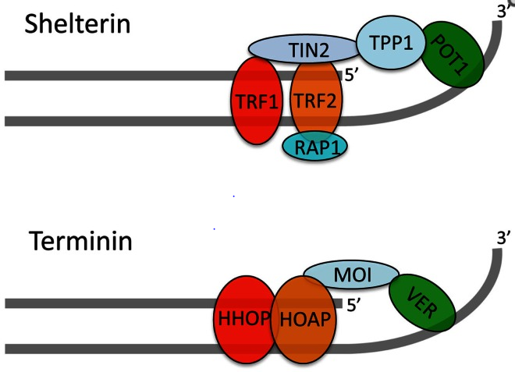
Shelterin is a chromosome protecting protein complex found in humans

Terminin is a chromosome protecting protein complex found in fruit flies
Both of which show extreme similarities
Woc is also located at chromosome ends in fruit flies and humans and plays a similar role to that of the terminin complex
Is the woc protein significant for proper function of ver, and thus the terminin complex?
- Raffa, Grazia D., et al. "Organization and evolution of Drosophila terminin: similarities and differences between Drosophila and human telomeres."Frontiers in oncology 3 (2013).

Methodology
I will first acquire two sets of wild type fruit flies in the larvae development phase delivered from flybase.org. Most studies use this period in development to test effects of proteins on chromosome fusion (Raffa et al. 2010, 2011, 2013, Gao et al. 2010). I will sort them in halves and will perform the gene knockout on one of the two sets of fruit flies. To perform the gene knockout I will first need the specific sequence I will want to ‘knockout.’ To do so I will look up the sequence information from flybase.org and will use other websites via flybase.org to obtain the correct information.
A gene knockout will be performed in order to test the significance the woc protein may have in terminin function. I will use a transposon to insert itself to ‘break’ the sequence of DNA that programs woc for half of the fruit fly sample (Raffa et al. 2011, 2013). The goal of this gene knockout is to disrupt the DNA sequence that programs woc specifically. Then after the insertion I will compare and contrasts the two fly samples. The wild type sample will only breed with themselves while the newly woc mutant fly sample will breed with themselves. This will hopefully form generations of woc mutated fruit flies, and thus further analysis can be made to determine whether Verrocchio is present/functioning properly in chromosome ends.
Once the knockout mutation is made I would study the presence of ver in chromosome ends, if I see little to no presence than I will assume that Verrocchio, and potentially the terminin complex rely on woc to program the woc protein to make terminin function properly.

III. Discussion
If all goes well I would expect to see chromosome fusion in the sample of flies with the mutated woc gene. This would give indication that Verrocchio and other potential subunits of terminin can be at risk if woc is mutated.
This will also give rise to the question of the significance of woc in human chromosomes. Is it viable in humans? Is woc necessary in human chromosome health? These are questions that can be produced by result of his experiment. It will only lead to a better understand of woc in both fruit flies and humans, thus giving the spotlight to telomere biology in humans.

Works Cited
- Biessmann, Harald, Steven B. Carter, and James M. Mason. "Chromosome ends in Drosophila without telomeric DNA sequences." Proceedings of the National Academy of Sciences 87.5 (1990): 1758-1761.
- Cenci, Giovanni, et al. "The Drosophila HOAP protein is required for telomere capping." Nature cell biology 5.1 (2002): 82-84.
- Frydrychová, Radmila, et al. "Phylogenetic distribution of TTAGG telomeric repeats in insects." Genome 47.1 (2004): 163-178.
- Gao, Guanjun, et al. "HipHop interacts with HOAP and HP1 to protect Drosophila telomeres in a sequence‐independent manner." The EMBO journal29.4 (2010): 819-829.
- Font-Burgada J., Rossell D., Auer H., Azorin F. (2008).Drosophila HP1c isoform interacts with the zinc-finger proteins WOC and Relative-of-WOC to regulate gene expression. Genes Dev. 22, 3007–302310.1101/gad.481408
- Muller H. J. (1938). The remaking of chromosomes. Collect. Net 8, 182–195
- Nielsen, Lena, and J. E. Edström. "Complex telomere-associated repeat units in members of the genus Chironomus evolve from sequences similar to simple telomeric repeats." Molecular and cellular biology 13.3 (1993): 1583-1589.
- Raffa, Grazia D., et al. "Organization and evolution of Drosophila terminin: similarities and differences between Drosophila and human telomeres."Frontiers in oncology 3 (2013).
- Raffa, Grazia D., et al. "ORGANIZATION AND MAINTENANCE OF DROSOPHILA TELOMERES: THE ROLES OF TERMININ AND NON-TERMININ PROTEINS." ЦИТОЛОГИЯ 55.3 (2013): 204-208.
- Raffa, Grazia D., et al. "Terminin: a protein complex that mediates epigenetic maintenance of Drosophila telomeres." Nucleus 2.5 (2011): 383-391.
- Raffa, Grazia D., et al. "Verrocchio, a Drosophila OB fold-containing protein, is a component of the terminin telomere-capping complex." Genes & development24.15 (2010): 1596-1601.
- Roth, Charles W., et al. "Chromosome end elongation by recombination in the mosquito Anopheles gambiae." Molecular and cellular biology 17.9 (1997): 5176-5183.
- Sean Gallagher, Deb Chakavarti. Keck Graduate Institute of Applied Life Sciences, UVP, LLC, Proteomic Center, Keck Graduate Institute of Applied Life Sciences.
- Wolfe, Scot A., et al. "Analysis of zinc fingers optimized< i> via</i> phage display: evaluating the utility of a recognition code." Journal of molecular biology 285.5 (1999): 1917-1934.

