Measuring myelin protein expression levels with a MeCP2 knockout
Rachel Siefring
November 29, 2014

Introduction
Cases of the autism spectrum disorder (ASD) are increasing, with one in 68 children being diagnosed with some form of the disorder (Bhat, 2014, abstract). ASD covers a broad spectrum of neurodevelopmental disorders which are based on a child’s social interaction and communication, as well as cognitive functioning. Although the manifestation of ASD varies from child to child, most children have a barrier in communication and exhibit specific interests and behaviors. Identification of specific syndromes within ASD depends on the severity of a child’s behaviors and symptoms, as well as genetic factors. Symptoms of ASD start to exhibit themselves during the first few years of life, a critical period of brain development. (Ebert and Greenberg 2013, Kleijer et al. 2014).
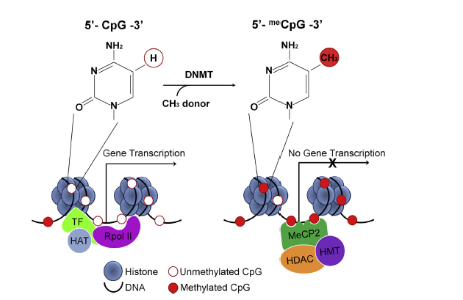
One particular syndrome within ASD, Rett Syndrome (RTT), has been associated with a mutation in the methyl-CpG-binding protein 2 (MeCP2) (Amir et al, 1999, p. 185). MeCP2 is an activator and repressor of transcription (Chahrour et al, 2008; Ebert and Greenberg, 2013; Karpova, 2014; Cortes-Mendoza, 2014). MeCP2 is involved in specific gene expression, including the expression of brain-derived neurotrophic factor (BDNF), an important protein in axon maturation (Vora 2014). When the promoter regions of this gene have methylated cytosines, MeCP2 will bind to the DNA, along with histone deacetylase (HDAC) and histone methyltransferase (HMT) proteins, winding it into a tighter chromatin structure. (Cortes-Mendoza et al, 2014; Karpova, 2014; Chahrour et al, 2008) Additionally, MeCP2 acts as an activator of DNA. An increase in Ca²⁺ concentration results in the phosphorylation of MeCP2. Phosphorylated MeCP2 turns off the gene silencing complex, making MeCP2 an activator (Cortes-Mendoza, Chahrour).
Figure 1: Figure 1 of Karpova, 2014, showing the methylation of a gene and the involvement of MeCP2.
Because of its role in the expression of BDNF, research about MeCP2 has mainly focused on its role in neuronal and axonal development. However, a few researchers have begun exploring the role of MeCP2 in glial cells, specifically oligodendrocytes. Only found in the central nervous system (CNS), oligodendrocytes are a type of glial cell which produce myelin for certain neuronal axons. Myelin is essential for proper conduction of signals throughout the CNS. During early development, oligodendrocytes undergo a distinct sequence of developmental events, allowing myelination to occur properly. (Bradl and Lassmann, 2010). These cells express a whole host of proteins during development and myelination, including proteolipid protein (PLP), myelin basic protein (MBP), myelin-associated glycoprotein (MAG), 2', 3'-cyclic nucleotide 3'-phosphodiesterase (CNPase), and cell surface proteoglycan (NG2).
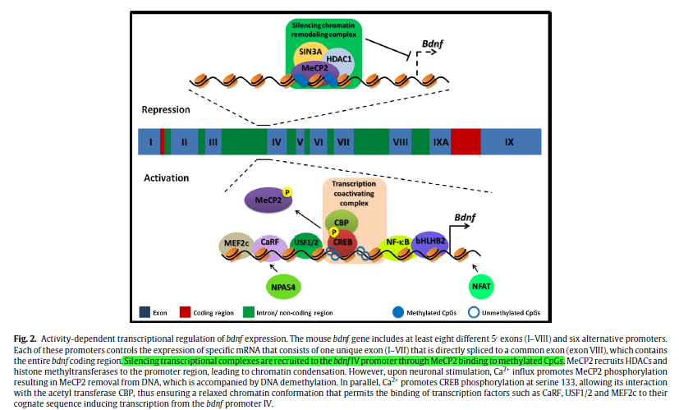
Using transgenic knockout rats, Vora et al (2014) sought to understand whether a truncated form of MeCP2 would affect the expression levels of myelin genes, compared to normal MeCP2. This experiment tested for changes in mRNA expression of myelin proteins with wild type and truncated forms of MeCP2, using quantitative real-time reverse transcription polymerase chain reaction (qRT-PCR). Using this method, they discovered a 2.38 fold difference between the two different rat groups expression of myelin basic protein (MBP) in the corpus callosum. Additionally, they found a 4.59 fold difference between the two groups in myelin-associated glycoprotein (MAG) in the corpus callosum. In both instances, the truncated MeCP2 rats were seen to have an upregulation in myelin genes.
Figure 2: Figure 2 of Cortes-Mendoza et al, the top panel shows MeCP2 acting as a repressor of the BDNF gene. The bottom panel shows MeCP2 acting as an activator of the BDNF gene.
Experiment
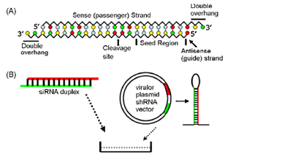
Vora et al studied the role of MeCP2 in the context of the entire rat brain. Although differences in myelin genes were found, these differences do not necessarily apply to oligodendrocytes and their singular role in myelin formation and development. I propose that the effect of MeCP2 on myelin proteins be studied in vitro, by use of oligodendrocyte cultures.
Figure 3: Figure 2 of Shen paper showing the synthesis of siRNA.
Using previously described methods (Sato-Bigbee, et al, 1999), oligodendrocytes will be isolated from the corpus callosum of rats of differing ages: 4, 11, and 21 days. These time points have been previously shown to be important time points in the development of oligodendrocytes.
Saini et al (2005) completed an experimental method similar to the one being proposed. Upon isolation, these oligodendrocytes will be placed in two different cultures: one for western blot analysis and another for immunocytochemistry as described by Saini et al (Saini et al, 2005). A knockout of MeCP2 in oligodendrocytes will be completed using the small interfering RNA (siRNA) method. siRNA consists of a synthesized, double-stranded RNA sequence that matches a 21 nucleotide sequence on the expected mRNA strand. After being transfected into the cells, the siRNA binds to the mRNA, thus prohibiting translation of the MeCP2 gene and degrading the mRNA (Shan, 2010). Oligodendrocytes from each of the three age groups will be incubated with MeCP2 siRNA for six hours using specific reagents. Following this, a western blot will be performed to ensure that MeCP2 is no longer being expressed. Because the transfection process can end in cell death, the control groups will be “transfected” with a random siRNA complex, serving as a negative control (Shan, p. 1248).
If all has gone well at this point, myelin protein expression will be measured using western blot analysis and immunocytochemistry. Cell lysates for each of the age groups and their controls will be generated for the western blots. The following antibodies will be applied to the lysates: MeCP2, MBP, MAG, and anti-β-actin (the control). The same antibodies will be applied to the cultured cells, in addition to a fluorescent antibody. Images the cultures will be taken with a fluorescence microscope.
Discussion
I expect to see an overexpression of myelin proteins in the knockout of MeCP2. Overall, a few researchers have seen myelin proteins upregulated with a knockout or truncated version of MeCP2 when using a knockout mice or rat system (Vora, 2014; Nguyen, 2013). Completing this experiment would provide more evidence to support the hypothesis that MeCP2 plays an integral role in oligodendrocytes. Furthermore, it would produce further insight concerning the involvement of MeCP2 in glial cells.
Several problems could come up during this experiment. Isolating oligodendrocytes from the corpus callosum of a young rat brain is incredibly difficult due to the small size of postnatal rats. Additionally the potential number of isolated cells is very small. Thus, the results may not provide enough support or necessary information. Additionally, other tissue and cells which might implement MeCP2 are not being measured in this experiment.
Western blot and immunocytochemistry methods, although widely accepted by the neurobiology community, are qualitative results, not quantitative results. Thus, extrapolation of these results in a broad sense may be impractical. Also, the results from this experiment will be different to compare with the results from previous experiments, such as Vora et al, and Nguyen et al. These two experiments used Rett syndrome mouse models, with Vora et al measuring myelin gene expression levels. This experiment will be measuring protein expression instead of gene expression. Even though Nguyen et al used western blot and immunocytochemistry methods, comparison of results will be difficult.
Nonetheless, this experiment will further our scientific understanding of oligodendrocytes and their relationship with MeCP2.
References
- Amir, R. et al. (1999). Rett syndrome is caused by mutations in X-linked MECP2, encoding methyl-CpG-binding protein 2. Nature Genetics, 23: 185-188.
- Kleijer, K., Schmeisser, M., Krueger, D., Boeckers, T., Scheiffele, P., Bourgeron, T., Brose, N., and J. Burbach. 2014. Neurobiology of autism gene products: towards pathogenesis and drug targets. Psychopharmacology. 231: 1037-1062.
- Chahrour, M., et al. (2008). MeCP2, a key contributor to neurological disease, activates and represses transcription. Science, 320: 1224-1229.
- Ebert, D. & M. Greenberg. (2013). Activity-dependent neuronal signalling and autism spectrum disorder. Nature, 493: 327-337.
- Vora, P., et al. (2010). A novel transcriptional regulator of myelin gene expression: implications for neurodevelopmental disorders. Lippincott Williams & Wilkins, 0959-4965: 917-921.
- Zeidán-Chuliá, F., et al. (2014). The glial perspective of autism spectrum disorders. Neuroscience and Biobehavioral Reviews, 38: 160-172.
- Karpova, N. (2014). Role of BDNF epigenetics in activity-dependent neuronal plasticity. Neuropharmacology, 76: 709-718.
- Cortes-Mendoza, J., et al. (2013). Shaping synaptic plasticity: the role of activity-mediated epigenetic regulation on gene transcription. International Journal of Developmental Neuroscience. 31: 359-369.
- Sato-Bigbee, C., et al. (1999). Different neuroligands and signal transduction pathways stimulate CREB phosphorylation at specific developmental stages along oligodendrocyte differentiation. Journal of Neurochemistry, 72: 139-147.
- Saini, H., et al. (2005). Novel role of sphinogosine kinase 1 as a mediator of neurotrophin-3 action in oligodendrocyte progenitors. Journal of Neurochemistry, 95: 1298-1310.
- Shan, G. (2010). RNA interference as a gene knockdown technique. The International Journal of Biochemistry and Cell Biology, 42: 1243-1251.
- Nguyen, M., et al. (2013). Oligodendrocyte lineage cells contribute unique features to Rett Syndrome neuropathology. Neurobiology of Disease, 33(48): 18764-18774.
- Bradl, M. and H. Lassmann. (2010). Oligodendrocytes: biology and pathology. Acta Neuropathol, 119: 37-53.

