Identifying the Role of Neutrophil Extracellular Traps in Cancer Patients
I. Introduction
Cancer is one of the most researched diseases in medical research today seeing as how there are over 100 types of it, it is viable that therapeutic methods are found to halt its process. Today the main way to combat cancer is the use of chemotherapy, radiation, surgery, and biologic therapies. However, effective these methods may be cancer patients can still relapse or be naïve to therapy. In order to find new ways to combat cancer, it must first be understood, and how the body reacts to it. Advanced as medical research is today, the human body and all of its components are not fully understood. For example, in the last decade it has been discovered that a leukocyte, neutrophils, can produce an extracellular trap called a NET (neutrophil extracellular trap) in order to trap, disarm, and kill bacterium and other antigens.¹
The discovery of this new cell behavior resulted in extensive research to determine why and how this NET is formed and the possible collateral results it may have on the body. It has been determined that neutrophils are not the only leukocyte to release an ET (extracellular trap) that contain a web like structure of DNA with several antimicrobial components and proteins, but monocytes/macrophages, eosinophils, and mast cells may also develop an ET. The process by which these leukocytes create ETs is described as ETosis in where the cell kills itself in order to produce this structure.² ETs have now been linked to autoimmune disorders, inflammation, pregnancy, and most recently, cancer. Even though ETs have now been discovered to be involved in cancer, surprisingly not a lot of research has and is being conducted towards it.
In an effort to gain insight on whether or not ETs have a role in cancer, Brinkman et al (2013)³, studied pediatric patients with Ewing sarcoma (ES), to see if NETs were present. To their knowledge, no studies involving NETs and ES have been done together, so they started off examining the histopathological data from the diagnostic biopsies of the patients. They suggested the data to be skewed though, for some of the biopsies were not done prior to chemotherapy treatment. (Fig 1)³
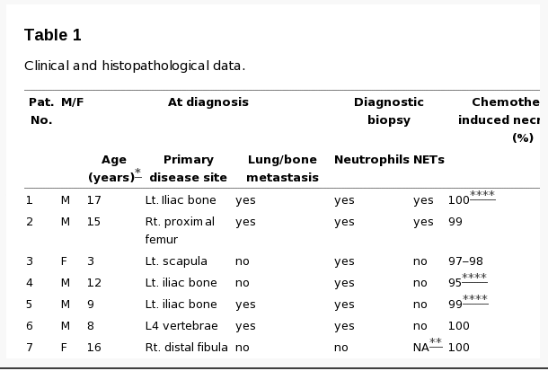
Figure 1: Histopathological data from the biopsies

Stained sections of the tumors were analyzed to see if tumor-associated neutrophils (TANs) were present. If they were, smaller sections of the sample were cut and stained again to observe if NETs were also present. (Figure 2)³ It was determined that two of the patients contained both TANs and NETs. Both patients had metastasis and began treatment after the biopsy had taken place and then relapsed after 12, and 18 months of treatment.
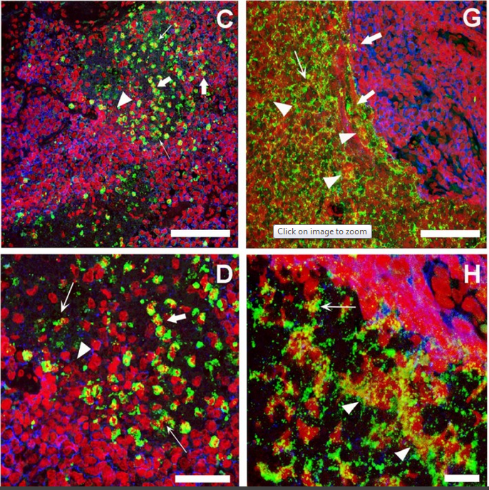
Figure 2: C,D correspond to patient 1, while G,H correspond to patient 2. The green corresponds to the staining of a known protein, MPO, in neutrophils and the red is DNA. The thick white arrows point to neutrophils in the process of NETosis, thin white arrows point to where NETs are located, and white arrowheads point to MPO and extracellular DNA
As seen in Figure 2, NETs can are viewed to be interacting with the tumor cells, especially where some of them are actually inside the tumor expected to be removing necrotic tumor cells. It is definite that NETs play a possible role in cancer, but it is unsure whether they aid in tumor production or regression, based on the fact that they contain the ability to do both.⁴ NETs could pose a threat to tumor cells by killing them or causing activation of the immune system, where they have been observed to kill melanoma cells and slow the growth of these cells by utilizing the antimicrobial proteins it possess.⁵ Or neutrophils could aid tumor cells by preventing their cellular death.⁶ However, due to the fact that both of the patients with metastatic ES displayed evidence of TANs and relapsed may suggest that NETs aid cancer cells. This also means that NETs could be a prognostic genetic marker in cancer patients to determine their risk and outcome of cancer therapies. Due to the overwhelming evidence both sides suggest in whether or not NETs have pro or anti-tumor activity is why this proposal will cover an experiment that will test for the role NETs play in patients with cancer.
II.A. Experiment
The main goal of this experiment is to determine whether NETs actually play a role in cancer cells and have either a pro or anti-tumor activity in 20-30 metastasis patients with similar cancer types that display evidence of TANs. Biopsies will be taken once before cancer treatments have begun, and then in intervals of 2 months after therapy have begun to determine the roles of NETs. If the patients respond well to cancer therapies and the biopsies show NET function of apoptosis of the cancer cells, then NETs are anti-tumor active, but if the patients get worse and are naive to the cancer therapies or relapse, then NETs must play pro-tumor active role in cancer patients.
II.B. Biopsies and Staining
In order to determine if patients have TANs, a histopathological biopsy of the tumor sites will have to be taken before any therapeutic methods are implemented. The samples will be stained using immunofluorescence stains. Hematoxylin and eosin will be used to stain the sample first so that TANs may be viewed.³ Once the presence of the TANs are confirmed 5µm thick pieces will be cut from the same slide, heated, then washed with animal serum and stained with rabbit antibodies so the NET structure can be observed.⁷ To observe these stains on a cellular level images will be captured using the Leica computer software.⁸ Objects being viewed that have crossovers of stains are more likely to be neutrophils since the majority of these antibodies derive from animal neutrophils and react with human neutrophils. The biopsies taken every 2 months will go through the same process in order to see if there are any resulting changes or placement of the NETs.

III.C. Patients
I want to test a larger sample size of 20-30 patients with the same type of cancer in order to try and obtain better results. Patients should have a healthy background and no prior infections or complications before the biopsy of their tumor is taken. Melanoma or ES would be more preferred seeing as it would be less painful and more practical to take a skin biopsy to determine the histopathalogical results every two months instead of taking bone marrow or organ tissue.
IV. Discussion
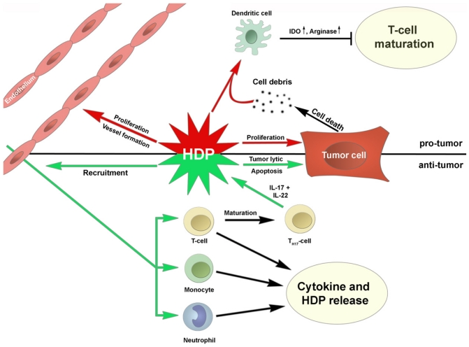
I feel if everything goes well I can discern from the outcomes of the health of the patients if NETs play a role in cancer, and if this role is pro or anti-tumor active. If the NETs are pro-tumorigenic I should expect to see a high percentage of patients relapsing or showing naivety to their therapy. I would also suspect to see NETs preventing tumor apoptosis by secretion of an extracellular matrix that is not usually present when observing the biopsy results obtained during patient cancer therapies.⁶ If the NETs prevent apoptosis in other ways then I would expect the tumor to grow in size and tumor cells to aggregate to other parts of the body. On the other hand if NETs show to be anti-tumorigenic then I would like to see a high percentage of the patients survive and respond well to therapy. If NETs play a vital role in suppressing tumors then patients may recover at an accelerated rate. Neutrophils have also been shown to be cytotoxic to tumors when stimulated, so I would expect to see a decrease in tumor size and an increased number of necrotic tumor tissue on the biopsy results.⁹ If the neutrophils induce an inflammatory reaction to recruit other leukocytes to the tumor cite, then maybe I would be lucky enough to catch some of the other cells there. If the metastasis slows then this could be a result as to the NET structure capturing and preventing aggregation. Figure 3¹⁰ shows some bioptic pathways that may take place for either case.

If symptoms of the patients with and without TANs are similar and there is not a whole lot of ambiguity determined by the results, then NETs may not play a role in cancer. It may be difficult to determine all these results by just symptoms or health of the patients, so a graph to track progress and health should be implemented.
The main problem I see with this experiment is that I don’t have control over anything in the experiment, and I’m not changing any of the variables to try and return different results. So I will be totally dependent on being able to observe the histopatholigical results from the biopsies. If one of the patients develops an opportunistic infection or other complications, this may interfere with the results and cause an unexpected change in the immune response that will not be consistent. If patients are too ill or the risk of obtaining a biopsy is too high, then I will not get all the results necessary to make a deduction to answer the hypothesis raised. The underlying statement is, the experiment is too dependent on variables that I have no control over.
Disclosure
I first thought about doing a pulse chase experiment involving rats that were given cancer via chemical injection. Then having a control, positive control, and a negative control. The first step would be testing to see if the rats showed signs of TANs and if they did then neutrophils would be isolated from a healthy rat, marked and then injected into the unhealthy rat followed by a dose of unmarked neutrophils to see if anything happened (control). Then for the positive control I found an article where stimulated rat neutrophils are known to have cytotoxic affects on tumors. So I have that as a reference. Then for the negative control, I would have a healthy rat and expect to see no changes. I was a little unsure about using this experiment seeing as I don’t have anyone to ask about it at the moment. However, I am willing to make changes and can take all the advice I can.
References
- Brinkmann V., Reichard U., Goosmann C., Fauler B., Uhlemann Y., Weiss D. S., et al. (2004).Neutrophil extracellular traps kill bacteria. Science 303, 1532–1535.10.1126/science.1092385 http://www.ncbi.nlm.nih.gov/pubmed/15001782

- Guimarães-Costa A.B., Nascimento M.T., Wardini A.B., Pinto-da-Silva L.H., Saraiva E.M. ETosis: A Microbicidal Mechanism beyond Cell Death. J. Parasitol. Res. 2012;2012:929743. http://www.ncbi.nlm.nih.gov/pubmed/22536481/

- Brinkmann V., Goosmann C., Kühn L. I., Zychlinsky A. (2013). Automatic quantification of in vitro NET formation. Front. Immunol. 3:413.10.3389/fimmu.2012.00413 http://www.ncbi.nlm.nih.gov/pmc/articles/PMC3589747/

- Souto J. C., Vila L, Brú A. (2011). Polymorphonuclear neutrophils and cancer: intense and sustained neutrophilia as a treatment against solid tumors. Med. Res. Rev. 31 311–363. http://www.ncbi.nlm.nih.gov/pubmed/19967776

- Odajima T., Onishi M., Hayama E., Motoji N., Momose Y., Shigematsu A. (1996).Cytolysis of B-16 melanoma tumor cells mediated by the myeloperoxidase and lactoperoxidase systems. Biol. Chem. 377689–693. http://www.ncbi.nlm.nih.gov/pubmed/8960369

- Acuff H. B., Carter K. J., Fingleton B., Gorden D. L., Matrisian L. M. (2006). Matrix metalloproteinase-9 from bone marrow-derived cells contributes to survival but not growth of tumor cells in the lung microenvironment. Cancer Res. 66 259–266. http://www.ncbi.nlm.nih.gov/pubmed/16397239

- EST109245 Rat PC-12 cells, NGF-treated (9 days) Rattus norvegicus cDNA clone RPNAP26 5- end, mRNA sequence. http://www.ncbi.nlm.nih.gov/nucest/978759

- Microscopy Core Facility, Max Planck Institute for Infection Biology, Berlin, Germany

- Dallegri F., Ottonello L., Ballestrero A., Dapino P., Ferrando F., Patrone F., et al. (1991). Tumor cell lysis by activated human neutrophils: analysis of neutrophil-delivered oxidative attack and role of leukocyte function-associated antigen 1. Inflammation 15 15–30. http://www.ncbi.nlm.nih.gov/pubmed/1647368

- Al-Benna S., Shai Y., Jacobsen F., Steinstraesser L. (2011). Oncolytic activities of host defense peptides. Int. J. Mol. Sci. 12 8027–8051. http://www.ncbi.nlm.nih.gov/pubmed/22174648

