Components of Neutrophil Extracellular Traps and their Origin
I. Introduction
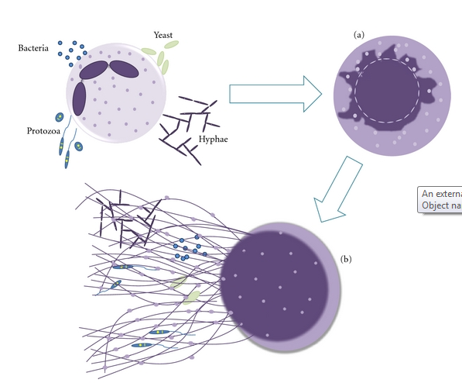
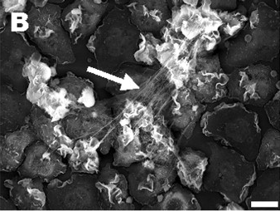
The body’s immune system, although extensively researched, is still not fully understood even as advanced as medical technology and research is today. The immune system is the body’s first line of defense against microbes, pathogens, and bacteria that attempt to invade and wreak havoc from within. In an effort to combat these antigens, neutrophils are sent to seek out and kill them. Neutrophils are the most abundant type of white blood cell and arguably the most viable in the immune system seeing as how they are the body’s first line of defense. Usually neutrophils kill bacteria by phagocytosis, by swallowing it up, but in just the past decade a new development in the structure of neutrophils has been observed, neutrophil extracellular traps. These neutrophil extracellular traps (NETs) were first observed and discovered in 2004, by Brinkman et al. where stimulated neutrophils were shown to release a DNA web structure containing several antimicrobial factors and enzymes (Figure 1)¹. Since then NETs have been shown as a secondary structure to capture bacteria² and play roles in autoimmune diseases, inflammation, and even cancer.³ In addition to neutrophils; macrophages/monocytes, mast cells, and eosinophils can produce extracellular traps (ETs).^{4,5} These leukocytes go through a process called ETosis where the cell dies and releases a series of DNA ETs. NETosis (Figure 2)⁶ is can be triggered by synthetic and physiological molecules to release NETs, here are just a few in a long list (Figure 3).⁶
Figure 1: Electron microscope view of stimulated neutrophils producing NETs
Although NETs and ETs have been in involved in a wide range of experiments, there is still little to be known about where some of the enzymes in NETs derive from and what structure forms them. To discern what effects the neutrophils’ ability to produce NETs, Fuchs et al. (2007), exposed neutrophils to different bacteria and stimulation methods to produce NETs.⁷ First, NET formation was observed after neutrophils were dyed with a die that turns the cytoplasm of living cells blue and is lost after they die which would indicate that the neutrophil dies in the process of NETosis.⁸ (Videos can also be viewed of this process in order to visualize the process). These neutrophils were stimulated by phorbol myristate acetate (PMA) making the neutrophil activate every protein at its disposal, and viewed to see how long it took to produce NETs. The authors concluded that neutrophils only extended NETs when the cell was dying and after the cell membrane had been ruptured confirming the theory that NETosis kills the neutrophil. However, NETs were not formed when neutrophils went through regulated cell death or if they were already dead, meaning that NETosis is a different form of cell death. Next, to determine what specifically induced NETosis, Fuchs et al. referenced previous works that had determined two things needed to happen in order to activate neutrophils in the immune system. First NADPH oxidase had to bind to the cell membrane of neutrophils and transfer electrons to oxygen in the neutrophil so that it could make reactive oxygen species (ROS) like hydrogen peroxide.⁹ Then granules, small particles, interfused with the neutrophil to resulting it to release its antimicrobial factors and enzymes.¹⁰
Figure 2 shows a drawing of NETosis
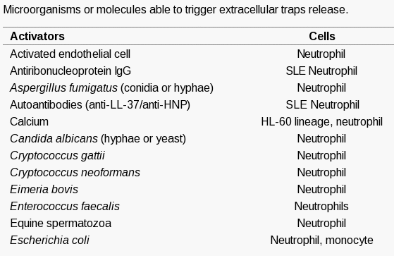
The combination of these two methods is what makes neutrophils so detrimental to bacteria. It was thought that ROS factors played an important role in the formation of NETs so the authors then used neutrophils from CGD (chronic granulomatous disease) and tried the same experiment. CGD patients are known to have mutations in the NADPH oxidase and have a deficiency in the immune system.¹¹ Neutrophils were not able to produce NETs or induce NETosis as a result to the mutations caused of the ROS factors. Knowing this information, it was deduced that ROS were an underlying regulator for NETosis, but the entire pathway is still unknown.
Figure 3: List of several physiological and synthetic molecules that can induce NETosis
However, about two years later, in 2009, new discoveries made by Wang et al. showed the importance PAD4 (peptidylarginine deaminase 4) played in the production of NETs.¹² PADs are enzymes that convert the amino acid arginine to citrulline in proteins. Wang et al. observed that 15 minutes after PAD₄ is activated in neutrophils, they started to rupture and release web-like chromatin structures. Further investigation revealed that PAD₄ sought out and targeted histone residues with arginine in them and citrullated them causing the chromatin to condense and result in the structure stated above. To test this theory, the authors treated the histones PAD₄ targeted with Cl-amidine which inactivates the calcium bond it forms with histones before activating it. This resulted in an inhibition of PAD₄ and NETs could not be produced. In order to find out more about NETs and their origin the goal of this proposal will manipulate neutrophil functions and test to see if all of the antimicrobial factors and DNA actually derive from neutrophils.
II. Experiment
II.A. Summary
In order to see if the DNA structure, and antimicrobial components, and enzymes all derive from neutrophils, isolated neutrophils will be injected into mice with an induced inflammatory reaction and tracked in vivo. The mice will be euthanized 2 days after neutrophils are viewed to reach the inflammation site, and then slide samples of the inflammation site will be made and stained by immunofluorescence means so that neutrophils can be observed. For this to work there will have to be 3 controls: A positive control where neutrophils will have PAD₄ inhibited a negative control in which neutrophils will be uninhibited, and a control that will be untreated.
II.B. Inducing an Inflammatory Reaction
To cause an inflammatory reaction in mice that will be known to stimulate neutrophils to produce NETs, a lipopolysaccharide will be sub-dermally implanted into each mouse. Lipopolysaccharides (LPS) have been proven by Brinkman et al. (2004) to induce inflammation severe enough to cause NETosis.¹ LPS derive from the membranes of Gram-negative bacteria, and once detected by the immune system will simulate the body thinking there is a bacterial infection and order neutrophils be sent to the infectious site to combat it.
II.C. Isolating Neutrophils
About 15 mL of blood will be taken from healthy mice and then the neutrophil isolation protocol will be followed.¹³
- All materials are to be brought to room temperature.
- Put 5.0 mL of neutrophil isolation media in a centrifuge tube and layer 5.0 mL of blood over the media.
- Centrifuge
- This will result in 6 density layers, remove the top 3 layers and dispose
- Remove the neutrophils (4th layer) and the layer of isolation media below into a new centrifuge tube.
- Dilute the new solution with 10 mL of Hanks Buffer Salt Solution (HBSS) that does not have calcium or magnesium in it, and invert so the cells are suspended.
- Centrifuge
- Add 2 mL of Red Cell Lysis Buffer so that any remaining red blood cells are destroyed, and then mix the solution.
- Centrifuge and then remove any lysed red cells
- Add 500µL of the same HBSS solution and mix, then dilute the solution to 10 mL.
- Centrifuge and remove any unwanted cells.
- Resuspend in 250µl of HBSS with calcium and magnesium.

II.D. Tracking Neutrophils in vivo
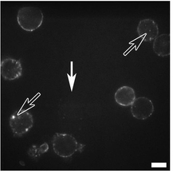
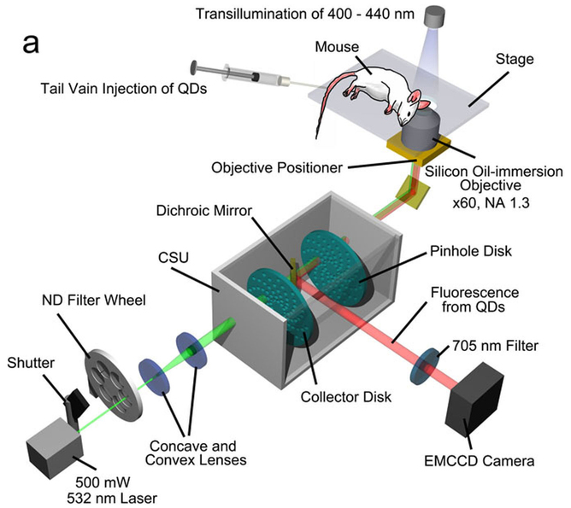
An invasive method for tracking neutrophils will be used as to not cause any additional inflammation than previously described. To do this Quantum Dots (QD) will be conjugated with an anti-body specific to the cell membrane of neutrophils. Doing this will cause the QD – antibodies to bind to only neutrophils of the mice and avoid tracking any other leukocytes and contaminate results. The QD – antibodies will be engulfed into the membrane and show a bright white dot when viewed by a high power laser (Figure 4).¹⁴ The antibody used will be anti-Ly6G, it specifically bonds to a protein (Gr-1) in neutrophil granulocytes making it an exceptional marker. Both the neutrophils and QD – antibodies will be injected via the tail vein. The neutrophils can be viewed using the high intensity laser described by Fig4 and will look something like (Figure 5).¹⁴ Neutrophils that are to have PAD₄ inhibited will first be incubated for 15 minutes with Cl-amidine so they will be incapable of producing NETs.
Figure 4 shows how the neutrophils can be viewed without having to disturb the mouse

Figure 5 displays neutrophils with QDs to identify them

II.E. Immunofluorescence Staining of Tissue
In order to detect NET structures, antimicrobial factors, and enzymes antibodies containing fluorophores (chemical compound that can re-emit light upon excitation) will be used to attach to these molecules and allow them to be viewed under a fluorescent microscope. When tissue samples are taken from the inflammation site they will first be dehydrated and sliced into 5µm samples. Next, they will be rehydrated and stained with hematoxylin and eosin. Hematoxylin binds to and colors DNA in samples while eosin binds to eosinophilic like structures (neutrophils/NETs) and allow them to be viewed. The other items to be marked are as follows:
- Neutrophil DNA
- Calprotectin
- Myeloperoxidase (MPO)
- Cathelicidin
- Pentraxin 3
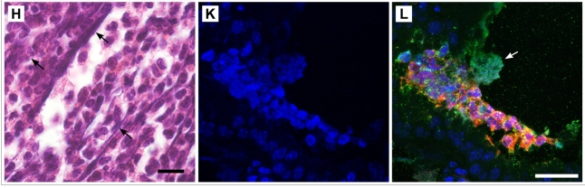
All of these molecules are known to be associated with neutrophils and NETs but have not always been found in the structure for studies in vitro.¹⁵ Methods for staining these molecules involved using rabbit antibodies, because they contain similar DNA strands and will effectively bind to the molecules. Doing a histology report combined with these methods will determine the results. (Figure 6)¹⁵
Figure 6
What immunofluorescence staining looks like for epithelium of mice lungs. L shows NET structures and the staining of several proteins and molecules

III. Discussion
If everything goes as planned I would expect to see obvious evidence of NETs in the histology reports of the inflammation areas of only one of the mice. The other should only show neutrophils and no NETs because the PAD₄ will have been successfully suppressed. If neutrophils contain all the required components they need for their NET structures, I should not see any fluorescent antibodies when observing the histology reports of the mice with suppressed neutrophils. Additionally the reports with NETs should reveal all of the stained molecules within the proximity of the structures. However, if evidence suggests that there are molecules associated with NETs found outside the inactivated neutrophils, then these are absorbed into the NETs by other means and said molecules do not derive from NETs but rather they are obtained by other means. Experiments may have to be run in vitro with blood samples and stimulated neutrophils to see where these molecules come from, or if not, then neutrophils could be concluded to state they have all the materials they need to fight antigens. Either way the world will be one step closer in discerning how these cells work and the mysteries behind them.
The problem is I need some way to track the neutrophils in vivo without causing any more harm to the mice, so if the non-invasive method does not work and I cannot tell when/if neutrophils arrive at the inflammation site then I will have no idea if they are even involved in the process other than previous research. I also do not know if suppressing PAD₄ will cause any other additional changes to inhibit the neutrophil’s ability to travel through the blood. Additionally, I don’t how long the inhibition is or if the cell will regain the ability to produce NETs in a given amount of time since the experiment stimulated neutrophils immediately after suppressing PAD₄. If non-invasive tracking proves inconclusive then other means of tracking maybe implemented. Growing up a mouse with labeled neutrophils would be a viable option. Then I could take blood samples from different spots on the body, including the inflammation spot, to see if the labeled neutrophils are present.
Neutrophils that are being injected from one healthy mouse to an infected one may be rejected since they are not the own host’s cell. If this happens then I would have to take neutrophils from the same mouse. The trouble with this is that neutrophils have a short lifespan and I would have to take them while the mice are still healthy and prior to sub-dermally implanting LPS. Then I would be required to wait for a reaction to occur and that could be as long as a few days after implantation. By this time, the neutrophils lifespan is cut short and tracking may become obsolete. The neutrophils would have to be frozen or taken from a close relative to see if they were accepted into the host allowing for optimal results.
Staining may also produce results that are hard to determine since the hematoxylin and eosin mark everything and not just neutrophils and NETs. These cells may not even be at the cultured sample site and nothing may show up. If so, then I may consider taking tissue samples from other sites as well as blood samples to see if NETs are produced. This would suggest that neutrophils can be stimulated by other means than by directly coming into contact with an antigen which would provide for more testing in the future.
Other leukocytes may play a role in an inflammatory reaction such as this and should be tracked and observed to see if they produce ETs in the same circumstances. Maybe neutrophils gain different proteins or molecules from its fellow leukocytes rather than themselves. If this is not the case then further experimentation and explanation of why some antimicrobial factors are not found but claim to associate with neutrophils.¹⁵

References

- Brinkmann V., Reichard U., Goosmann C., Fauler B., Uhlemann Y., Weiss D. S., et al. (2004).Neutrophil extracellular traps kill bacteria. Science 303, 1532–1535.10.1126/science.1092385 http://www.ncbi.nlm.nih.gov/pubmed/15001782

- McDonald B, Urrutia R, Yipp BG, Jenne CN, Kubes P. Intravascular neutrophil extracellular traps capture bacteria from the bloodstream during sepsis. Cell Host Microbe. 2012;12(3):324–333. doi: 10.1016/j.chom.2012.06.011. http://www.ncbi.nlm.nih.gov/pubmed/22980329

- Radic M, Kaplan J. M, Extracellular traps interconnect cell biology, microbiology, and immunology. Front Immunol. 2013; 4: 160. http://www.ncbi.nlm.nih.gov/pmc/articles/PMC3690543/

- von Köckritz-Blickwede M, Goldmann O, Thulin P, Heinemann K, Norrby-Teglund A, Rohde M, Medina E. Phagocytosis-independent antimicrobial activity of mast cells by means of extracellular trap formation. Blood. 2008 Mar 15; 111(6):3070-80. http://www.ncbi.nlm.nih.gov/pubmed/18182576/

- Yousefi S, Gold JA, Andina N, Lee JJ, Kelly AM, Kozlowski E, Schmid I, Straumann A, Reichenbach J, Gleich GJ, Simon HU. Catapult-like release of mitochondrial DNA by eosinophils contributes to antibacterial defense. Nat Med. 2008 Sep; 14(9):949-53 http://www.ncbi.nlm.nih.gov/pubmed/18690244/

- Guimarães-Costa A.B., Nascimento M.T., Wardini A.B., Pinto-da-Silva L.H., Saraiva E.M. ETosis: A Microbicidal Mechanism beyond Cell Death. J. Parasitol. Res. 2012;2012:929743. http://www.ncbi.nlm.nih.gov/pubmed/22536481/?ncbi_mmode=std

- Fuchs TA, Abed U, Goosmann C, et al. Novel cell death program leads to neutrophil extracellular traps. Journal of Cell Biology. 2007;176(2):231–241. http://www.ncbi.nlm.nih.gov/pubmed/17210947/

- http://www.jcb.org/cgi/content/full/jcb.200606027/DC1 (Videos must be viewed in FireFox Browser) Losman, M.J., T.M. Fasy, K.E. Novick, and M. Monestier. 1992. Monoclonal autoantibodies to subnucleosomes from a MRL/Mp(-)+/+ mouse. Oligoclonality of the antibody response and recognition of a determinant composed of histones H2A, H2B, and DNA. J. Immunol.148:1561–1569. http://www.ncbi.nlm.nih.gov/pubmed/1371530/

- Hampton, M.B., A.J. Kettle, and C.C. Winterbourn. 1998. Inside the neutrophil phagosome: oxidants, myeloperoxidase, and bacterial killing. Blood. 92:3007–3017. http://www.ncbi.nlm.nih.gov/pubmed/9787133

- Klebanoff, S.J. 1999. Oxygen metabolites from phagocytes. InJ.I. Gallin and R. Snyderman, editors. Inflammation: Basic Principles and Clinical Correlates. Lippincott Williams & Wilkins, Philadelphia. 721–768 pp.

- Heyworth, P.G., A.R. Cross, and J.T. Curnutte. 2003. Chronic granulomatous disease. Curr. Opin. Immunol.15:578–584. http://www.ncbi.nlm.nih.gov/pubmed/14499268

- Wang Y, Li M, Stadler S, Correll S, Li P, et al. Histone hypercitrullination mediates chromatin decondensation and neutrophil extracellular trap formation. J Cell Biol. 2009;184:205–213. http://www.ncbi.nlm.nih.gov/pmc/articles/PMC2654299/

- Oh, H., Siano, B., Diamond, S. Neutrophil Isolation Protocol. J. Vis. Exp. (17), e745, doi:10.3791/745 (2008). http://www.jove.com/video/745/neutrophil-isolation-protocol?ID=745

- Kikushima, Kenji, Kita, Sayaka, Higuchi, Hideo. A non-invasive imaging for the in vivo tracking of high-speed vesicle transport in mouse neutrophils. Sci. Rep. 2013/05/31/online. http://www.nature.com/srep/2013/130530/srep01913/full/srep01913.html#ref7

- Urban CF, Ermert D, Schmid M, Abu-Abed U, Goosmann C, et al. Neutrophil extracellular traps contain calprotectin, a cytosolic protein complex involved in host defense against Candida albicans.PLoS Pathog. 2009;5:e1000639 http://www.ncbi.nlm.nih.gov/pubmed/19876394/

